**GSU ACM Club Application**

**Table of Contents**

**Introduction** **8**

Team Members **8**

**Feasibility Study** **9**

Executive Summary: 9

The Client 9

Task to be Completed: 9

Domain Analysis 9

Requirements Analysis 9

Suggested Deliverables: 10

Process to be Involved: 10

VII. Outline Plan: 11

VIII. Visibility Plan: 11

External: 11

IX. Risk Analysis: 11

X. Technical Requirements: 11

XI. Conclusion: 12

**Software Requirements** **12**

**1. Introduction** **12**

1.1 Purpose 13

1.2 Scope 13

1.3 Definitions, Acronyms, and Abbreviations. 13

1.4 References 13

1.5 Overview 14

**2. The Overall Description** **14**

2.1 Product Perspective 14

2.1.1 System Interfaces 14

2.1.2 Interfaces 14

2.1.3 Hardware Interfaces 14

2.1.4 Software Interfaces 15

2.1.5 Communications Interfaces 15

2.1.6 Memory Constraints 15

2.1.7 Operations 15

2.2 Product Functions 16

2.3 User Characteristics 16

2.4 Constraints 16

2.5 Assumptions and Dependencies 16

2.6 Apportioning of Requirements. 16

**3. Specific Requirements** **17**

3.1 External Interfaces 17

3.1.1 User Interfaces 17

3.1.2 Software Interfaces 17

3.2 Functions 17

3.5 Design Constraints 18

3.5.1 Standards Compliance 18

3.6 Software System Attributes 18

3.6.1 Reliability 19

3.6.2 Availability 19

3.6.3 Security 19

3.6.4 Maintainability 19

3.6.5 Portability 19

**4. Change Management Process** **19**

**Project Schedule** **19**

Timeline 21

PERT Diagram 22

LOC Estimation 22

**Design** **22**

Design Methodology 22

Definitions, Acronyms, and Abbreviations 23

Overview 23

**Proposed Software Architecture** **24**

Overview 24

Subsystem Decomposition 24

Hardware and Software Mapping 25

Persistent Data Management 26

Security Management 26

**Object Design** **27**

3.1 Overview 27

3.2 State Machine 29

3.3 Object Interaction 30

3.4 Detailed Class Design 30

3.4.1 30

State Chart 31

Data Model 32

**Testing** **32**

**Post Mortem** **32**

Introduction 33

Report Goals 33

Project Overview 33

Performance 34

Key Accomplishments 34

Key Problem Areas 35

Overall Project Assessment 35

Key Lessons Learned 35

Post Project Tasks/Future Considerations 35

**Appendix** **35**

User Manual 35

Starting the Application 36

Creating an Account 36

Logging in 38

Navigating the Dashboard 39

Viewing Events 40

Viewing your Profile 42

Editing your Profile 43

Changing your Profile Picture 44

Changing your Password 45

Viewing Members / Mentors 45

Chatting with Other Users 47

Requesting a Tutor 48

Viewing / Accepting a Tutoring Request 49

Viewing / Voting on Polls 50

Viewing Alumni 51

Paying Club Dues 52

Viewing the About Us Page 53

Viewing a Member's Profile 53

Using the Administrator Control Panel 54

Creating an Event 55

Creating a Poll 56

Taking Attendance 56

Viewing Attendance 57

Setting User Titles 58

Updating the News 59

Source Code 60

Main Files 60

Controls 70

Helpers 76

Models 78

Services 83

ViewModels 85

Views 183

# **Introduction**

Our tenure in the Computer Science program instilled the principles of hard-work, the confidence to dive into unfamiliar territory, the excitement of overcoming complex problems, and the building of life long friendships. The capstone project is regarded as a test that proves a CS student has learned the skills & knowledge to join the workforce. We were first introduced to our project by a team member who was the President of the Association for Computer Machinery (ACM). We were assigned with developing an application that would enhance communication and tools for ACM.

The Georgia Southern’s Association for Computer Machinery (ACM) club connects student members with professional development tools. ACM traditionally had to utilize multiple applications and devices to relay information pertaining to the club to its members. To counter the problem of utilizing multiple applications and devices, the ACM club application will be a consolidated tool that will be primarily a communication application, but include useful extensions.

The following information in this software document will outline the plans of building the previously stated ACM application. This document serves as a timeline of our semester building our capstone project.

# **Team Members**

Griffin Bryant

Computer Science Department

Georgia Southern University

[gb02243@georgiasouthern.edu](mailto:gb02243@georgiasouthern.edu)

Mansi Pandya

Computer Science Department

Georgia Southern University

mp06160[@georgiasouthern.edu](mailto:mansi_a_pandya@georgiasouthern.edu)

Dylan Myers

Computer Science Department

Georgia Southern University

[dm05800@georgiasouthern.edu](mailto:dm05800@georgiasouthern.edu)

Marquise Jennette

Computer Science Department

Georgia Southern University

[mj03661@georgiasouthern.edu](mailto:mj03661@georgiasouthern.edu)

Everrick Wright

Computer Science Department

Georgia Southern University

[ew02726@georgiasouthern.edu](mailto:ew02726@georgiasouthern.edu)

# **Feasibility Study**

## Executive Summary:

### The Client

Association for Computer Machinery is the client, however, Dr. Andrew Allen served as the spokesperson for the project. For future implementations Dr. Pradipta De has expressed interests of being the client.

## Task to be Completed:

The objective is to build an Application for the ACM club which connects members with professional tools. The design can be used by students who enroll into the club in future. The results can assist members with academic guidance and networking. The system is divided into two parts: front end functionality and database back end.

## Domain Analysis

The Application will function as an all-in-one resource for its members. It will provide students with exclusive club events along with academic help. The Application will allow admins to change and update information. The member details will follow from the database which they entered while signing up. The stored member information will be used in tutoring and chat functionality. Furthermore, the system will allow members to update their details. This will immediately update the records in the database.

## Requirements Analysis

The system shall have a login system. The security measures must be given a priority. Every member’s data is strongly secured. The login system ensures that the credentials and communications are kept safe. A combination of email address/password and its validation must be maintained.

The system should allow non-members to see events and create an account. The student community at Georgia Southern University must be allowed to visit the Application's Event page and view upcoming events. The non-members shall create an account with the ACM club to become a member. This would aware students to join the club.

The system must also allow its members to view events. The members must have access to all the ACM events in the Application.

The system should allow members to request a mentor. The tutors must be requested by the students based on what courses they can offer help. The members must be able to provide course names to request a session.

The system must allow administrators to create anonymous voting polls for executive board members. The executive board members must be defined as an e-board member in the database to let them participate in voting polls. The polls should only be available for the executive board members.

The system should be able to keep a tally of attendance at every meeting. The administrator must have the ability to enter the names of all present attendees in a meeting. The names must get stored in the database and it must get updated.

The system must allow members to see a list of GSU ACM alumni. The system should make sure that only the members of the club have access to this list.

The system should allow members to open event locations in their default map application. The events must have a location added and the member should be able to open the location on their respective map application.

## Suggested Deliverables:

Our entire capstone project will be focussed on to create a fully functional Application for the GSU ACM club. The major deliverable product will be the Application itself. We will present it to the faculty at the end of the semester.

## Process to be Involved:

The process begins once after the feasibility plan has been discussed.

1. Determine the requirements
2. Plan the design
3. Design a prototype
4. Implementation
5. Testing
6. Deploy
7. Maintain

## VII. Outline Plan:

1. 2/24/2020 - SRS document turned in
2. 3/1/2020 - Deep design planning
3. By mid-March we should be in development and implementing UI individually. We should be then ready to merge our work.

## VIII. Visibility Plan:

### External:

Our client, Dr. Allen Andrew is located in the IT Building. We will meet him regularly to check on our work. We will plan to talk to him both- via email and in person. We will present live working of our system and we will consider his inputs.

## IX. Risk Analysis:

Pre-assessed risks:

1. Our AWS server being down, which we mitigated by having a backup server.
2. Xamarin forms bugs, which we assessed to be not likely to happen.
3. Visual Studio having a bug, which we assessed to be unlikely to happen
4. Our Github master branch being overwritten , which we mitigated by using Github’s ability to roll back branches to earlier builds.
5. Our internet being down , which we mitigated by making sure to catch up on work so we were not behind.

## X. Technical Requirements:

Amazon Web Services:

Amazon Web Services (AWS) is a secured cloud platform. It is widely used for database storage and content delivery. The reason we opted for AWS is that it is secure and flexible. The platform is convenient in every environment and language. All the communication with our database will be handled by AWS.

Xamarin:

Xamarin is one of the leading open source platforms to design applications for iOS and Android. Our project will require cross platform development and so Xamarin is a perfect fit.

## XI. Conclusion:

Our tenure in the Computer Science program instilled the principles of hard-work, the confidence to dive into unfamiliar territory, the excitement of overcoming complex problems, and the building of life long friendships. The capstone project is regarded as a test that proves a CS student has learned the skills & knowledge to join the workforce. We were first introduced to our project by a team member who was the President of the Association for Computer Machinery (ACM). We were assigned with developing an application that would enhance communication and tools for ACM. Through teamwork and research we have built a working cross platform mobile application that can be utilized by the local chapter of ACM. Furthermore, through the use of functional, structural, and integrational testing we can assert the application will pass acceptance testing. Our capstone project has challenged us, but has given us the confidence to continue our learning through graduation.

# Software Requirements

# **1. Introduction**

The purpose of the Software Requirements Specification is to outline the requirements for the student Association for Computing Machinery application. Will be cross platform, will use a database, and will use a web hosting service.

## **1.1 Purpose**

The ACM application will be a mobile application to provide a platform for communication and resources for ACM members and computer science students.

## **1.2 Scope**

1. Our application will be a mobile application for the ACM.
2. The application will be used as a tool for ACM members, ACM Executive Board members, and Georgia Southern ACM Alumni members.
3. The tool should be mainly utilized as a chat system with additional add ons.
4. The benefits of our application will be to provide a streamlined application that will allow members and admin to communicate and schedule events more effectively.
5. The objectives of our software will be to allow members and admin to fulfill the requirements they have specified.
6. The goal will be to produce software that will be easy to use and efficiently complete its tasks.

## **1.3 Definitions, Acronyms, and Abbreviations.**

ACM - Association for Computing Machinery

MySQL - The database management system

AWS - Amazon Web Services

## **1.4 References**

<https://aws.amazon.com>

<https://dotnet.microsoft.com/apps/xamarin>

<https://visualstudio.microsoft.com>

## 

## **1.5 Overview**

This document contains all of the software requirement specifics. It contains a general description of the types of users who will be using our application, how it is going to work, and what technologies we are using to make it work. We will also outline and describe specific components of the project.

# **2. The Overall Description**

The main tasks with respect to our software will be to provide a user account for admin and users. The admin being the executive members and the users being the ACM members and alumni. The admin will be able to schedule events, post ACM videos, and be able send messages out to users. The users will then be given the opportunity to ask for mentorship on particular subjects related to the ACM. Alumni users will also be given the choice to still be involved with the ACM.

## **2.1 Product Perspective**

This product is designed to run on either Android or iOS devices. The sole requirement for the user is a mobile device and an active internet connection.

### **2.1.1 System Interfaces**

iOS - This system will be the interface for iPhone users. It will have the same functionality as the android system, and both will be connected to one database. The database will be built by us, thus no connecting API will have to be utilized. The iOS system will connect to Amazon Web Services.

Android - This system will be the interface for android users. It will have the same functionality as the iOS system, and will share the same database as the iOS system. This system will connect to Amazon Web Services.

### **2.1.2 Interfaces**

Our application will interface from whichever mobile device the user is on to the database.

### **2.1.3 Hardware Interfaces**

The ACM Application will work on Android and iOS mobile devices. Because most of the applications features will require an internet connection as well as location data, the devices will also require internet connectivity and GPS signal.

### 

### 

### **2.1.4 Software Interfaces**

1. Name: Xamarin
2. Mnemonic:
3. Version: 4.3
4. Source: <https://dotnet.microsoft.com/apps/xamarin>
5. Name: Visual Studios
6. Mnemonic: VS
7. Version Number: 16.0
8. Source: <https://visualstudio.microsoft.com>
9. Name: GitHub
10. Mnemonic: Git
11. Version Number:
12. Source: <https://github.com>
13. Name: Amazon Web Services
14. Mnemonic: AWS
15. Version Number: 21.0
16. Source: <https://aws.amazon.com>

### **2.1.5 Communications Interfaces**

The main interfaces for are communications will be a AWS cloud server that will handle the requests of clients. We also will use a API of a chat like GroupMe to integrate with our own app

### **2.1.6 Memory Constraints**

Our target RAM size is between 50 - 60M of RAM and not exceeding 60 M. This memory constraint is based off of GroupMe's most current required memory constraint of 60MB.

### **2.1.7 Operations**

The user will have several operations when logging onto the application. The main operation will be the main chat room where casual communication can take place between eboard members, standard acm members, and alumni. From the main chat room the user will have the options of changing chat rooms or selecting from several tabs. A regular user will have the options of ACM sponsored videos, events with gps, pay dues, and look for tutoring help. The admin will be able to add/drop members, change roles, add events for regular users to attend, accept dues, and assign people who are able to tutor. The chat will be saved and able to have recovery options due to semi-constant backups.

## **2.2 Product Functions**

The main function of the ACM application is the group chat functionality

* This function will allow users to send messages and the rest of the chat’s application will be updated with the sent message.

Other sub-functionalities include:

* GPS tracking to set ACM events
* Different chat rooms for different topics (alumni chat, executive board chat, memes chat, homework chat)
* A matching algorithm for mentors/mentees
* A section that displays/links ACM sponsored videos

## **2.3 User Characteristics**

ACM executive members will have the power to add events, moderate the chat, and upload ACM videos.

ACM members will be able to ask for mentorship, message others, select chat groups, and know the geographic location of events.

## **2.4 Constraints**

The application will comply with the Americans with Disabilities Act Standards for Accessible Design. Because the application will handle user accounts, security is important and all user information will be encrypted.

## **2.5 Assumptions and Dependencies**

It is assumed that users with iPhones will be using iOS version 13.3.1 or newer and users with Android devices will be using Android version 10.0 or newer.

## **2.6 Apportioning of Requirements.**

**Requirements that may be delayed until future versions of the system.**

* The system may have a point system to rank members based on the things they have done for the ACM club
* The system should allow users to get in contact with possible employers for internships, co-ops, and jobs
* The system should allow users to see a list of known ACM GSU employers
* The system may have the ability for administrators to keep a tally of the attendance at each meeting
* The system may allow administrators to accept electronic payments via paypal or venmo
* The system may allow administrators to create anonymous voting polls for the executive board

# **3. Specific Requirements**

## **3.1 External Interfaces**

### **3.1.1 User Interfaces**

Users will interact with the ACM Application through their mobile device. The resolution and orientation of the application will depend on the device used and the orientation the user holds it at. The Xamarin Framework allows us to create a responsive application that will automatically scale for each device/orientation. When the user is navigating the app, there will be various menus and forms for them to navigate and use to submit information. There will also be an on-screen keyboard for the user to type with while chatting with other users or entering information into the forms.

### **3.1.2 Software Interfaces**

The ACM Application will interface with AWS to host all of the back-end information including the database and files. We plan to use MySQL version 8.0.19 for our database.We also expect to use an API like GroupMe to handle all of the chat functionalities.

## **3.2 Functions**

* The system shall have the ability to log onto the application
* The system database shall store titles of board members
* The system shall set eboard members as club administrators
* The system shall allow users to view events
* The system shall allow users to open event locations in their default map application
* The system shall allow users to request a mentor
* The system shall allow the tutor to be matched by things like class experience
* The system may have a rating system for mentors
* The application shall be able to send notifications for meetings and events via email or push notification
* The system shall prevent messages containing profanity from being sent to in the chat
* Users shall be able to message other users directly
* Users shall be able to send messages inside of groups with set topics
* Non-members shall be able see events and create an account
* Administrators shall have the ability to approve new users
* Users shall have the ability to create a profile
* The system may have a point system to rank members based on the things they have done for the ACM club
* The system should allow users to see a list of known ACM GSU alumni
* The system shall have the ability to keep a tally of the attendance at each meeting
* The system shall allow a user to be removed from the ACM app after deferring to ACM constitution
* The system shall allow administrators to create anonymous voting polls for the executive board

## **3.5 Design Constraints**

Since we will be using a framework we will be limited to the features of whichever framework we use.

### **3.5.1 Standards Compliance**

The ACM application will conform to the Americans with Disabilities Act Standards for Accessible Design and the WAI’s Addresses Mobile Accessibility standards. These standards state that all electronic and information technology must be accessible to people with disabilities.

## 

## **3.6 Software System Attributes**

* The login process should be completed ***within 3 seconds***
* The system shall have the functionality of assigning roles with a displayed title such as ***President, Vice-President, Treasurer, Officer, Secretary***
* The system shall allow users to use a chat system ***that saves messages for 1 semester’s length***
* The system shall allow users to request a tutor ***and the request is sent within 1 minute***
* The application shall be able to send notifications for meetings and events via email or push notification ***that is sent out within 30 seconds from initiation***
* The system shall prevent messages containing profanity from being sent to in the chat ***immediately***
* Users shall be able to message other users directly ***that is sent within 1 minute***
* Administrators shall have the ability to approve new users ***members are added immediately (3-5 seconds)***
* Users shall have the ability to create a profile ***and it be displayed immediately***
* The system shall allow administrators to kick a user out of the ACM app ***access of logging into application should be enacted immediately after removal***

### **3.6.1 Reliability**

The system should be able to handle its required users concurrently. The system should be able to handle high messaging rates. The system should not have frequent crashes.

### **3.6.2 Availability**

The system should be available 24/7. Because we are using AWS our application's server-side availability will be limited to Amazon's services uptime. Client-side availability will be dependent on the user's device availability.

### **3.6.3 Security**

We will utilize password encryption via RSA encryption to ensure password security. We will sanitize all incoming data. We will use getters and setters to avoid unwarranted access of data.

### **3.6.4 Maintainability**

Due to the nature of mobile applications, the ACM Application will have to be updated periodically to suit the most recent version of whichever operating system is in use. The Xamarin framework simplifies this process with a built-in migration tool for the most recent API for iOS and Android devices.

### **3.6.5 Portability**

The portability of the application between iOS and Android will not be difficult because all of our development will be cross-platform through Xamarin. However, if we were to try to port it to a web application it would take a lot of extra work because Xamarin doesn't currently support web development. If we were to create a web-accessible version of our application, we would have to start from scratch for that portion.

# **4. Change Management Process**

Our group will be open to minor changes to the application requirements as long as the team reaches a consensus on whether or not the change is feasible. All changes shall be submitted in writing to the team leader so they cannot be lost/forgotten. Requested changes will then be passed on to be discussed with the rest of the team for approval.

# Project Schedule

## Timeline

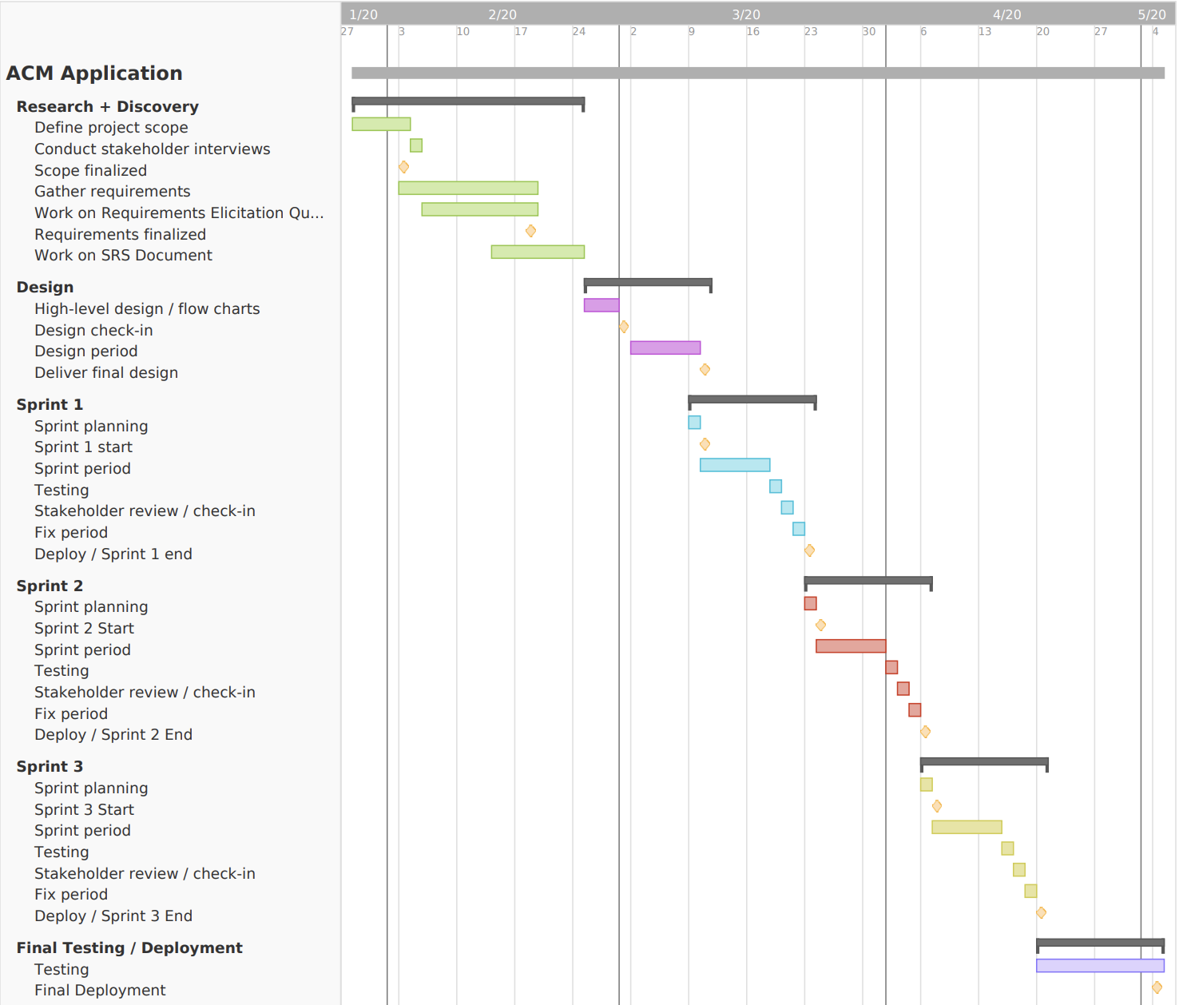

## PERT Diagram



## LOC Estimation

39,875 total lines of code.

# Design

## Design Methodology

The ACM application development will be based on the Agile Software Development Lifecycle. The Agile Lifecycle was chosen because it advocates adaptive planning, evolutionary development, quick delivery, and continual improvement. We will follow the cycle of meeting, planning, designing, developing, testing, and evaluating. The whole process will be driven by the use cases that we designed (see 5.2 – Appendix B) during our planning phase and illustrated in our Software Requirements and Specifications document (SRS). This document addresses the design model, the deployment model, and the implementation models. Our design models are created in Chapter 2 and Chapter 3. The models created are Sequence Diagrams, Class Diagrams, and State Charts. Our design models serve as input into the deployment models. From these diagrams and the Agile approach, section 2.3 discusses the mapping of these models to the hardware of the platform. Once we understand how to map the models to our hardware, we can use the deployment model as a metamodel for the implementation model which produces code.

## Definitions, Acronyms, and Abbreviations

***ACM*** - Association for Computing Machinery

***MySQL*** - The database management system

***AWS*** - Amazon Web Services

***MVVM*** - Model-View-ViewModel

## Overview

In subsequent chapters a detailed understanding of the ACM application will be obtained. In Chapter 2, Proposed Software Architecture, the architecture and accompanying UML profiles of the ACM Application will be examined. The includes a discussion of the generative architecture used to produce code in Section 2.4. In Chapter 3, Object Design, a detailed overview of the structure of the ACM application will be discussed along with important interactions needed for the correct developpment of the system. This chapter will outline the class structure of several objects needed for the development phase. In chapter 4, Glossary, several terms used throughout this design document are defined. This chapter will be useful when an obscure term is encountered so that the reader can thoroughly understand the material. In Chapter 5, Appendix, additional supplementary information can be found. This section contains use case diagrams, use cases, detailed class diagrams, code, and a log of group meetings. By the end of this document, the reader will have an understanding of the design and possible implementation of the ACM Application.

# Proposed Software Architecture

The software architecture is arguably the most important design decision of any software system or component. It is essentially the decision that could make or break the project, guide future design decisions, and provide an overall structural theme that will remain until the "shelf life" of the system expires. Because of the importance of software design architecture, it is vital to design and understand the system correctly. Failure to achieve this goal may lead to the complete failure of the software financially and programatically.

To achieve the goal of understanding the ACM Application design thoroughly and correctly, this chapter strives to address all of the design considerations completely. In section 2.1 an overview of the entire proposed system architecture is discussed. In Section 2.2, Subsystem Decomposition, we will describe each of the major subsystems and identify the use cases associated with each subsystem. In Section 2.3, Hardware and Software Mapping, we will explain how the subsystems will be mapped between hardware and software. In Section 2.4, Persistent Data Management, we will identify the data that we need to store and the structure we will use to store it. In Section 2.5, Security Management, we will describe the security protocols that we plan to use in our design.

## Overview

Team 6 will use a Model-View-ViewModel (MVVM) pattern. MVVMs are used when you need flexible design work, when unit testing is required, when it is important to have reusable components, and when development work needs to be simultaneous.

Team 6 also plans to implement the three-tier style architecture. This style includes a presentation tier, an application tier and a data tier. Utilizing this tier, we can improve performance, availability, and scalability.

## Subsystem Decomposition

The ACM Application is decomposed into four packages. The packages will be the chat communication API, the mentor system, the main application, and the database. Users will log into the main application which will access the database for most of its information including user login and profile information, event information, and other ACM club information. The database subsystem will store the actual information that is accessed from the main application. The mentoring subsystem will allow users to request a mentor with experience in a specific subject to help them with that subject. The chat subsystem will use an API to allow users to send messages directly to each other as well as to a group with multiple users.

## Hardware and Software Mapping

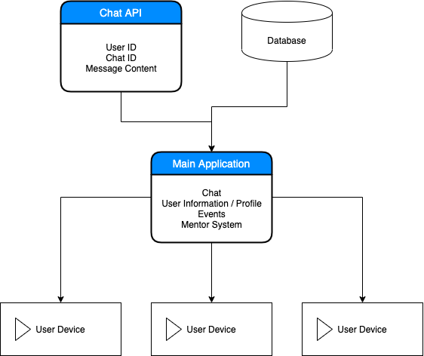

## Persistent Data Management

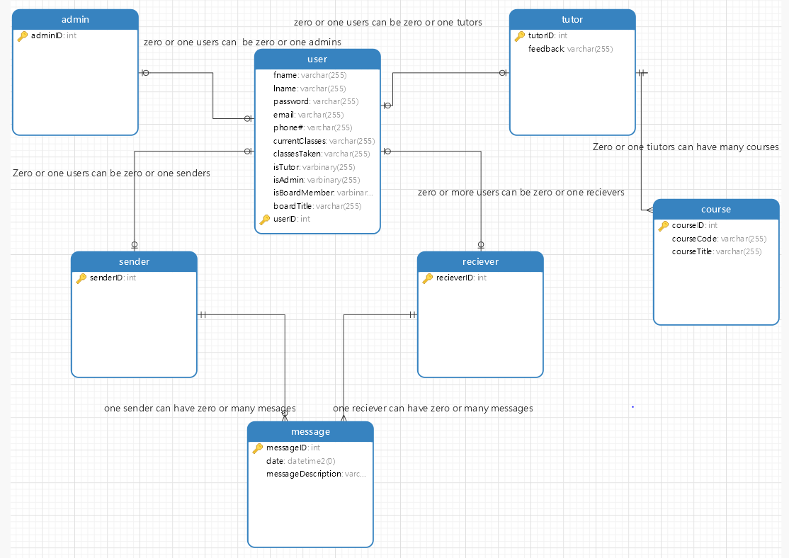

## Security Management

Rivest-Shamir-Adleman (RSA) will be used for password encryption in our application. RSA is an algorithm asymmetric cryptographic algorithm. Asymmetric meaning there are two different keys; one of which will be a public key and given to anyone. The other key must be private. Implementing a private and public key generator and prime factorization passwords will be difficult to break.

A backup of a database can be done in 4 ways: Full backup, incremental backup, differential backup, and mirror backup. The most optimal for our system will be a mirror backup in which it does not store old obsolete files after being deleted in the main database. The downside of downside backups is if files are accidently deleted, they can be lost from the backup as well if not discovered before the next scheduled backup.

Bugs and vulnerabilities in a code are starting points for many errors in applications. Encapsulation and minification of code to reduce the chance code can be reversed engineered, testing repeatedly, and clear and easily updatable/patchable code will be implemented in development.

# Object Design

The design and structure of objects, like the system architecture, is important. A proper design of objects can prevent software rot, improve ease of maintenance, improve software efficiency, and improve overall robustness. To achieve this "holy-grail" of design, designers must document the design of objects. To properly document the object design, designers tend to rely on several UML diagramming techniques, such as class diagrams, sequence diagrams, and state charts.

In this chapter, several object design diagrams are discussed for the ACM application. In Section 3.1, an overview of the structural relationships between classes is discussed with an accompanying minimal class diagram. In Section 3.2, State Machine, we will display a state machine for the overall system and the main control object in each major subsystem. In Section 3.3, Object Interaction, we will include more refined sequence diagrams to display object interactions. In Section 3.4, Detailed Class Design, we will explain the purpose of each class and refer to the appropriate class diagram in Appendix C.

## 3.1 Overview

## 

## 3.2 State Machine

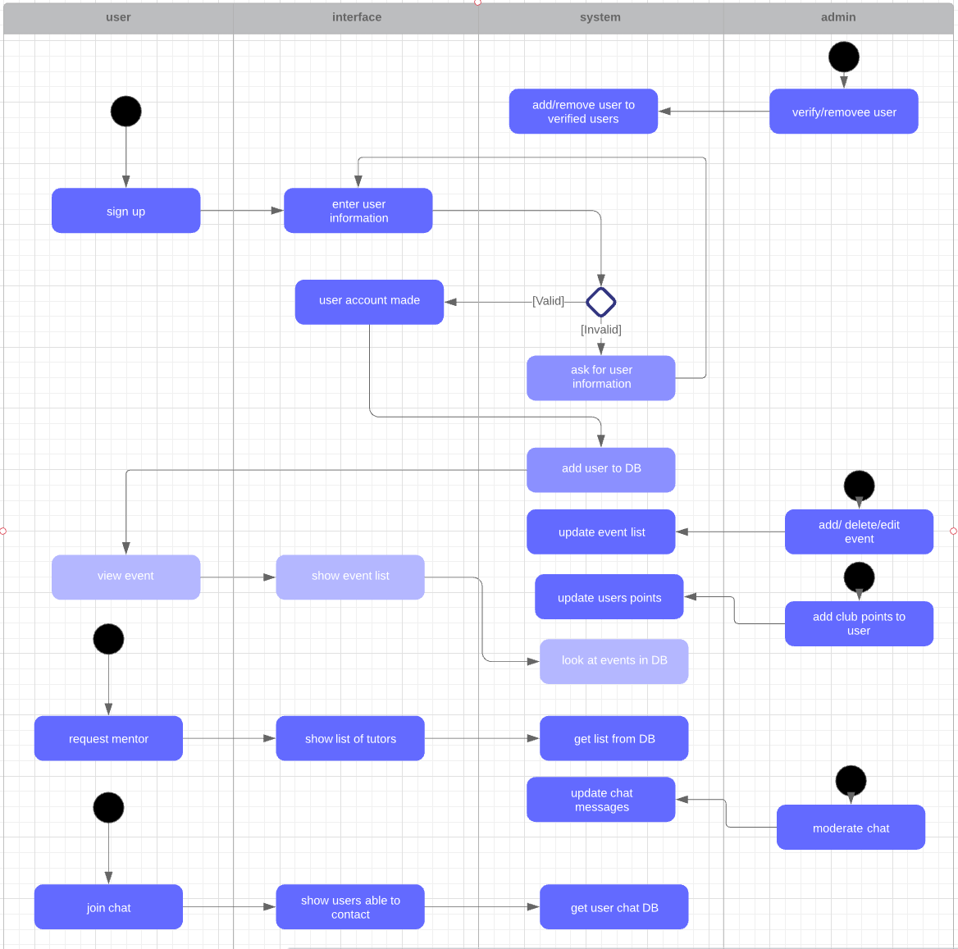

## 3.3 Object Interaction

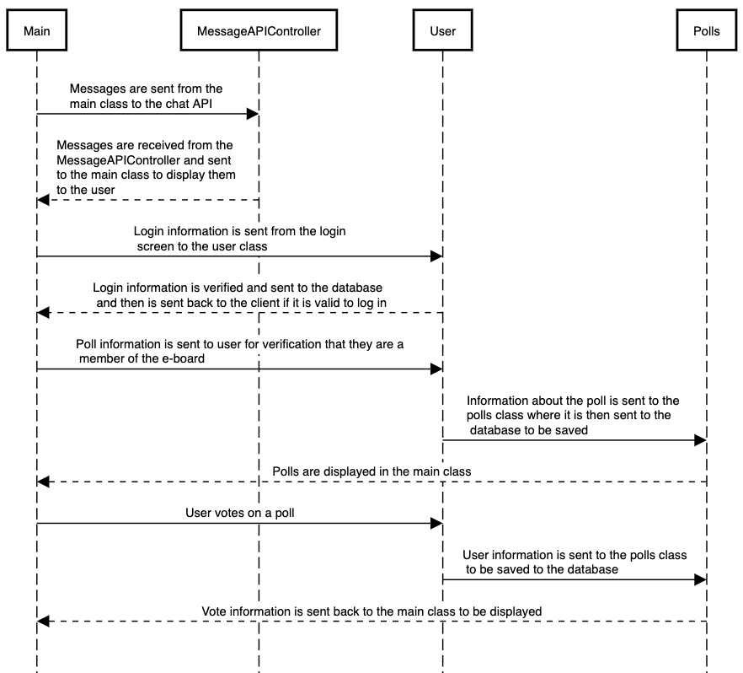

## 3.4 Detailed Class Design

### 3.4.1

The singleton design pattern is used to limit creation of a class to only one object. This is beneficial for our application in which only one user should be allowed to log into a device. The pattern also provides a way to access its only object which can be accessed directly without needing to instantiate the object of the class.

The factory method design pattern is a creational pattern that uses methods to deal with the problem of creating objects without having to specify the exact class of the object that will be created. Objects are created by calling a factory method and are either specified in an interface and implemented by child classes or implemented in a base class and overridden by derived classes.

The observer design pattern is closely related to the model-view view-model pattern in which the view part of the MVVM is like the observer pattern. There is a subject that holds all of the data and the state of the data, then, you have observers (users) that will pull the data from the subject.This pattern can be used for updating, notifications, and even handling subscribers.

The strategy pattern is an advanced version of an if else statement. An interface is implemented for a base class and then used to find the right use of a method from a derived class. The right use, or implementation, will be decided at runtime.

## State Chart



## Data Model

# Testing

**System Level Requirements Validation**

Software always exists in a broad system context. Although system requirements may have already been established before a software engineer begins his or her work, it is important to determine that system requirements are complete and consistent. If they are not, "push-back" must occur. That is, the software engineering organization must demand clarification from those who have developed system level requirements. The following check will help you to assess system requirements for completeness and consistency. For this checklist, the more questions that elicit a negative response, the higher the risk that the system model will not provide a solid foundation for software engineering work.

* Have the business context and justification for the system been properly developed?
* Has overall feasibility been addressed?
* Have all stakeholders been identified and polled for agreement?
* Have the overall function and behavior of the system been defined?
* Based on existing documentation/information, do you understand the system in the context of each of the views in the system engineering hierarchy?
* Have system processes been adequately (unambiguously) and consistently defined?
* Is system output and input adequately defined?
* Have system-level assumptions, simplifications, limitations, constraints and preferences been explicitly and unambiguously stated?
* Has simulation been done to demonstrate technological feasibility?
* Has a data architecture been identified?
* Has an application (functional) architecture been defined?
* Has the required technology infrastructure for the system been adequately defined?
* *For business applications:* Have ISP and BAA (SEPA, 5/e, p. 253) been performed?
* Has requirements elicitation been performed at the system level?
* Has the scope of the system been bounded?
* Has business and technical feasibility been assessed?
* Have usage scenarios been created at the system level?
* Has a requirements management process been established for the system?
* Has allocation occurred for all system elements?
* Is the allocation for software reasonable and well-defined?
* Have appropriate traceability tables been developed?
* Has a system model (e.g., a Hatley-Pirbhai model) been developed?

**Software Requirements Specification Checklist**

The Software Requirements Specification is the work product that is often produced as a consequence of the analysis activity. The checklist that follows will help you to assist the quality of this document. . For this checklist, the more questions that elicit a negative response, the higher the risk that the specification will not adequately serve its purpose.

* Do stated goals and objectives for software remain consistent with system goals and objectives?
* Have important interfaces to all system elements been described?
* Have all data objects been described? Have all attributes been identified?
* Do major functions remain within scope and have each been adequately described?
* Have functions been refined (elaborated) to an appropriate level of detail?
* Is information flow adequately defined for the problem domain?
* Are diagrams clear; can each stand alone without supplementary text?
* Is the behavior of the software consistent with the information it must process and the functions it must perform?
* Have events and states been identified?
* Are design constraints realistic?
* Have technological risks been fully defined?
* Have alternative software requirements been considered?
* Have validation criteria been stated in detail; are they adequate to describe a successful system?
* Have inconsistencies, omissions or redundancy been identified and corrected?
* Is the customer contact complete?
* Has the user reviewed the Preliminary User's Manual or prototype?
* Be on the lookout for persuasive connectors (e.g., certainly, therefore, clearly, obviously, it follows that), ask why?
* Watch out for vague terms (e.g., some, sometimes, often, usually, ordinarily, most, mostly); ask for clarification.
* When lists are given, but not completed, be sure all items are understood. Keys to look for: "etc., and so forth, and so on, such as."
* Be sure stated ranges don't contain unstated assumptions (e.g., Valid codes range from 10 to 100. Integer? Real? Hex?)
* Beware of vague verbs such as "handled, rejected, processed, skipped, eliminated." There are many ways they can be interpreted.
* Beware of ambiguous pronouns (e.g., The I/O module communicates with the data validation module and its control flag is set. Whose control flag?)
* Look for statements that imply certainty (e.g., always, every, all, none, never), then ask for proof.
* When a term is explicitly defined in one place, try substituting the definition for other occurrences of the term

**Reviewing the Software Design Model**

The design model resides at the core of the software engineering process. It is the place where quality is built into the software (and the place where quality is assessed. For this checklist, the more questions that elicit a negative response, the higher the risk that the analysis model will adequately serve its purpose. . For this checklist, the more questions that elicit a negative response, the higher the risk that the design model will not adequately serve its purpose.  
*General issues:*

* Does the overall design implement all explicit requirements? Has a traceability table been developed?
* Does the overall design achieve all implicit requirements?
* Is the design represented in a form that is easily understood by outsiders?
* Is design notation standardized? Consistent?
* Does the overall design provide sufficient information for test case design?
* Is the design created using recognizable architectural and procedural patterns?
* Does the design strive to incorporate reusable components?
* Is the design modular?
* Has the design defined both procedural and data abstractions that can be reused?
* Has the design been defined and represented in a stepwise fashion?
* Has the resultant software architecture been partitioned for ease of implementation? Maintenance?
* Have the concepts of information hiding and functional independence been followed throughout the design?
* Has a *Design Specification* been developed for the software?

***For data design:***

* Have data objects defined in the analysis model been properly translated into required data structures?
* Do the data structures contain all attributes defined in the analysis model?
* Have any new data structures and/or attributes been defined at design time?
* How do any new data structures and/or attributes related to the analysis model and to overall user requirements?
* Have the simplest data structures required to do the job been chosen?
* Can the data structures be implemented directly in the programming language of choice?
* How are data communicated between software components? It is communicated by having MVVM(Model -View -View Model) design pattern that takes the UI and organizes it in a way that allows the data to be communicated effectively.
* Do explicit data components (e.g., a database) exist? If so, what is their role? Yes, there is a database that holds information for each user and admin , along with messaging and tutoring.

*For architectural design:*

* Has a library of architectural styles been considered prior to the definition of the resultant software architecture?
* Has architectural tradeoff analysis been performed?
* Is the resultant software architecture a recognizable architectural style?
* Has the architecture been exercised against existing usage scenarios?
* Has an appropriate mapping been used to translate the analysis model into the architectural model?
* Can quality characteristics associated with the resultant architecture (e.g., a factored call-and-return architecture) be readily identified from information provided in the design model?

*For user interface design:*

* Have the results of task analysis been documented?
* Have goals for each user task been identified?
* Has an action sequence been defined for each user task?
* Have various states of the interface been documented?
* Have objects and actions that appear within the context of the interface been defined?
* Have the three "golden rules" (SEPA, 5/e, p. 402) been maintained throughout the GUI design?
* Has flexible interaction been defined as a design criterion throughout the interface?
* Have expert and novice modes of interaction been defined?
* Have technical internals been hidden from the casual user?
* Is the on-screen metaphor (if any) consistent with the overall applications?
* Are icons clear and understandable?
* Is interaction intuitive?
* Is system response time consistent across all tasks?
* Has an integrated help facility been implemented?
* Are all error messages displayed by the interface easy to understand? Do they help the user resolve the problem quickly?
* Is color being used effectively?
* Has a prototype for the interface been developed?
* Have user's impressions of the prototype been collected in an organized manner?

*For component-level design:*

* Have proof of correctness techniques (SEPA, 5/e, Chapter 26) been applied to all algorithms?
* Has each algorithm been "desk-tested" to uncover errors? Is each algorithm correct?
* Is the design of the algorithm consistent with the data structured that the component manipulates?
* Have algorithmic design alternatives been considered? If yes, why was this design chosen?
* Has the complexity of each algorithm been computed?
* Have structured programming constructs been used throughout?

## **Traceability Table:**

|  |  |  |
| --- | --- | --- |
| Requirement | Test Case ID | Status |
| The system shall have the ability to log onto the application | TC_1  TC_2  TC_26  TC_27 | TC_1 – Pass  TC_2 – Pass  TC_26 – Pass  TC_27 – Pass |
| The system database shall store titles of board members | TC_29  TC_28 | TC_29 – Pass  TC_28 – Pass |
| The system shall set eboard members as club administrators | TC_16  TC_18  TC_19  TC_24  TC_28 | TC_16 – Pass  TC_18 – Pass  TC_19 – Pass  TC_24 – Pass  TC_28 – Pass |
| The system shall allow users to view events | TC_5  TC_25 | TC_5 – Pass  TC_25 – Pass |
| The system shall allow users to open event locations in their default map application | TC_14 | TC_14 – Fail |
| The system shall allow users to request a mentor | TC_3 | TC_3 – Pass |
| The system shall allow the tutor to be matched by things like class experience | TC_4 | TC_4 – Fail |
| The application shall be able to send notifications for meetings and events via email or push notification | TC_13 | TC_13 – Fail |
| The system shall prevent messages containing profanity from being sent to in the chat | TC_15 | TC_15 – Fail |
| Users shall be able to message other users directly |  |  |
| Users shall be able to send messages inside of groups with set topics |  |  |
| Non-members shall be able see events and create an account | TC_6  TC_17 | TC_6 – Pass  TC_17 – Pass |
| Users shall have the ability to create a profile | TC_16  TC_20  TC_21  TC_22  TC_23 | TC_16 – Pass  TC_20 – Pass  TC_21 – Pass  TC_22 – Pass  TC_23 – Pass |
| The system should allow users to see a list of known ACM GSU alumni | TC_7 TC_9  TC_10 | TC_7 – Pass  TC_9 – Pass  TC_10 – Fail |
| The system shall have the ability to keep a tally of the attendance at each meeting | TC_12 | TC_12 – Pass |
| The system shall allow a user to be removed from the ACM app after deferring to ACM constitution | TC_11 | TC_11 – Fail |
| The system shall allow administrators to create anonymous voting polls for the executive board | TC_8 | TC_8 – Pass |

# 

# **Testing:**

Conducting Unit Tests:

## **Requirement Tests:**

### **Test Case 1:**

|  |  |  |  |  |  |
| --- | --- | --- | --- | --- | --- |
| **Test Case #:** TC_1 | | | **Test Case Name:** Sign Up Page | | |
| **System:** Login Page | | | **Subsystem:** Sign Up Page | | |
| **Designed By:** Everrick Wright | | | **Designed Date:** April 19, 2020 | | |
| **Executed By:** Everrick Wright | | | **Execution Date:** April 19, 2020 | | |
| **Short Description:** The system shall allow the mentor to be matches by things like class experience | | | | | |
| **Stp#** | **Action** | **Expected System Response** | | **Pass/ Fail** | **Comment** |
| **1** | User opens ACM application | Dashboard screen is presented | | Pass |  |
| **2** | User Clicks Login Button | Login Screen is presented with opens to sign up or log in | | Pass |  |
| **3** | User enters first & last name, email address, and phone number, password and confirmed password | User receives message that account is created | | Pass | **User account should be created in database** |
| **4** | User is taken to the home page | ACM dashboard | | Pass |  |
| **Post-conditions:**  The user has usability to all normal app features excluding control panel. | | | | | |

### **Test Case 2:**

|  |  |  |  |  |  |
| --- | --- | --- | --- | --- | --- |
| Test Case #: TC_2 | | | Test Case Name: Login | | |
| System: Login Page | | | Subsystem: Sign Up Page | | |
| Designed By: Mansi Pandya | | | Designed Date: April 19, 2020 | | |
| Executed By: Mansi Pandya | | | Execution Date: April 19, 2020 | | |
| Short Description: User logs into their account and is unable to login | | | | | |
| Step# | Action | Expected System Response | | Pass/ Fail | Com-ment |
| 1 | User clicks Login button | User transferred to page with data fields that they are to fill in | | Pass |  |
| 2 | User enters name, email address, and phone number | Application prompts ‘name, email id doesn’t exist’ | | Pass |  |
| 3 | The page directs to the Signup page | User transferred to page with data fields that they are to fill in | | Pass |  |
| 4 | User clicks Submit button | ACM Dashboard | | Pass |  |
| Post-conditions:  The user has ability to all App features | | | | | |

### **Test Case 3:**

|  |  |  |  |  |  |
| --- | --- | --- | --- | --- | --- |
| **Test Case #:** TC_3 | | | **Test Case Name:** Requesting a mentor | | |
| **System:** Tutoring Requests | | | **Subsystem:** Tutoring Requests | | |
| **Designed By:** Everrick Wright | | | **Designed Date:** April 19, 2020 | | |
| **Executed By:** Everrick Wright | | | **Execution Date:** April 19, 2020 | | |
| **Short Description:** The system shall allow the mentor to be matches by things like class experience | | | | | |
| **Stp#** | **Action** | **Expected System Response** | | **Pass/ Fail** | **Comment** |
| **1** | User Logins | Successful login | | Pass |  |
| **2** | User Clicks “Tutoring” tab | Tutoring screen is presented | | Pass |  |
| **3** | User enters class they need help with & a prospective date | Event should be sent to Tutoring requests screen able to be selected | | Pass | **Data should be stored in database** |
| **4** | User notified of match | Notification sent of match | | Fail | **No system implementation** |
| **Post-conditions:**  N/A | | | | | |

### **Test Case 4:**

|  |  |  |  |  |  |
| --- | --- | --- | --- | --- | --- |
| **Test Case #:** TC_4 | | | **Test Case Name:** Match by Class Experience | | |
| **System:** Tutoring Requests | | | **Subsystem:** Tutoring Requests | | |
| **Designed By:** Everrick Wright | | | **Designed Date:** April 19, 2020 | | |
| **Executed By:** Everrick Wright | | | **Execution Date:** April 19, 2020 | | |
| **Short Description:** The system shall allow the mentor to be matches by things like class experience | | | | | |
| **Stp#** | **Action** | **Expected System Response** | | **Pass/ Fail** | **Comment** |
| **1** | User Logins | Successful login  Taken to dashboard page | | Pass |  |
| **2** | User Clicks “Tutoring” tab | Tutoring screen is presented | | Pass |  |
| **3** | User enters class they need help with & a prospective date | Event should be sent to Tutoring requests screen able to be selected | | Pass | **Data should be stored in database** |
| **4** | Matching of mentor by class experience | Specific events show if class is marked as taken | | Fail | **No system implementation** |
| **Post-conditions:**  N/A | | | | | |

### 

### **Test Case 5:**

|  |  |  |  |  |  |
| --- | --- | --- | --- | --- | --- |
| **Test Case #:** TC_5 | | | **Test Case Name:** Events | | |
| **System:** Events | | | **Subsystem:** N/A | | |
| **Designed By:** Everrick Wright | | | **Designed Date:** April 19, 2020 | | |
| **Executed By:** Everrick Wright | | | **Execution Date:** April 19, 2020 | | |
| **Short Description:** The systems shall allow users to view events | | | | | |
| **Stp#** | **Action** | **Expected System Response** | | **Pass/ Fail** | **Comment** |
| **1** | User logins | Successful Login Attempt | | Pass |  |
| **2** | User Clicks Events tab | Events screen is promptly shown with current events | | Pass | **Events pulled from database** |
| **Post-conditions:**  N/A | | | | | |

### 

### **Test Case 6:**

|  |  |  |  |  |  |
| --- | --- | --- | --- | --- | --- |
| **Test Case #:** TC_6 | | | **Test Case Name:** Non-members view | | |
| **System:** Dashboard | | | **Subsystem:** Events & About Us | | |
| **Designed By:** Everrick Wright | | | **Designed Date:** April 19, 2020 | | |
| **Executed By:** Everrick Wright | | | **Execution Date:** April 19, 2020 | | |
| **Short Description:** Non-members (not logged in) shall be able to see events, about us, and able to create account | | | | | |
| **Stp#** | **Action** | **Expected System Response** | | **Pass/ Fail** | **Comment** |
| **1** | User Opens Application | Dashboard screen is opened, only viewable tabs are events & about us | | Pass |  |
| **2** | User clicks events | Events page opens | | Pass |  |
| **3** | User clicks about us | About us page opens | | Pass |  |
| **4** | User can log in **(see Test Case 1)** | **Test Case 1** | | N/A |  |
| **Post-conditions:**  See test case 1 for step #4 | | | | | |

### **Test Case 7:**

|  |  |  |  |  |  |
| --- | --- | --- | --- | --- | --- |
| Test Case #: TC_7 | | | Test Case Name: Alumni page | | |
| System: Alumni | | | Subsystem: N/A | | |
| Designed By: Mansi Pandya | | | Designed Date: April 19, 2020 | | |
| Executed By: Mansi Pandya | | | Execution Date: April 19, 2020 | | |
| Short Description: The system shall allow users to see list of known ACM GSU alumni | | | | | |
| Step# | Action | Expected System Response | | Pass/ Fail | Com-ment |
| 1 | User logins | Successful Login Attempt | | Pass |  |
| 2 | User Clicks Alumni tab | List of ACM Alumni is showed | | Pass | **Alumni are pulled from database** |
| Post-conditions:  N/A | | | | | |

### **Test Case 8:**

|  |  |  |  |  |  |
| --- | --- | --- | --- | --- | --- |
| Test Case #: TC_8 | | | Test Case Name: Create polls | | |
| System: Control Panel | | | Subsystem: Polls | | |
| Designed By: Mansi Pandya | | | Designed Date: April 19, 2020 | | |
| Executed By: Mansi Pandya | | | Execution Date: April 19, 2020 | | |
| Short Description: The system shall allow administrators to create anonymous polls for executive board | | | | | |
| Step# | Action | Expected System Response | | Pass/ Fail | Com-ment |
| 1 | Admin logins | Successful Login Attempt | | Pass |  |
| 2 | Admin clicks Polls tab, clicks on Create Poll, Options and Post Poll | Poll is posted | | Pass | **Poll is posted on Events page** |
| Post-conditions:  N/A | | | | | |

### **Test Case 9:**

|  |  |  |  |  |  |
| --- | --- | --- | --- | --- | --- |
| Test Case #: TC_9 | | | Test Case Name: Employers page | | |
| System: Alumni | | | Subsystem: N/A | | |
| Designed By: Mansi Pandya | | | Designed Date: April 19, 2020 | | |
| Executed By: Mansi Pandya | | | Execution Date: April 19, 2020 | | |
| Short Description: The system shall allow users to see list of known ACM GSU alumni | | | | | |
| Step# | Action | Expected System Response | | Pass/ Fail | Com-ment |
| 1 | User logins | Successful Login Attempt  Transferred to home page | | Pass |  |
| 2 | User Clicks Employers tab | List of GSU ACM employers is shown | | Pass | **Alumni are pulled from database** |
| Post-conditions:  N/A | | | | | |

### **Test Case 10:**

|  |  |  |  |  |  |
| --- | --- | --- | --- | --- | --- |
| Test Case #: TC_10 | | | Test Case Name: Employers page | | |
| System: Alumni | | | Subsystem: N/A | | |
| Designed By: Mansi Pandya | | | Designed Date: April 20, 2020 | | |
| Executed By: Mansi Pandya | | | Execution Date: April 20, 2020 | | |
| Short Description: The system should allow users to get in contact with possible employers for internships, co-ops, and jobs | | | | | |
| Step# | Action | Expected System Response | | Pass/ Fail | Com-ment |
|  |  |  | |  |  |
| Post-conditions: | | | | | |

### **Test Case 11:**

### 

|  |  |  |  |  |  |
| --- | --- | --- | --- | --- | --- |
| Test Case #: TC_11 | | | Test Case Name: Remove members | | |
| System: Control Panel | | | Subsystem: N/A | | |
| Designed By: Mansi Pandya | | | Designed Date: April 20, 2020 | | |
| Executed By: Mansi Pandya | | | Execution Date: April 20, 2020 | | |
| Short Description: The system shall allow a user to be removed from the ACM app after deferring to ACM constitution | | | | | |
| Step# | Action | Expected System Response | | Pass/ Fail | Com-ment |
|  |  |  | |  |  |
| Post-conditions: | | | | | |

### **Test Case 12:**

### 

|  |  |  |  |  |  |
| --- | --- | --- | --- | --- | --- |
| Test Case #: TC_12 | | | Test Case Name: Attendance | | |
| System: Control Panel | | | Subsystem: N/A | | |
| Designed By: Mansi Pandya | | | Designed Date: April 20, 2020 | | |
| Executed By: Everrick Wright | | | Execution Date: April 24, 2020 | | |
| Short Description: The system shall have the ability to keep a tally of the attendance at each meeting | | | | | |
| Step# | Action | Expected System Response | | Pass/ Fail | Com-ment |
| 1 | Admin Successful login | Login attempt pass | | pass |  |
| 2 | Click on “control pane’” tab | Checks to see if admin, if so, control panel page opens | | pass |  |
| 3 | Clicks on attendance button | Taken to attendance page | | pass |  |
| 4 | Enters names of people attending | Names saved and accounted for | | pass |  |
| Post-conditions: | | | | | |

### **Test Case 13:**

### 

|  |  |  |  |  |  |
| --- | --- | --- | --- | --- | --- |
| Test Case #: TC_13 | | | Test Case Name: Notifications | | |
| System: Control Panel | | | Subsystem: N/A | | |
| Designed By: Mansi Pandya | | | Designed Date: April 20, 2020 | | |
| Executed By: Mansi Pandya | | | Execution Date: April 20, 2020 | | |
| Short Description: The application shall be able to send notifications for meetings and events via email or push notification | | | | | |
| Step# | Action | Expected System Response | | Pass/ Fail | Com-ment |
|  |  |  | |  |  |
| Post-conditions: | | | | | |

### **Test Case 14:**

### 

|  |  |  |  |  |  |
| --- | --- | --- | --- | --- | --- |
| Test Case #: TC_14 | | | Test Case Name:Event locations | | |
| System: Events | | | Subsystem: N/A | | |
| Designed By: Mansi Pandya | | | Designed Date: April 20, 2020 | | |
| Executed By: Mansi Pandya | | | Execution Date: April 20, 2020 | | |
| Short Description: The system shall allow users to open event locations in their default map application | | | | | |
| Step# | Action | Expected System Response | | Pass/ Fail | Com-ment |
|  |  |  | |  |  |
| Post-conditions: | | | | | |

### **Test Case 15:**

### 

|  |  |  |  |  |  |
| --- | --- | --- | --- | --- | --- |
| Test Case #: TC_15 | | | Test Case Name: Remove profanity messages | | |
| System: Chat | | | Subsystem: N/A | | |
| Designed By: Mansi Pandya | | | Designed Date: April 20, 2020 | | |
| Executed By: Mansi Pandya | | | Execution Date: April 20, 2020 | | |
| Short Description:The system shall prevent messages containing profanity from being sent to in the chat | | | | | |
| Step# | Action | Expected System Response | | Pass/ Fail | Com-ment |
|  |  |  | |  |  |
| Post-conditions: | | | | | |

System Testing:

## **Testing GUIs:**

|  |  |  |
| --- | --- | --- |
| Test Case | Part Tested | Pass/Fail |
| TC 1 | Navigation Bar | Pass |
| TC 2 | Dashboard Button | Pass |
| TC 3 | Dashboard Event Button | Fail |
| TC 4 | Dashboard Chat Button | Fail |
| TC 5 | Dashboard Profile Button | Fail |
| TC 6 | Login Button | Pass |
| TC 7 | Logout Button | Pass |
| TC 8 | Control Panel Button | Pass |
| TC 9 | Events Button | Pass |
| TC 10 | Profile Button | Pass |
| TC 11 | Members Button | Pass |
| TC 12 | Chat Button | Pass |
| TC 13 | Tutoring Button | Pass |
| TC 14 | Polls Button | Pass |
| TC 15 | Alumni Button | Pass |
| TC 16 | Pay Dues Button | Pass |
| TC 17 | About Us Button | Pass |
| TC 18 | Create Events Button | Pass |
| TC 19 | Create Polls Button | Pass |
| TC 20 | Attendance Button | Pass |
| TC 21 | User Titles Button | Pass |
| TC 22 | Update News Button | Pass |
| TC 23 | Create an Event: Event Title | Pass |
| TC 24 | Create an Event: Location | Pass |
| TC 25 | Create an Event: Date | Pass |
| TC 26 | Create an Event: Details | Pass |
| TC 27 | Create an Event: Create Event Button | Pass |
| TC 28 | Create an Event: Cancel Button | Pass |
| TC 29 | Create Poll: Poll Title | Pass |
| TC 30 | Create a Poll: Option Field | Pass |
| TC 31 | Create a Poll: Add Option Button | Pass |
| TC 32 | Create a Poll: X Button | Pass |
| TC 33 | Create a Poll: Post Poll Button | Pass |
| TC 34 | Create a Poll: Cancel Button | Pass |
| TC 35 | View Attendance: Take Attendance Button | Pass |
| TC 36 | View Attendance: Date Field | Pass |
| TC 37 | View Attendance: Cancel Button | Pass |
| TC 38 | View Attendance: Search Button | Pass |
| TC 39 | Take Attendance: Name Field | Pass |
| TC 40 | Take Attendance: Save Button | Pass |
| TC 41 | Take Attendance: Cancel Button | Pass |
| TC 42 | User Titles: First Name Field | Pass |
| TC 43 | User Titles: Last Name Field | Pass |
| TC 44 | User Titles: Cancel Button | Pass |
| TC 45 | User Titles: Search Button | Pass |
| TC 46 | User Titles: Edit User Button | Pass |
| TC 47 | Edit User: Title Field | Pass |
| TC 48 | Edit User: Admin Box | Pass |
| TC 49 | Edit User: Save Button | Pass |
| TC 50 | Create News Item: Title Field | Pass |
| TC 51 | Create News Item: Details Field | Pass |
| TC 52 | Create News Item: Post Button | Pass |
| TC 53 | Create News Item: Cancel Button | Pass |
| TC 54 | Profile: Edit Profile Button | Pass |
| TC 55 | Profile: Change Password Button | Pass |
| TC 56 | Edit Profile: Upload Image Button | Fail |
| TC 57 | Edit Profile: First Name Field | Pass |
| TC 58 | Edit Profile: Last Name Field | Pass |
| TC 59 | Edit Profile: Email Field | Pass |
| TC 60 | Edit Profile: Phone Field | Pass |
| TC 61 | Edit Profile: Cancel Button | Pass |
| TC 62 | Edit Profile: Update Profile Button | Pass |
| TC 63 | Edit Profile: Change Password Button | Fail |
| TC 64 | Change Password: Upload Image Button | Fail |
| TC 65 | Change Password: Current Password Field | Pass |
| TC 67 | Change Password: New Password Field | Pass |
| TC 68 | Change Password: Confirm Field | Pass |
| TC 69 | Change Password: Cancel Button | Pass |
| TC 70 | Change Password: Update Password Button | Pass |
| TC 71 | Members: Members Tab | Pass |
| TC 72 | Members: Mentors Tab | Pass |
| TC 73 | Members: Profile Button | Fail |
| TC 74 | Members: Search Button | Fail |
| TC 75 | Chat: DMs Tab | Pass |
| TC 76 | Chat: Public Channels | Pass |
| TC 77 | Tutoring: Course Title Field | Pass |
| TC 78 | Tutoring: Add Session | Pass |
| TC 79 | Polls: Active Polls Tab | Pass |
| TC 80 | Polls: Past Polls Tab | Pass |
| TC 81 | Polls: Option Buttons | Pass |
| TC 82 | Alumni: Search Button | Fail |
| TC 83 | Alumni: Profile Button | Fail |
| TC 84 | Pay Dues: Cash App Button | Pass |
| TC 85 | Pay Dues: Amazon Pay Button | Pass |
| TC 86 | Pay Dues: PayPal Button | Pass |
| TC 97 | About Us: Learn More Button | Pass |

## **Conducting Validation Tests:**

### 

### 

### 

### **Test Case 16:**

|  |  |  |  |  |  |
| --- | --- | --- | --- | --- | --- |
| Test Case #: TC_16 | | | Test Case Name: Members added to database | | |
| System: Login | | | Subsystem: N/A | | |
| Designed By: Marquise Jennett | | | Designed Date: April 20, 2020 | | |
| Executed By: Marquise Jennett | | | Execution Date: April 20, 2020 | | |
| Short Description: User logs into the account | | | | | |
| Step# | Action | Expected System Response | | Pass/ Fail | Com-ment |
| 1 | User clicks Login button | User transferred to page with data fields that they are to fill in | | Pass |  |
| 2 | User enters name, email address, and phone number |  | | Pass |  |
| 3 | User clicks Login button | Login success | | Pass |  |
| 4 | Users information is stored into the database | The contents are displayed. Members have access to these pages: Dashboard, events, members, chat tutoring, polls, alumni, pay dues, about us. | | Pass |  |
| Post-conditions:  Users password, name, phone number, and email address are added and saved into the database | | | | | |

### **Test Case 17:**

|  |  |  |  |  |  |
| --- | --- | --- | --- | --- | --- |
| Test Case #: TC_17 | | | Test Case Name: Non-member menu | | |
| System: Main Page | | | Subsystem: N/A | | |
| Designed By: Marquise Jennett | | | Designed Date: April 20, 2020 | | |
| Executed By: Marquise Jennett | | | Execution Date: April 20, 2020 | | |
| Short Description: Non-member user opens app | | | | | |
| Step# | Action | Expected System Response | | Pass/ Fail | Com-ment |
| 1 | User open apps | App opens to the Main page of the app | | Pass |  |
| 2 | User clicks on the Navigation bar | Because the user is not a member they only have access to the main page, event page, and about page | | Pass |  |
| Post-conditions: | | | | | |

### **Test Case 18:**

|  |  |  |  |  |  |
| --- | --- | --- | --- | --- | --- |
| Test Case #: TC_18 | | | Test Case Name: Member Menu | | |
| System: Login Page | | | Subsystem: N/A | | |
| Designed By: Marquise Jennett | | | Designed Date: April 20, 2020 | | |
| Executed By: Marquise Jennett | | | Execution Date: April 20, 2020 | | |
| Short Description: Members login | | | | | |
| Step# | Action | Expected System Response | | Pass/ Fail | Com-ment |
| 1 | User clicks Login button | User transferred to page with data fields that they are to fill in | | Pass |  |
| 2 | User enters name, email address, and phone number |  | | Pass |  |
| 3 | User clicks Login button | Login success | | Pass |  |
| 4 | User clicks on the Navigation bar | Members have access to these only these pages: Dashboard, events, members, chat tutoring, polls, alumni, pay dues, about us. | | Pass |  |
| Post-conditions:  N/A | | | | | |

### **Test Case 19:**

|  |  |  |  |  |  |
| --- | --- | --- | --- | --- | --- |
| Test Case #: TC_19 | | | Test Case Name: Admin Menu | | |
| System: Control Panel | | | Subsystem: N/A | | |
| Designed By: Marquise Jennett | | | Designed Date: April 20, 2020 | | |
| Executed By: Marquise Jennett | | | Execution Date: April 20, 2020 | | |
| Short Description: The system shall allow admins to login and view ACM member details | | | | | |
| Step# | Action | Expected System Response | | Pass/ Fail | Com-ment |
| 1 | User clicks Login button | Login success | | Pass |  |
| 2 | User clicks on the Navigation tab | Admins have access to all of the member pages and the added page of control panel | | Pass |  |
| Post-conditions:  N/A | | | | | |

### **Test Case 20:**

|  |  |  |  |  |  |
| --- | --- | --- | --- | --- | --- |
| Test Case #: TC_20 | | | Test Case Name: Changing Name | | |
| System: Profile | | | Subsystem: N/A | | |
| Designed By: Marquise Jennett | | | Designed Date: April 20, 2020 | | |
| Executed By: Marquise Jennett | | | Execution Date: April 20, 2020 | | |
| Short Description: The system shall allow to edit name | | | | | |
| Step# | Action | Expected System Response | | Pass/ Fail | Com-ment |
| 1 | User clicks Login button | Login success | | Pass |  |
| 2 | User clicks Profile | Transferred to profile page | | Pass |  |
| 3 | User clicks Edit Profile | Transferred to profile edit page | | Pass |  |
| 4 | User changes name |  | | Pass | **The user's name is changed in the database.** |
| 5 | User clicks Save | User taken back to profile page | | Pass |  |
| Post-conditions:  N/A | | | | | |

### **Test Case 21:**

|  |  |  |  |  |  |
| --- | --- | --- | --- | --- | --- |
| Test Case #: TC_21 | | | Test Case Name: Changing password | | |
| System: Profile | | | Subsystem: N/A | | |
| Designed By: Marquise Jennett | | | Designed Date: April 20, 2020 | | |
| Executed By: Marquise Jennett | | | Execution Date: April 20, 2020 | | |
| Short Description: The system shall allow user to edit Name | | | | | |
| Step# | Action | Expected System Response | | Pass/ Fail | Com-ment |
| 1 | User clicks Login button | Login success | | Pass |  |
| 5 | User clicks Profile | Transferred to profile page | | Pass |  |
| 6 | User clicks Update Password | Transferred to update password page | | Pass |  |
| 7 | User enters old password and new password |  | | Pass | **If current password is incorrect password won't change** |
| 8 | User clicks Update password | User taken back to profile page | | Pass | **Users password is changed in the database** |
| Post-conditions:  N/A | | | | | |

### **Test Case 22:**

|  |  |  |  |  |  |
| --- | --- | --- | --- | --- | --- |
| Test Case #: TC_22 | | | Test Case Name: Changing email | | |
| System: Profile | | | Subsystem: N/A | | |
| Designed By: Marquise Jennett | | | Designed Date:April 20, 2020 | | |
| Executed By: Marquise Jennett | | | Execution Date: April 20, 2020 | | |
| Short Description: The system shall allow user to edit Email | | | | | |
| Step# | Action | Expected System Response | | Pass/ Fail | Com-ment |
| 1 | User clicks Login button | Login success | | Pass |  |
| 2 | User clicks profile | Transferred to profile page | | Pass |  |
| 3 | User clicks edit profile | Transferred to profile edit page | | Pass |  |
| 4 | User changes Email |  | | Pass |  |
| 5 | User clicks Save | User taken back to profile page | | Pass | **Users email is changed in the database** |
| Post-conditions:  N/A | | | | | |

### **Test Case 23:**

|  |  |  |  |  |  |
| --- | --- | --- | --- | --- | --- |
| Test Case #: TC_23 | | | Test Case Name: Changing phone number | | |
| System: Profile | | | Subsystem: N/A | | |
| Designed By: Marquise Jennett | | | Designed Date: April 20, 2020 | | |
| Executed By: Marquise Jennett | | | Execution Date: April 20, 2020 | | |
| Short Description: The system shall allow user to edit Phone Number | | | | | |
| Step# | Action | Expected System Response | | Pass/ Fail | Com-ment |
| 1 | User clicks Login button | Login success | | Pass |  |
| 2 | User clicks profile | Transferred to profile page | | Pass |  |
| 3 | User clicks edit profile | Transferred to profile edit page | | Pass |  |
| 4 | User changes phone number |  | | Pass | **Allows users to change number to any number** |
| 5 | User clicks Save | User taken back to profile page | | Pass | **Users phone number is changed in the database** |
| Post-conditions:  N/A | | | | | |

### **Test Case 24:**

|  |  |  |  |  |  |
| --- | --- | --- | --- | --- | --- |
| Test Case #: TC_24 | | | Test Case Name: Admins adding Admins | | |
| System: Control Panel | | | Subsystem: N/A | | |
| Designed By: Marquise Jennett | | | Designed Date: April 20, 2020 | | |
| Executed By: Marquise Jennett | | | Execution Date: April 20, 2020 | | |
| Short Description: Admins change the member to admins | | | | | |
| Step# | Action | Expected System Response | | Pass/ Fail | Com-ment |
| 1 | Admin clicks Login button | Login success | | Pass |  |
| 2 | Admin clicks Control Panel | Transferred to control panel page | | Pass |  |
| 3 | Admin clicks User Titles | Transferred to user titles page | | Pass |  |
| 4 | Admin enter a members name |  | | Pass |  |
| 5 | User clicks Search | Members with that name shows up | | Pass |  |
| 6 | Admin clicks Edit User |  | | Pass |  |
| 7 | Admin checks “Is user admin” box |  | | Pass |  |
| 8 | Admin clicks Save | User updated message shows up | | Pass | **Member is changed to admin in database** |
| Post-conditions:  N/A | | | | | |

### **Test Case 25:**

|  |  |  |  |  |  |
| --- | --- | --- | --- | --- | --- |
| Test Case #: TC_25 | | | Test Case Name: Create Event | | |
| System: Control Panel | | | Subsystem: N/A | | |
| Designed By: Marquise Jennett | | | Designed Date: April 20, 2020 | | |
| Executed By: Marquise Jennett | | | Execution Date: April 20, 2020 | | |
| Short Description: The system shall allow admins to create events | | | | | |
| Step# | Action | Expected System Response | | Pass/ Fail | Com-ment |
| 1 | Admin clicks Login button | Login success | | Pass |  |
| 2 | Admin clicks Control Panel | Transferred to control panel page | | Pass |  |
| 6 | Admin clicks Create Event | Transferred to create event page | | Pass |  |
| 7 | Admin enters Event title, location, date, and details |  | | Pass |  |
| 8 | Admin clicks post event | Confirmation message is displayed | | Pass |  |
| 9 | Admin clicks edit user |  | | Pass |  |
| Post-conditions:  Poll is added to database and displayed on Polls page | | | | | |

### **Test Case 26:**

|  |  |  |  |  |  |
| --- | --- | --- | --- | --- | --- |
| Test Case #: TC_26 | | | Test Case Name: Login with incorrect credentials | | |
| System: Login Page | | | Subsystem: Sign Up Page | | |
| Designed By: Mansi Pandya | | | Designed Date: April 19, 2020 | | |
| Executed By: Mansi Pandya | | | Execution Date: April 19, 2020 | | |
| Short Description: User logs in using non existing or incorrect credentials | | | | | |
| Step# | Action | Expected System Response | | Pass/ Fail | Com-ment |
| 1 | User clicks Login button | User transferred to page with data fields that they are to fill in | | Pass |  |
| 2 | User email and name | Application prompts ‘name, email id doesn’t exist’ | | Pass |  |
| 3 | The page directs to the Signup page | User transferred to page with data fields that they are to fill in | | Pass |  |
| 4 | User clicks Submit button | If incorrect email or password error message is shown to the user | | Pass |  |
| Post-conditions:  See test cast 2 | | | | | |

### 

### 

### **Test Case 27:**

|  |  |  |  |  |  |
| --- | --- | --- | --- | --- | --- |
| Test Case #: TC_27 | | | Test Case Name: Password length not between 8-16 | | |
| System: Login Page | | | Subsystem: Sign Up Page | | |
| Designed By: Mansi Pandya | | | Designed Date: April 19, 2020 | | |
| Executed By: Mansi Pandya | | | Execution Date: April 19, 2020 | | |
| Short Description: User logs in with a password that has improper length | | | | | |
| Step# | Action | Expected System Response | | Pass/ Fail | Com-ment |
| 1 | User clicks Login button | User transferred to page with data fields that they are to fill in | | Pass |  |
| 2 | User clicks sign up button | User transferred to sign up page | | Pass |  |
| 3 | User enter name, email, password, and phone number | Password length invalid text is shown | | Pass |  |
| 4 | User clicks ok | User is returned to sign up page | | Pass |  |
| Post-conditions:  See Test case 1 | | | | | |

### 

### **Test Case 28:**

|  |  |  |  |  |  |
| --- | --- | --- | --- | --- | --- |
| Test Case #: TC_28 | | | Test Case Name: Admin Changing user titles | | |
| System: Alumni | | | Subsystem: N/A | | |
| Designed By: Mansi Pandya | | | Designed Date: April 19, 2020 | | |
| Executed By: Mansi Pandya | | | Execution Date: April 19, 2020 | | |
| Short Description: Admin changing a users title | | | | | |
| Step# | Action | Expected System Response | | Pass/ Fail | Com-ment |
| 1 | Admin logins | Successful Login Attempt  Transferred to home page | | Pass |  |
| 2 | Admin open menu bar | List of pages is displayed | | Pass |  |
| 3 | Admin clicks control panel | User transferred to control panel page | | Pass |  |
| 4 | Admin clicks user titles | User transferred to user titles page | | Pass |  |
| 5 | Admin enters first and last name of user |  | | Pass |  |
| 6 | Admin clicks Search | List of matching names show up | | Pass | **Names are pulled from Members database table** |
| 7 | Admin clicks edit user | User transferred to edit user page | | Pass |  |
| 8 | Admin enters new titles |  | | Pass |  |
| 9 | Admin clicks save | User is returned to user titles page | | Pass |  |
| Post-conditions:  Users title is updated in the database | | | | | |

### 

### **Test Case 29:**

|  |  |  |  |  |  |
| --- | --- | --- | --- | --- | --- |
| Test Case #: TC_29 | | | Test Case Name:Admin Changing user titles (Search Failed) | | |
| System: Alumni | | | Subsystem: N/A | | |
| Designed By: Mansi Pandya | | | Designed Date: April 19, 2020 | | |
| Executed By: Mansi Pandya | | | Execution Date: April 19, 2020 | | |
| Short Description: Admin changing a users title using unrecognized name | | | | | |
| Step# | Action | Expected System Response | | Pass/ Fail | Com-ment |
| 1 | Admin logins | Successful Login Attempt  Transferred to home page | | Pass |  |
| 2 | Admin open menu bar | List of pages is displayed | | Pass |  |
| 3 | Admin clicks control panel | User transferred to control panel page | | Pass |  |
| 4 | Admin clicks user titles | User transferred to user titles page | | Pass |  |
| 5 | Admin enters first and last name of user |  | | Pass |  |
| 6 | Admin clicks Search | Name cannot be found error message pops up  Returned to user title page | | Pass | **Names are pulled from Members database table** |
| Post-conditions:  See test case 17 and/or 21 | | | | | |

## **Test coverage(Statement/branch):**

### **MemberListViewModel, GetMembers():**

Number of executed statements = 32

Total number of statements = 42

Statement coverage = (32/42) x 100 = 76.2%

Considering the most minimum branch, number of branches covered = 1

Total branches/decision = 4

Branch coverage= (1/4) x 100 = 25%

### **MemberListViewModel, GetMentors():**

Number of executed statements = 8

Total number of statements = 11

Statement coverage = (8/11) x 100 = 72.7%

Considering the most minimum branch, number of branches covered = 1

Total branches/decision = 2

Branch coverage= (1/2) x 100 = 50%

## 

## **Product/Process quality (Mccabe’s complexity):**

### **MemberListViewModel, GetMembers():**

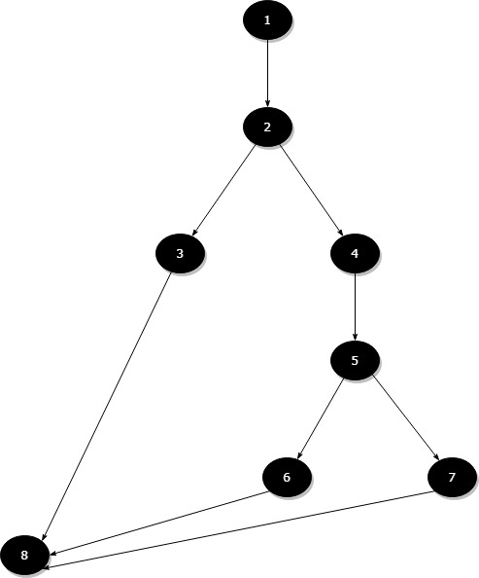

Mathematically, Mccabe’s number is, V(G) = E - N + 2

Where, E - Number of edges, N - Number of Nodes.

Mccabe’s number = 9-8+2= 3

### **MemberListViewModel, GetMentors():**

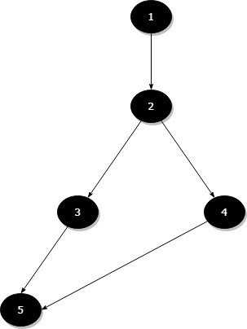

Mathematically, Mccabe’s number is, V(G) = E - N + 2

Where, E - Number of edges, N - Number of Nodes.

Mccabe’s number = 5-5+2= 2

# Post Mortem

## Introduction

During this entire project semester, we aimed to make our application be of great use to the ACM at Georgia Southern. We as a team worked hard in order to achieve this even with a few hiccups along the way. We faced challenges with communication as we had to move to distance work because of the pandemic. We faced challenges with database design. We also faced issues with the platform and APIs we chose to use. And finally the last big challenge we faced was with our chat requirement of our application. Even with all these challenges, we as a team came together and got our project done to the best of our abilities given the resources and time constraints we have.

## Report Goals

Our report is meant as a brief overview of the challenges and learning moments we faced during the development of our product. We will discuss specific cases of our development phase that we feel is important to highlight. We will share these in order to show what we learned during this project.

Project Parameters

The project parameters included the functional and nonfunctional requirements that our project entailed. As these are the things that the project demanded to have and us to produce them. We however were not able to implement everything prescribed in the requirements which we discuss in more detail later.

### Project Overview

Our project began in the requirements phase where we were to hash out the fine details on the specific requirements of our project. One of the challenges we face during this part of development was the unique aspect of one of our team members being both a developer and customer for the product as with the other teams their customer was a person on the outside. This situation did have its benefits as the customer understood software so they asked for requirements that they actually understood. It also had its costs as this made it harder for us to come up with specific requirements since we had a lot of creative power. We also felt that this didn't prepare us properly for a real world scenario in software engineering as having the customer on the same team almost never happens.

In the next phase of development we set up our github repository and began to work with Xamarin our chosen platform to work on. We did find issues in setting up a github repository as none of us had much experience in setting it up , and wasn't taught this in none of our classes up to this point. We did figure out all this eventually but it still would have been nice to have some background knowledge in this area. As for the Xamarin we thought to begin with, this seemed like a good platform to use since it allowed us to develop for both IOS and Android at the same time, but we learned later that this platform has some major frustrations.

In our next phase of development , was when we moved to distance work on the project because of the school closure. It was during this time that our database manager Dylan began to work on the cloud server connections and getting the interfaces to communicate between the two. By the end of this sprint , we had a simple application that allowed for log in, sign up and logout. One of the major challenges we faced with this part was working with the Xamarin platform in regards to interface development and sql connections. One Xamarin didn't work well with any cloud based server outside of Microsoft Azure since Zamarin is owned by Microsoft. Another was that it was a steep learning process of how to build interfaces in Xamarin since it uses both C# and XML.

In the next phase of our development, we continued to add features that were prescribed by the requirements. We added most of the requirements we intended to add. The only requirement we weren't able to implement was the chat requirement. The chat requirement was not implemented because of several reasons. One reason being that there was barely any documentation for an API that we could use with our application and the ones that there were required us to pay for them. Another reason was that this task was asking for more than what was feasible given all the other requirements that needed to be implemented. We made a mock chat function that could be later expanded upon by different teams later. Along with us implementing the last of the requirements, we began to test our product. During our testing , we tried to get the highest coverage possible. We also did serval on the spot fixes of random bugs we found while testing.

## Performance

### Key Accomplishments

1. Got experience working using Clubhouse
2. AWS connected mobile application
3. Xamarin forms app that built both an IOS and Android application
4. Implemented a application user flow that applied the principles we learned in HCI
5. Worked as a team on a large scale project.
6. Worked from distance as a team with excellent communication.
7. Got experience working with a large scale project with a repository in Github
8. Got experience in testing a large scale project

### Key Problem Areas

1. Xamrin forms not having much documentation compared to some of the other platforms we could have used
2. AWS not being clear on the per hour pricing of having a cloud server
3. Naming conventions on some of the files could have been more enforced more so that it would have been clear to read code.
4. Xamarin’s high learning curve that comes with learning there MVVM approach to building software.

### Overall Project Assessment

## Key Lessons Learned

1. We learned that never to assume something will be easy to implement especially in an inexperienced environment.
2. We learned that it is best to not only rely on internet forums for input ,but to rely also on your team.
3. We learned that it's best to overestimate the time needed to implement than to under assume.
4. We learned that its key to regularly meet and discuss with your team what tasks need to get done and issues addressed.

### Post Project Tasks/Future Considerations

In our future tasks , the biggest thing we would like to implement is a actually working chat function. We think that it can be done, but our team just didn't have the resources and time in order to complete. We would also like to have more real world use of our application in order to stress test its abilities. Hopefully, in the future these functionalities will be added.

# Appendix

## User Manual

### Starting the Application

In order to use the GSU ACM Club Application, the user must have either an iPhone or Android mobile device and have internet connectivity for 90% of the features. The user will have to find the application on the app store and download it to their device. Once the application is downloaded they can open it and will be immediately directed to the dashboard.

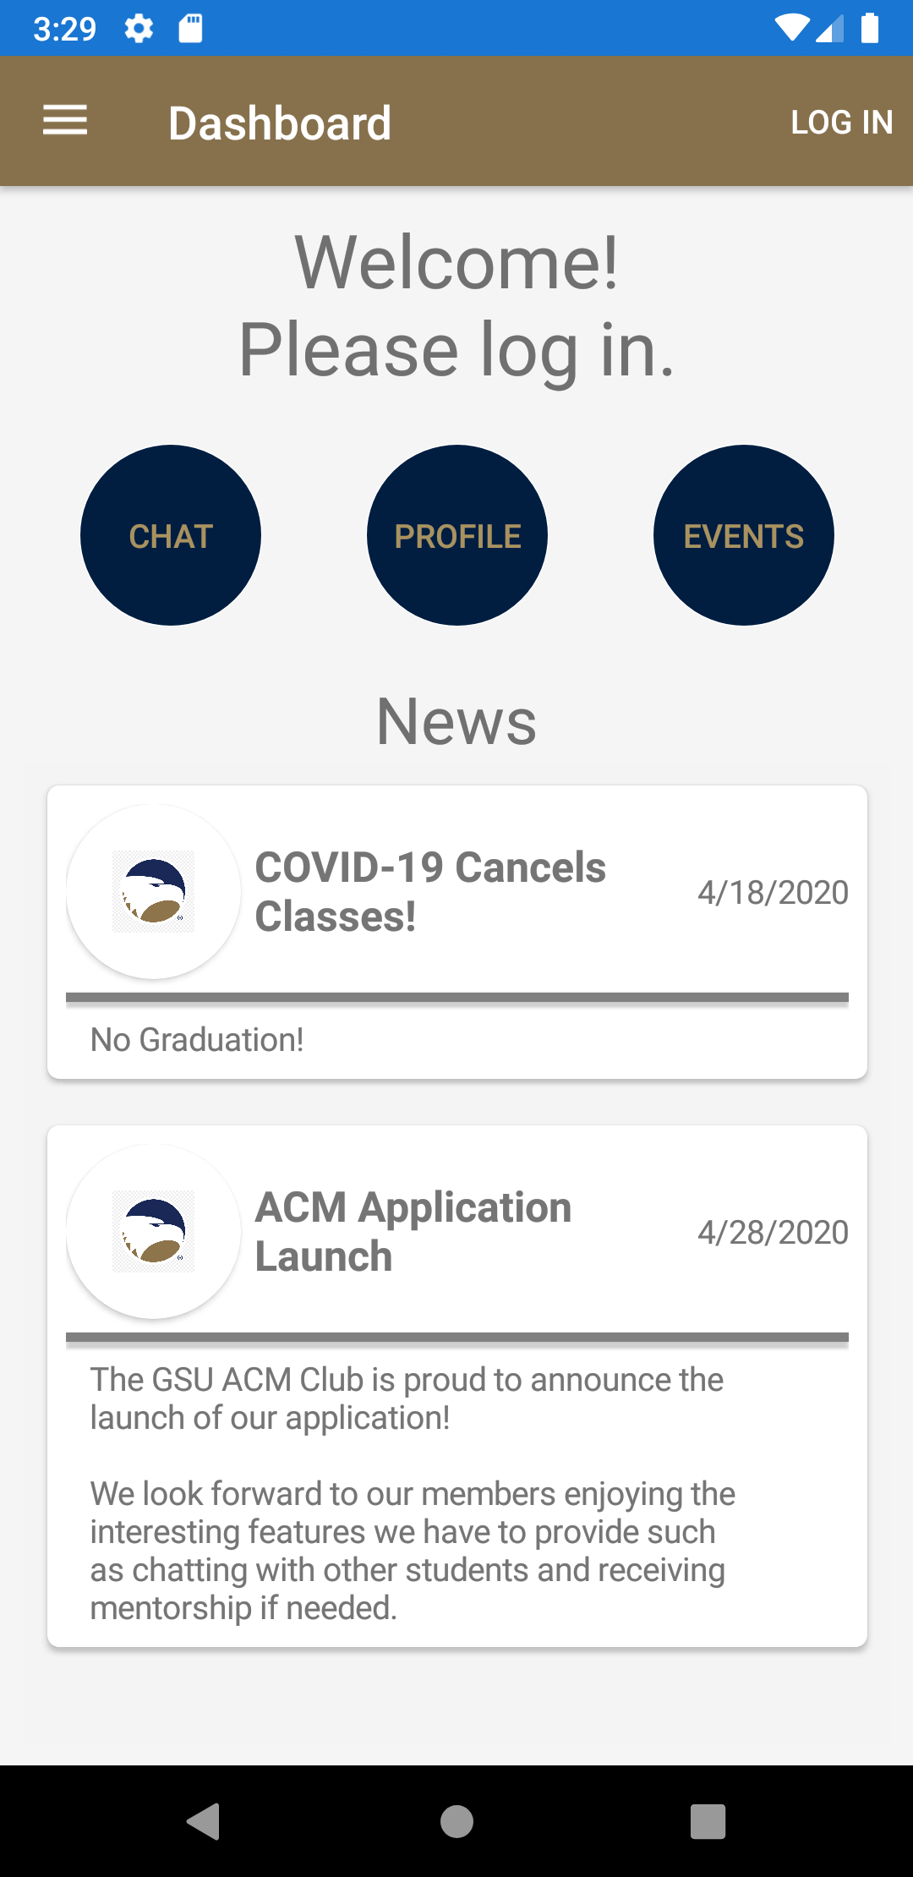

(Figure 1.0)

### Creating an Account

Once the user has started the application, they can create an account by tapping on the "LOG IN" button in the top right hand corner of their navbar.

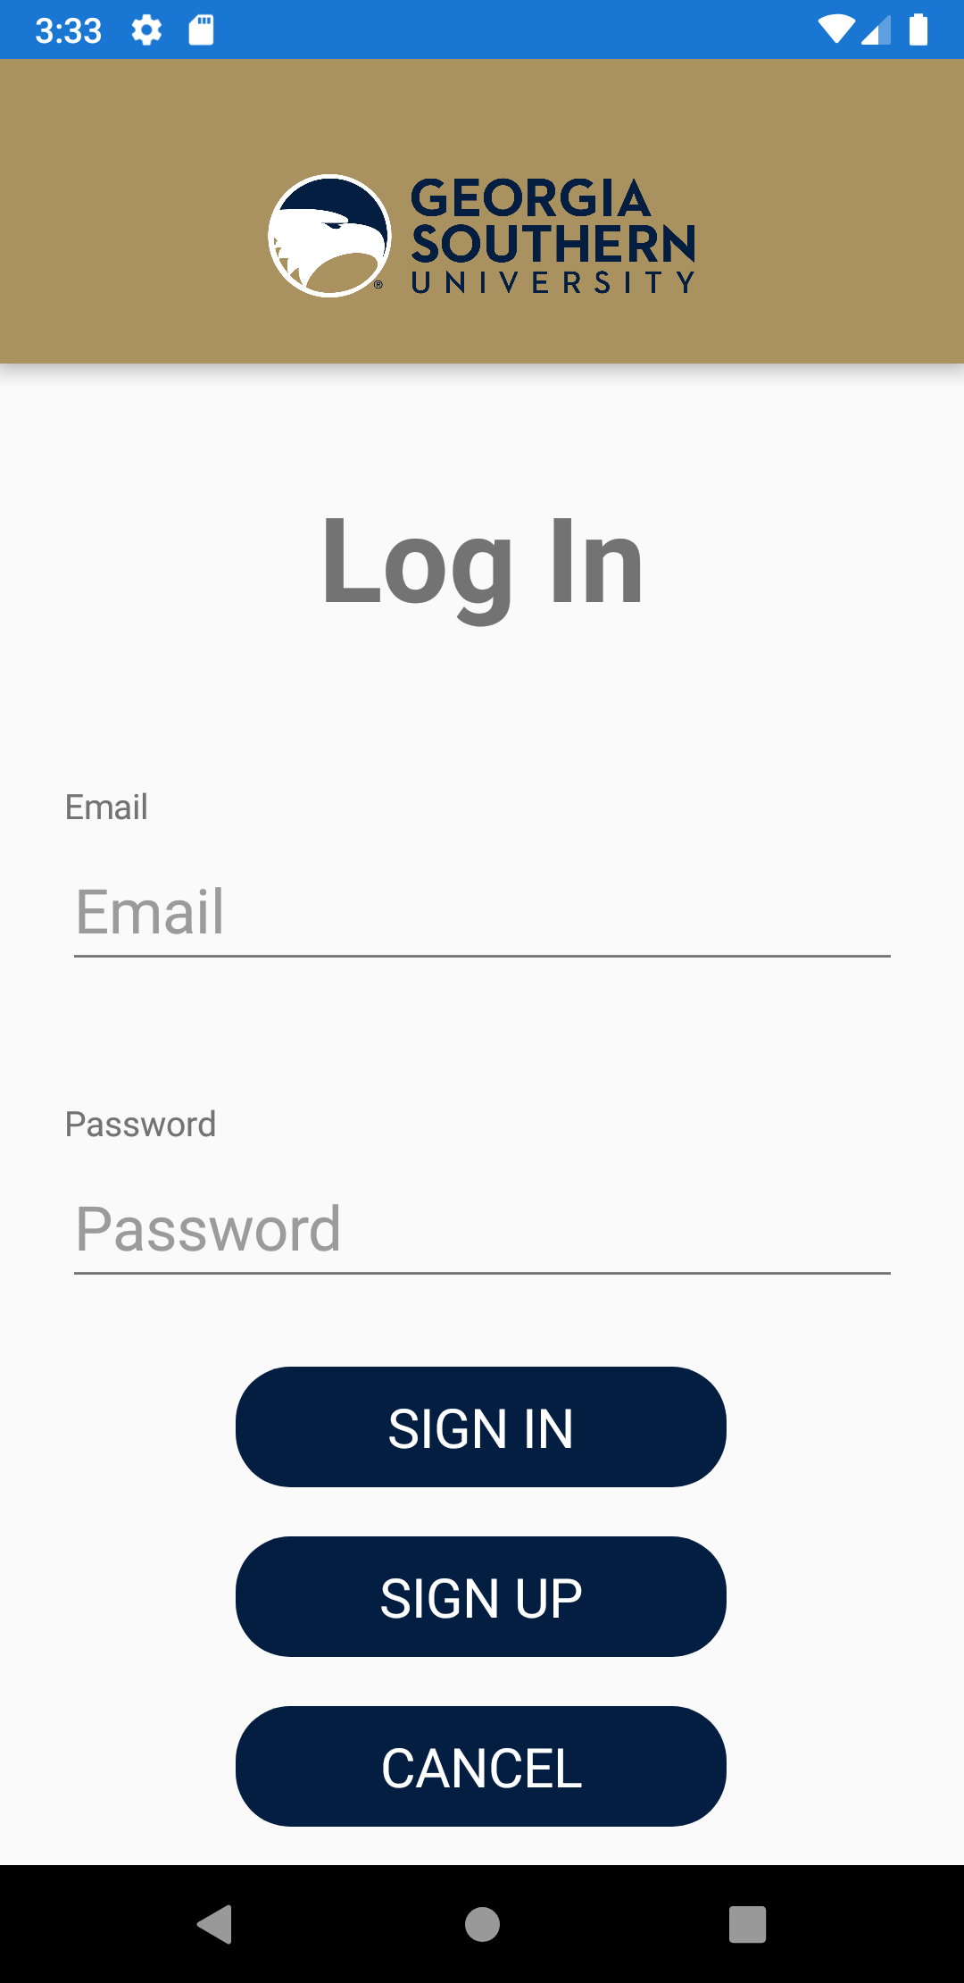

(Figure 2.0)

From this screen they will be prompted to either sign in, sign up, or cancel back to the dashboard. In this instance we will tap "SIGN UP"

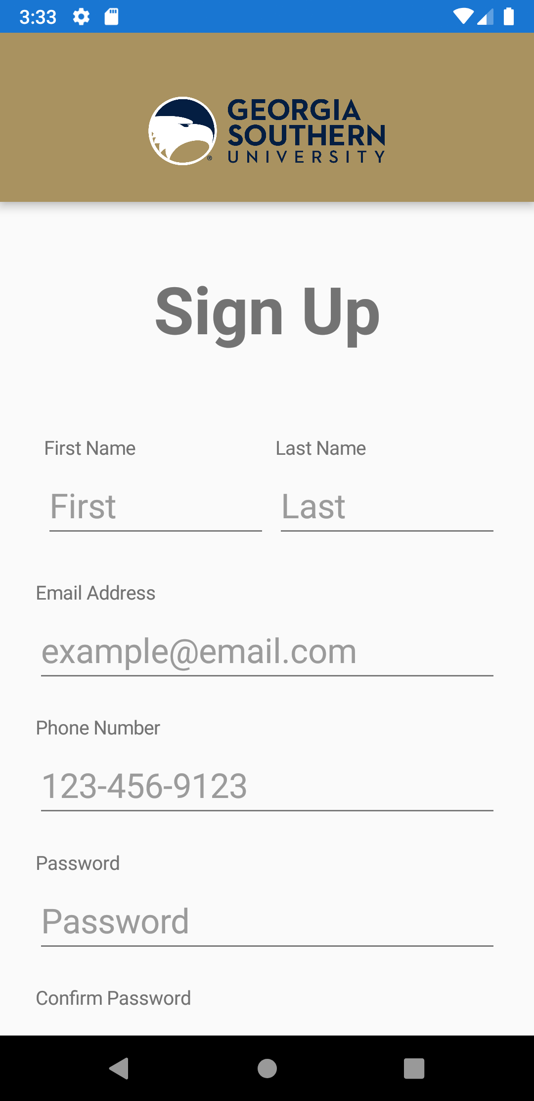

(Figure 3.0)

After entering in all of the relevant information, the user will tap on "CREATE ACCOUNT" and receive a message that their account has been created.

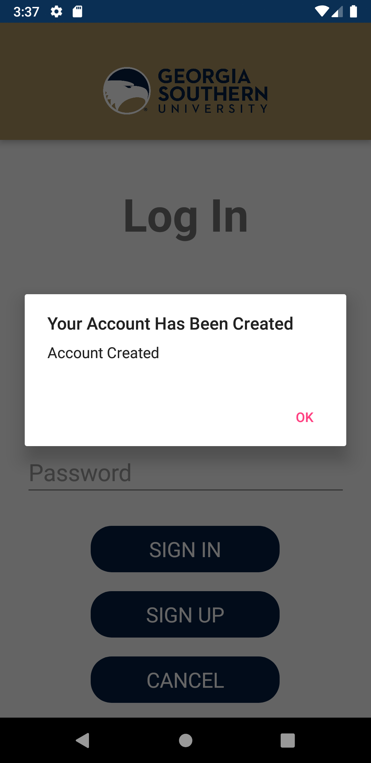

(Figure 3.1)

### Logging in

After the user has created an account they will be redirected to the login screen where they will enter their user information and tap on the "SIGN IN" button. If all of the information is correct the user will be redirected to the dashboard

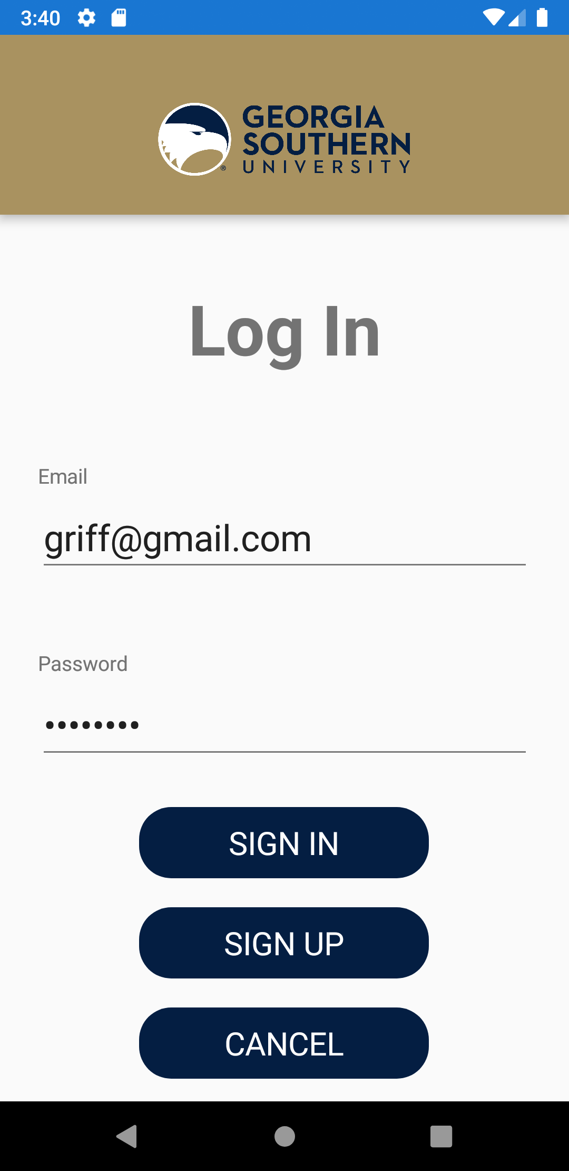

(Figure 4.0)

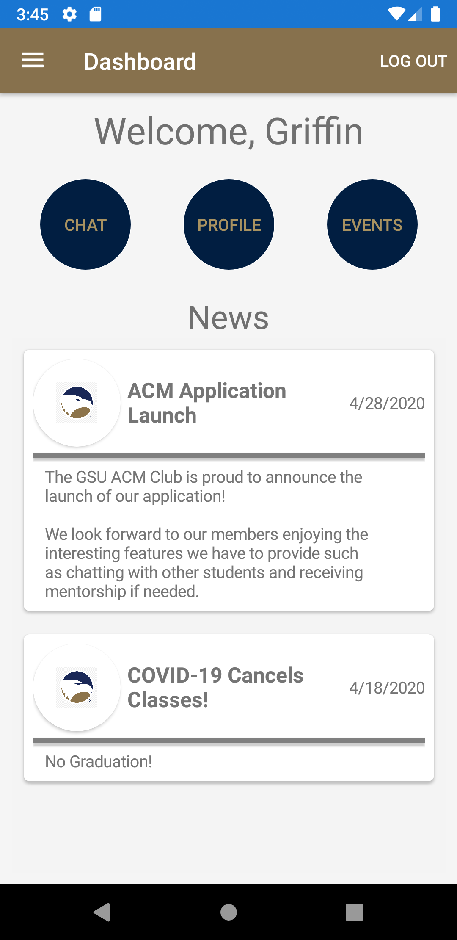

(Figure 4.1)

### Navigating the Dashboard

When the user is on the dashboard, they will see the current ACM news in order by the most recent posting date. The user will have a few options for navigation: the nav menu and the dashboard buttons. If the user chooses one of the dashboard buttons they will be directed to the respective page for that button. If the user chooses to navigate via the nav menu, they can either select to log out in the top right or they can select from the flyout menu by tapping on the button in the top left corner.

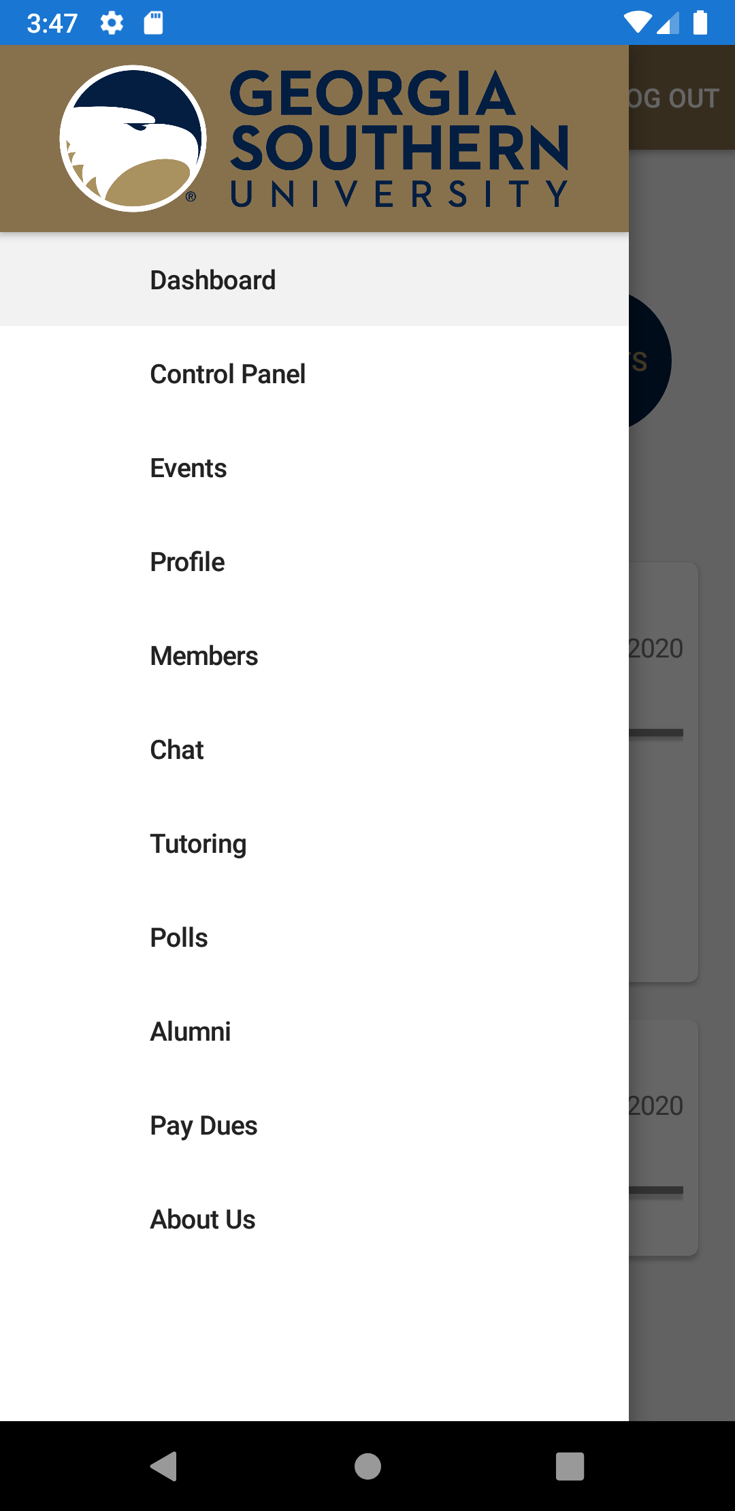

(Figure 5.0)

The menu items that the users will see depend on their status as a member in the application. If the user is not signed in they will see the menu displayed in Figure 5.1, If the user is signed in as a member they will see the menu displayed in Figure 5.2, if the user is signed in as a tutor they will see the menu displayed in Figure 5.3, if the user is signed in as an administrator, they will see the menu displayed in 5.0, if the user is a combination of any of the previous roles, they will see a combination of the options respective to whatever role they possess.

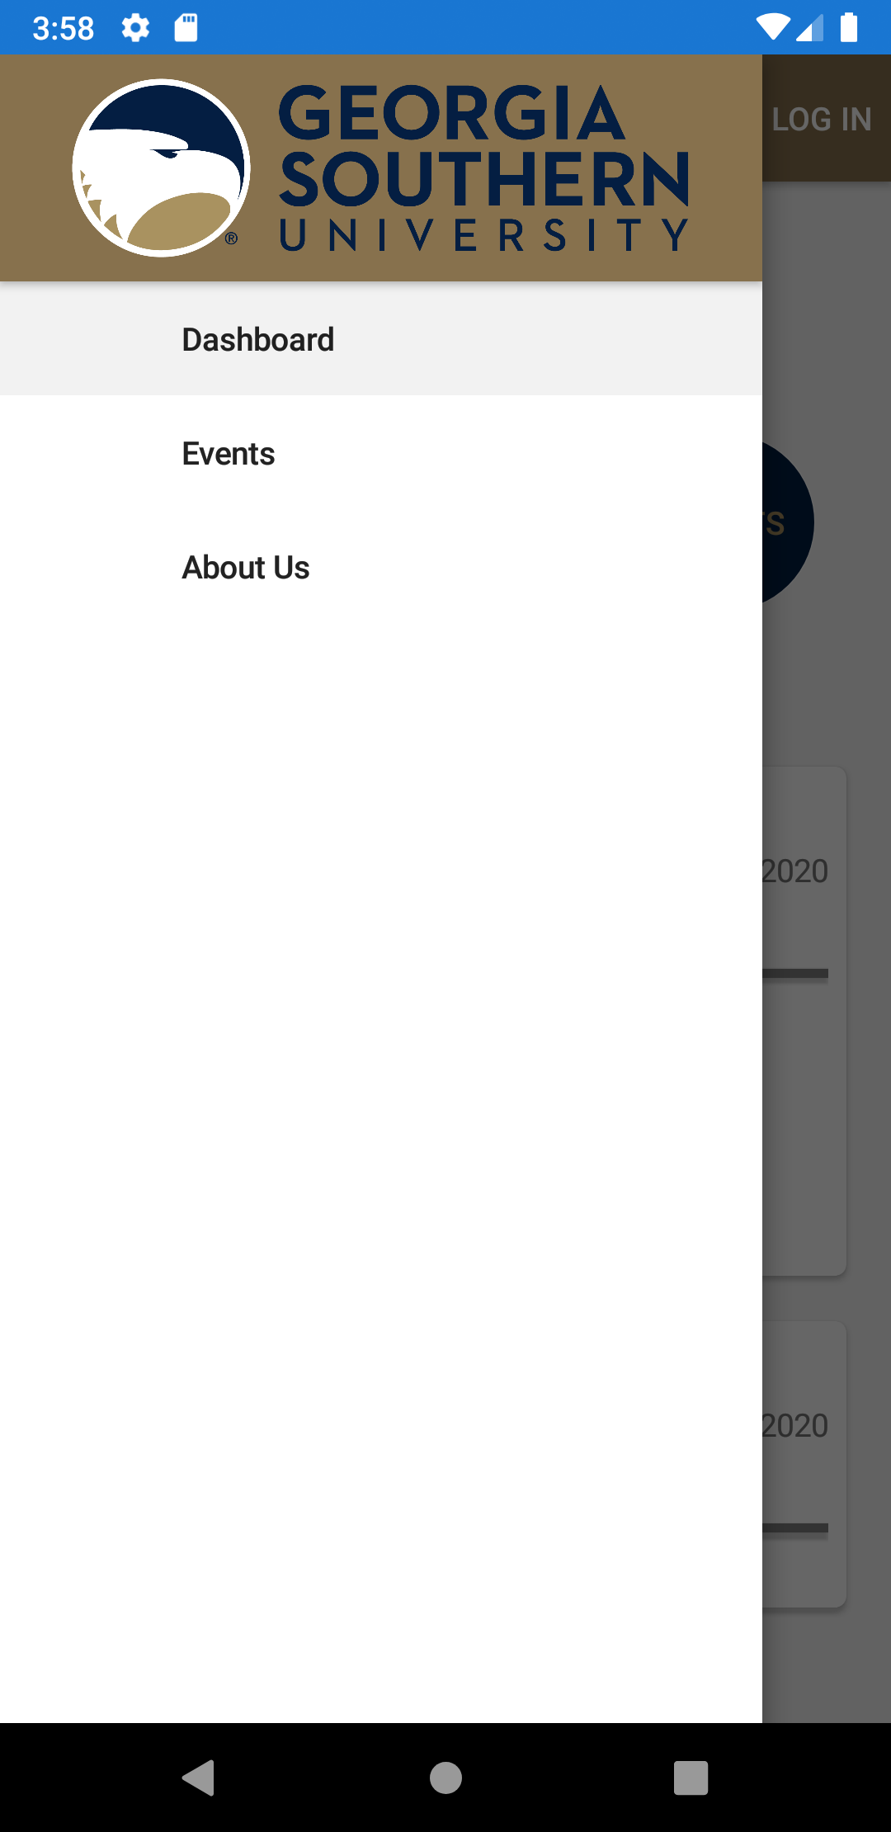 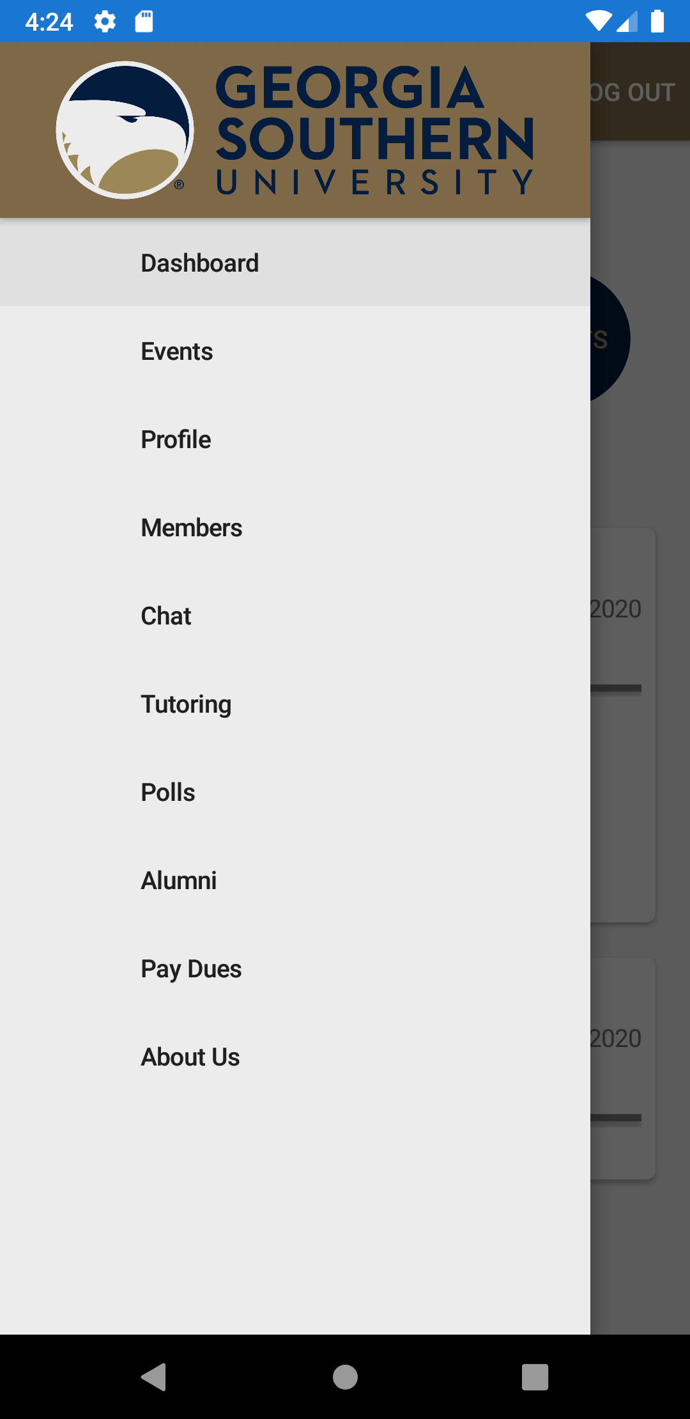 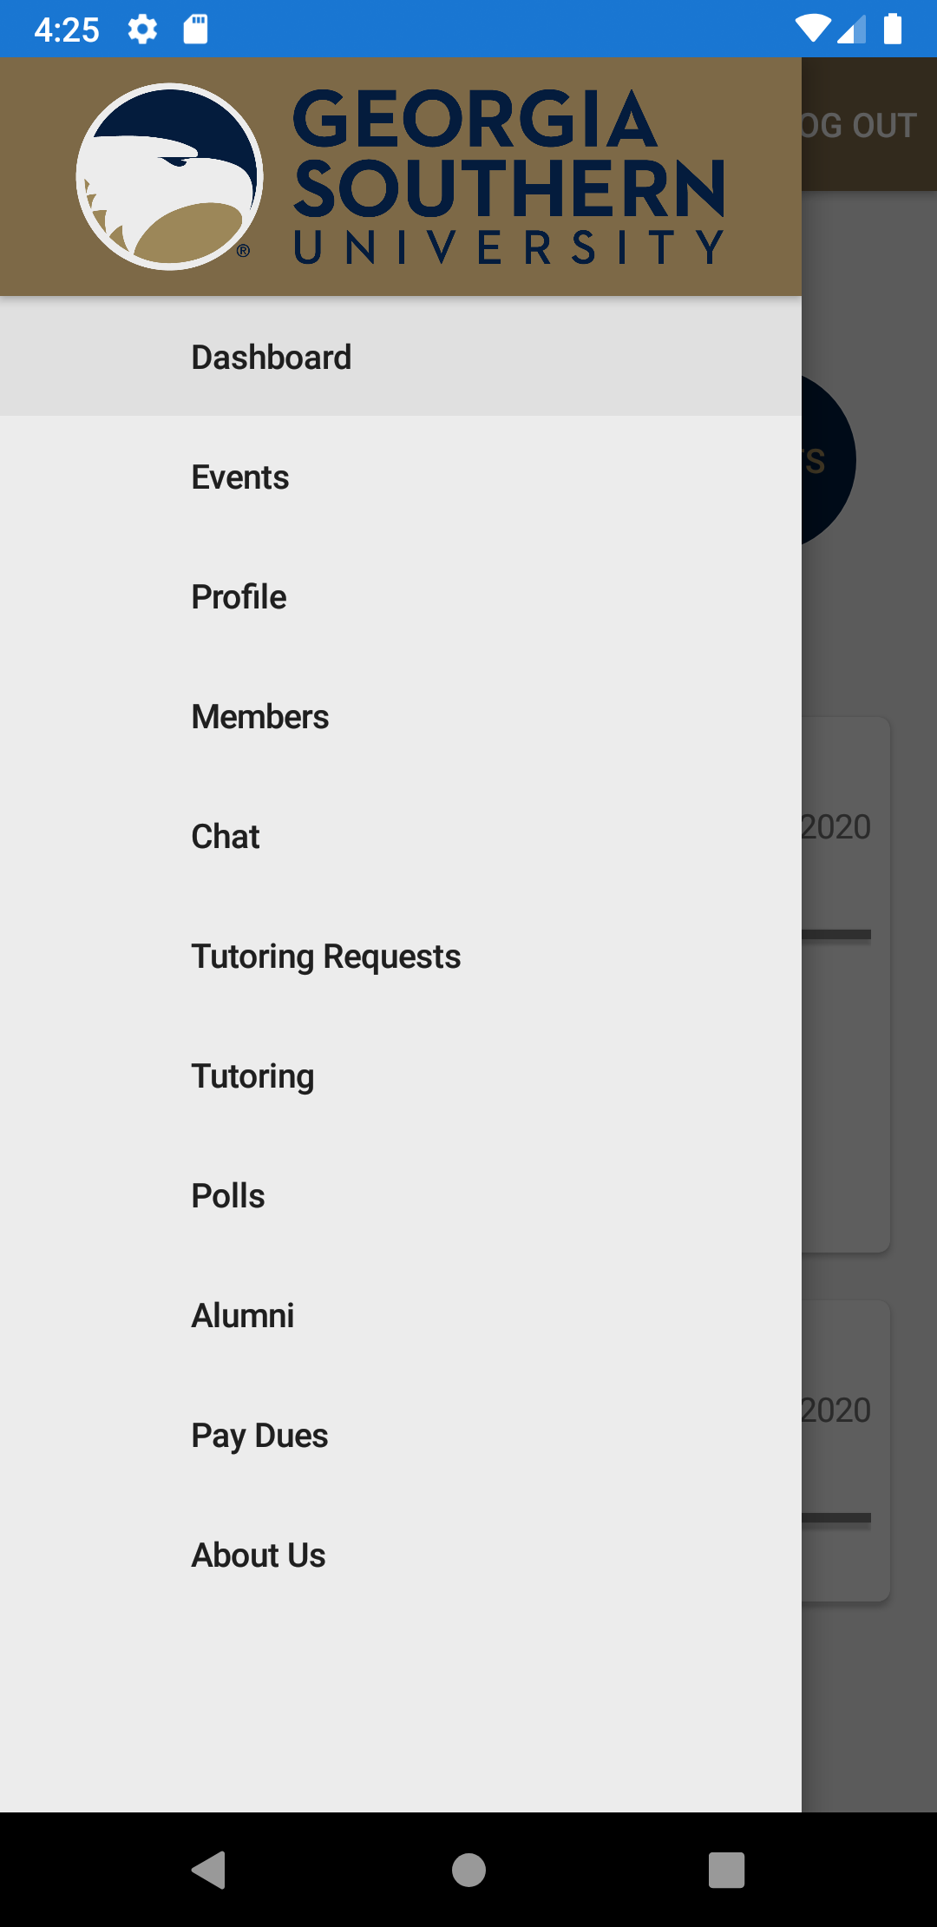

(Figure 5.1) (Figure 5.2) (Figure 5.3)

### Viewing Events

If the user is signed in, they can view events either from the dashboard or from the nav menu. Either tap on the "EVENTS" button from the dashboard or tap on the nav menu and tap "Events".

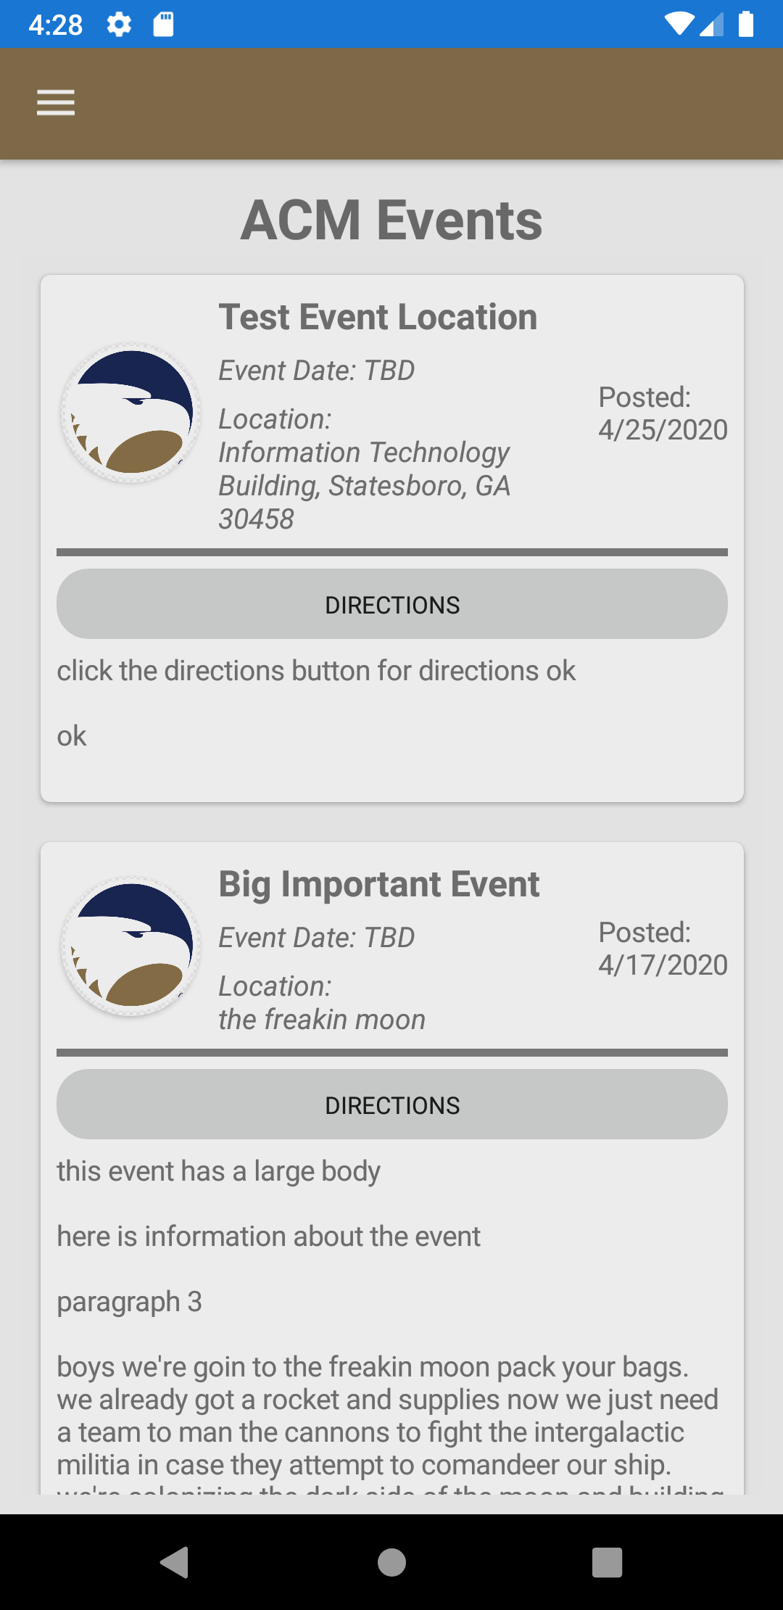

(Figure 6.0)

Once the user is on this page, they will see a list of ACM events organized by the date they were posted. The user can scroll through the events or tap on "DIRECTIONS" to open the location in their native maps application.

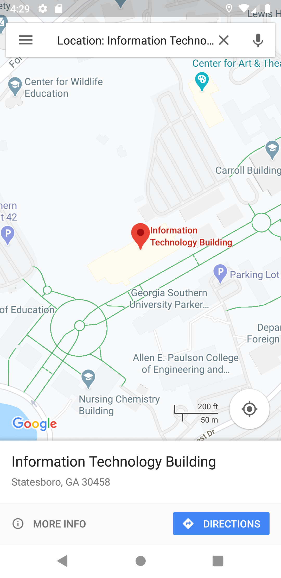

(Figure 6.1)

To leave this page, the user can use the nav menu in the top left hand corner to reach another page.

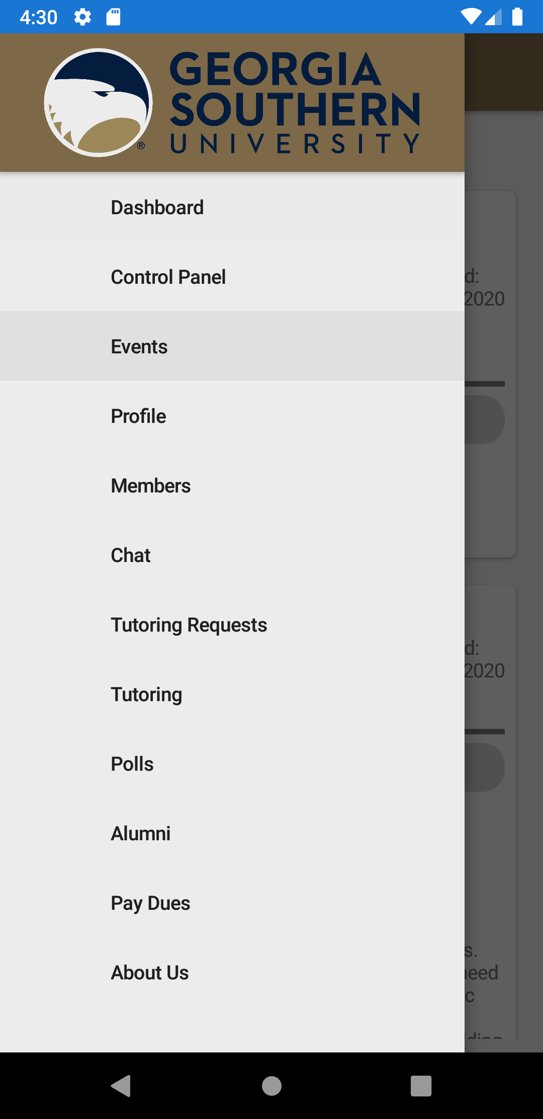

(Figure 6.2)

### Viewing your Profile

To reach your profile, the user will either use the profile button from the dashboard or from the nav menu in the top left hand corner.

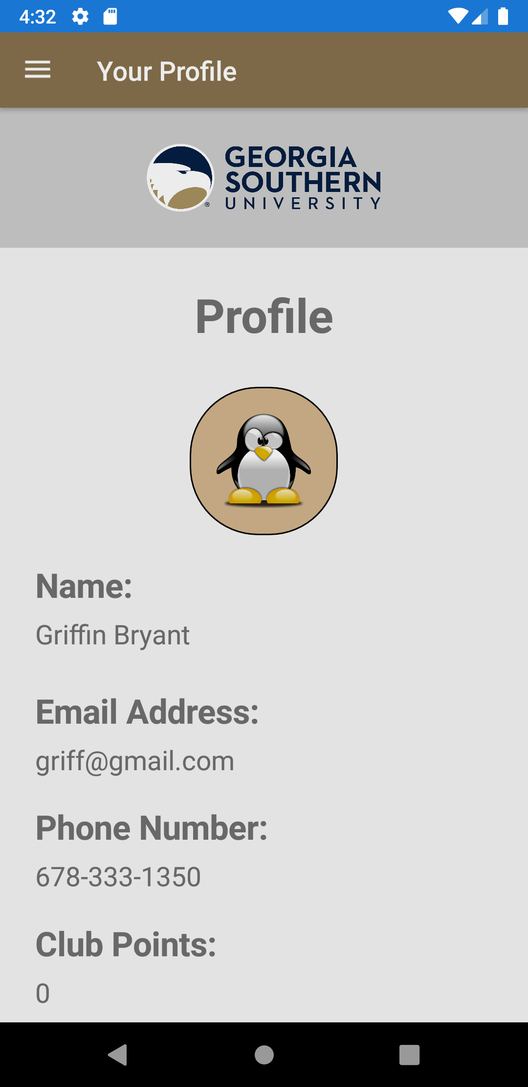

(Figure 7.0)

### Editing your Profile

To edit your profile, the user will scroll down on the profile page until they see the "EDIT PROFILE" button.

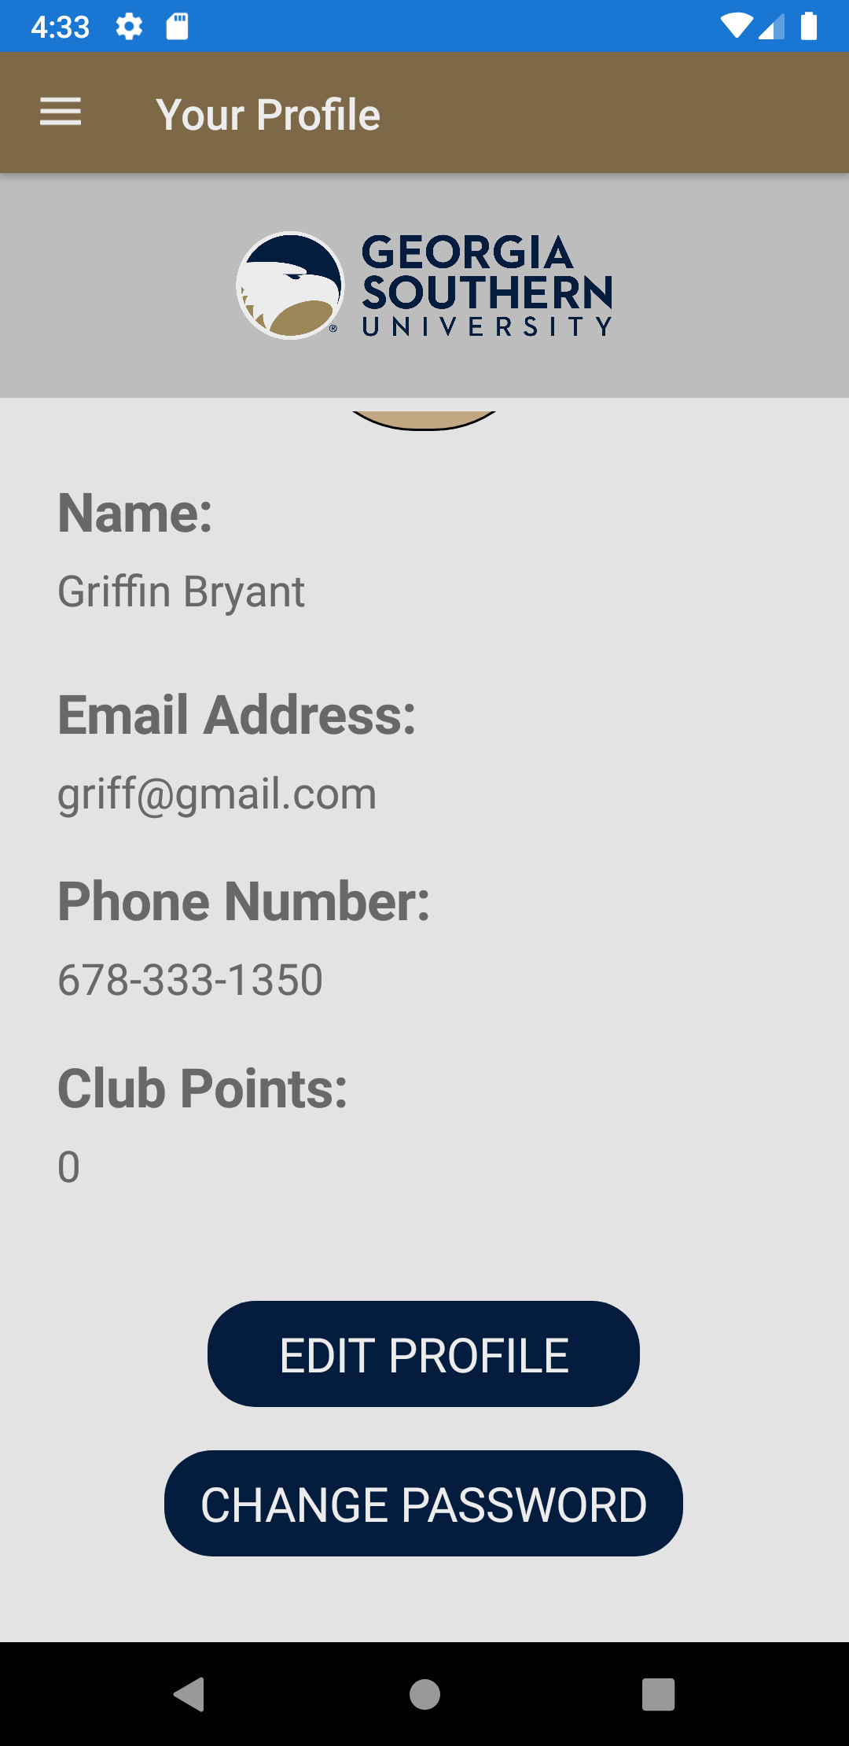

(Figure 8.0)

The user will then tap "EDIT PROFILE" where they will be redirected to the edit profile page (Figure 8.1). Once on this page the user can edit any of the information they want and then press "PICK IMAGE" to change their profile image, "UPDATE PROFILE" to save their updated information, "CANCEL" to discard any changes, or scroll down to "CHANGE PASSWORD" to change their password.

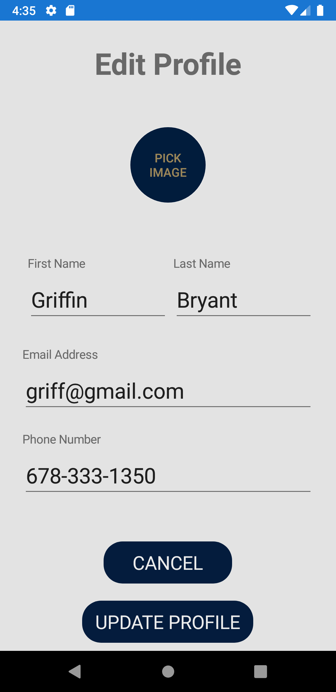

(Figure 8.1)

#### Changing your Profile Picture

To change your profile picture, the user will tap "PICK IMAGE" on the edit user page. They will then be directed to the profile images page (Figure 8.2) where they can tap on an image to update their profile.

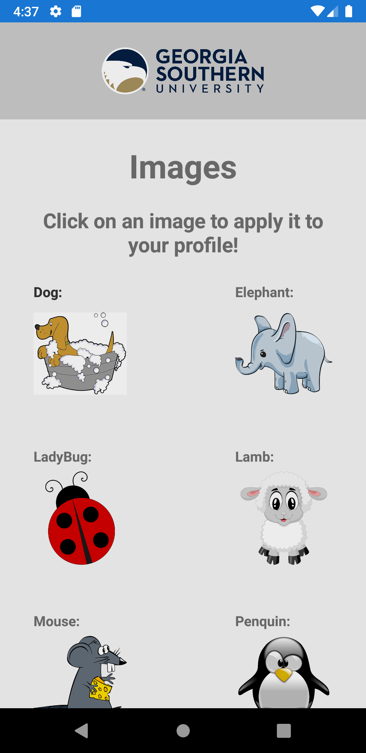

(Figure 8.2)

#### Changing your Password

To change your password, the user can either tap "CHANGE PASSWORD" on their profile page or on the edit profile page. They will then be redirected to the change password page where they can enter their new password and tap "UPDATE PASSWORD" to save their changes.

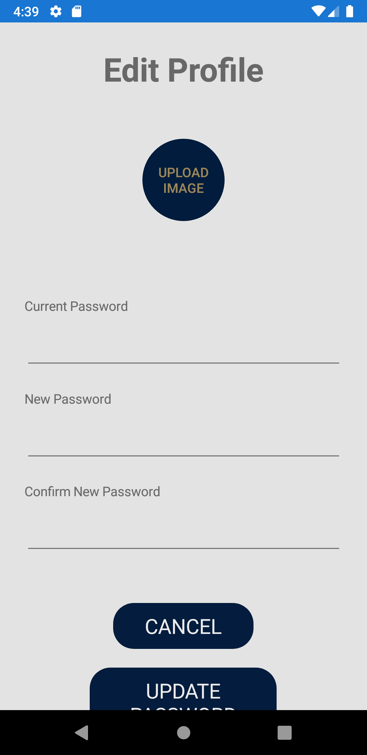

(Figure 8.3)

### Viewing Members / Mentors

To view members of the application, the user can access the member page from the nav menu in the top left hand corner. Once they select the members page, they will see a scrollable list of the current registered members and their respective titles.

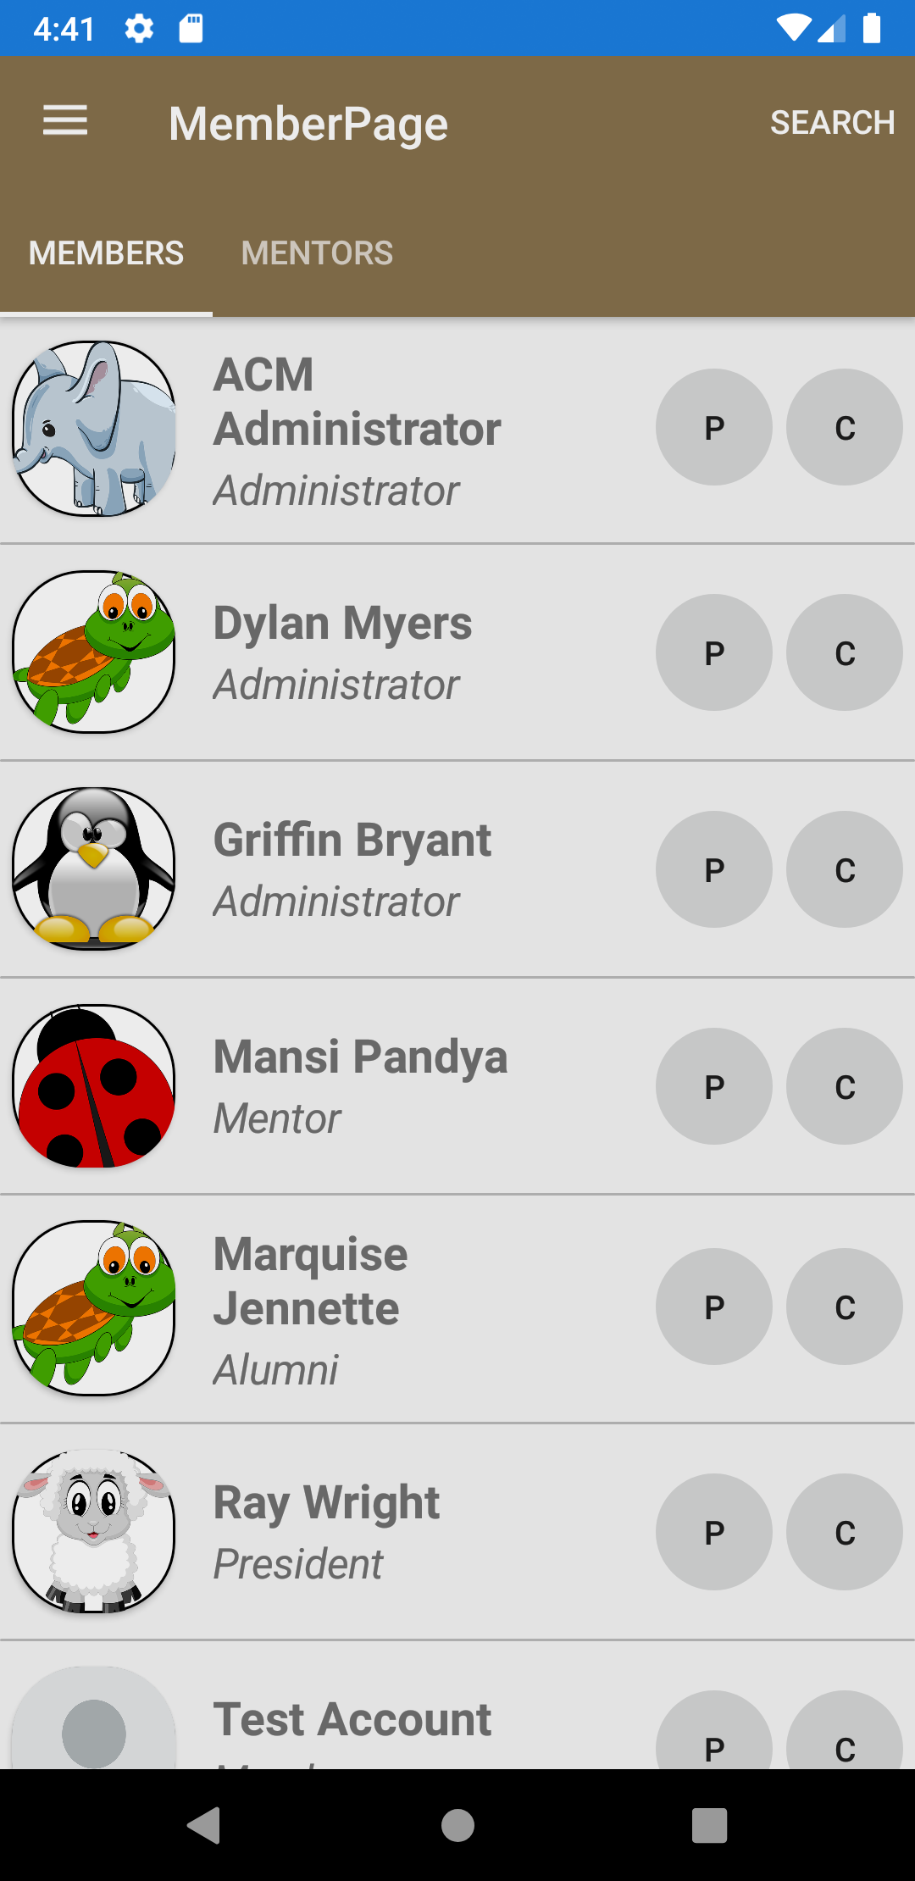

(Figure 9.0)

On this page, the user can scroll through the list of members, or tap on the "MENTORS" button underneath the navbar to see a list of registered mentors.

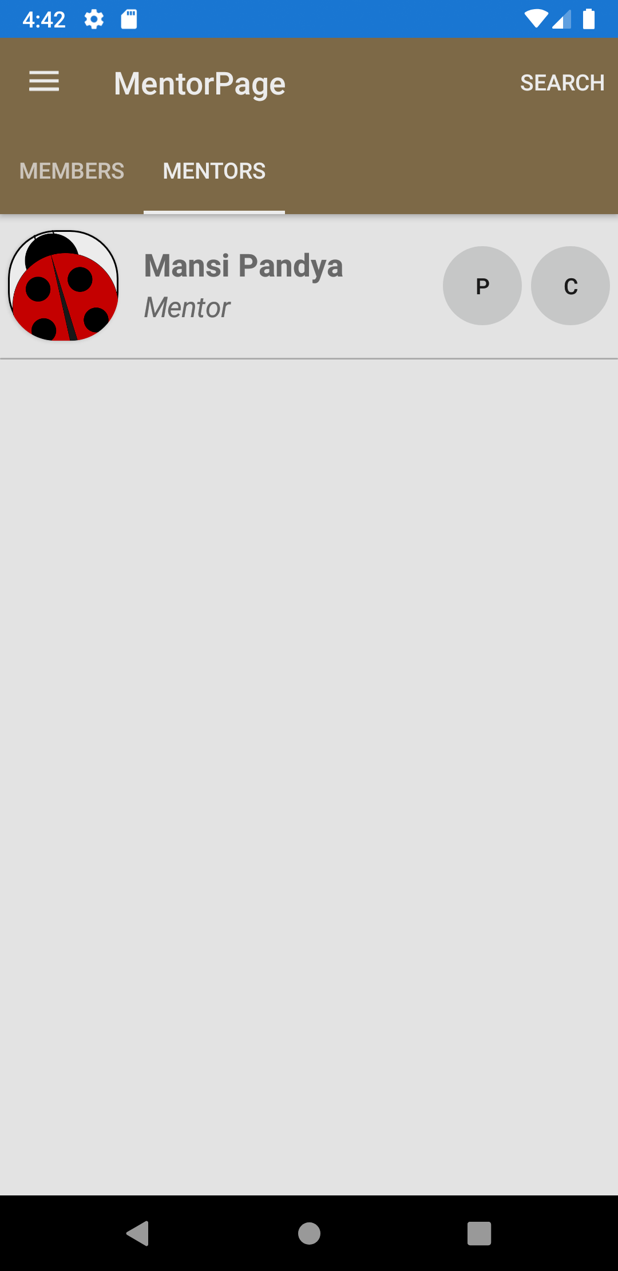

(Figure 9.1)

The user can also tap "SEARCH" in the top right hand corner to easily find another member (Figure 9.2). When on the search page, the user can either enter a first name, last name, or title/role to search for and press the search button to display all of the users relevant to their search (Figure 9.3).

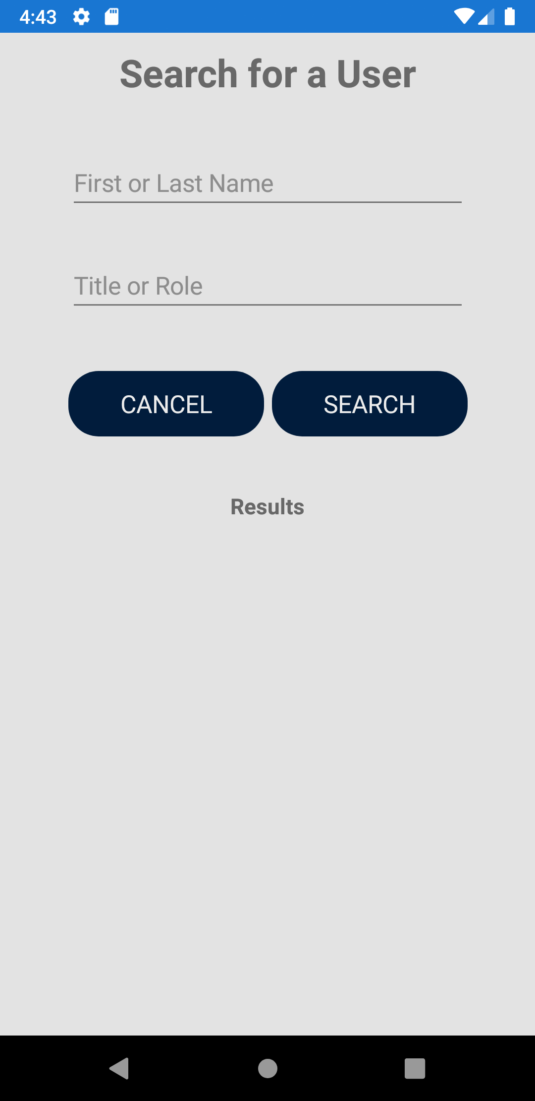 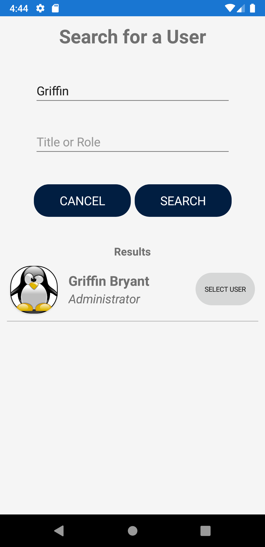

(Figure 9.2) (Figure 9.3)

### Chatting with Other Users

To chat with other users, the user must be registered with the ACM Application. Registered users can reach the chat page either from the dashboard or from the nav menu. After tapping "CHAT" the user will be redirected to the chat list page where they will see all of their direct messages and public channels.

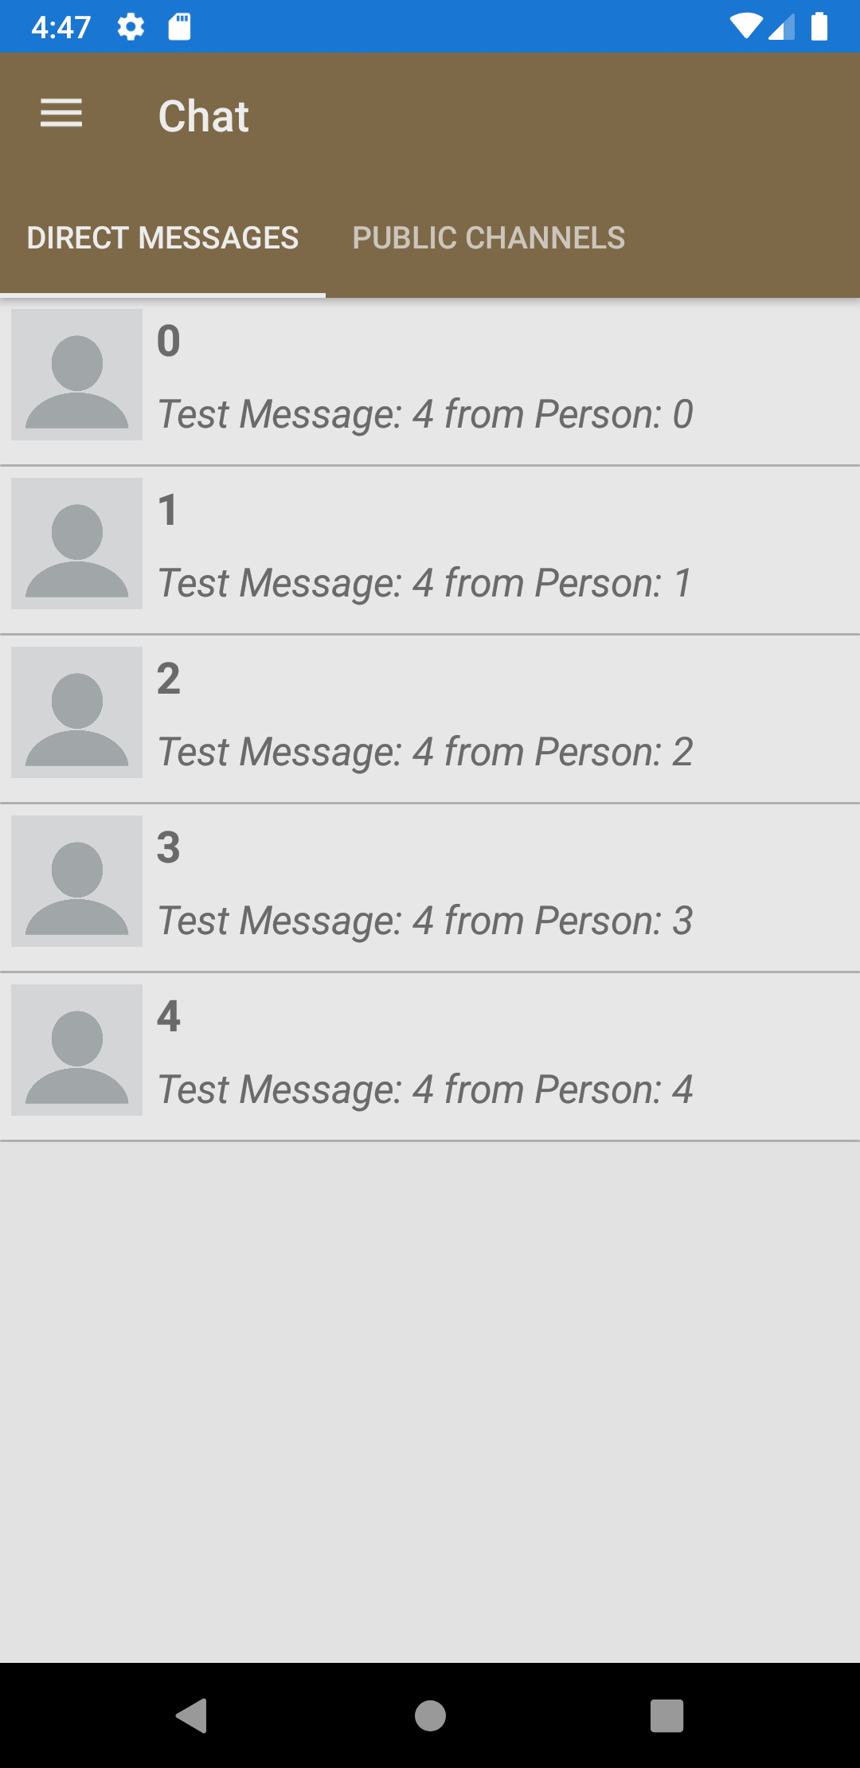

(Figure 10.0)

To send a message, the user can also press the "C" button next to a member's name in the member list (Figure 9.0). If there is a message in their current chats list, the user can tap on the row containing the message and the app will open the chat session.

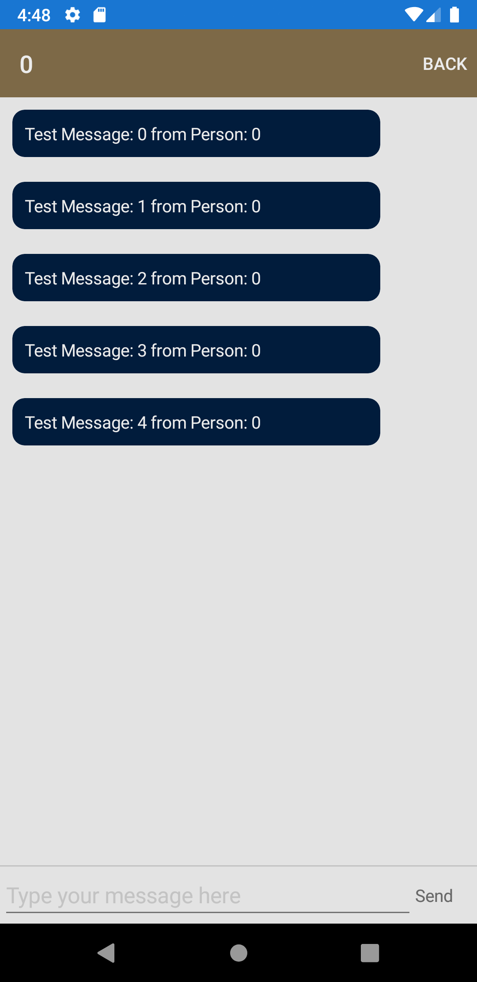

(Figure 10.1)

From the chat session page, the user will see the name of the person they are chatting with in the top left hand corner and they will see their messages in the center. The user can send a message by tapping in the box that says "Type your message here…" (Figure 10.2) After typing their message, the user can press the "Send" button and the message will be sent and will display in the center (Figure 10.3).

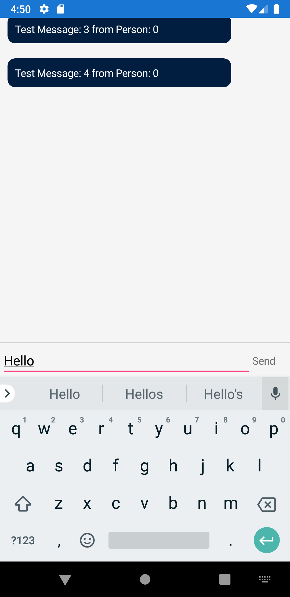 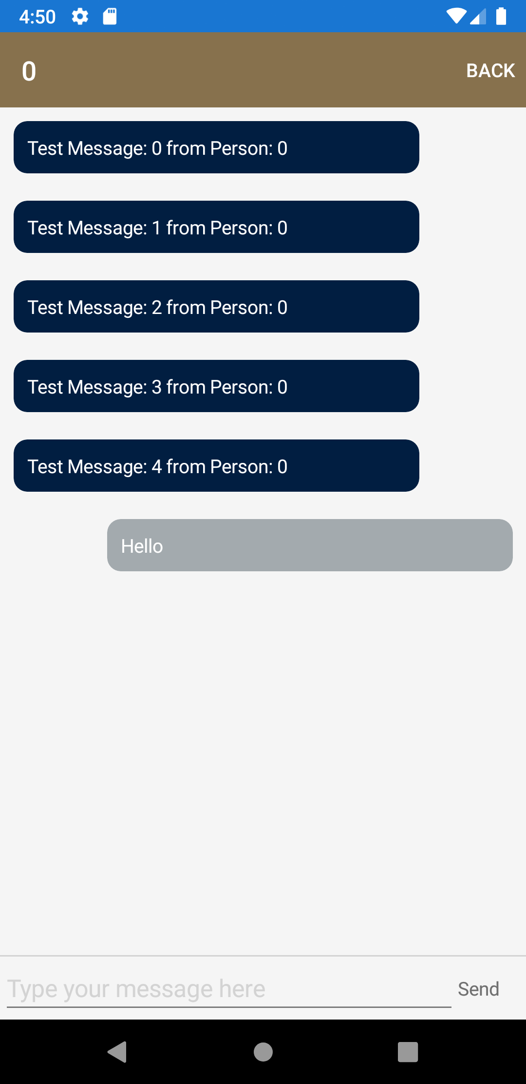

(Figure 10.2) (Figure 10.3)

### Requesting a Tutor

To request a tutor, the user will tap on the "Tutoring" button in the nav menu. They will be redirected to the tutor request page (Figure 11.0) where they can enter a course title and request a date for their tutor session (Figure 11.1). The user can then tap the "ADD SESSION" button and their request will be posted. (Figure 11.2)

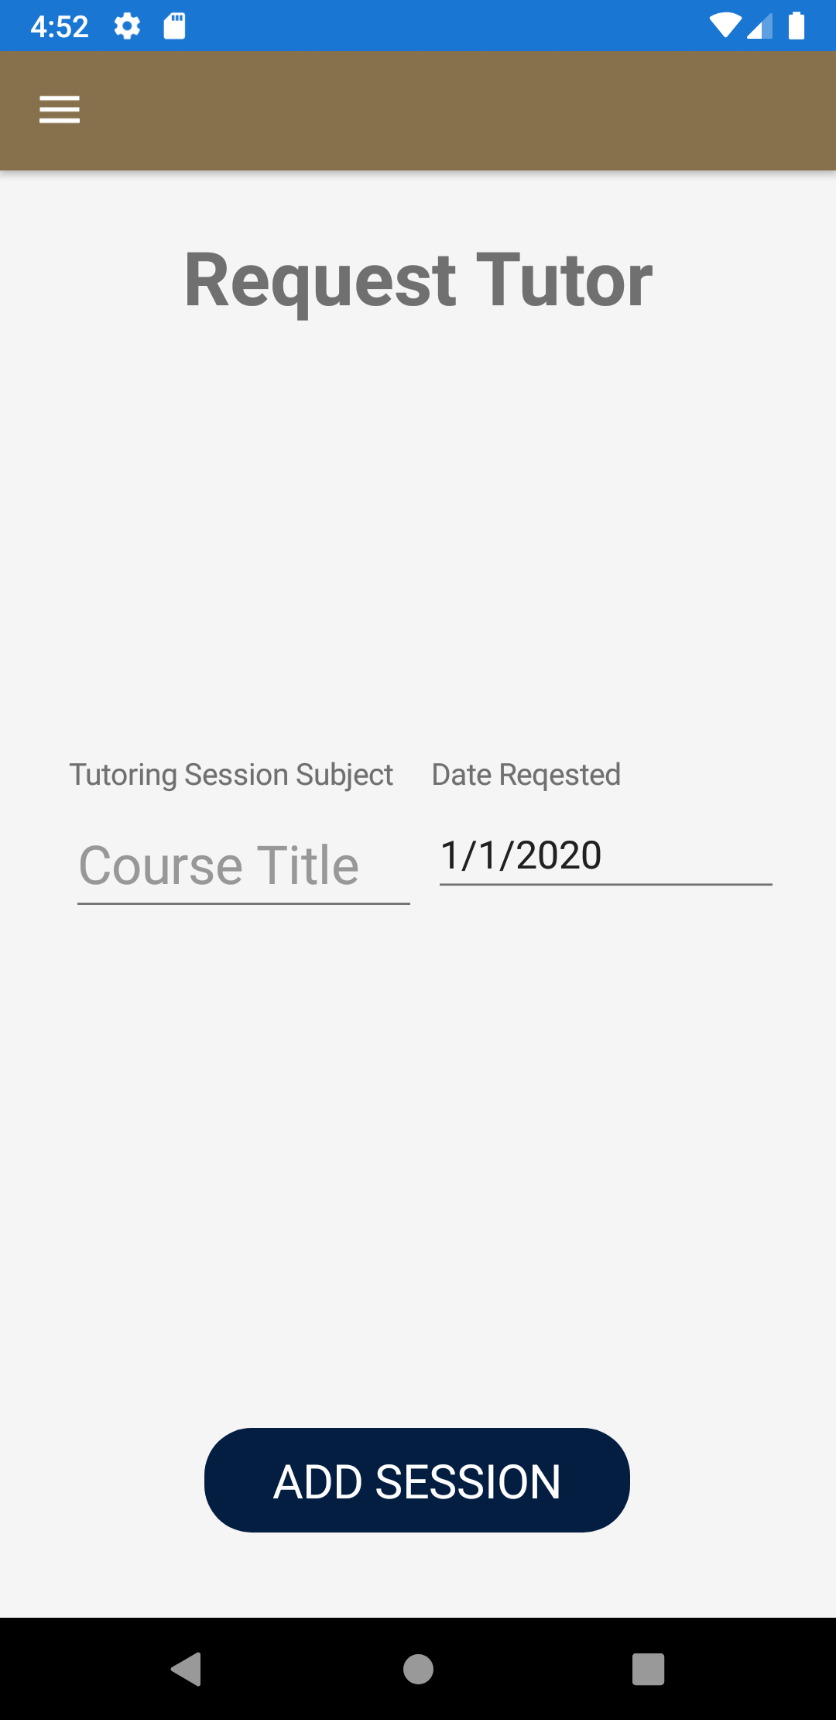 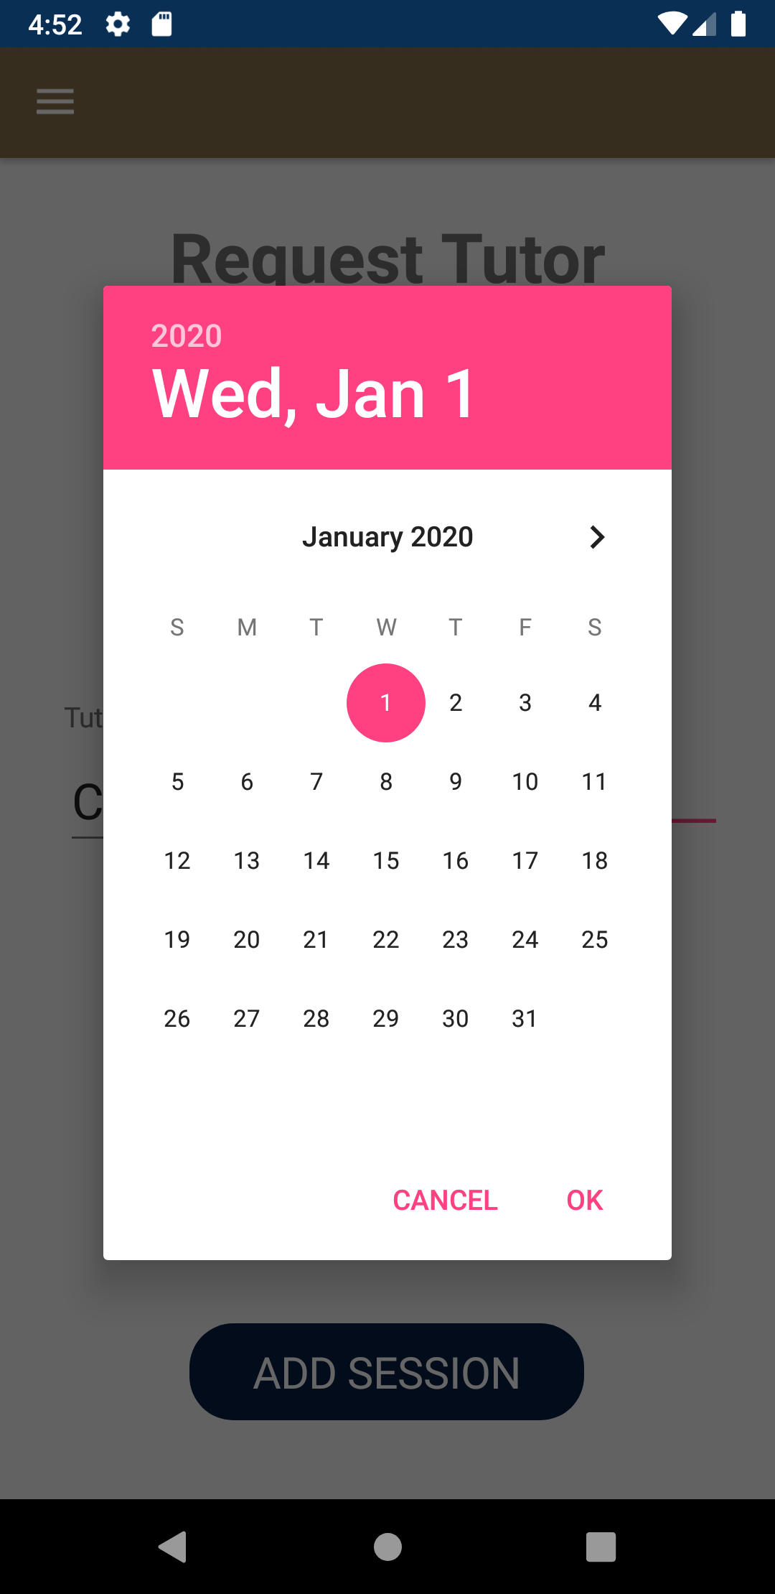 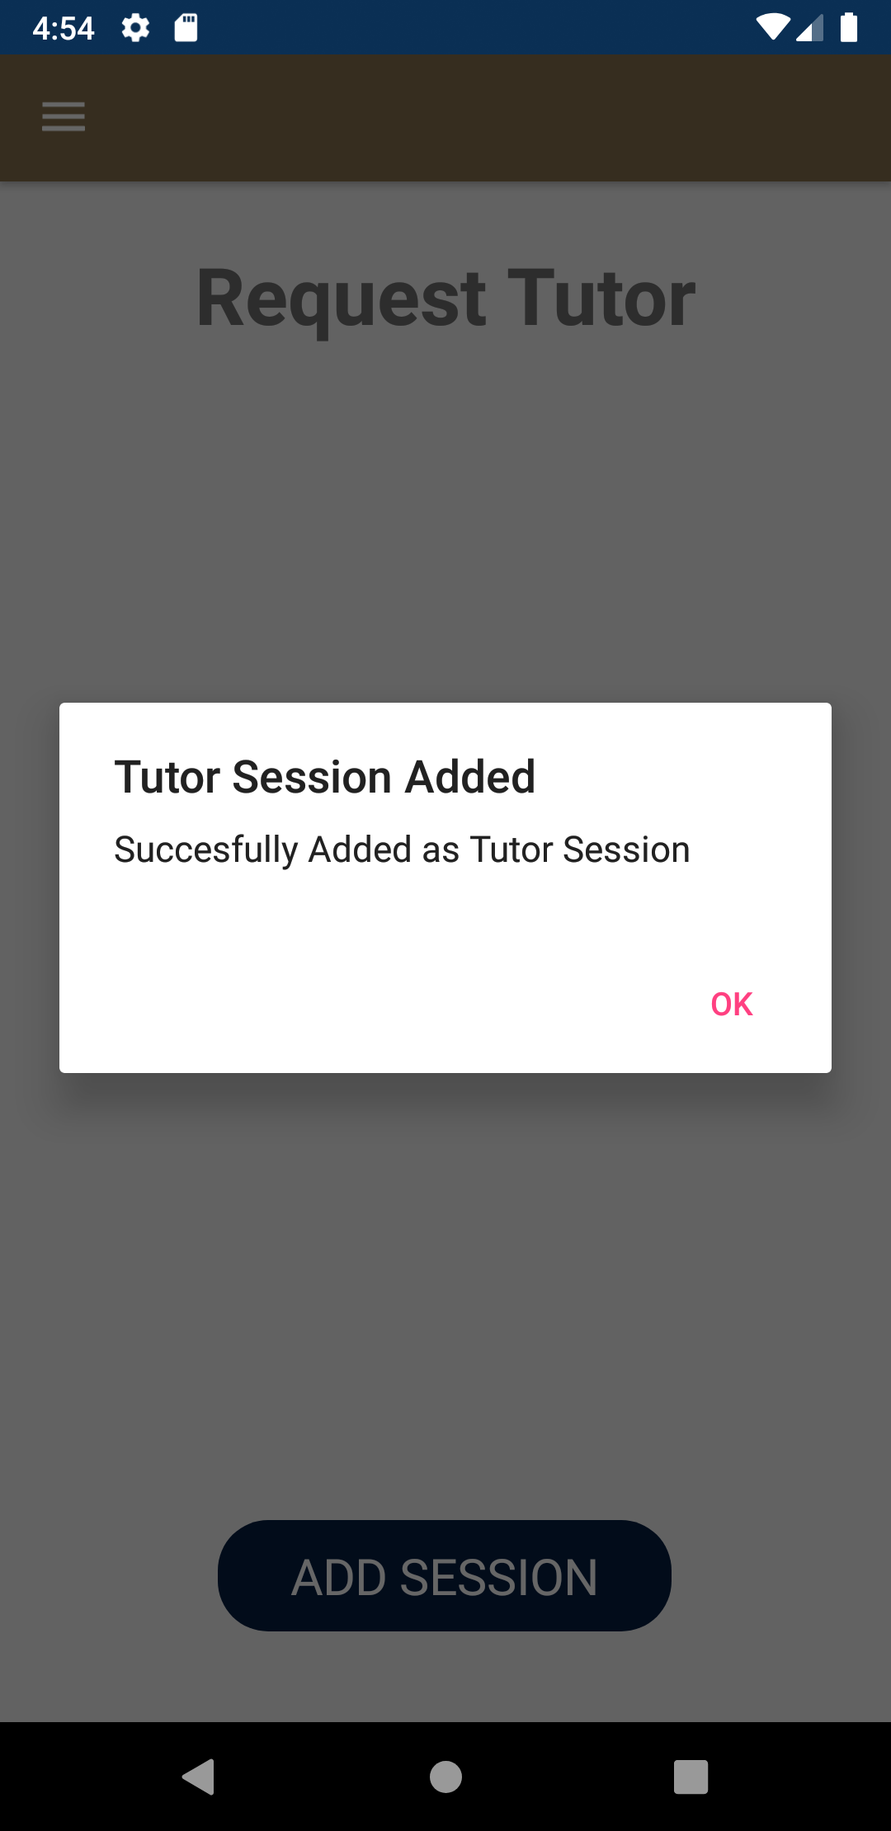

(Figure 11.0) (Figure 11.1) (Figure 11.2)

### Viewing / Accepting a Tutoring Request

If the user is logged in as a tutor, they can access the current tutor requests from the nav menu. After tapping the "Tutoring Requests" button they will be redirected to the requests page.

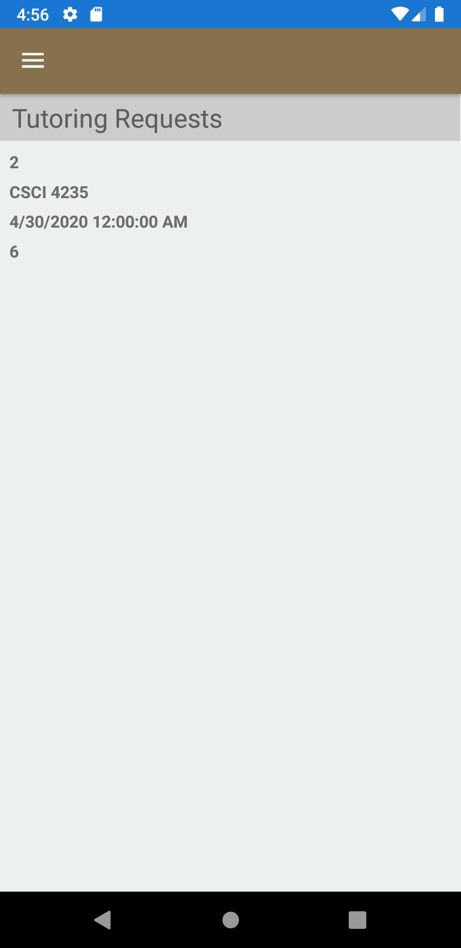

(Figure 12.0)

From this page, the user can accept a tutoring session by tapping on the tutoring request and pressing "YES"

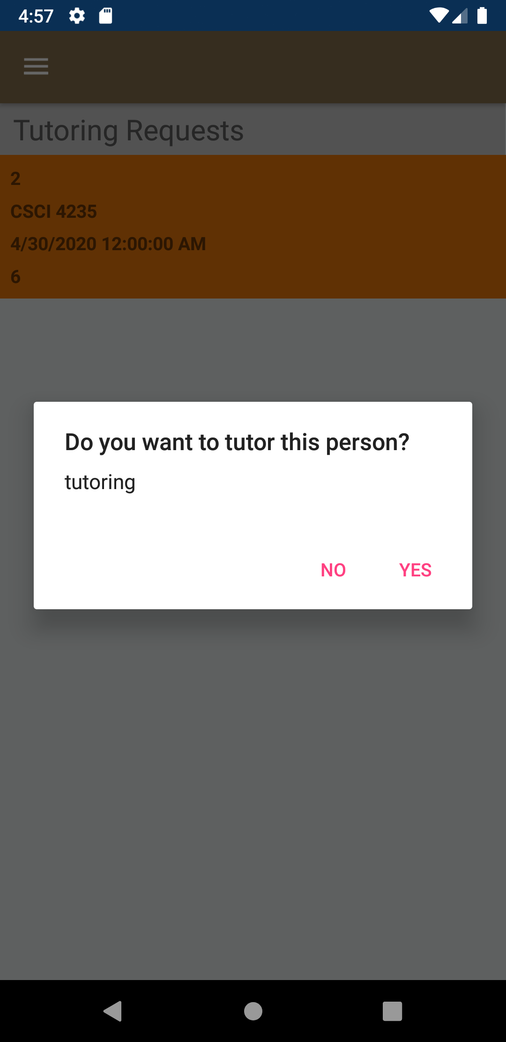

(Figure 12.1)

### Viewing / Voting on Polls

To view and vote on polls, the user must be signed in. The user can then access the polls page from the nav menu where they will be redirected to the "Active Polls" page (Figure 13.0). If there are no active polls, the page will be empty and the user can select to look at past polls (Figure 13.1).

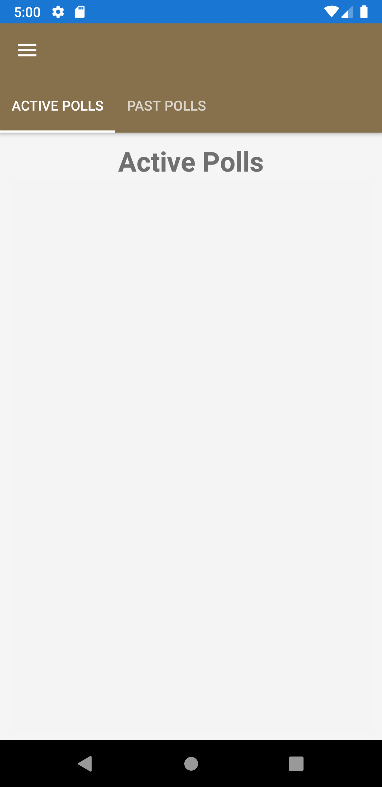 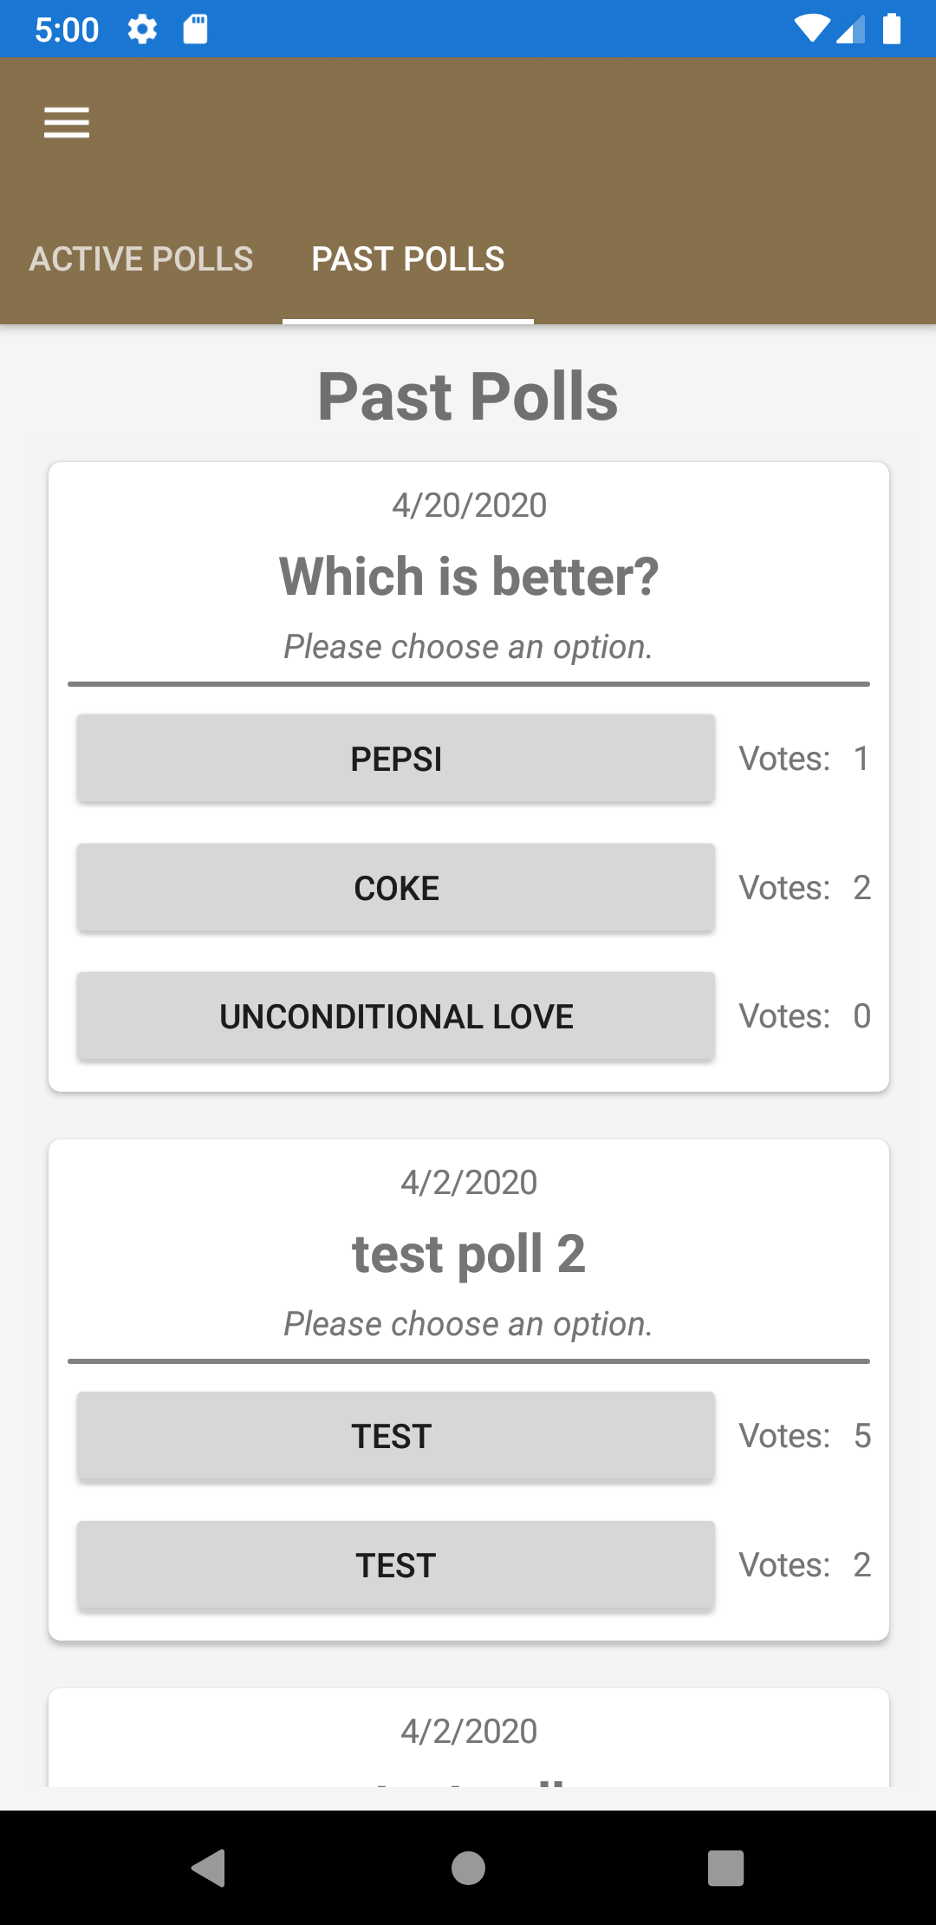

(Figure 13.0) (Figure 13.2)

To vote on a poll, simply tap on the option you want to vote for and the vote will be recorded.

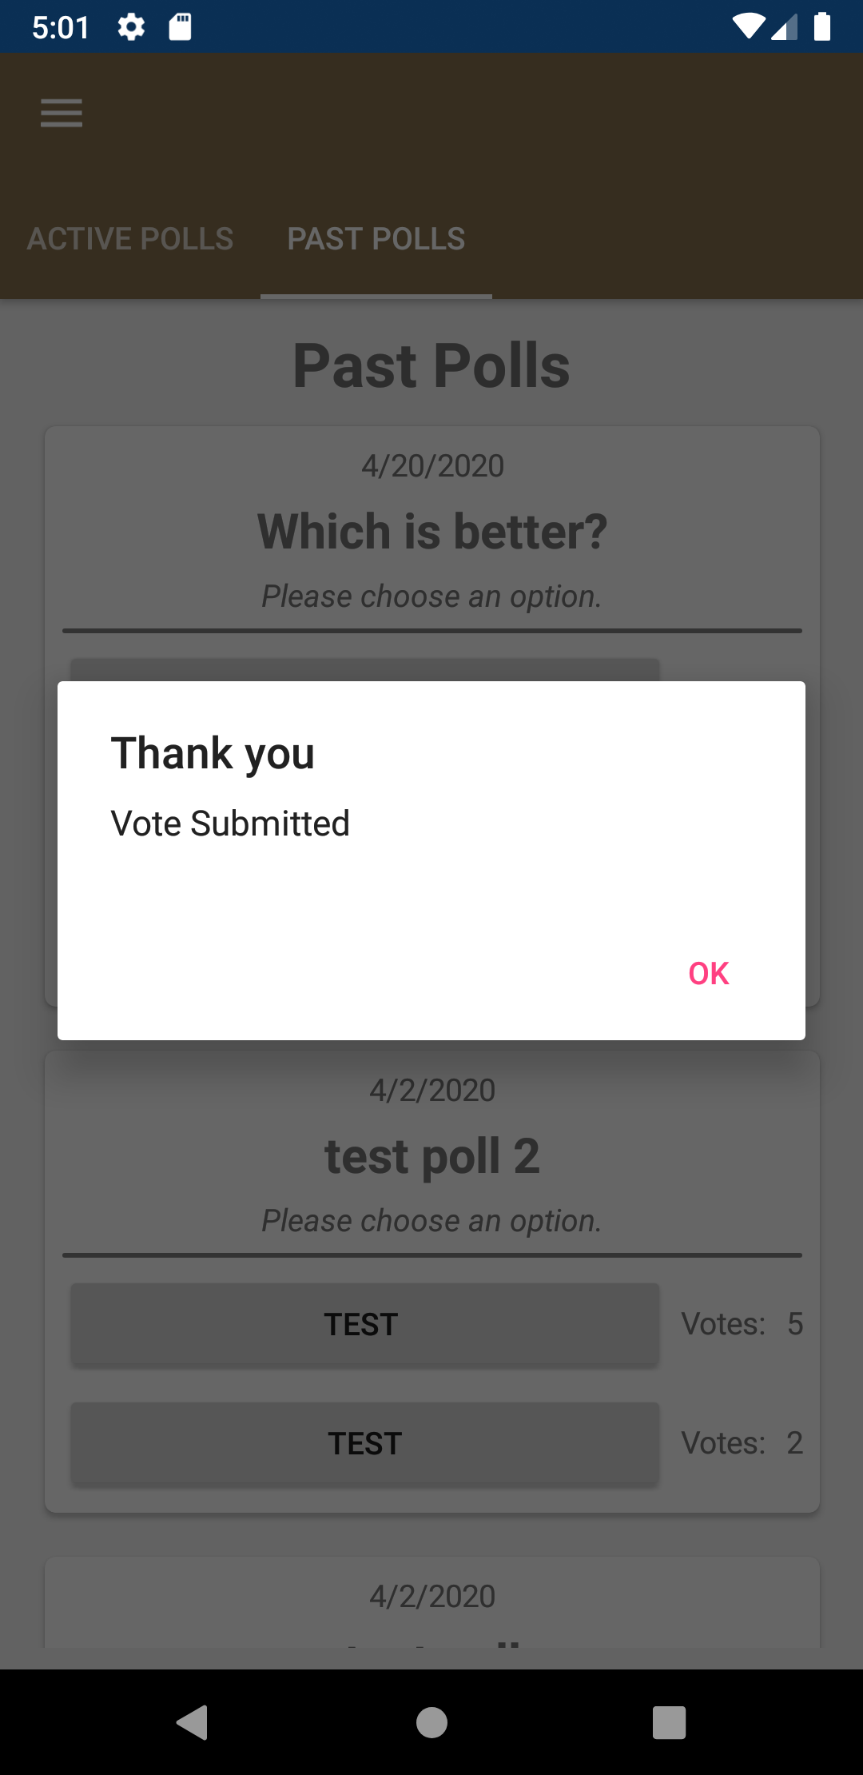

(Figure 13.3)

### Viewing Alumni

To view the alumni page, the user must be logged in. Once they are logged in they can access the alumni page by tapping "Alumni" in the nav menu. From this page, the user can scroll through the list of alumni and view their profile or also search the list.

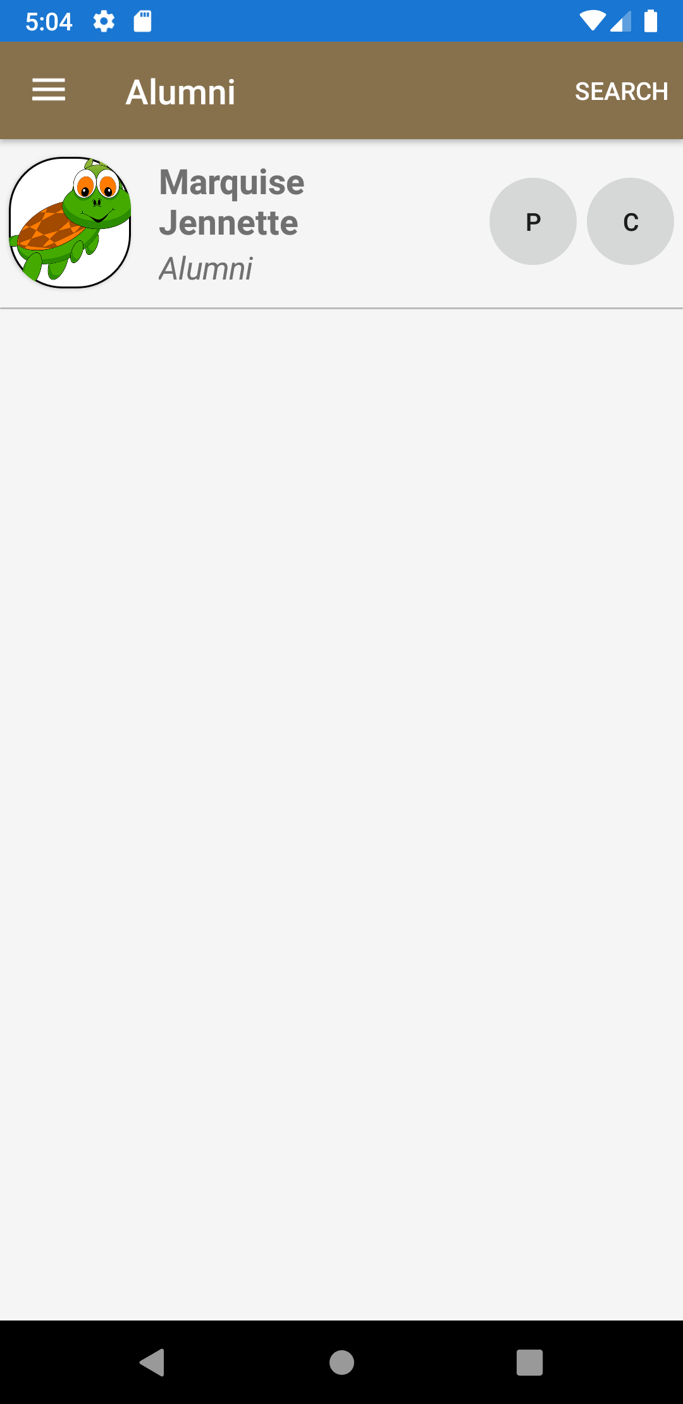

(Figure 14.0)

### Paying Club Dues

To pay club dues, you must be signed in as a member. To access the page the user can tap the "Pay dues" button in the nav menu where they will be redirected to the pay dues page.

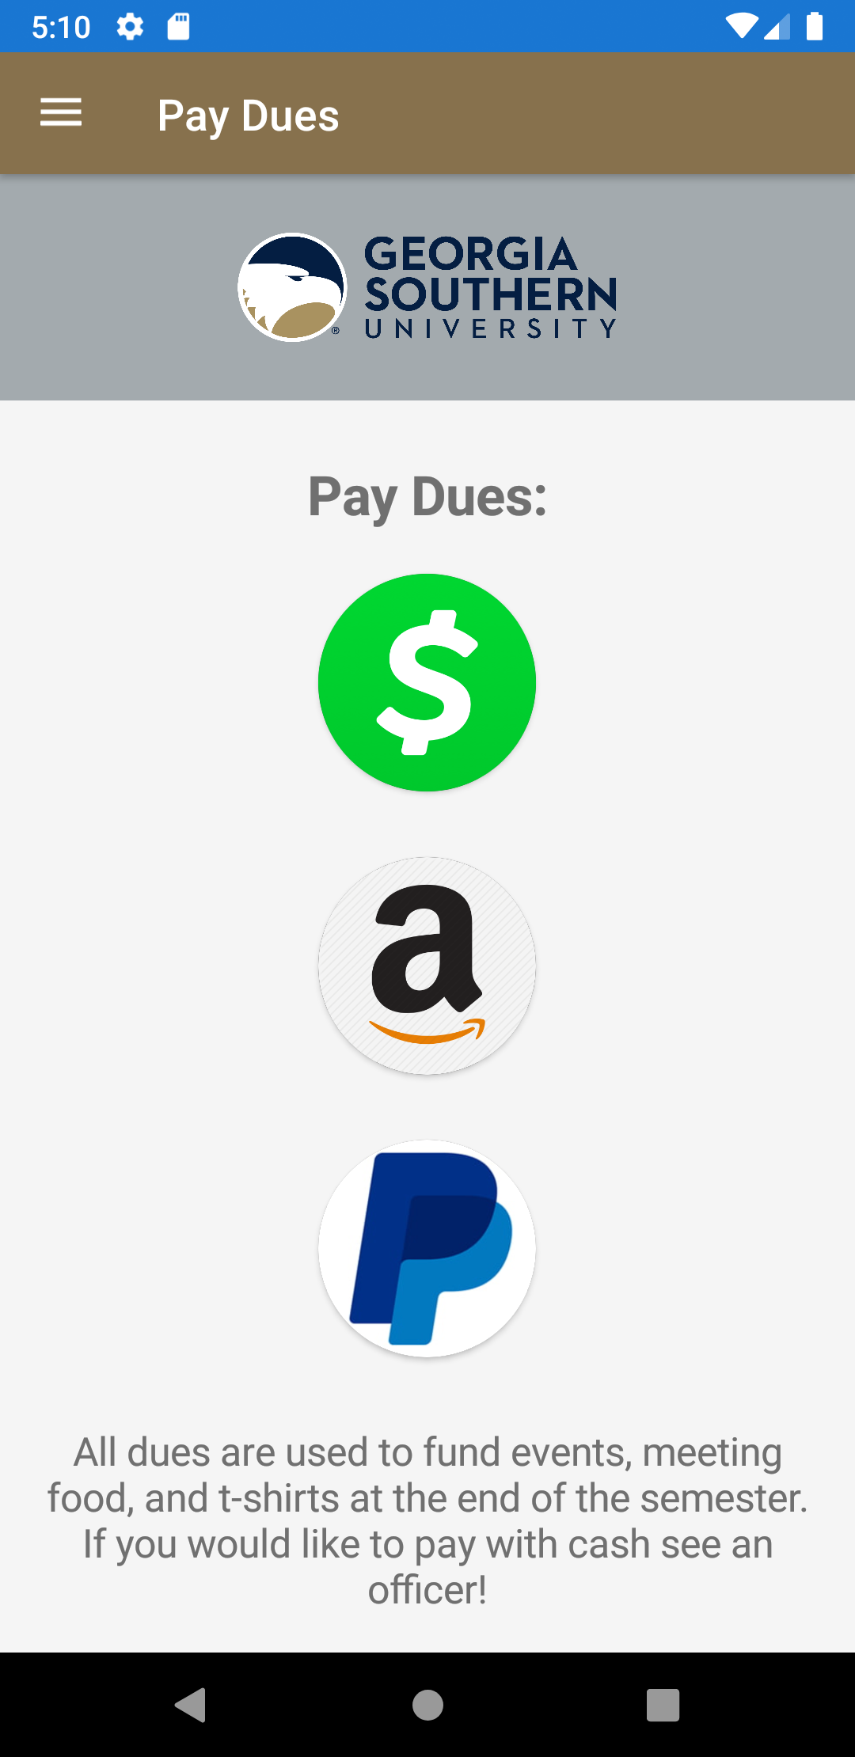

(Figure 15.0)

From this page, the user can tap on whichever method of payment they would like to use and they will be redirected to the payment processor.

### Viewing the About Us Page

To view the about us page, the user will simply tap the "About Us" button in the nav menu and they will be redirected to the About Us page.



(Figure 16.0)

### Viewing a Member's Profile

To view another member's profile, the user will have to be on the Members, Alumni, or Mentors page. From this page the user can tap the "P" button next to any member's name and they will be redirected to the user's profile.

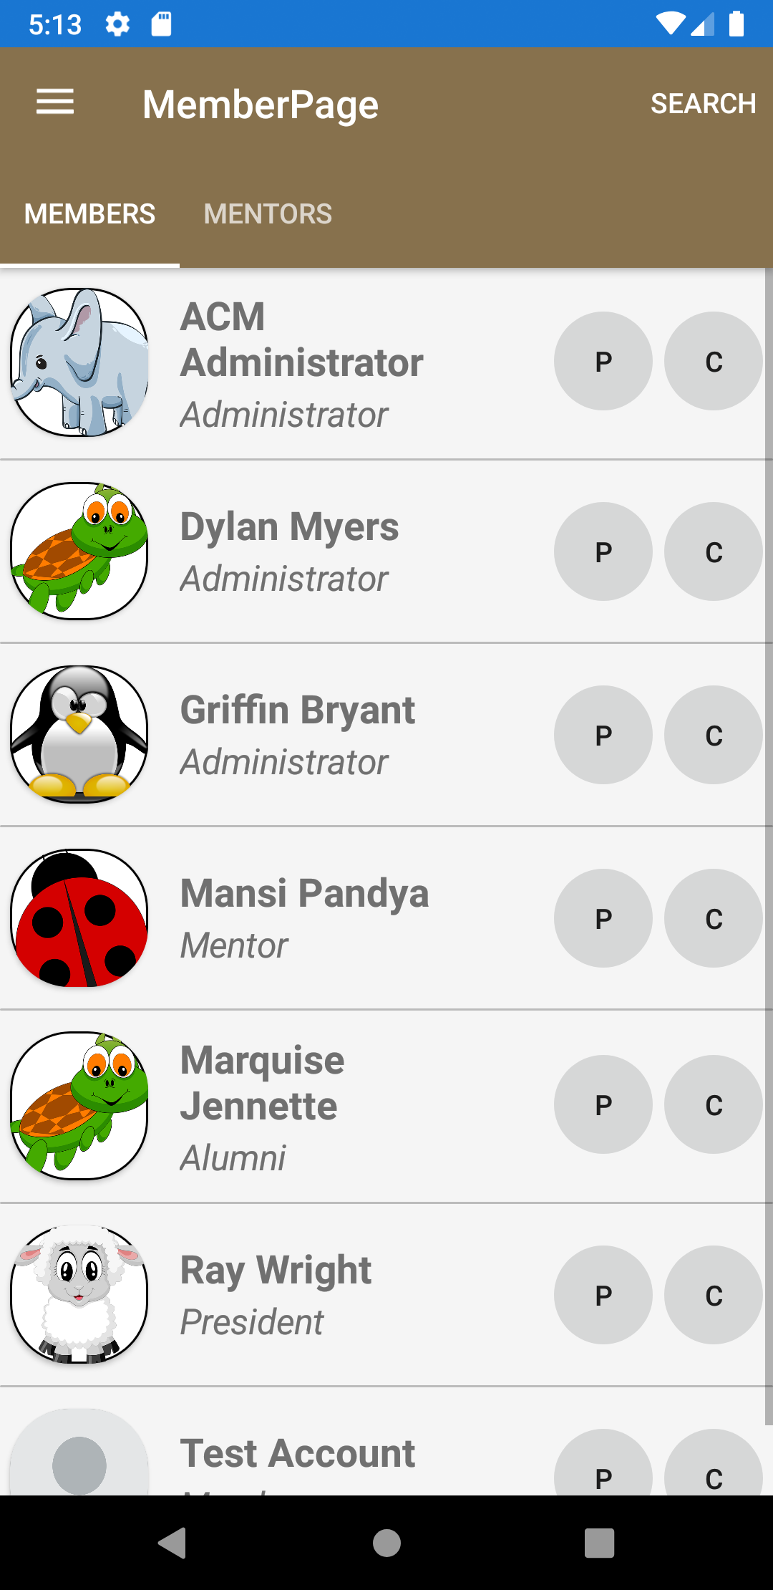 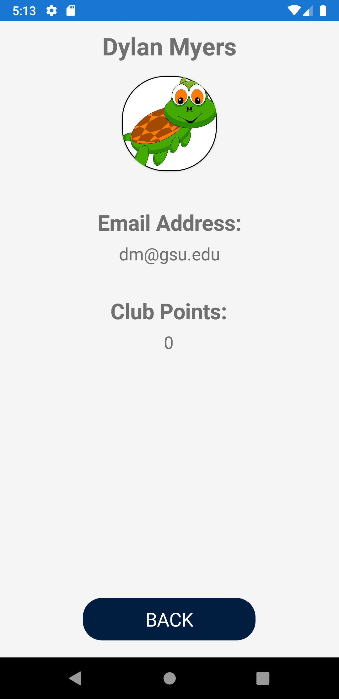

(Figure 16.0) (Figure 16.0)

### Using the Administrator Control Panel

To use the administrator control panel, the user must be logged in as an administrator. To access the control panel, tap the "Control Panel" button in the nav menu and the user will be redirected to the Administrator Control Panel.

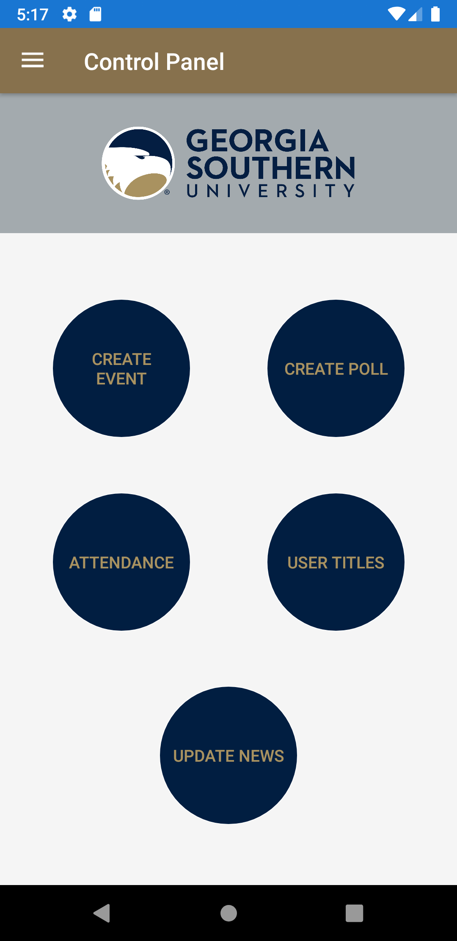

(Figure 16.0)

#### Creating an Event

To create an event, the administrator must tap the "CREATE EVENT" button in the control panel and they will be redirected to the create event page.

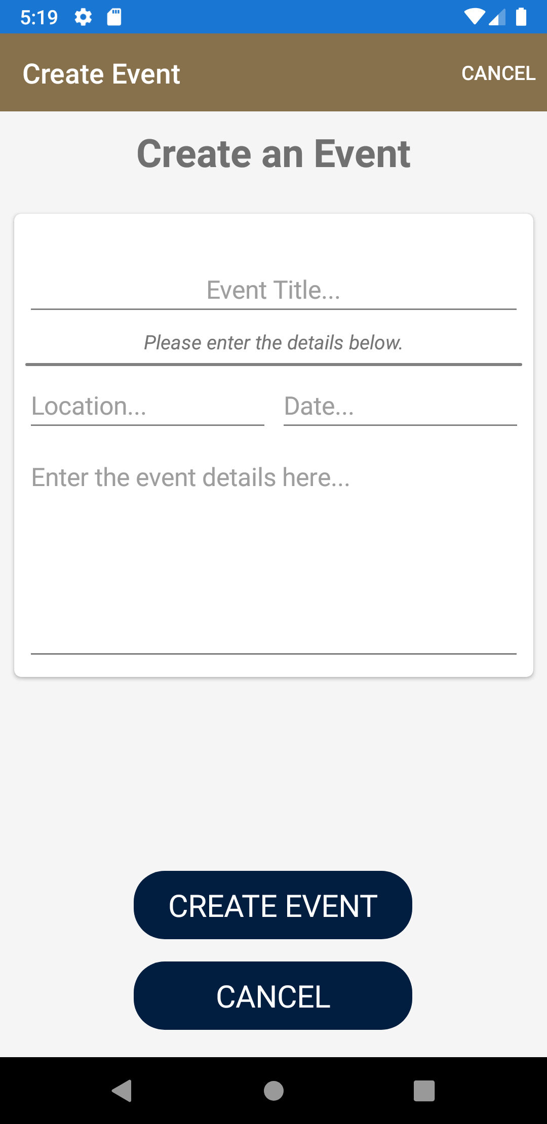

(Figure 16.1)

From this page, the administrator can enter an Event Title, Event Location, Event Date, and Event Details into the event box and tap "CREATE EVENT" to post the event to the events page (Figure 16.2) or "CANCEL" to discard the changes.

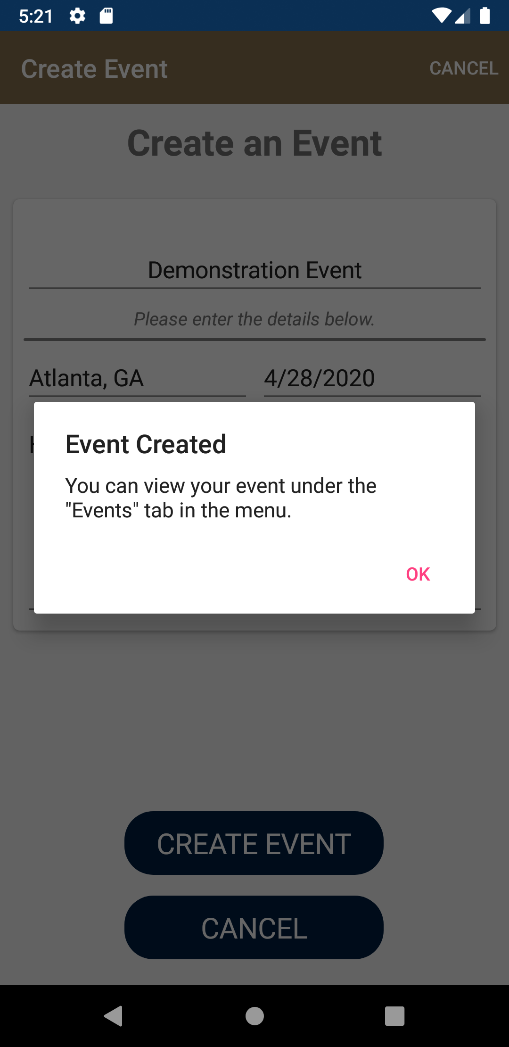

(Figure 16.2)

#### Creating a Poll

To create a poll, the administrator will tap on the "CREATE POLL" button in the control panel. From here, the administrator can enter a poll title and include at least 2 poll options (Figure 16.3). To add more options, the administrator can press the "ADD OPTION" button and add up to 10 options. To remove an option, the administrator can press the "X" button next to the option that they would like to remove.

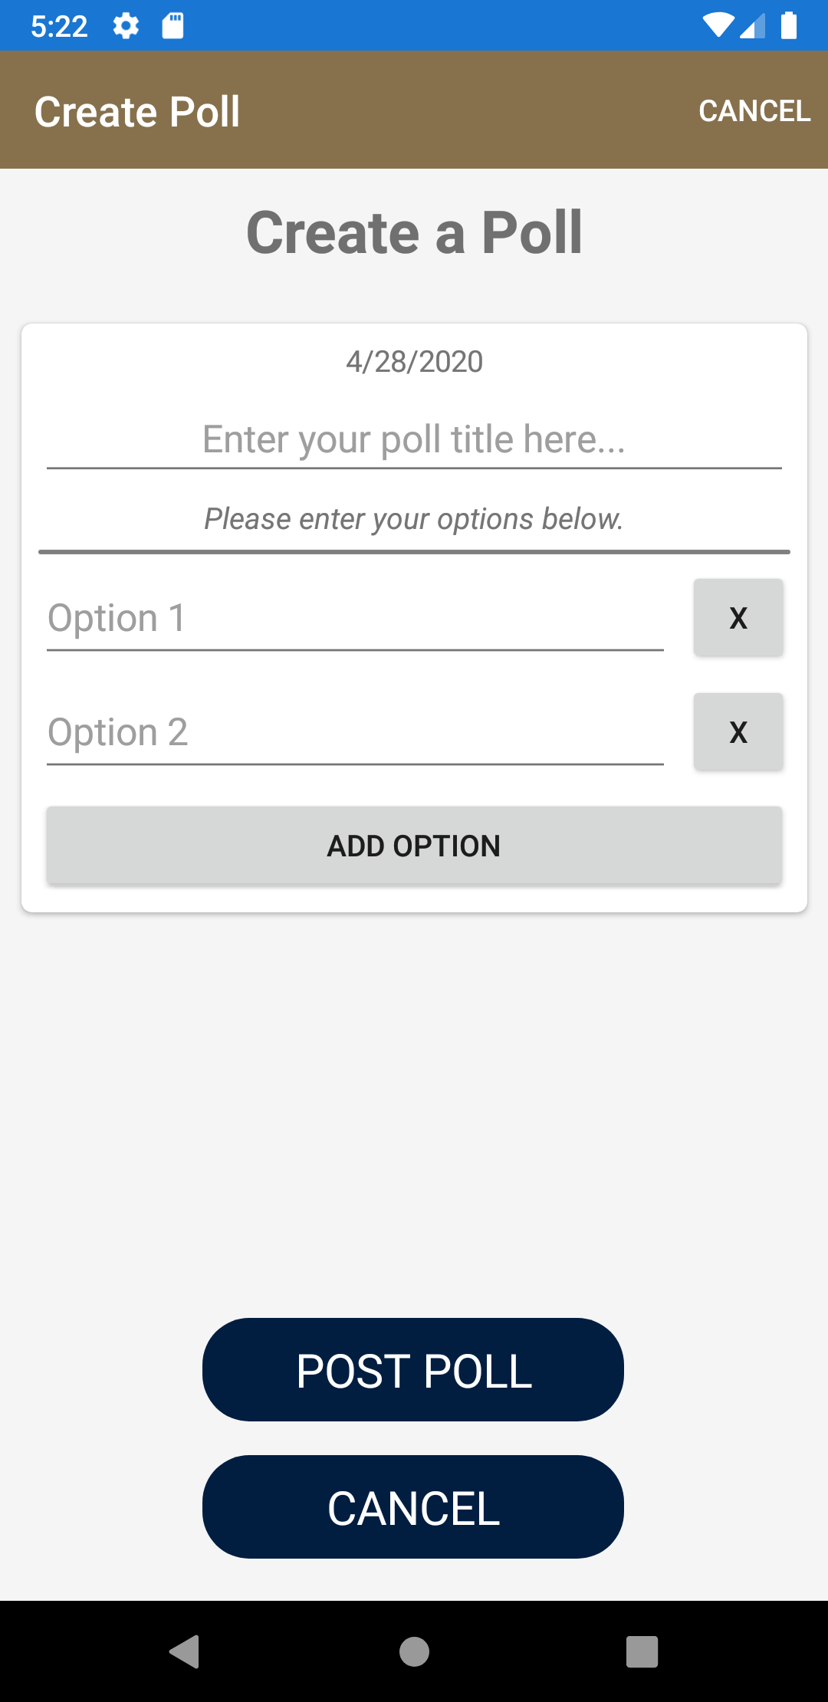

(Figure 16.3)

#### Taking Attendance

To take attendance, the administrator will press the "ATTENDANCE" button in the control panel. They will then be redirected to the attendance page (Figure 16.4). From this page, the administrator will press the "TAKE ATTENDANCE" button and they will be redirected to the take attendance page where they can enter in the names of the people who were present at the meeting (Figure 16.5) and save by pressing the "SAVE" button (Figure 16.6)

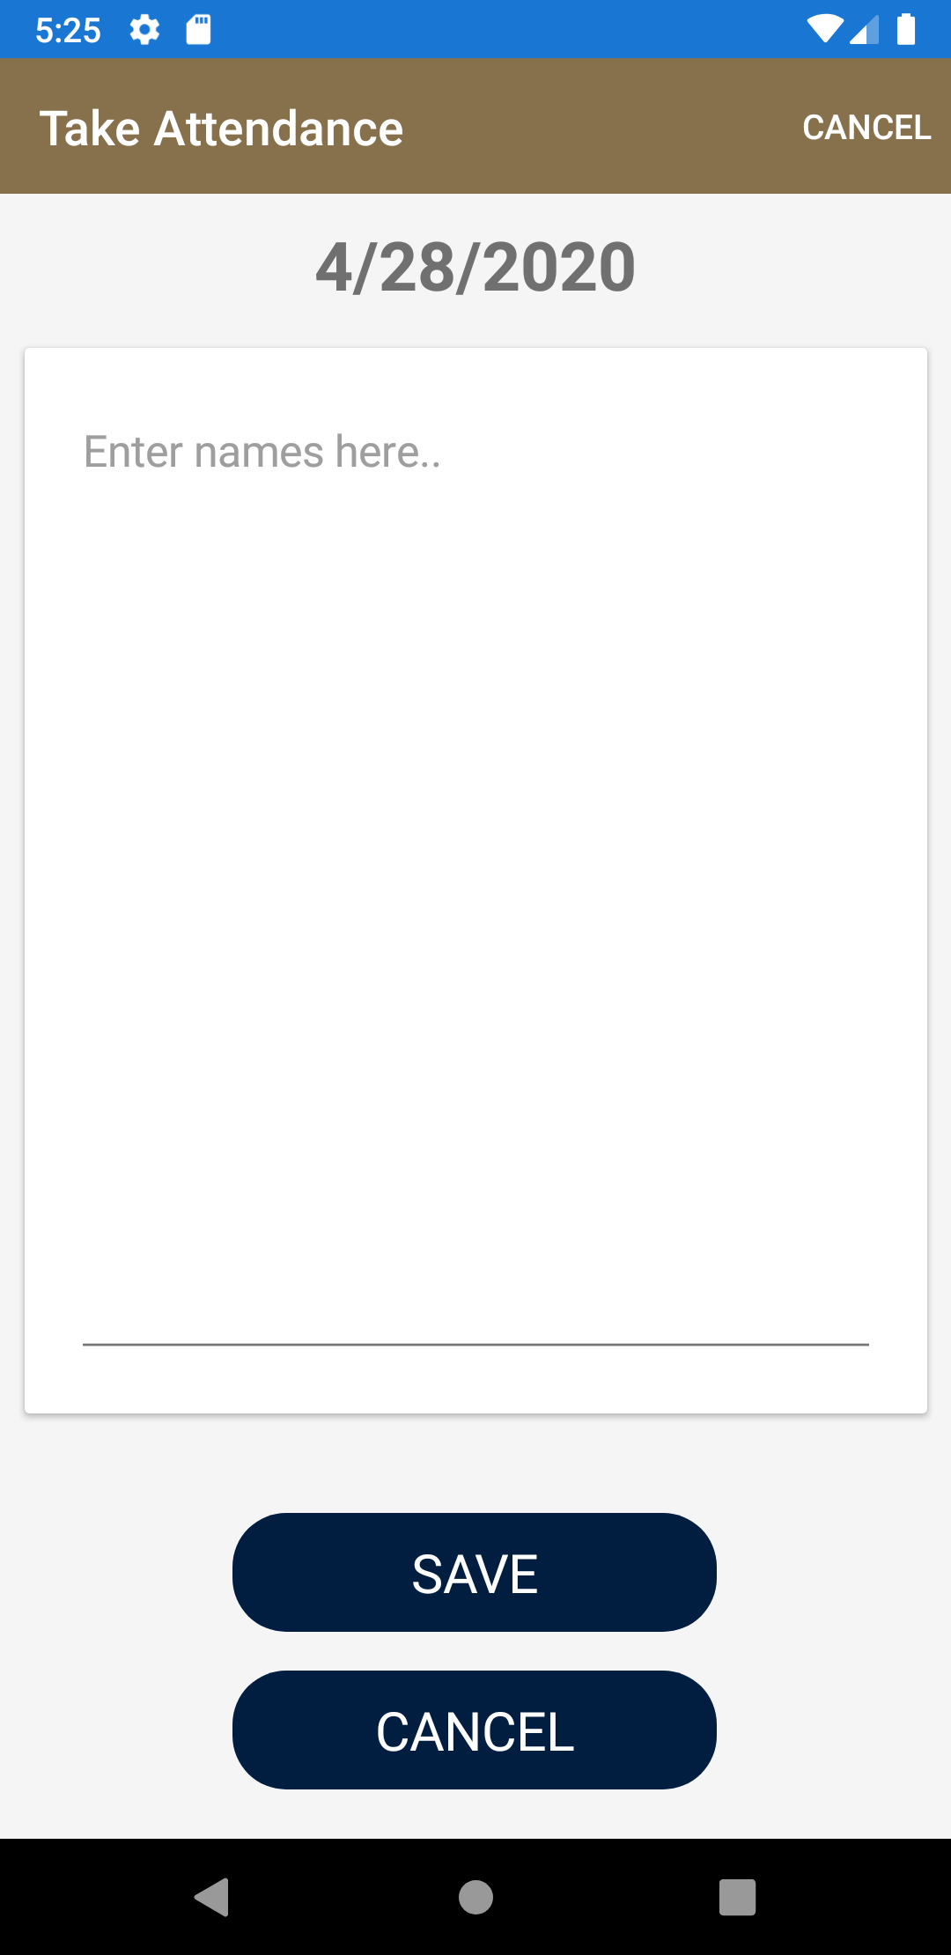 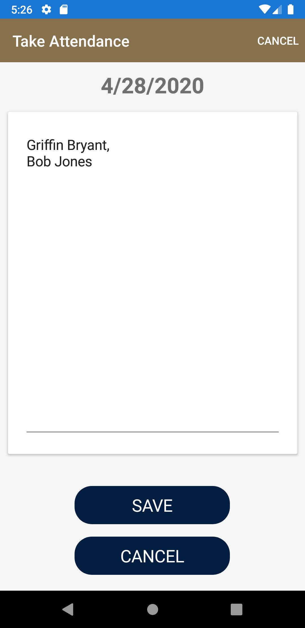 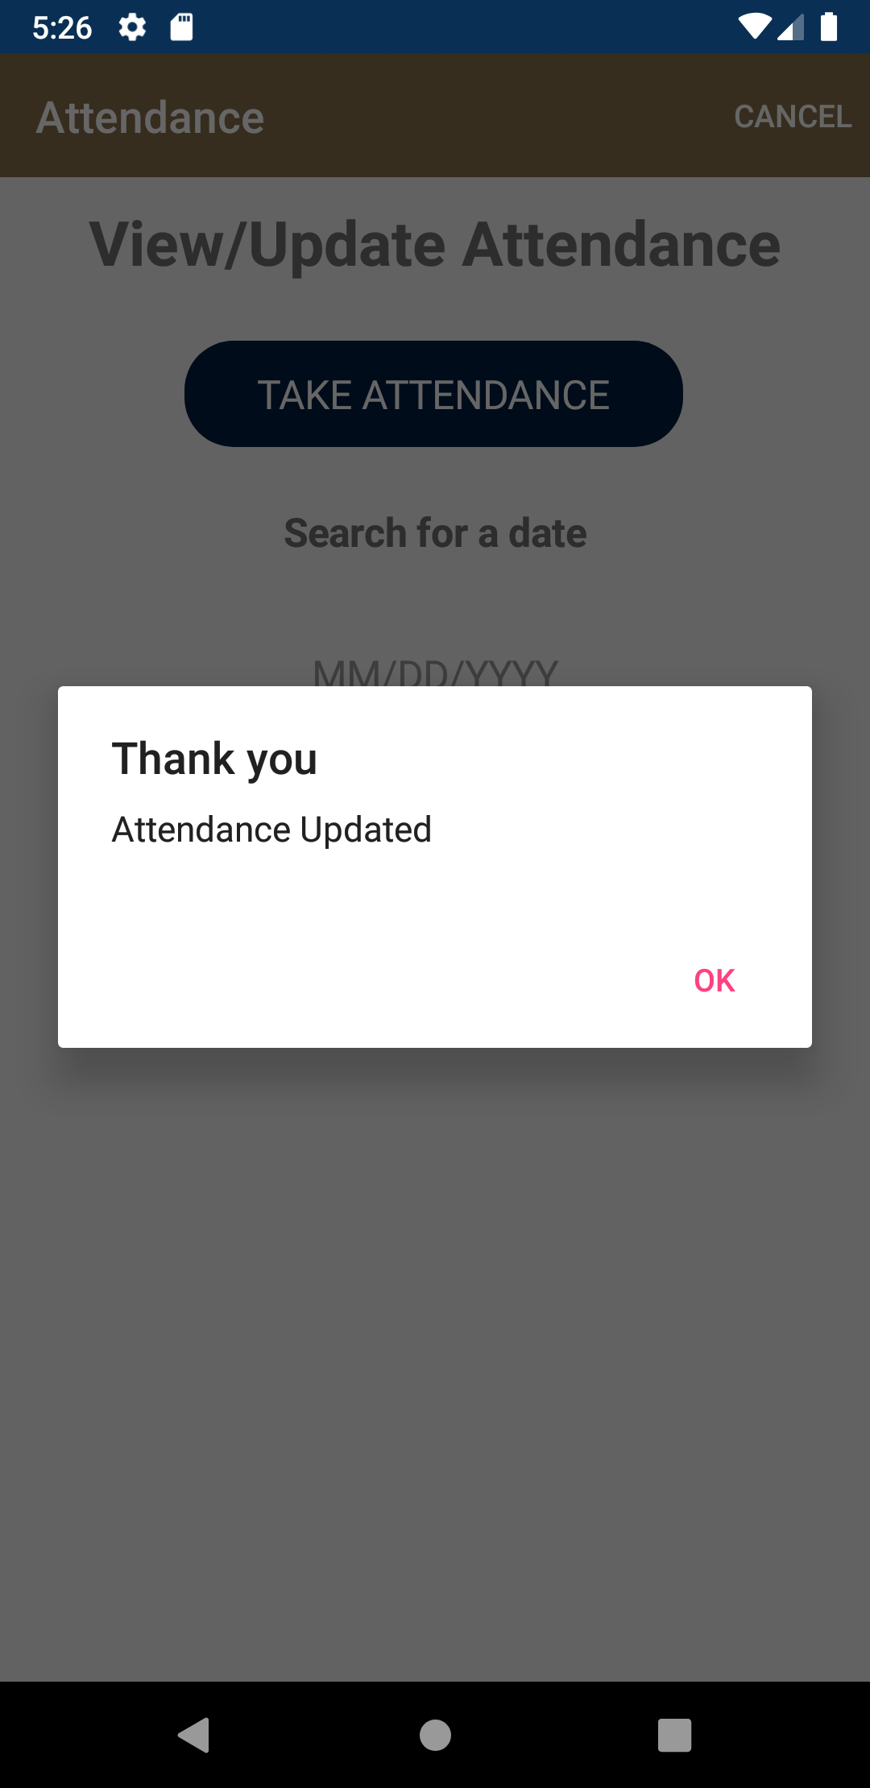

(Figure 16.4) (Figure 16.5) (Figure 16.6)

#### Viewing Attendance

To view attendance, the administrator will open the attendance page by tapping the "ATTENDANCE" button. They will then enter the date they would like to check attendance for in the "MM/DD/YYYY" box and press the "SEARCH" button

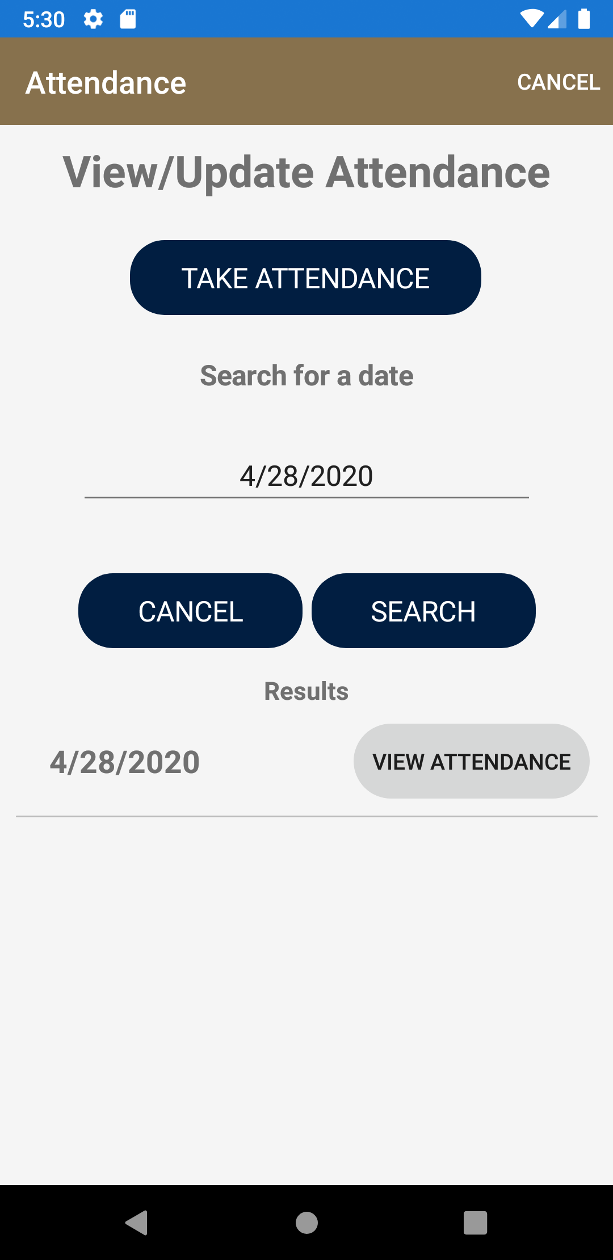

(Figure 16.7)

If a record of attendance is found for that day, it will display in the results box. To view the attendance for that day, the administrator will press the "VIEW ATTENDANCE" button and they will be redirected to the attendance page for that day.

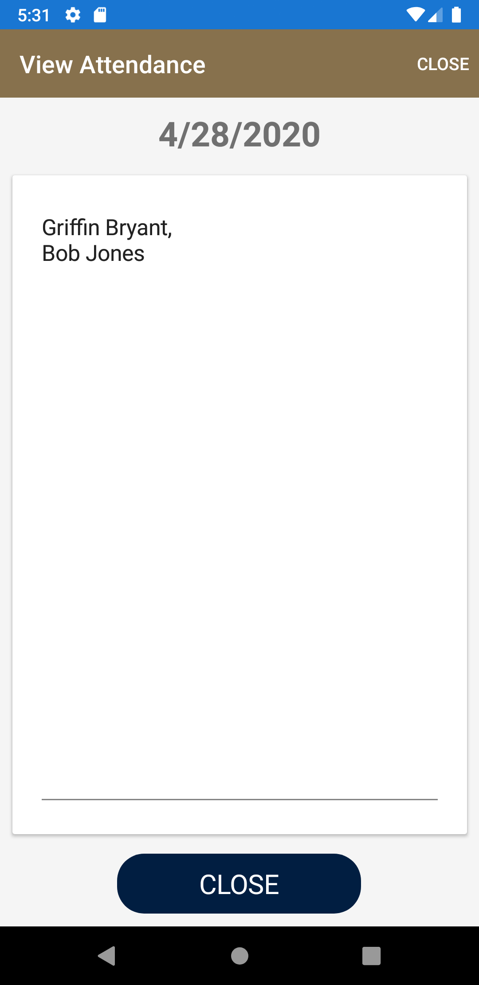

(Figure 16.8)

#### Setting User Titles

To edit user's titles, the administrator will press the "USER TITLES" button in the administrator control panel. They will then be redirected to the user search page.

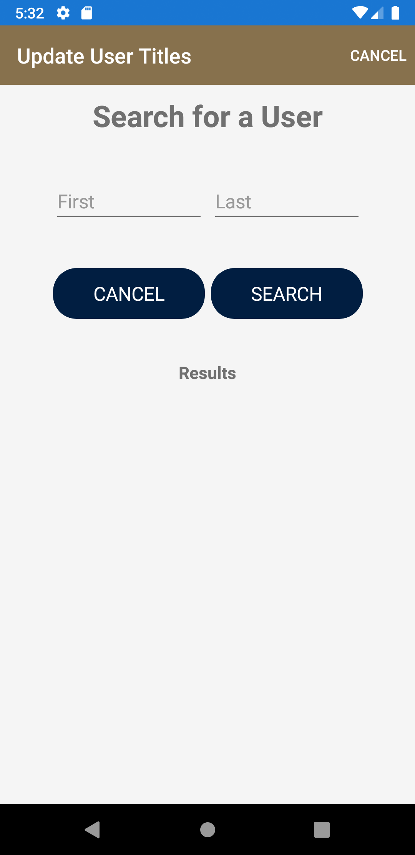

(Figure 16.9)

The administrator can enter a first, last, or first AND last name of the user they would like to search for in the search boxes and press the "SEARCH" button to find the user.

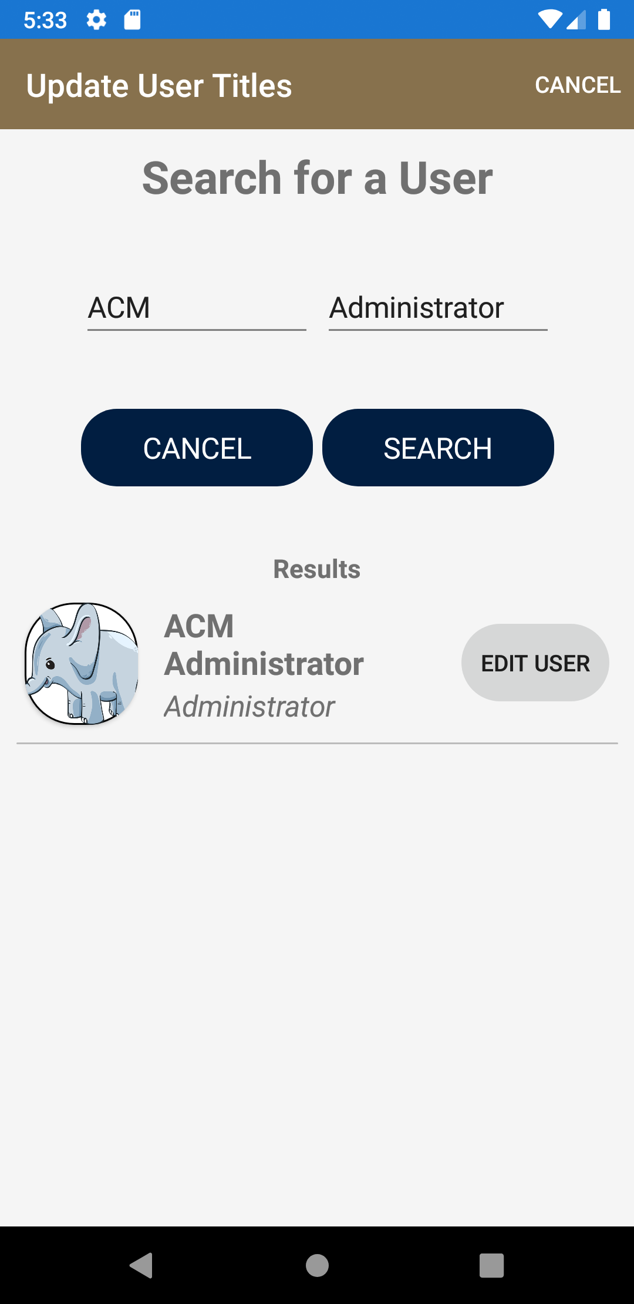

(Figure 16.10)

The administrator then can select the "EDIT USER" button to view the current information about the user and update it by pressing the "SAVE" button or discard the changes by pressing the "CANCEL" button.

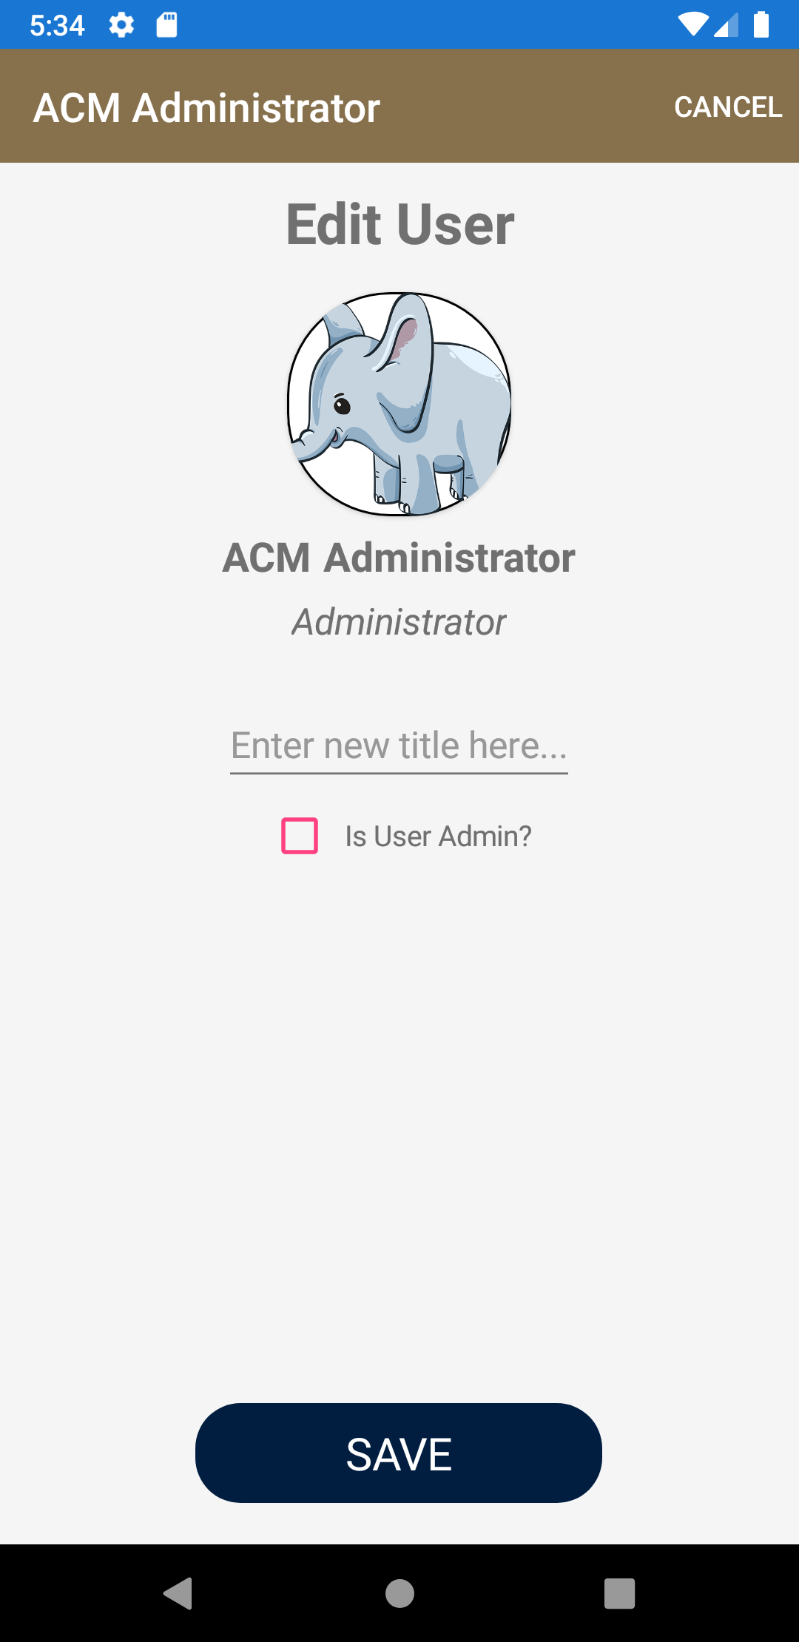

(Figure 16.11)

#### Updating the News

To update the news, the administrator will press the "UPDATE NEWS" button in the administrator control panel. They will then be redirected to the Update News page where they can enter the title of the news post and the news message which must be at least 120 characters. To save the news item, the administrator will then press "POST" and the news item will be updated in the news feed.

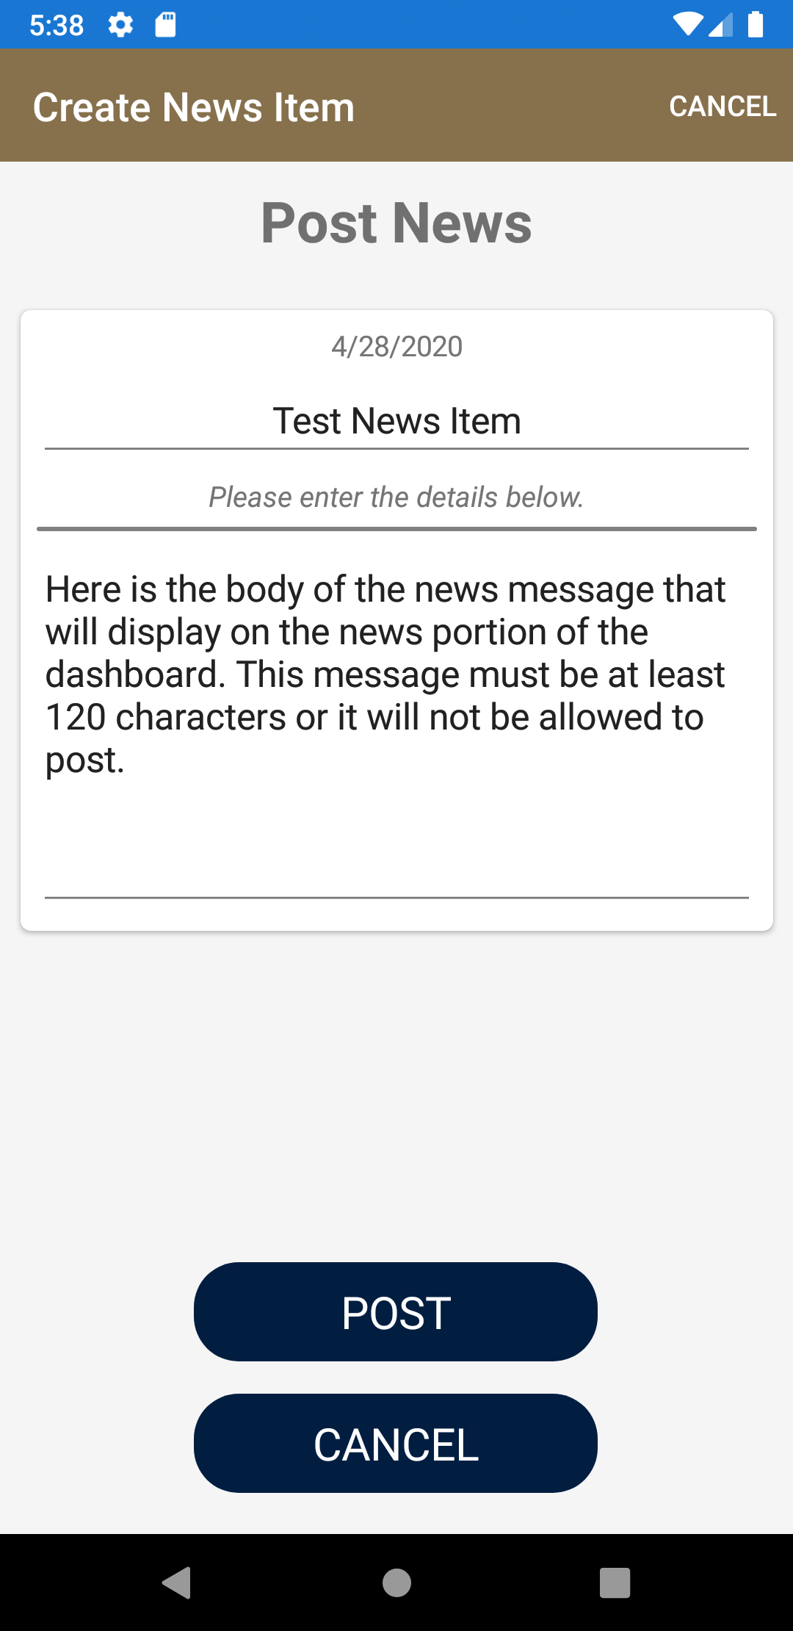 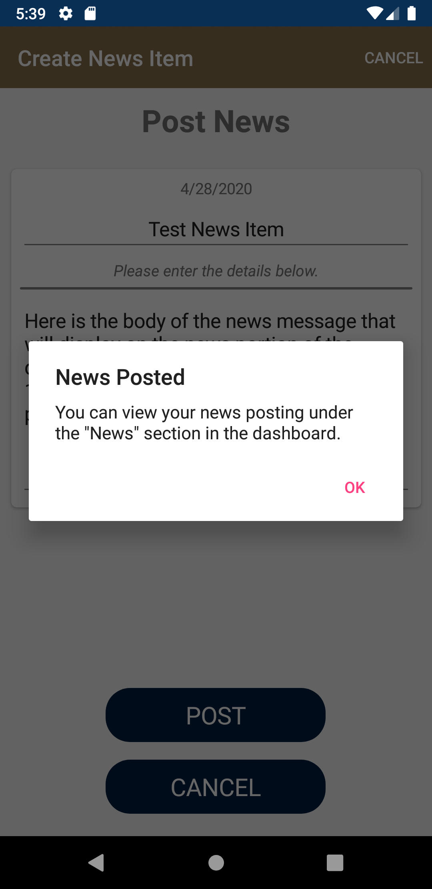

(Figure 16.12) (Figure 16.13)

## Source Code

### Main Files

#### AppShell.xaml

|  |
| --- |
| <?xml version="1.0" encoding="UTF-8"?> <Shell  xmlns="http://xamarin.com/schemas/2014/forms"  xmlns:x="http://schemas.microsoft.com/winfx/2009/xaml"  xmlns:local="clr-namespace:GSUACM"  xmlns:views="clr-namespace:GSUACM.Views"  xmlns:dash="clr-namespace:GSUACM.Views.Dashboard"  xmlns:chatviews="clr-namespace:GSUACM.Views.Chat"  xmlns:polls="clr-namespace:GSUACM.Views.Polls"  xmlns:controlpanel="clr-namespace:GSUACM.Views.Control_Panel"  x:Class="GSUACM.AppShell"  BackgroundColor="{DynamicResource GSUGold}"  x:Name="MainShell">  <!-- FLYOUT -->  <Shell.FlyoutHeader>  <Grid HeightRequest="100" BackgroundColor="{DynamicResource GSUGold}">  <Image Source="{local:ImageResource GSUACM.Images.gsu_logo.png}"  Aspect="AspectFit"  HeightRequest="100"  HorizontalOptions="FillAndExpand" />  </Grid>  </Shell.FlyoutHeader>   <!--  <FlyoutItem Title="Dashboard" Icon="home.png">  <ShellContent ContentTemplate="{DataTemplate dash:DashboardPage}"/>  </FlyoutItem>  <FlyoutItem Title="Profile" Icon="home.png">  <ShellContent Route="home" ContentTemplate="{DataTemplate views:HomePage}"/>  </FlyoutItem>  <FlyoutItem Title="Members" Icon="home.png">  <Tab>  <ShellContent Title="Members" ContentTemplate="{DataTemplate views:MemberListPage}"/>  <ShellContent Title="Mentors" ContentTemplate="{DataTemplate views:MentorListPage}"/>  </Tab>  </FlyoutItem>  <FlyoutItem Title="Chat" Icon="home.png">  <Tab>  <ShellContent Title="Messages" ContentTemplate="{DataTemplate chatviews:MessageListPage}"/>  <ShellContent Title="Channels" ContentTemplate="{DataTemplate chatviews:ChannelListPage}"/>  </Tab>  </FlyoutItem>    <FlyoutItem Title="Events" Icon="home.png">  <ShellContent ContentTemplate="{DataTemplate views:EventsPage}" />  </FlyoutItem>  <FlyoutItem Title="Tutoring" Icon="home.png">  <ShellContent ContentTemplate="{DataTemplate views:RequestTutor}" />  </FlyoutItem>  <FlyoutItem Title="Tutoring Requests" Icon="home.png">  <ShellContent ContentTemplate="{DataTemplate views:TutoringRequestsPage}" />  </FlyoutItem>  <FlyoutItem Title="Polls" Icon="home.png">  <Tab>  <ShellContent Title="Active Polls" ContentTemplate="{DataTemplate polls:ActivePollsPage}"/>  <ShellContent Title="Past Polls" ContentTemplate="{DataTemplate polls:PastPollsPage}"/>  </Tab>  </FlyoutItem>  <FlyoutItem Title="Alumni" Icon="home.png">  <ShellContent ContentTemplate="{DataTemplate views:EmployerPage}" />  </FlyoutItem>  <FlyoutItem Title="Control Panel" Icon="home.png">  <ShellContent ContentTemplate="{DataTemplate controlpanel:ControlPanelPage}" />  </FlyoutItem>   <FlyoutItem Title="Pay Dues" Icon="home.png">  <ShellContent ContentTemplate="{DataTemplate views:PayDuesPage}" />  </FlyoutItem>   <FlyoutItem Title="About" Icon="home.png">  <ShellContent ContentTemplate="{DataTemplate views:AboutPage}" />  </FlyoutItem>  -->   <!-- END FLYOUT --> </Shell> |

#### AppShell.xaml.cs

|  |
| --- |
| using GSUACM.Services; using GSUACM.Views; using GSUACM.Views.Chat; using GSUACM.Views.Control_Panel; using GSUACM.Views.Dashboard; using GSUACM.Views.Polls; using System; using System.Collections.Generic; using System.ComponentModel; using System.Linq; using System.Text; using System.Threading.Tasks;  using Xamarin.Forms; using Xamarin.Forms.Xaml;  namespace GSUACM {  [XamlCompilation(XamlCompilationOptions.Compile)]  public partial class AppShell : Shell, INotifyPropertyChanged  {   public AppShell()  {  InitializeComponent();   #region DASHBOARD REGION  ShellSection DashboardSection = new ShellSection()  {  Title = "Dashboard"  };  DashboardSection.Items.Add(new ShellContent()  {  Content = new DashboardPage()  });  #endregion   #region EVENTS REGION  ShellSection EventsSection = new ShellSection()  {  Title = "Events"  };  EventsSection.Items.Add(new ShellContent()  {  Content = new EventsPage()  });  #endregion   #region ABOUT REGION  ShellSection AboutSection = new ShellSection()  {  Title = "About Us"  };  AboutSection.Items.Add(new ShellContent()  {  Content = new AboutPage()  });  #endregion   MainShell.Items.Add(DashboardSection);   if (GlobalVars.User == null)  {  MainShell.Items.Add(EventsSection);  MainShell.Items.Add(AboutSection);  }  else if (GlobalVars.User != null)  {   #region PROFILE REGION  ShellSection ProfileSection = new ShellSection()  {  Title = "Profile"  };  ProfileSection.Items.Add(new ShellContent()  {  Content = new HomePage()  });  #endregion   #region MEMBERS REGION  ShellSection MembersSection = new ShellSection()  {  Title = "Members"  };  MembersSection.Items.Add(new ShellContent()  {  Title = "Members",  Content = new MemberListPage()   });  MembersSection.Items.Add(new ShellContent()  {  Title = "Mentors",  Content = new MentorListPage()  });  #endregion   #region CHAT REGION  ShellSection ChatSection = new ShellSection()  {  Title = "Chat"  };  ChatSection.Items.Add(new ShellContent()  {  Title = "Direct Messages",  Content = new MessageListPage()   });  ChatSection.Items.Add(new ShellContent()  {  Title = "Public Channels",  Content = new ChannelListPage()  });  #endregion   #region TUTORING REGION  ShellSection TutoringSection = new ShellSection()  {  Title = "Tutoring"  };  TutoringSection.Items.Add(new ShellContent()  {  Content = new RequestTutor()  });  #endregion   #region TUTORING REQUESTS REGION  ShellSection TutoringRequestsSection = new ShellSection()  {  Title = "Tutoring Requests"  };  TutoringRequestsSection.Items.Add(new ShellContent()  {  Content = new TutoringRequestsPage()  });  #endregion   #region POLLS REGION  ShellSection PollsSection = new ShellSection()  {  Title = "Polls"  };  PollsSection.Items.Add(new ShellContent()  {  Title = "Active Polls",  Content = new ActivePollsPage()   });  PollsSection.Items.Add(new ShellContent()  {  Title = "Past Polls",  Content = new PastPollsPage()  });  #endregion   #region ALUMNI REGION  ShellSection AlumniSection = new ShellSection()  {  Title = "Alumni"  };  AlumniSection.Items.Add(new ShellContent()  {  Content = new EmployerPage()  });  #endregion   #region PAY DUES REGION  ShellSection PayDuesSection = new ShellSection()  {  Title = "Pay Dues"  };  PayDuesSection.Items.Add(new ShellContent()  {  Content = new PayDuesPage()  });  #endregion   if (GlobalVars.User.isAdmin)  {   #region CONTROL PANEL REGION  ShellSection ControlPanelSection = new ShellSection()  {  Title = "Control Panel"  };  ControlPanelSection.Items.Add(new ShellContent()  {  Content = new ControlPanelPage()  });  #endregion   if (GlobalVars.User.isTutor)  {  MainShell.Items.Add(ControlPanelSection);  MainShell.Items.Add(EventsSection);  MainShell.Items.Add(ProfileSection);  MainShell.Items.Add(MembersSection);  MainShell.Items.Add(ChatSection);  MainShell.Items.Add(TutoringRequestsSection);  MainShell.Items.Add(TutoringSection);  MainShell.Items.Add(PollsSection);  MainShell.Items.Add(AlumniSection);  MainShell.Items.Add(PayDuesSection);  MainShell.Items.Add(AboutSection);  }  else  {  MainShell.Items.Add(ControlPanelSection);  MainShell.Items.Add(EventsSection);  MainShell.Items.Add(ProfileSection);  MainShell.Items.Add(MembersSection);  MainShell.Items.Add(ChatSection);  MainShell.Items.Add(TutoringSection);  MainShell.Items.Add(PollsSection);  MainShell.Items.Add(AlumniSection);  MainShell.Items.Add(PayDuesSection);  MainShell.Items.Add(AboutSection);  }  }  else if (GlobalVars.User.isTutor)  {  MainShell.Items.Add(EventsSection);  MainShell.Items.Add(ProfileSection);  MainShell.Items.Add(MembersSection);  MainShell.Items.Add(ChatSection);  MainShell.Items.Add(TutoringRequestsSection);  MainShell.Items.Add(TutoringSection);  MainShell.Items.Add(PollsSection);  MainShell.Items.Add(AlumniSection);  MainShell.Items.Add(PayDuesSection);  MainShell.Items.Add(AboutSection);  }  else  {  MainShell.Items.Add(EventsSection);  MainShell.Items.Add(ProfileSection);  MainShell.Items.Add(MembersSection);  MainShell.Items.Add(ChatSection);  MainShell.Items.Add(TutoringSection);  MainShell.Items.Add(PollsSection);  MainShell.Items.Add(AlumniSection);  MainShell.Items.Add(PayDuesSection);  MainShell.Items.Add(AboutSection);  }  }  }  } } |

#### App.xaml

|  |
| --- |
| <?xml version="1.0" encoding="utf-8"?> <Application  xmlns="http://xamarin.com/schemas/2014/forms"  xmlns:x="http://schemas.microsoft.com/winfx/2009/xaml"  xmlns:d="http://xamarin.com/schemas/2014/forms/design"  xmlns:mc="http://schemas.openxmlformats.org/markup-compatibility/2006"  mc:Ignorable="d"  x:Class="GSUACM.App">  <Application.Resources>  <ResourceDictionary>  <!--Global Styles-->  <Color x:Key="GSUGold">#87714D</Color>  <Color x:Key="LightGold">#a99260</Color>  <Color x:Key="GSUBlue">#011E41</Color>  <Color x:Key="GSUGray">#A3AAAE</Color>  <Style TargetType="NavigationPage">  <!--<Setter Property="BarBackgroundColor" Value="{StaticResource NavigationPrimary}" />-->  <Setter Property="BarBackgroundColor" Value="{DynamicResource GSUGold}" />  <Setter Property="BarTextColor" Value="White" />  </Style>  <Style TargetType="ContentPage" ApplyToDerivedTypes="True">  <Setter Property="BackgroundColor" Value="WhiteSmoke" />  </Style>  </ResourceDictionary>  </Application.Resources> </Application> |

#### App.xaml.cs

|  |
| --- |
| using GSUACM.Services; using GSUACM.Models; using System; using Xamarin.Forms; using Xamarin.Forms.Xaml;  namespace GSUACM {  public partial class App : Application  {  public App()  {  InitializeComponent();  if (Application.Current.Properties.ContainsKey("UserID"))  {  GlobalVars.InstantiateUser(Application.Current.Properties["UserFName"].ToString(),   Application.Current.Properties["UserLName"].ToString(),   Application.Current.Properties["UserID"].ToString(),   Application.Current.Properties["UserTitle"].ToString(),   Application.Current.Properties["UserIsAdmin"].ToString(),  Application.Current.Properties["UserEmail"].ToString(),  Application.Current.Properties["UserPhone"].ToString(),  Application.Current.Properties["UserClubPoints"].ToString(),  Application.Current.Properties["UserImage"].ToString());  }  else  {  App.Current.MainPage = new AppShell();  }  }   protected override void OnStart()  {  }   protected override void OnSleep()  {  Application.Current.SavePropertiesAsync();  }   protected override void OnResume()  {  }  } } |

#### ImageResourceExtension.cs

|  |
| --- |
| using System; using System.Reflection; using Xamarin.Forms; using Xamarin.Forms.Xaml;  namespace GSUACM {  [ContentProperty(nameof(Source))]  public class ImageResourceExtension : IMarkupExtension  {  public string Source { get; set; }   public object ProvideValue(IServiceProvider serviceProvider)  {  if (Source == null)  {  return null;  }   // Do your translation lookup here, using whatever method you require  var imageSource = ImageSource.FromResource(Source, typeof(ImageResourceExtension).GetTypeInfo().Assembly);   return imageSource;  }  } } |

### Controls

#### ExtendedListView.cs

|  |
| --- |
| using System; using System.Collections.Generic; using System.Linq; using System.Text; using System.Windows.Input; using Xamarin.Forms;  namespace GSUACM.Controls {  public class ExtendedListView : ListView  {  public ExtendedListView() : this(ListViewCachingStrategy.RecycleElement)  {  }   public ExtendedListView(ListViewCachingStrategy cachingStrategy) : base(cachingStrategy)  {  this.ItemSelected += OnItemSelected;  this.ItemTapped += OnItemTapped;  this.ItemAppearing += OnItemAppearing;  this.ItemDisappearing += OnItemDisappering;  }   public static readonly BindableProperty TappedCommandProperty =  BindableProperty.Create(nameof(TappedCommand), typeof(ICommand), typeof(ExtendedListView), default(ICommand));   public ICommand TappedCommand  {  get { return (ICommand)GetValue(TappedCommandProperty); }  set { SetValue(TappedCommandProperty, value); }  }   public static readonly BindableProperty ItemAppearingCommandProperty =  BindableProperty.Create(nameof(ItemAppearingCommand), typeof(ICommand), typeof(ExtendedListView), default(ICommand));   public ICommand ItemAppearingCommand  {  get { return (ICommand)GetValue(ItemAppearingCommandProperty); }  set { SetValue(ItemAppearingCommandProperty, value); }  }   public static readonly BindableProperty ItemDisappearingCommandProperty =  BindableProperty.Create(nameof(ItemDisappearingCommand), typeof(ICommand), typeof(ExtendedListView), default(ICommand));    public ICommand ItemDisappearingCommand  {  get { return (ICommand)GetValue(ItemDisappearingCommandProperty); }  set { SetValue(ItemDisappearingCommandProperty, value); }  }    private void OnItemSelected(object sender, SelectedItemChangedEventArgs e)  {  var listView = (ExtendedListView)sender;  if (e == null) return;  listView.SelectedItem = null;   }   private void OnItemTapped(object sender, ItemTappedEventArgs e)  {  if (TappedCommand != null)  {  TappedCommand?.Execute(e.Item);  }  SelectedItem = null;  }   private void OnItemAppearing(object sender, ItemVisibilityEventArgs e)  {  if (ItemAppearingCommand != null)  {  ItemAppearingCommand?.Execute(e.Item);  }  }    private void OnItemDisappering(object sender, ItemVisibilityEventArgs e)  {  ItemDisappearingCommand?.Execute(e.Item);  }    public void ScrollToFirst()  {   Device.BeginInvokeOnMainThread(() =>  {  try  {  if (ItemsSource != null && ItemsSource.Cast<object>().Count() > 0)  {  var msg = ItemsSource.Cast<object>().FirstOrDefault();  if (msg != null)  {  ScrollTo(msg, ScrollToPosition.Start, false);  }   }  }  catch (Exception ex)  {  System.Diagnostics.Debug.WriteLine(ex.ToString());  }   });  }   public void ScrollToLast()  {  Device.BeginInvokeOnMainThread(() =>  {  try  {  if (ItemsSource != null && ItemsSource.Cast<object>().Count() > 0)  {  var msg = ItemsSource.Cast<object>().LastOrDefault();  if (msg != null)  {  ScrollTo(msg, ScrollToPosition.End, false);  }   }  }  catch (Exception ex)  {  System.Diagnostics.Debug.WriteLine(ex.ToString());  }   });  }  } } |

#### ExtendedEditorControl.cs

|  |
| --- |
| using System; using System.Collections.Generic; using System.Text; using Xamarin.Forms;  namespace GSUACM.Controls {  public class ExtendedEditorControl : Editor  {  public static BindableProperty PlaceholderProperty  = BindableProperty.Create(nameof(Placeholder), typeof(string), typeof(ExtendedEditorControl));   public static BindableProperty PlaceholderColorProperty  = BindableProperty.Create(nameof(PlaceholderColor), typeof(Color), typeof(ExtendedEditorControl), Color.LightGray);   public static BindableProperty HasRoundedCornerProperty  = BindableProperty.Create(nameof(HasRoundedCorner), typeof(bool), typeof(ExtendedEditorControl), false);   public static BindableProperty IsExpandableProperty  = BindableProperty.Create(nameof(IsExpandable), typeof(bool), typeof(ExtendedEditorControl), false);   public bool IsExpandable  {  get { return (bool)GetValue(IsExpandableProperty); }  set { SetValue(IsExpandableProperty, value); }  }  public bool HasRoundedCorner  {  get { return (bool)GetValue(HasRoundedCornerProperty); }  set { SetValue(HasRoundedCornerProperty, value); }  }   public string Placeholder  {  get { return (string)GetValue(PlaceholderProperty); }  set { SetValue(PlaceholderProperty, value); }  }   public Color PlaceholderColor  {  get { return (Color)GetValue(PlaceholderColorProperty); }  set { SetValue(PlaceholderColorProperty, value); }  }   public ExtendedEditorControl()  {  TextChanged += OnTextChanged;  }   ~ExtendedEditorControl()  {  TextChanged -= OnTextChanged;  }   private void OnTextChanged(object sender, TextChangedEventArgs e)  {  if (IsExpandable)  InvalidateMeasure();    }  } } |

#### Cards/CardView.cs

|  |
| --- |
| using System; using System.Collections.Generic; using System.Text; using Xamarin.Forms;  namespace GSUACM.Controls.Cards  {  class CardView : ContentView  {  public static readonly BindableProperty CardTitleProperty = BindableProperty.Create(nameof(CardTitle), typeof(string), typeof(CardView), string.Empty);  public static readonly BindableProperty CardAuthorProperty = BindableProperty.Create(nameof(CardAuthor), typeof(string), typeof(CardView), string.Empty);  public static readonly BindableProperty CardDateProperty = BindableProperty.Create(nameof(CardDate), typeof(string), typeof(CardView), string.Empty);  public static readonly BindableProperty CardTimeProperty = BindableProperty.Create(nameof(CardTime), typeof(string), typeof(CardView), string.Empty);  public static readonly BindableProperty CardBodyProperty = BindableProperty.Create(nameof(CardBody), typeof(string), typeof(CardView), string.Empty);    public string CardTitle  {  get => (string)GetValue(CardTitleProperty);  set => SetValue(CardTitleProperty, value);  }  public string CardAuthor  {  get => (string)GetValue(CardAuthorProperty);  set => SetValue(CardAuthorProperty, value);  }  public string CardDate  {  get => (string)GetValue(CardDateProperty);  set => SetValue(CardDateProperty, value);  }  public string CardTime  {  get => (string)GetValue(CardTimeProperty);  set => SetValue(CardTimeProperty, value);  }  public string CardBody  {  get => (string)GetValue(CardBodyProperty);  set => SetValue(CardBodyProperty, value);  }  } } |

### Helpers

#### ChatTemplateSelector.cs

|  |
| --- |
| using GSUACM.Models.ChatModels; using GSUACM.Views.Chat.Cells; using System; using System.Collections.Generic; using System.Text; using Xamarin.Forms; using GSUACM.Services;  namespace GSUACM.Helpers {  class ChatTemplateSelector : DataTemplateSelector  {  DataTemplate incomingDataTemplate;  DataTemplate outgoingDataTemplate;   public ChatTemplateSelector()  {  this.incomingDataTemplate = new DataTemplate(typeof(IncomingViewCell));  this.outgoingDataTemplate = new DataTemplate(typeof(OutgoingViewCell));  }   protected override DataTemplate OnSelectTemplate(object item, BindableObject container)  {  var messageVm = item as Message;  if (messageVm == null)  return null;   // TODO: fix this for the new user class  return (messageVm.SenderID == GlobalVars.User.userID) ? outgoingDataTemplate : incomingDataTemplate;  }  } } |

#### PickPicturePage.xaml.cs

|  |
| --- |
| using GSUACM.ViewModels; using System; using System.Collections.Generic; using System.Linq; using System.Text; using System.Threading.Tasks;  using Xamarin.Forms; using Xamarin.Forms.Xaml;  namespace GSUACM.Views {  public partial class pickPicturePage : ContentPage  {  public pickPicturePage()  {  InitializeComponent();  BindingContext = new pickPictureViewModel(this.Navigation);  }   void ImageButton_Clicked(System.Object sender, System.EventArgs e)  {  }  } } |

### Models

#### Attendance.cs

|  |
| --- |
| using System; using System.Collections.Generic; using System.Text;  namespace GSUACM.Models  {  public class Attendance  {  public string Date { get; set; }  public string Body { get; set; }  } } |

#### Event.cs

|  |
| --- |
| using System; using System.Collections.Generic;  using System.Text;  namespace GSUACM.Models {  class Event  {  public string EventID { get; set; }  public string Title { get; set; }  public string Location { get; set; }  public string PostDate { get; set; }  public string Date { get; set; }  public string Body { get; set; }  public string UserID { get; set; }  } } |

#### NewsItem.cs

|  |
| --- |
| using System; using System.Collections.Generic; using System.Text;  namespace GSUACM.Models {  public class NewsItem  {  public string Title { get; set; }  public string Author { get; set; }  public string Date { get; set; }  public string Time { get; set; }  public string Body { get; set; }  // TODO: test with a string shorter than 120  public string BodyPreview => Body.Substring(0,120)+"...";  } } |

#### Poll.cs

|  |
| --- |
| using System; using System.Collections.Generic; using System.Collections.ObjectModel; using System.Text; using System.Windows.Input;  namespace GSUACM.Models {  public class Poll  {  public string PollAuthorID { get; set; }  public string PollID { get; set; }  public string Title { get; set; }  public string Date { get; set; }  public ObservableCollection<Option> Options { get; set; }  public int TotalVotes { get; set; }  public bool isActive { get; set; }  public class Option  {  public string PollID { get; set; }  public string OptionID { get; set; }  public string Text { get; set; }  public string Votes { get; set; }  public string OptionPlaceHolder { get; set; }  public ICommand VoteCommand { get; set; }  }  } } |

#### Request.cs

|  |
| --- |
| using System; using System.Collections.Generic; using System.Text;  namespace GSUACM.Models  {  public class Request  {   public string subject{get;set;}  public string Date { get; set; }  public string userid { get; set; }  public int sessionID { get; set; }  } } |

#### User.cs

|  |
| --- |
| using System; using System.Collections.Generic; using System.Text; using System.Windows.Input;  namespace GSUACM.Models {  [Serializable]  public class User  {  public string fname { get; set; }  public string lname { get; set; }  public string fullName => fname + " " + lname;  public string password { get; set; }  public string email { get; set; }  public string phone { get; set; }  public bool isTutor { get; set; }  public bool isAdmin { get; set; }  public bool isBoardMember { get; set; }  public string title { get; set; }  public string userID { get; set; }  public string ClubPoints { get; set; }  public string ProfileImage { get; set; }  public ICommand SelectUserCommand { get; set; }  } } |

#### ChatModels/Chat.cs

|  |
| --- |
| using System;  using System.Collections.Generic; using System.Text;  namespace GSUACM.Models.ChatModels {  public class Chat  {  public string Chat_ID { get; set; }  public bool IsGroup { get; set; }  } } |

#### ChatModels/ChatPreview.cs

|  |
| --- |
| using System; using System.Collections.Generic; using System.Text;  namespace GSUACM.Models.ChatModels {  public class ChatPreview  {  public string Chat_ID { get; set; }  public string F_name { get; set; }  public string L_name { get; set; }  public string FullName => F_name + " " + L_name;  public string Msg_Preview { get; set; }  } } |

#### ChatModels/Message.cs

|  |
| --- |
| using System; using System.Collections.Generic; using System.Text;  namespace GSUACM.Models.ChatModels {  public class Message  {  public string MessageID { get; set; }  public string RoomID { get; set; }  public string Text { get; set; }  public string DateTime { get; set; }  public string SenderID { get; set; }  public string RecieverID { get; set; }  public bool IsChannel { get; set; }   } } |

#### ChatModels/Participants.cs

|  |
| --- |
| using System; using System.Collections.Generic; using System.Text;  namespace GSUACM.Models.ChatModels {  public class Participants  {  public string Chat_ID { get; set; }  public string User_ID { get; set; }  } } |

#### ChatModels/User.cs

|  |
| --- |
| using System;  using System.Collections.Generic; using System.Text;  namespace GSUACM.Models.ChatModels {  public class User  {  public string F_name { get; set; }  public string L_name { get; set; }  public string User_ID { get; set; }  public string FullName => F_name + " " + L_name;  } } |

### Services

#### ChatSimulator.cs

|  |
| --- |
| using GSUACM.Models.ChatModels; using System; using System.Collections.Generic; using System.Collections.ObjectModel; using System.Text;  namespace GSUACM.Services {  public static class ChatSimulator  {  public static ObservableCollection<Message> Messages { get; set; }  // simulate {messages} messages from {people} people  public static void Simulate(int messages, int people)  {  Messages = new ObservableCollection<Message>();  for (int i = 0; i < people; i++)  {  for (int j = 0; j < messages; j++)  {  Messages.Add(new Message() {  RoomID = i.ToString(),  SenderID = i.ToString(),  RecieverID = "6",  DateTime = DateTime.Now.ToString(),  MessageID = Guid.NewGuid().ToString(),  Text = "Test Message: "+j+" from Person: "+i,  IsChannel = false  });  }  }  }  } } |

#### GlobalVars.cs

|  |
| --- |
| using GSUACM.Models; using System; using System.Collections.Generic; using System.Collections.ObjectModel; using System.Text; using Xamarin.Forms;  namespace GSUACM.Services {  public static class GlobalVars  {  public static User SelectedUser { get; set; }   public static User User { get; set; }    //TODO: retrieve all user info  public static void InstantiateUser(string fname, string lname, string userID, string title, string isAdmin, string email, string phone, string points, string image)  {  User = new User  {  fname = fname,  lname = lname,  userID = userID,  title = title,  isAdmin = bool.Parse(isAdmin),  email = email,  phone = phone,  ClubPoints = points,  ProfileImage = image    };  Application.Current.MainPage = new AppShell();  }  public static ObservableCollection<Request> request = new ObservableCollection<Request>();   } } |

### ViewModels

#### ChatViewModels/ChannelListViewModel.cs

|  |
| --- |
| using GSUACM.Models.ChatModels; using GSUACM.Services; using GSUACM.Views.Chat; using System; using System.Collections.Generic; using System.ComponentModel; using System.Text; using System.Windows.Input; using Xamarin.Forms;  namespace GSUACM.ViewModels.ChatViewModels {  class ChannelListViewModel : INotifyPropertyChanged  {  public INavigation Navigation { get; set; }  public List<Message> Channels { get; set; }  public ICommand DeleteCommand { get; private set; }  public ICommand OpenChatCommand { get; private set; }   public ChannelListViewModel(INavigation navigation)  {  this.Navigation = navigation;  DeleteCommand = new Command<string>(DeleteChannel);  OpenChatCommand = new Command<string>(OpenChannel);  //TODO: get chat data from API  //MockIncomingMessage.SimulateChannels(5, 3, 2);  UpdateList();  }   private void UpdateList()  {  //Channels = new List<Message>(MockIncomingMessage.GetChannels());  //PropertyChanged(this, new PropertyChangedEventArgs("Messages"));  }   public void DeleteChannel(string channel)  {  //MockIncomingMessage.RemoveChannel(channel);  UpdateList();  //PropertyChanged(this, new PropertyChangedEventArgs("Messages"));  }   public async void OpenChannel(string channel)  {  //await Navigation.PushModalAsync(new NavigationPage(new ChatPage(channel, true)));  }   public event PropertyChangedEventHandler PropertyChanged;  } } |

#### ChatViewModels/ChatPageViewModel.cs

|  |
| --- |
| using GSUACM.Models.ChatModels; using GSUACM.Services; using System; using System.Collections.Generic; using System.Collections.ObjectModel; using System.ComponentModel; using System.Text; using System.Windows.Input; using Xamarin.Forms;  namespace GSUACM.ViewModels.ChatViewModels {  class ChatPageViewModel : INotifyPropertyChanged  {  public INavigation Navigation { get; set; }  public ICommand BackCommand { get; private set; }  public ObservableCollection<Message> Messages { get; set; } = new ObservableCollection<Message>();  public string TextToSend { get; set; }  public string Chat_Title { get; set; }  public string RoomID { get; set; }  public ICommand OnSendCommand { get; set; }  public ChatPageViewModel(INavigation navigation, string RoomID)  {  this.Navigation = navigation;  BackCommand = new Command(CloseModal);  this.RoomID = RoomID;   UpdateChat(RoomID);   OnSendCommand = new Command(() =>  {  if (!string.IsNullOrEmpty(TextToSend))  {  ChatSimulator.Messages.Add(new Message() { Text = TextToSend, SenderID = GlobalVars.User.userID, RoomID = RoomID, MessageID = Guid.NewGuid().ToString() });  Messages.Add(new Message() { Text = TextToSend, SenderID = GlobalVars.User.userID, RoomID = RoomID, MessageID = Guid.NewGuid().ToString()});   TextToSend = string.Empty;  }   });  }  public void UpdateChat(string roomID)  {  //TODO: get chat data from API  Messages = new ObservableCollection<Message>();  foreach (Message message in ChatSimulator.Messages)  {  if(message.RoomID == roomID)  {  Messages.Add(message);  }  }  Chat_Title = Messages[0].RoomID;  }   public void CloseModal()  {  Messages.Clear();  Navigation.PopModalAsync();  }   public event PropertyChangedEventHandler PropertyChanged;  } } |

#### ChatViewModels/MessageListViewModel.cs

|  |
| --- |
| using GSUACM.Models.ChatModels; using GSUACM.Services; using GSUACM.Views.Chat; using System; using System.Collections.Generic; using System.Collections.ObjectModel; using System.ComponentModel; using System.Linq; using System.Windows.Input; using Xamarin.Forms;  namespace GSUACM.ViewModels.ChatViewModels {  class MessageListViewModel  {  public INavigation Navigation { get; set; }  public ObservableCollection<Message> Messages { get; set; }  public ICommand DeleteCommand { get; private set; }  public ICommand OpenChatCommand { get; private set; }   public MessageListViewModel(INavigation navigation)  {  this.Navigation = navigation;  if (GlobalVars.User == null)  GoHome();  else  {  DeleteCommand = new Command<string>(DeleteChat);  OpenChatCommand = new Command<string>(OpenChat);  //TODO: get chat data from API  ChatSimulator.Simulate(5, 5);  UpdateList();   }  }   private async void GoHome()  {  await Application.Current.MainPage.DisplayAlert("Oops!", "You must be logged in to access this page.", "Ok");  Application.Current.MainPage = new AppShell();  }   private void UpdateList()  {  Messages = new ObservableCollection<Message>();  foreach (Message message in ChatSimulator.Messages)  {  var item = Messages.SingleOrDefault(x => x.RoomID == message.RoomID);  if (item != null)  {  Messages.Remove(item);  item = null;  }  Messages.Add(message);  //Console.WriteLine("Message Added");  }  }   public void DeleteChat(string RoomID)  {  var item = Messages.SingleOrDefault(x => x.RoomID == RoomID);  if (item != null)  {  Messages.Remove(item);  item = null;  }  var item2 = ChatSimulator.Messages.SingleOrDefault(x => x.RoomID == RoomID);  if (item2 != null)  {  ChatSimulator.Messages.Remove(item);  item2 = null;  }   UpdateList();  }   public async void OpenChat(string RoomID)  {  await Navigation.PushModalAsync(new NavigationPage(new ChatPage(RoomID)));  }  } } |

#### ControlPanel/AttendancePanelViewModel.cs

|  |
| --- |
| using GSUACM.Models; using GSUACM.Views.Control_Panel.Attendance; using MySql.Data.MySqlClient; using System; using System.Collections.Generic; using System.Collections.ObjectModel; using System.ComponentModel; using System.Data; using System.Text; using System.Windows.Input; using Xamarin.Forms;  namespace GSUACM.ViewModels.ControlPanel {  class AttendancePanelViewModel : INotifyPropertyChanged  {  public INavigation Navigation { get; set; }  public ICommand CloseWindowCommand { get; set; }  public ICommand SearchCommand { get; set; }  public ICommand SelectAttendanceCommand { get; set; }  public ICommand PostAttendanceCommand { get; set; }  public string EntryDate { get; set; }  public string ResultDate { get; set; }  public ObservableCollection<Attendance> AttendanceCollection { get; set; }  public DataTable QueryResults { get; set; }  public AttendancePanelViewModel(INavigation navigation)  {  this.Navigation = navigation;  CloseWindowCommand = new Command(CloseWindow);  SearchCommand = new Command(SearchDatabase);  SelectAttendanceCommand = new Command<Attendance>(SelectAttendance);  PostAttendanceCommand = new Command(PostAttendance);  MessagingCenter.Subscribe<TakeAttendanceViewModel>(this, "attendance", (sender) =>  {  SearchDatabase();  });  }   private void PostAttendance(object obj)  {  Navigation.PushModalAsync(new NavigationPage(new TakeAttendancePage()));  }   private void SelectAttendance(Attendance attendance)  {  Navigation.PushModalAsync(new NavigationPage(new ViewAttendancePage(attendance)));  }   public event PropertyChangedEventHandler PropertyChanged;   private async void SearchDatabase()  {  AttendanceCollection = new ObservableCollection<Attendance>();  DB db = new DB();  QueryResults = new DataTable();  if (db.openConnection() == false)  {  db.closeConnection();  await Application.Current.MainPage.DisplayAlert("Server Error", "Try Again Later", "Ok");  }  else  {  if (!String.IsNullOrWhiteSpace(EntryDate))  {  // create the adapter and query  MySqlCommand command = new MySqlCommand("SELECT date, body FROM attendance WHERE date LIKE @entrydate", db.getConnection());  command.Parameters.Add("@entrydate", MySqlDbType.VarChar).Value = EntryDate;  MySqlDataAdapter adapter = new MySqlDataAdapter();  db.openConnection();  adapter.SelectCommand = command;   // set the adapter output  adapter.Fill(QueryResults);   if (QueryResults.Rows.Count > 0)  {  // convert the query result table into a list  for (int i = 0; i < QueryResults.Rows.Count; i++)  {  Attendance attendance = new Attendance()  {  Date = QueryResults.Rows[i]["date"].ToString(),  Body = QueryResults.Rows[i]["body"].ToString(),  };  AttendanceCollection.Add(attendance);  PropertyChanged(this, new PropertyChangedEventArgs("AttendanceCollection"));  }  db.closeConnection();  }  else  {  await Application.Current.MainPage.DisplayAlert("No Results", "No attendance dates with that date were found.", "Ok");  }  db.closeConnection();  }  else  {  await Application.Current.MainPage.DisplayAlert("Oops!", "Please enter a date", "Ok");  }  db.closeConnection();  }  db.closeConnection();  }   private void CloseWindow()  {  Navigation.PopModalAsync();  }  } } |

#### ControlPanel/ControlPanelViewModel.cs

|  |
| --- |
| using GSUACM.Services; using GSUACM.Views.Control_Panel; using GSUACM.Views.Control_Panel.Attendance; using System; using System.Collections.Generic; using System.Text; using System.Windows.Input; using Xamarin.Forms;  namespace GSUACM.ViewModels.ControlPanel {  class ControlPanelViewModel  {  public INavigation Navigation { get; set; }  public ICommand CreatePollCommand { get; set; }  public ICommand CreateEventCommand { get; set; }  public ICommand OpenAttendanceCommand { get; set; }  public ICommand OpenTitlesCommand { get; set; }  public ICommand OpenNewsCommand { get; set; }  public ControlPanelViewModel(INavigation navigation)  {  this.Navigation = navigation;  CreatePollCommand = new Command(OpenCreatePoll);  CreateEventCommand = new Command(OpenCreateEvent);  OpenTitlesCommand = new Command(OpenUserTitles);  OpenNewsCommand = new Command(OpenNews);  OpenAttendanceCommand = new Command(OpenAttendance);  if (GlobalVars.User == null || !GlobalVars.User.isAdmin)  GoHome();  }   private async void OpenAttendance()  {  await Navigation.PushModalAsync(new NavigationPage(new AttendancePanelPage()));  }   private async void OpenNews()  {  await Navigation.PushModalAsync(new NavigationPage(new NewsPanelPage()));  }   private async void OpenUserTitles()  {  await Navigation.PushModalAsync(new NavigationPage(new TitlesPanelPage()));  }   private async void GoHome()  {  await Application.Current.MainPage.DisplayAlert("Oops!", "You must be logged in as an Adminstrator to access this page.", "Ok");  Application.Current.MainPage = new AppShell();  }   private async void OpenCreateEvent()  {  await Navigation.PushModalAsync(new NavigationPage(new EventsPanelPage()));  }   public async void OpenCreatePoll()  {  await Navigation.PushModalAsync(new NavigationPage(new PollsPanelPage()));  }  } } |

#### ControlPanel/EditTitleResultsViewModel.cs

|  |
| --- |
| using GSUACM.Models; using GSUACM.Services; using MySql.Data.MySqlClient; using System; using System.Collections.Generic; using System.ComponentModel; using System.Text; using System.Windows.Input; using Xamarin.Forms;  namespace GSUACM.ViewModels.ControlPanel {  class EditTitleResultsViewModel : INotifyPropertyChanged  {  public INavigation Navigation { get; set; }  public User SelectedUser { get; set; }  public string PageTitle { get; set; }  public string FirstName { get; set; }  public string LastName { get; set; }  public string Title { get; set; }  public ICommand CloseWindowCommand { get; set; }  public ICommand SaveUserCommand { get; set; }  public bool UserIsAdmin { get; set; }  public string NewTitle { get; set; }  public string ProfileImage { get; set; }  public EditTitleResultsViewModel(INavigation navigation)  {  this.Navigation = navigation;  CloseWindowCommand = new Command(CloseWindow);  SaveUserCommand = new Command(SaveUser);  SelectedUser = GlobalVars.SelectedUser;  PageTitle = SelectedUser.fullName;  FirstName = SelectedUser.fname;  LastName = SelectedUser.lname;  Title = SelectedUser.title;  UserIsAdmin = SelectedUser.isAdmin;  ProfileImage = GlobalVars.SelectedUser.ProfileImage;  }   private async void SaveUser()  {  DB db = new DB();  if (db.openConnection() == false)  {  db.closeConnection();  await Application.Current.MainPage.DisplayAlert("Server Error", "Try Again Later", "Ok");  }  else  {  // create the adapter and query  MySqlCommand command = new MySqlCommand("UPDATE user SET isAdmin = "+UserIsAdmin+", title = (\'"+NewTitle+"\') WHERE userID LIKE(\"" + SelectedUser.userID + "\")", db.getConnection());  MySqlDataAdapter adapter = new MySqlDataAdapter();  //Console.WriteLine("Command Created");  db.openConnection();  adapter.SelectCommand = command;   if (command.ExecuteNonQuery() == 1)  {  await Application.Current.MainPage.Navigation.PopModalAsync();  await Application.Current.MainPage.DisplayAlert("Thank you", "User Updated", "Ok");  }  else  await Application.Current.MainPage.DisplayAlert("Server Error", "Try Again Later", "Ok");  db.closeConnection();  }  db.closeConnection();  MessagingCenter.Send(this, "title");  }   private async void CloseWindow(object obj)  {  GlobalVars.SelectedUser = null;  await Navigation.PopModalAsync();  }   public event PropertyChangedEventHandler PropertyChanged;  } } |

#### ControlPanel/EventsPanelViewModel.cs

|  |
| --- |
| using GSUACM.Models; using GSUACM.Services; using MySql.Data.MySqlClient; using System; using System.Collections.Generic; using System.Text; using System.Windows.Input; using Xamarin.Forms;  namespace GSUACM.ViewModels.ControlPanel {  class EventsPanelViewModel  {  private Event Event { get; set; }  private bool canPostEvent { get; set; }  public INavigation Navigation { get; set; }  public ICommand PostEventCommand { get; set; }  public ICommand CloseWindowCommand { get; set; }  public string EventTitle { get; set; }  public string EventLocation { get; set; }  public string EventPostDate { get; set; }  public string EventDate { get; set; }  public string EventBody { get; set; }  public string EventUserID { get; set; }  public EventsPanelViewModel(INavigation navigation)  {  this.Navigation = navigation;  CloseWindowCommand = new Command(CloseWindow);  if(GlobalVars.User == null || GlobalVars.User.isAdmin == false)  GoHome();  else  {  PostEventCommand = new Command(PostEvent);  EventUserID = GlobalVars.User.userID;  EventPostDate = DateTime.Now.ToString().Substring(0, 9);  }  }   private async void GoHome()  {  await Application.Current.MainPage.DisplayAlert("Oops!", "You must be logged in as an Administrator to access this page.", "Ok");  Application.Current.MainPage = new AppShell();  }   private async void PostEvent(object obj)  {  CreateEvent();  if (canPostEvent)  {  SendToDatabase();  MessagingCenter.Send(this, "event");  }  else  await Application.Current.MainPage.DisplayAlert("Oops!", "Make sure you filled out all of the fields!", "Ok");  }   private async void SendToDatabase()  {  DB db = new DB();  if (db.openConnection() == false)  {  db.closeConnection();  await Application.Current.MainPage.DisplayAlert("Server Error", "Try Again Later", "Ok");  }  else  {  // create the adapter and query  MySqlCommand command = new MySqlCommand("INSERT INTO event(title, location, postdate, date, body, userID) VALUES(@title, @location, @postdate, @date, @body, @userID)", db.getConnection());  command.Parameters.Add("@title", MySqlDbType.VarChar).Value = Event.Title;  command.Parameters.Add("@location", MySqlDbType.VarChar).Value = Event.Location;  command.Parameters.Add("@postdate", MySqlDbType.VarChar).Value = Event.PostDate;  command.Parameters.Add("@date", MySqlDbType.VarChar).Value = Event.Date;  command.Parameters.Add("@body", MySqlDbType.VarChar).Value = Event.Body;  command.Parameters.Add("@userID", MySqlDbType.VarChar).Value = Event.UserID;  MySqlDataAdapter adapter = new MySqlDataAdapter();  //Console.WriteLine("Command Created");  db.openConnection();  adapter.SelectCommand = command;  // send the query  if (command.ExecuteNonQuery() == 1)  {  await Application.Current.MainPage.DisplayAlert("Event Created", "You can view your event under the \"Events\" tab in the menu.", "Ok");  await Navigation.PopModalAsync();  }  else  await Application.Current.MainPage.DisplayAlert("Server Error", "Try Again Later", "Ok");  db.closeConnection();  }  db.closeConnection();  }   public void CreateEvent()  {  canPostEvent = false;  Event = new Event()  {  Title= EventTitle,  Location = EventLocation,  PostDate = EventPostDate,  Date = EventDate,  Body = EventBody,  UserID = EventUserID  };   if (Event.Title == null || Event.Location == null || Event.PostDate == null || Event.Date == null || Event.Body == null || Event.UserID == null || Event.Body.Length < 4)  canPostEvent = false;  else  canPostEvent = true;  }   public async void CloseWindow()  {  await Navigation.PopModalAsync();  }  } } |

#### ControlPanel/NewsPanelViewModel.cs

|  |
| --- |
| using GSUACM.Models; using GSUACM.Services; using MySql.Data.MySqlClient; using System; using System.Collections.Generic; using System.Text; using System.Windows.Input; using Xamarin.Forms;  namespace GSUACM.ViewModels.ControlPanel {  class NewsPanelViewModel  {  public INavigation Navigation { get; set; }  public ICommand PostNewsCommand { get; set; }  public ICommand CloseWindowCommand { get; set; }  public NewsItem NewsItem { get; set; }  private bool canPostNews { get; set; }  public string AuthorID { get; set; }  public string NewsTitle { get; set; }  public string NewsBody { get; set; }  public string NewsPostDate { get; set; }  public NewsPanelViewModel(INavigation navigation)  {  this.Navigation = navigation;  CloseWindowCommand = new Command(CloseWindow);  PostNewsCommand = new Command(PostNews);  if (GlobalVars.User == null || GlobalVars.User.isAdmin == false)  GoHome();  else  {  AuthorID = GlobalVars.User.userID;  PostNewsCommand = new Command(PostNews);  NewsPostDate = DateTime.Now.ToString().Substring(0, 9);  }  }  private async void GoHome()  {  await Application.Current.MainPage.DisplayAlert("Oops!", "You must be logged in as an Administrator to access this page.", "Ok");  Application.Current.MainPage = new AppShell();  }   private async void PostNews()  {  CreateNews();  if (canPostNews)  {  SendToDatabase();  MessagingCenter.Send(this, "news");  }  else  await Application.Current.MainPage.DisplayAlert("Oops", "News item must be at least 120 characters long.", "Ok");  }   private async void SendToDatabase()  {  DB db = new DB();  if (db.openConnection() == false)  {  db.closeConnection();  await Application.Current.MainPage.DisplayAlert("Server Error", "Try Again Later", "Ok");  }  else  {  // create the adapter and query  MySqlCommand command = new MySqlCommand("INSERT INTO newsitem(title, author, date, body) VALUES (@title, @author, @date, @body)", db.getConnection());  command.Parameters.Add("@title", MySqlDbType.VarChar).Value = NewsItem.Title;  command.Parameters.Add("@author", MySqlDbType.VarChar).Value = NewsItem.Author;  command.Parameters.Add("@date", MySqlDbType.VarChar).Value = NewsItem.Date;  command.Parameters.Add("@body", MySqlDbType.VarChar).Value = NewsItem.Body;  MySqlDataAdapter adapter = new MySqlDataAdapter();  //Console.WriteLine("Command Created");  db.openConnection();  adapter.SelectCommand = command;  // send the query  if (command.ExecuteNonQuery() == 1)  {  await Application.Current.MainPage.DisplayAlert("Event Created", "You can view your event under the \"Events\" tab in the menu.", "Ok");  await Navigation.PopModalAsync();  }  else  await Application.Current.MainPage.DisplayAlert("Server Error", "Try Again Later", "Ok");  db.closeConnection();  }  }   private async void CreateNews()  {  canPostNews = false;  NewsItem = new NewsItem()  {  Title = NewsTitle,  Author = AuthorID,  Body = NewsBody,  Date = NewsPostDate,  };  Console.Write(NewsItem.Title +" "+NewsItem.Author+" "+NewsItem.Body+" "+NewsItem.Date);  if(NewsItem.Body.Length < 120)  {  canPostNews = false;  }  else if(NewsItem.Author != null && NewsItem.Body != null && NewsItem.Date != null)  canPostNews = true;  }   public async void CloseWindow()  {  await Navigation.PopModalAsync();  }  } } |

#### ControlPanel/PollsPanelViewModel.cs

|  |
| --- |
| using GSUACM.Models; using GSUACM.Services; using MySql.Data.MySqlClient; using System; using System.Collections.Generic; using System.Collections.ObjectModel; using System.Linq; using System.Text; using System.Text.RegularExpressions; using System.Windows.Input; using Xamarin.Forms; using static GSUACM.Models.Poll;  namespace GSUACM.ViewModels.ControlPanel {  class PollsPanelViewModel  {  public string CreatedPollID { get; set; }  public bool canCreatePoll { get; set; }  public string PollTitle { get; set; }  public Poll Poll { get; set; }  public int optionsCounter { get; set; }  public ObservableCollection<Option> PollOptions { get; set; }  public string Date { get; set; }  public INavigation Navigation { get; set; }  public ICommand CloseWindowCommand { get; set; }  public ICommand PostPollCommand { get; set; }  public ICommand AddOptionCommand { get; set; }  public ICommand RemoveOptionCommand { get; set; }  public PollsPanelViewModel(INavigation navigation)  {  this.Navigation = navigation;   if (GlobalVars.User == null || GlobalVars.User.isAdmin == false)  GoHome();  else  {  CloseWindowCommand = new Command(CloseWindow);  PostPollCommand = new Command(PostPoll);  AddOptionCommand = new Command(AddOption);  RemoveOptionCommand = new Command<string>(RemoveOption);  Date = DateTime.Now.ToString().Substring(0,9);  CreatedPollID = Guid.NewGuid().ToString().Substring(0,8);   PollOptions = new ObservableCollection<Option>();  PollOptions.Add(new Option() { PollID = CreatedPollID, OptionID = CreatedPollID.Substring(0, 8) + "_" + optionsCounter++, OptionPlaceHolder = "Option " + (optionsCounter).ToString() });  PollOptions.Add(new Option() { PollID = CreatedPollID, OptionID = CreatedPollID.Substring(0, 8) + "_" + optionsCounter++, OptionPlaceHolder = "Option " + (optionsCounter).ToString() });  canCreatePoll = false;  }   }   private async void GoHome()  {  await Application.Current.MainPage.DisplayAlert("Oops!", "You must be logged in as an Administrator to access this page.", "Ok");  Application.Current.MainPage = new AppShell();  }   private void AddOption()  {  if (PollOptions.Count < 10)  {  PollOptions.Add(new Option() { PollID = CreatedPollID, OptionID = CreatedPollID.Substring(0,8) + "_" + optionsCounter++, OptionPlaceHolder = "Option " + (optionsCounter).ToString() });  //optionsCounter++;  }  else  {  Application.Current.MainPage.DisplayAlert("Cannot Add Option", "You have reached the maximum number of options.", "Ok");  }  }   private void RemoveOption(string s)  {  Console.WriteLine("Trying to remove option");  if(PollOptions.Count <= 2)  {  Application.Current.MainPage.DisplayAlert("Cannot Remove Option", "There must be at least 2 options in a poll!", "Ok");  }  else  {  var item = PollOptions.SingleOrDefault(x => x.OptionPlaceHolder == s);  if (item != null)  {  PollOptions.Remove(item);  item = null;  }  }  }   private async void PostPoll()  {  CreatePollObject();  //TestPrintPoll();  if (canCreatePoll)  {  SendToDatabase();  await Application.Current.MainPage.DisplayAlert("Poll Created", "You can view your poll under the \"Polls\" tab in the menu.", "Ok");  await Navigation.PopModalAsync();  MessagingCenter.Send(this, "poll");  }  else  await Application.Current.MainPage.DisplayAlert("Oops!", "Make sure you completed all of the poll fields!", "Ok");  }   private async void SendToDatabase()  {  DB db = new DB();  if(db.openConnection() == false)  {  db.closeConnection();  await Application.Current.MainPage.DisplayAlert("Server Error", "Try Again Later", "Ok");  }  else  {  // create the adapter and query  MySqlCommand command = new MySqlCommand("INSERT INTO poll(pollID, pollAuthorID, title, date) VALUES (@pollID, @pollAuthorID, @title, @date)", db.getConnection());  command.Parameters.Add("@pollID", MySqlDbType.VarChar).Value = Poll.PollID;  command.Parameters.Add("@pollAuthorID", MySqlDbType.VarChar).Value = Poll.PollAuthorID;  command.Parameters.Add("@title", MySqlDbType.VarChar).Value = Poll.Title;  command.Parameters.Add("@date", MySqlDbType.VarChar).Value = Poll.Date;  MySqlDataAdapter adapter = new MySqlDataAdapter();  //Console.WriteLine("Command Created");  db.openConnection();  adapter.SelectCommand = command;   // send the query  if (command.ExecuteNonQuery() == 1)  {  foreach(Option o in Poll.Options.ToList())  {  // create the adapter and query  MySqlCommand command2 = new MySqlCommand("INSERT INTO option(optionID, pollID, text) VALUES (@optionID, @pollID, @text)", db.getConnection());  command2.Parameters.Add("@optionID", MySqlDbType.VarChar).Value = o.OptionID;  command2.Parameters.Add("@pollID", MySqlDbType.VarChar).Value = o.PollID;  command2.Parameters.Add("@text", MySqlDbType.VarChar).Value = o.Text;  MySqlDataAdapter adapter2 = new MySqlDataAdapter();  //Console.WriteLine("Command Created");  adapter2.SelectCommand = command2;  if(command2.ExecuteNonQuery() != 1)  {  await Application.Current.MainPage.DisplayAlert("Server Error", "Try Again Later", "Ok");  break;  }  }  }else  await Application.Current.MainPage.DisplayAlert("Server Error", "Try Again Later", "Ok");  db.closeConnection();  }  db.closeConnection();  }   private void TestPrintPoll()  {  Console.WriteLine("-----Poll Content-----\nID: "+Poll.PollID+"\nTitle: " + Poll.Title + "\n\tOptions:");  foreach (Option o in Poll.Options.ToList())  {  Console.WriteLine("\t\t- ID: "+o.OptionID+"\n\t\t\t - Text: "+o.Text);  }  }   private void CreatePollObject()  {  bool minOptionsHaveText = false;  int countText = 0;  Poll = new Poll();  //TODO: integrate with user system  Poll.PollAuthorID = GlobalVars.User.userID;  Poll.Date = Date;  Poll.PollID = CreatedPollID;  Poll.Title = PollTitle;  Poll.Options = PollOptions;   foreach(Option o in Poll.Options.ToList())  {  if(o.Text != null)  {  countText++;  }  if (countText >= 2)  minOptionsHaveText = true;  else  minOptionsHaveText = false;  }   if (Poll.Title == null || Poll.Options.Count < 2 || !minOptionsHaveText)  canCreatePoll = false;  else  {  canCreatePoll = true;  foreach (Option o in Poll.Options.ToList())  {  if (o.Text == null || o.Text.Length < 1)  Poll.Options.Remove(o);  }  }   }   private void CloseWindow()  {  Poll = null;  PollOptions = null;  Navigation.PopModalAsync();  }  } } |

#### ControlPanel/TakeAttendanceViewModel.cs

|  |
| --- |
| using MySql.Data.MySqlClient; using System; using System.Collections.Generic; using System.Text; using System.Windows.Input; using Xamarin.Forms;  namespace GSUACM.ViewModels.ControlPanel {  class TakeAttendanceViewModel  {  public INavigation Navigation { get; set; }  public ICommand CloseWindowCommand { get; set; }  public ICommand TakeAttendanceCommand { get; set; }  public string CurrentDate { get; set; }  public string AttendanceBody { get; set; }  public TakeAttendanceViewModel(INavigation navigation)  {  this.Navigation = navigation;  CloseWindowCommand = new Command(CloseWindow);  TakeAttendanceCommand = new Command(TakeAttendance);  CurrentDate = DateTime.Now.ToString().Substring(0, 9);  }   private async void TakeAttendance()  {  DB db = new DB();  if (db.openConnection() == false)  {  db.closeConnection();  await Application.Current.MainPage.DisplayAlert("Server Error", "Try Again Later", "Ok");  }  else  {  // create the adapter and query  MySqlCommand command = new MySqlCommand("INSERT INTO attendance(date, body) VALUES (@date, @body)", db.getConnection());  command.Parameters.Add("@date", MySqlDbType.VarChar).Value = CurrentDate;  command.Parameters.Add("@body", MySqlDbType.VarChar).Value = AttendanceBody;  MySqlDataAdapter adapter = new MySqlDataAdapter();  db.openConnection();  adapter.SelectCommand = command;   if (command.ExecuteNonQuery() == 1)  {  await Application.Current.MainPage.Navigation.PopModalAsync();  await Application.Current.MainPage.DisplayAlert("Thank you", "Attendance Updated", "Ok");  }  else  await Application.Current.MainPage.DisplayAlert("Server Error", "Try Again Later", "Ok");  db.closeConnection();  }  db.closeConnection();  MessagingCenter.Send(this, "sttendance");  }   private void CloseWindow()  {  Navigation.PopModalAsync();  }  } } |

#### ControlPanel/TitlesPanelViewModel.cs

|  |
| --- |
| using GSUACM.Models; using GSUACM.Services; using GSUACM.Views.Control_Panel; using MySql.Data.MySqlClient; using System; using System.Collections.Generic; using System.Collections.ObjectModel; using System.ComponentModel; using System.Data; using System.Text; using System.Windows.Input; using Xamarin.Forms;  namespace GSUACM.ViewModels.ControlPanel {  class TitlesPanelViewModel : INotifyPropertyChanged  {  public INavigation Navigation { get; set; }  public ICommand CloseWindowCommand { get; set; }  public ICommand SearchCommand { get; set; }  public ICommand SelectUserCommand { get; set; }  public string EntryFirst { get; set; }  public string EntryLast { get; set; }  public string ResultFirst { get; set; }  public string ResultLast { get; set; }  public string ResultUserID { get; set; }  public ObservableCollection<User> SearchResults { get; set; }  public DataTable QueryResults { get; private set; }   public TitlesPanelViewModel(INavigation navigation)  {  this.Navigation = navigation;  CloseWindowCommand = new Command(CloseWindow);  SearchCommand = new Command(SearchDatabase);  SelectUserCommand = new Command<User>(SelectUser);  MessagingCenter.Subscribe<EditTitleResultsViewModel>(this, "title", (sender) =>  {  SearchDatabase();  });  }   private async void SelectUser(User user)  {  GlobalVars.SelectedUser = user;  await Navigation.PushModalAsync(new NavigationPage(new EditTitleResultPage()));  }   public event PropertyChangedEventHandler PropertyChanged;   public void CloseWindow()  {  Navigation.PopModalAsync();  }  public async void SearchDatabase()  {  if(!String.IsNullOrWhiteSpace(EntryFirst))  if(EntryFirst.Contains(" "))  EntryFirst.Replace(" ", "");  if(!String.IsNullOrWhiteSpace(EntryLast))  if(EntryLast.Contains(" "))  EntryLast.Replace(" ", "");   SearchResults = new ObservableCollection<User>();  DB db = new DB();  QueryResults = new DataTable();  if (db.openConnection() == false)  {  db.closeConnection();  await Application.Current.MainPage.DisplayAlert("Server Error", "Try Again Later", "Ok");  }  else  {  if(!String.IsNullOrWhiteSpace(EntryFirst) && !String.IsNullOrWhiteSpace(EntryLast))  {  // create the adapter and query  MySqlCommand command = new MySqlCommand("SELECT fname, lname, userID, title, image FROM user WHERE fname LIKE @entryfirst AND lname LIKE @entrylast", db.getConnection());  command.Parameters.Add("@entryfirst", MySqlDbType.VarChar).Value = EntryFirst.Replace(" ", "");  command.Parameters.Add("@entrylast", MySqlDbType.VarChar).Value = EntryLast.Replace(" ", "");  MySqlDataAdapter adapter = new MySqlDataAdapter();  db.openConnection();  adapter.SelectCommand = command;   // set the adapter output  adapter.Fill(QueryResults);   if (QueryResults.Rows.Count > 0)  {  SearchResults = new ObservableCollection<User>();  // convert the query result table into a list  for (int i = 0; i < QueryResults.Rows.Count; i++)  {  User user = new User()  {  userID = QueryResults.Rows[i]["userID"].ToString(),  fname = QueryResults.Rows[i]["fname"].ToString(),  lname = QueryResults.Rows[i]["lname"].ToString(),  title = QueryResults.Rows[i]["title"].ToString(),  ProfileImage = QueryResults.Rows[i]["image"].ToString()  };  SearchResults.Add(user);  PropertyChanged(this, new PropertyChangedEventArgs("SearchResults"));  }  db.closeConnection();  }  else  {  await Application.Current.MainPage.DisplayAlert("No Results", "No users with that name were found.", "Ok");  }  db.closeConnection();   }  else if(!String.IsNullOrWhiteSpace(EntryFirst) && String.IsNullOrWhiteSpace(EntryLast))  {  // create the adapter and query  MySqlCommand command = new MySqlCommand("SELECT fname, lname, userID, title, image FROM user WHERE fname LIKE @entryfirst", db.getConnection());  command.Parameters.Add("@entryfirst", MySqlDbType.VarChar).Value = EntryFirst.Replace(" ","");  MySqlDataAdapter adapter = new MySqlDataAdapter();  db.openConnection();  adapter.SelectCommand = command;   // set the adapter output  adapter.Fill(QueryResults);   if (QueryResults.Rows.Count > 0)  {  SearchResults = new ObservableCollection<User>();  // convert the query result table into a list  for (int i = 0; i < QueryResults.Rows.Count; i++)  {  User user = new User()  {  userID = QueryResults.Rows[i]["userID"].ToString(),  fname = QueryResults.Rows[i]["fname"].ToString(),  lname = QueryResults.Rows[i]["lname"].ToString(),  title = QueryResults.Rows[i]["title"].ToString(),  ProfileImage = QueryResults.Rows[i]["image"].ToString()  };  SearchResults.Add(user);  PropertyChanged(this, new PropertyChangedEventArgs("SearchResults"));  }  db.closeConnection();  }  else  {  await Application.Current.MainPage.DisplayAlert("No Results", "No users with that name were found.", "Ok");  }  db.closeConnection();  }  else if(!String.IsNullOrWhiteSpace(EntryLast) && String.IsNullOrWhiteSpace(EntryFirst))  {  // create the adapter and query  MySqlCommand command = new MySqlCommand("SELECT fname, lname, userID, title, image FROM user WHERE lname LIKE @entrylast", db.getConnection());  command.Parameters.Add("@entrylast", MySqlDbType.VarChar).Value = EntryLast.Replace(" ", "");  MySqlDataAdapter adapter = new MySqlDataAdapter();  db.openConnection();  adapter.SelectCommand = command;   // set the adapter output  adapter.Fill(QueryResults);   if (QueryResults.Rows.Count > 0)  {  SearchResults = new ObservableCollection<User>();  // convert the query result table into a list  for (int i = 0; i < QueryResults.Rows.Count; i++)  {  User user = new User()  {  userID = QueryResults.Rows[i]["userID"].ToString(),  fname = QueryResults.Rows[i]["fname"].ToString(),  lname = QueryResults.Rows[i]["lname"].ToString(),  title = QueryResults.Rows[i]["title"].ToString(),  ProfileImage = QueryResults.Rows[i]["image"].ToString()  };  SearchResults.Add(user);  PropertyChanged(this, new PropertyChangedEventArgs("SearchResults"));  }  db.closeConnection();  }  else  {  await Application.Current.MainPage.DisplayAlert("No Results", "No users with that name were found.", "Ok");  }  db.closeConnection();  }  else  {  await Application.Current.MainPage.DisplayAlert("Oops", "Please enter a first and/or a last name to search for.", "Ok");  }    }  }  } } |

#### ControlPanel/ViewAttendanceViewModel.cs

|  |
| --- |
| using GSUACM.Models; using System; using System.Collections.Generic; using System.Text; using System.Windows.Input; using Xamarin.Forms;  namespace GSUACM.ViewModels.ControlPanel {  class ViewAttendanceViewModel  {  public INavigation Navigation { get; set; }  public ICommand CloseWindowCommand { get; set; }  public Attendance Attendance { get; set; }  public string AttendanceDate { get; set; }  public string AttendanceBody { get; set; }  public ViewAttendanceViewModel(INavigation navigation)  {  MissingAttendance();  }  public ViewAttendanceViewModel(INavigation navigation, Attendance attendance)  {  this.Navigation = navigation;  this.Attendance = attendance;  this.AttendanceBody = Attendance.Body;  this.AttendanceDate = Attendance.Date;  CloseWindowCommand = new Command(CloseWindow);  }   private void CloseWindow()  {  Navigation.PopModalAsync();  }   private async void MissingAttendance()  {  await Application.Current.MainPage.DisplayAlert("Server Error", "Attendance Not Found", "Ok");  await Navigation.PopModalAsync();  }  } } |

#### Dashboard/DashboardViewModel

|  |
| --- |
| using GSUACM.Models; using GSUACM.Services; using GSUACM.Views; using System; using System.Collections.Generic; using System.Collections.ObjectModel; using System.ComponentModel; using System.Runtime.CompilerServices; using System.Text; using System.Windows.Input; using Xamarin.Forms; using GSUACM.ViewModels; using GSUACM.ViewModels.ControlPanel; using System.Data; using MySql.Data.MySqlClient; using GSUACM.Views.Chat;  namespace GSUACM.ViewModels.Dashboard {  public class DashboardViewModel : INotifyPropertyChanged  {  public INavigation Navigation { get; set; }  //public string WelcomeMessage { get; set; }   public ObservableCollection<NewsItem> NewsItems { get; set; }  public string ToolbarText { get; set; }  public string WelcomeMessage { get; set; }  public bool isLoggedIn { get; set; }  public ICommand ToolbarCommand { get; set; }  public ICommand ChatCommand { get; set; }  public ICommand ProfileCommand { get; set; }  public ICommand EventsCommand { get; set; }  public DataTable QueryResults { get; set; }  public DashboardViewModel(INavigation navigation)  {  this.Navigation = navigation;  MessagingCenter.Subscribe<LoginViewModel, string>(this, "Hi", (sender, arg) =>  {  Application.Current.MainPage = new AppShell();  });   MessagingCenter.Subscribe<NewsPanelViewModel>(this, "news", (sender) =>  {  UpdateNewsItems();  });   if (GlobalVars.User == null)  {  WelcomeMessage = "Welcome!\nPlease log in.";    ToolbarText = "Log In";  isLoggedIn = false;  }  else  {  WelcomeMessage = "Welcome, " + GlobalVars.User.fname;  isLoggedIn = true;  ToolbarText = "Log Out";  }   ToolbarCommand = new Command(GetToolbarAction);  ChatCommand = new Command(OpenChatPage);  ProfileCommand = new Command(OpenProfilePage);  EventsCommand = new Command(OpenEventsCommand);  UpdateNewsItems();  }   private void OpenEventsCommand()  {  ICommand CloseCommand = new Command(CloseModal);  NavigationPage NewNav;  ToolbarItem toolbar = new ToolbarItem { Text = "Close" };  toolbar.Command = CloseCommand;  Navigation.PushModalAsync(NewNav = new NavigationPage(new EventsPage()));  NewNav.ToolbarItems.Add(toolbar);  }   private void OpenProfilePage()  {  ICommand CloseCommand = new Command(CloseModal);  NavigationPage NewNav;  ToolbarItem toolbar = new ToolbarItem { Text = "Close" };  toolbar.Command = CloseCommand;  Navigation.PushModalAsync(NewNav = new NavigationPage(new HomePage()));  NewNav.ToolbarItems.Add(toolbar);  }   private void OpenChatPage()  {  ICommand CloseCommand = new Command(CloseModal);  NavigationPage NewNav;  ToolbarItem toolbar = new ToolbarItem{ Text = "Close" };  toolbar.Command = CloseCommand;  Navigation.PushModalAsync(NewNav = new NavigationPage(new MessageListPage()));  NewNav.ToolbarItems.Add(toolbar);  }  public void CloseModal()  {  Navigation.PopModalAsync();  }    public event PropertyChangedEventHandler PropertyChanged;     public async void GetToolbarAction()  {  if (!isLoggedIn)  await Navigation.PushModalAsync(new LoginPage());  else  {  Application.Current.Properties.Clear();  GlobalVars.User = null;  WelcomeMessage = "Welcome!\nPlease log in.";  ToolbarText = "Log In";  isLoggedIn = false;  await Application.Current.MainPage.DisplayAlert("Logged Out", "You have successfully logged out.", "Ok");  Application.Current.MainPage = new AppShell();  }  }    public async void UpdateNewsItems()  {  NewsItems = new ObservableCollection<NewsItem>();  DB db = new DB();  QueryResults = new DataTable();  if (db.openConnection() == false)  {  db.closeConnection();  await Application.Current.MainPage.DisplayAlert("Server Error", "Try Again Later", "Ok");  }  else  {  // create the adapter and query for the polls list  MySqlCommand command = new MySqlCommand("SELECT * FROM newsitem", db.getConnection());  MySqlDataAdapter adapter = new MySqlDataAdapter();  db.openConnection();  adapter.SelectCommand = command;  // set the adapter output  adapter.Fill(QueryResults);   // fill events list  if (QueryResults.Rows.Count > 0)  {  for (int i = 0; i < QueryResults.Rows.Count; i++)  {  NewsItems.Add(new NewsItem()  {  Title = QueryResults.Rows[i]["title"].ToString(),  Author = QueryResults.Rows[i]["author"].ToString(),  Date = QueryResults.Rows[i]["date"].ToString(),  Body = QueryResults.Rows[i]["body"].ToString(),  });  }  }  else  {  await Application.Current.MainPage.DisplayAlert("Server Error", "No events were returned from the server.", "Ok");  }  db.closeConnection();  }  db.closeConnection();  }    protected void OnPropertyChanged([CallerMemberName] string propertyName = null)  {  PropertyChangedEventHandler handler = PropertyChanged;  if (handler != null)  {  PropertyChanged(this, new PropertyChangedEventArgs(propertyName));  }  }     } } |

#### AboutViewModel.cs

|  |
| --- |
| using System; using System.ComponentModel; using System.Windows.Input; using Xamarin.Essentials; using Xamarin.Forms;  namespace GSUACM.ViewModels {  public class AboutViewModel : INotifyPropertyChanged  {  public string Title { get; set; }  public AboutViewModel()  {  Title = "About";  OpenWebCommand = new Command(async () => await Browser.OpenAsync("https://xamarin.com"));  }   public ICommand OpenWebCommand { get; }   public event PropertyChangedEventHandler PropertyChanged;  } } |

#### AlumniViewModel.cs

|  |
| --- |
| using System; using System.Text; using MySql.Data.MySqlClient; using Xamarin.Forms; using System.Data; using GSUACM.Services; using System.Collections.ObjectModel; using GSUACM.ViewModels.ControlPanel; using System.ComponentModel; using GSUACM.Models; using System.Windows.Input; using GSUACM.Views;  namespace GSUACM.ViewModels {  public class AlumniViewModel: INotifyPropertyChanged  {  public ObservableCollection<User> Alumni { get; set; }  public ICommand goToSearch { get; }  public INavigation Navigation { get; set; }  private DataTable queryResults { get; set; }  public AlumniViewModel(INavigation navigation)  {  this.Navigation = navigation;  this.goToSearch = new Command(this.search);  // MessagingCenter.Subscribe<EditTitleResultsViewModel>(this, "title", (sender) =>  //{  // GetMembers();  //PropertyChanged(this, new PropertyChangedEventArgs("Members"));  //PropertyChanged(this, new PropertyChangedEventArgs("Mentors"));  //});  if (GlobalVars.User == null)  GoHome();  else  {  GetMembers();  }  }   public event PropertyChangedEventHandler PropertyChanged;   public async void search()  {  await this.Navigation.PushModalAsync(new searchPage());  }  private async void GoHome()  {  await Application.Current.MainPage.DisplayAlert("Oops!", "You must be logged in to access this page.", "Ok");  Application.Current.MainPage = new AppShell();  }   private async void GetMembers()  {  Alumni = new ObservableCollection<User>();  DB db = new DB();  queryResults = new DataTable();  if (db.openConnection() == false)  {  db.closeConnection();  await Application.Current.MainPage.DisplayAlert("Server Error", "Try Again Later", "Ok");  }  else  {  // create the adapter and query  MySqlDataAdapter adapter = new MySqlDataAdapter();  MySqlCommand command = new MySqlCommand("SELECT userID, fname, lname, title, image from user where title = 'Alumni'", db.getConnection());  //Console.WriteLine("Command Created");  db.openConnection();  adapter.SelectCommand = command;   // set the adapter output  adapter.Fill(queryResults);   if (queryResults.Rows.Count > 0)  {  // convert the query result table into a list  for (int i = 0; i < queryResults.Rows.Count; i++)  {  User user = new User()  {  userID = queryResults.Rows[i]["userID"].ToString(),  fname = queryResults.Rows[i]["fname"].ToString(),  lname = queryResults.Rows[i]["lname"].ToString(),  title = queryResults.Rows[i]["title"].ToString(),  ProfileImage = queryResults.Rows[i]["image"].ToString()  };  Alumni.Add(user);  }  db.closeConnection();  }  else  {  await Application.Current.MainPage.DisplayAlert("Server Error", "No users were returned from the server.", "Ok");  }  db.closeConnection();  }  db.closeConnection();     }   } } |

#### BecomeTutorViewModel.cs

|  |
| --- |
| using System; using System.Collections.Generic; using System.ComponentModel; using System.Text; using Xamarin.Forms; using MySql.Data.MySqlClient; using System.Windows.Input; using System.Data;  namespace GSUACM.ViewModels {  class BecomeTutorViewModel : INotifyPropertyChanged  {  public INavigation Navigation { get; set; }  public ICommand AddClassCommand { get; set; }  public ICommand CancelCommand { get; set; }   public string courseTitle { get; set; }  public string userID { get; set; }   public string courseCode { get; set; }  private DataTable table = new DataTable();  public BecomeTutorViewModel(INavigation navigation)  {  this.Navigation = navigation;  this.AddClassCommand = new Command(this.AddClassToTutor);  this.CancelCommand = new Command(this.buttonCancel_Click);  }   // label go to signup CLICK  private async void AddClassToTutor()  {    DB db = new DB();  if (db.openConnection() == false)  {  db.closeConnection();  await Application.Current.MainPage.DisplayAlert("Server Error", "Try Again Later", "Ok");  }  MySqlDataAdapter adapter = new MySqlDataAdapter();  String userid = userID;  String coursetitle = courseTitle;  String coursecode = courseCode;    MySqlCommand command3 = new MySqlCommand("select userID from tutor where userID = @userid4", db.getConnection());  command3.Parameters.Add("@userid4", MySqlDbType.VarChar).Value = Services.GlobalVars.User.userID;    adapter.SelectCommand = command3;  adapter.Fill(table);  Console.WriteLine("The email is " + checkTextBoxesValues());  db.openConnection();  if (table.Rows.Count == 0)  {  MySqlCommand command = new MySqlCommand("Insert into tutor(userID) values(@userid)", db.getConnection());  command.Parameters.Add("@email", MySqlDbType.VarChar).Value = Services.GlobalVars.User.email;  command.Parameters.Add("@userid", MySqlDbType.VarChar).Value = Services.GlobalVars.User.userID;  MySqlCommand command2 = new MySqlCommand("insert into course(courseCode,courseTitle,tutorID) values(@coursecode,@coursetitle,@userid2)", db.getConnection());  command2.Parameters.Add("@userid2", MySqlDbType.VarChar).Value = Services.GlobalVars.User.userID;  command2.Parameters.Add("@coursecode", MySqlDbType.VarChar).Value = courseCode;  command2.Parameters.Add("@coursetitle", MySqlDbType.VarChar).Value = courseTitle;  db.openConnection();  if (checkTextBoxesValues() == true)  {  if (command.ExecuteNonQuery() == 1 && command2.ExecuteNonQuery() == 1)  {  db.closeConnection();  await Application.Current.MainPage.DisplayAlert("Tutor Added", "Succesfully Added as Tutor", "Ok");    await Navigation.PopModalAsync();  }  else  {  db.closeConnection();  await Application.Current.MainPage.DisplayAlert("ERROR", "Failed to become tutor", "Ok");     }  }  else  {  db.closeConnection();  await Application.Current.MainPage.DisplayAlert("Information Left Blank", "Please Fill In Info", "Ok");    }  }  else  {  MySqlCommand command4 = new MySqlCommand("insert into course(courseCode,courseTitle,tutorID) values(@coursecode,@coursetitle,@userid3)", db.getConnection());  command4.Parameters.Add("@userid3", MySqlDbType.VarChar).Value = Services.GlobalVars.User.userID;  command4.Parameters.Add("@coursecode", MySqlDbType.VarChar).Value = courseCode;  command4.Parameters.Add("@coursetitle", MySqlDbType.VarChar).Value = courseTitle;  db.openConnection();  if (checkTextBoxesValues() == true)  {  if (command4.ExecuteNonQuery() == 1)  {  db.closeConnection();   await Application.Current.MainPage.DisplayAlert("Tutor Added", "Succesfully Added as Tutor", "Ok");    await Navigation.PopModalAsync();  }  else  {  db.closeConnection();  await Application.Current.MainPage.DisplayAlert("ERROR", "Failed to become tutor", "Ok");    }  }  else  {  db.closeConnection();  await Application.Current.MainPage.DisplayAlert("Information Left Blank", "Please Fill In Info", "Ok");    }  }  db.closeConnection();  }  public Boolean checkTextBoxesValues()  {   if (String.IsNullOrEmpty(Services.GlobalVars.User.email))  {  Console.WriteLine("The email is "+ GSUACM.Services.GlobalVars.User.email);  return false;  }  if (String.IsNullOrEmpty(courseCode))  {  return false;  }  if (String.IsNullOrEmpty(courseTitle))  {  return false;  }  else  {  return true;  }  }   private async void buttonCancel_Click()  {  await this.Navigation.PopModalAsync();  }  public event PropertyChangedEventHandler PropertyChanged;  }    } |

#### ChangePasswordViewModel.cs

|  |
| --- |
| using System; using System.ComponentModel; using System.Collections.Generic; using System.Data.SqlClient; using System.Windows.Input; using GSUACM.ViewModels; using MySql.Data.MySqlClient; using Xamarin.Forms; using System.Diagnostics; using System.Data; using GSUACM.Services; using GSUACM; using GSUACM.Views; using System.Runtime.CompilerServices;  namespace GSUACM.ViewModels {  public class ChangePasswordViewModel : INotifyPropertyChanged  {  public event PropertyChangedEventHandler PropertyChanged;  //tables for database columns  private DataTable table = new DataTable();   public string currentPassword { get; set; }  public string newPassword { get; set; }  public string newPasswordConfirm { get; set; }  public ICommand cancel { get; set; }  public ICommand changePassword { get; set; }  public INavigation Navigation { get; set; }    public ChangePasswordViewModel(INavigation navigation)  {  this.Navigation = navigation;  this.cancel = new Command(this.ReturnToProfile);  this.changePassword = new Command(this.getDBconnection);   }   private async void ReturnToProfile()  {  await Navigation.PopModalAsync();   }   private async void getDBconnection()  {  DB db = new DB();   if (db.openConnection() == false)  {  db.closeConnection();  await Application.Current.MainPage.DisplayAlert("Server Error", "Try Again Later", "Ok");  }  else  {  String oldPassWord = currentPassword;  String newPass1 = newPassword;  String newPass2 = newPasswordConfirm;  //checks if passwords match  if (String.IsNullOrWhiteSpace(oldPassWord) == true || String.IsNullOrWhiteSpace(newPass1) == true || String.IsNullOrWhiteSpace(newPass2) == true)  {  await Application.Current.MainPage.DisplayAlert("Null Attributes", "Empty Spaces", "Ok");  ReturnToProfile();  }  else if (string.Equals(oldPassWord, GlobalVars.User.password) == false)  {  await Application.Current.MainPage.DisplayAlert("Incorrect Password", "Ensure both passwords match & your old password is correct", "Ok");  ReturnToProfile();  }  else if (string.Equals(newPass1, newPass2) == false)  {  await Application.Current.MainPage.DisplayAlert("Incorrect Password", "Ensure both passwords match & your old password is correct", "Ok");  ReturnToProfile();  }  else if (newPass1.Length < 8 || newPass2.Length < 8)  {  await Application.Current.MainPage.DisplayAlert("Password Length", "Ensure both new passwords are at least 8 characters long", "Ok");  ReturnToProfile();  }    else  {  //database checks if oldpassword matches whats is stored  MySqlDataAdapter adapter = new MySqlDataAdapter();  MySqlCommand command = new MySqlCommand("update user set password = @newPassword where userID = @userid and password = @password", db.getConnection());  command.Parameters.Add("@newPassword", MySqlDbType.VarChar).Value = newPassword;  command.Parameters.Add("@password", MySqlDbType.VarChar).Value = currentPassword;  command.Parameters.Add("@userid", MySqlDbType.VarChar).Value = GlobalVars.User.userID;  db.openConnection();  adapter.SelectCommand = command;    command.ExecuteNonQuery();  GlobalVars.User.password = newPassword;    db.closeConnection();    await Application.Current.MainPage.DisplayAlert("Your Password is Updated", "Password Updated", "Ok");  await Navigation.PopModalAsync();  }  }  }   } } |

#### DB.cs

|  |
| --- |
| using MySqlConnector; using System; using System.Collections.Generic; using System.Text; using MySql.Data.MySqlClient; using System.Data.SqlClient;  namespace GSUACM.ViewModels {  class DB  {  // the connection  private MySqlConnection connection = new MySqlConnection("server=24.125.109.20;port=3306;username=swe;password=swe2020;database=GSUACM");    // create a function to open the connection  public bool openConnection()  {  if (connection.State == System.Data.ConnectionState.Closed)  {  if (IsServerConnected())  {   connection.Open();  return true;  }  else  {  return false;  }   }  else  {  return false;  }  }   // create a function to close the connection  public void closeConnection()  {  if (connection.State == System.Data.ConnectionState.Open)  {  connection.Close();  }  }   // create a function to return the connection  public MySqlConnection getConnection()  {  return connection;  }  public bool IsServerConnected()  {    try  {  connection.Open();  connection.Close();  return true;  }  catch (MySql.Data.MySqlClient.MySqlException)  {   return false;  }   }  } } |

#### EditProfileViewModel.cs

|  |
| --- |
| using System; using System.ComponentModel; using System.Collections.Generic; using System.Data.SqlClient; using System.Windows.Input; using GSUACM.ViewModels; using MySql.Data.MySqlClient; using Xamarin.Forms; using System.Diagnostics; using System.Data; using GSUACM.Services; using GSUACM; using GSUACM.Views; namespace GSUACM.ViewModels {  public class EditProfileViewModel : INotifyPropertyChanged  {  public INavigation Navigation { get; set; }  public ICommand cancel { get; }  public ICommand buttonUpdateProfile_Click { get; set; }  public ICommand changePasswowrd_Click { get; set; }  public ICommand pic { get; set; }  public String Email { get; set; }  public String fname { get; set; }  public String Number { get; set; }  public String lname { get; set; }  public String someImage { get; set; }      public EditProfileViewModel(INavigation navigation)   {  this.someImage = GlobalVars.User.ProfileImage;  this.Email = GlobalVars.User.email;  this.fname = GlobalVars.User.fname;  this.lname = GlobalVars.User.lname;  this.Number = GlobalVars.User.phone;  this.Navigation = navigation;  this.changePasswowrd_Click = new Command(this.changePasswordGo);  this.buttonUpdateProfile_Click = new Command(this.updateProfile);  this.cancel = new Command(this.ReturnToProfile);  this.pic = new Command(this.pickPicture);  }   private async void pickPicture()  {  await this.Navigation.PushModalAsync(new pickPicturePage());  }   //Profile page -> Editpage  private async void edit()  {  await this.Navigation.PushModalAsync(new editProfile());  }  //Editpage -> changePassword  private async void changePasswordGo()  {  await this.Navigation.PushModalAsync(new ChangedPassword());  }   //editPage -> profile page  private async void ReturnToProfile()  {  await Navigation.PopModalAsync();   }   private async void updateProfile()  {  DB db = new DB();   if (db.openConnection() == false)  {  db.closeConnection();  await Application.Current.MainPage.DisplayAlert("Server Error", "Try Again Later", "Ok");  }  else  {  String firstName = fname;  String lastName = lname;  String emailAddition = Email;  String num = Number;   MySqlDataAdapter adapter = new MySqlDataAdapter();  MySqlCommand command = new MySqlCommand("update user set email = @email,phone = @phone,fname = @fname,lname = @lname where userID = @userid", db.getConnection());  command.Parameters.Add("@email", MySqlDbType.VarChar).Value = emailAddition;  command.Parameters.Add("@phone", MySqlDbType.VarChar).Value = num;  command.Parameters.Add("@fname", MySqlDbType.VarChar).Value = firstName;  command.Parameters.Add("@lname", MySqlDbType.VarChar).Value = lastName;  command.Parameters.Add("@userid", MySqlDbType.VarChar).Value = GlobalVars.User.userID;  db.openConnection();  adapter.SelectCommand = command;   command.ExecuteNonQuery();  GlobalVars.User.email = emailAddition;  GlobalVars.User.phone = num;  GlobalVars.User.fname = firstName;  GlobalVars.User.lname = lastName;   db.closeConnection();   MessagingCenter.Send<EditProfileViewModel>(this, "member");  await Application.Current.MainPage.DisplayAlert("Your is Account Updated", "Account Updated", "Ok");  await Navigation.PopModalAsync();  }  }   public event PropertyChangedEventHandler PropertyChanged;  } } |

#### EventsPageViewModel.cs

|  |
| --- |
| using GSUACM.Models; using GSUACM.ViewModels.ControlPanel; using MySql.Data.MySqlClient; using System; using System.Collections.Generic; using System.Collections.ObjectModel; using System.Data; using System.Text; using System.Windows.Input; using Xamarin.Essentials; using Xamarin.Forms;  namespace GSUACM.ViewModels {  class EventsPageViewModel  {  public ObservableCollection<Event> EventsCollection { get; private set; }  public ICommand OpenMapsCommand { get; set; }  private DataTable QueryResults { get; set; }  public EventsPageViewModel()  {  OpenMapsCommand = new Command<string>(OpenMaps);  GetEventsFromDatabase();  MessagingCenter.Subscribe<EventsPanelViewModel>(this, "event", (sender) =>  {  GetEventsFromDatabase();  });  }   private async void OpenMaps(string location)  {  if (location.Contains(" "))  location.Replace(" ", "+");  if (Device.RuntimePlatform == Device.iOS)  {  await Launcher.OpenAsync("http://maps.apple.com/?q="+location);  }  else if (Device.RuntimePlatform == Device.Android)  {  await Launcher.OpenAsync("geo:0,0?q="+location);  }  else  {  await Application.Current.MainPage.DisplayAlert("Error", "Couldn't Open Maps App", "Ok");  }  }   private async void GetEventsFromDatabase()  {  EventsCollection = new ObservableCollection<Event>();  DB db = new DB();  QueryResults = new DataTable();  if (db.openConnection() == false)  {  db.closeConnection();  await Application.Current.MainPage.DisplayAlert("Server Error", "Try Again Later", "Ok");  }  else  {  // create the adapter and query for the polls list  MySqlCommand command = new MySqlCommand("SELECT * FROM event ORDER BY eventID DESC", db.getConnection());  MySqlDataAdapter adapter = new MySqlDataAdapter();  db.openConnection();  adapter.SelectCommand = command;  // set the adapter output  adapter.Fill(QueryResults);   // fill events list  if (QueryResults.Rows.Count > 0)  {  for (int i = 0; i < QueryResults.Rows.Count; i++)  {  EventsCollection.Add(new Event()  {  EventID = QueryResults.Rows[i]["eventID"].ToString(),  Title = QueryResults.Rows[i]["title"].ToString(),  Location = "Location:\n"+QueryResults.Rows[i]["location"].ToString(),  PostDate = "Posted:\n"+QueryResults.Rows[i]["postdate"].ToString(),  Date = "Event Date: "+QueryResults.Rows[i]["date"].ToString(),  Body = QueryResults.Rows[i]["body"].ToString(),  UserID = QueryResults.Rows[i]["userID"].ToString(),  });  }  }  else  {  await Application.Current.MainPage.DisplayAlert("Server Error", "No events were returned from the server.", "Ok");  }  db.closeConnection();  }  db.closeConnection();  }  } } |

#### HomePageViewModel.cs

|  |
| --- |
| using System; using System.ComponentModel; using System.Collections.Generic; using System.Data.SqlClient; using System.Windows.Input; using GSUACM.ViewModels; using MySql.Data.MySqlClient; using Xamarin.Forms; using System.Diagnostics; using System.Data; using GSUACM.Services; using GSUACM; using GSUACM.Views; namespace GSUACM.ViewModels  {   class HomePageViewModel : INotifyPropertyChanged  {  public DataTable table { get; set; }  public string Name { get; set; }  public string Email { get; set; }  public string Phone { get; set; }  public string ClubPoints { get; set; }    public ImageSource someImage { get; set; }   public INavigation Navigation { get; set; }  public ICommand CreateProfileCommand { get; set; }  public ICommand EditProfileCommand { get; set; }  public ICommand BecomeTutorCommand { get; set; }    public HomePageViewModel(INavigation navigation)  {   String pathName = "local:ImageResource GSUACM.ProfileImage.";  this.Navigation = navigation;    MessagingCenter.Subscribe<LoginViewModel, string>(this, "Hi", (sender, arg) => {  Name = Services.GlobalVars.User.fname + " " + Services.GlobalVars.User.lname;  Email = Services.GlobalVars.User.email;  Phone = Services.GlobalVars.User.phone;  ClubPoints = Services.GlobalVars.User.ClubPoints;  this.someImage = pathName + GlobalVars.User.ProfileImage;       });  MessagingCenter.Subscribe<EditProfileViewModel, string>(this, "Hi", (sender, arg) => {  Name = Services.GlobalVars.User.fname + " " + Services.GlobalVars.User.lname;  Email = Services.GlobalVars.User.email;  Phone = Services.GlobalVars.User.phone;  ClubPoints = Services.GlobalVars.User.ClubPoints;  this.someImage = pathName + GlobalVars.User.ProfileImage;   Console.WriteLine(someImage.ToString());  });        Name = Services.GlobalVars.User.fname + " " + Services.GlobalVars.User.lname;  Email = Services.GlobalVars.User.email;  Phone = Services.GlobalVars.User.phone;  ClubPoints = Services.GlobalVars.User.ClubPoints;  this.someImage = pathName + GlobalVars.User.ProfileImage;   this.CreateProfileCommand = new Command(this.buttonCreateProfile_Click);  this.EditProfileCommand = new Command(this.buttonEditProfile_Click);  this.BecomeTutorCommand = new Command(this.buttonBecomeTutor_Click);    Console.WriteLine(someImage.ToString());  }   public event PropertyChangedEventHandler PropertyChanged;   private async void buttonCreateProfile_Click()  {  await Navigation.PushAsync(new createProfile());  }  private async void buttonEditProfile_Click()  {  await Navigation.PushModalAsync(new editProfile());  }  private async void buttonBecomeTutor_Click()  {  await Navigation.PushModalAsync(new BecomeTutor());  }   /** public async void profileImage()  {  DB db = new DB();   if (db.openConnection() == false)  {  db.closeConnection();  await Application.Current.MainPage.DisplayAlert("Server Error", "Try Again Later", "Ok");  }  else  {  String pathname = "local:ImageResource GSUACM.ProfileImages.";  // create the adapter and query  MySqlCommand command = new MySqlCommand("SELECT image from user where userID = @userID", db.getConnection());   command.Parameters.Add("@userID", MySqlDbType.VarChar).Value = GlobalVars.User.userID;   MySqlDataAdapter adapter = new MySqlDataAdapter();  db.openConnection();  adapter.SelectCommand = command;   // set the adapter output  adapter.Fill(table);       pathname = pathname + table.Rows[0]["image"].ToString();  GlobalVars.User.profileImage = pathname;  MessagingCenter.Send<HomePageViewModel>(this, "change");    db.closeConnection();  }     }*/  }  } |

#### LoginViewModel.cs

|  |
| --- |
| using System; using System.ComponentModel; using System.Collections.Generic; using System.Data.SqlClient; using System.Windows.Input; using GSUACM.ViewModels; using MySql.Data.MySqlClient; using Xamarin.Forms; using System.Diagnostics; using System.Data; using GSUACM.Services; using GSUACM; using GSUACM.Views; using GSUACM.Models; using System.Collections.ObjectModel;  namespace GSUACM.ViewModels {  public class LoginViewModel : INotifyPropertyChanged  {  public string email { get; set; }  public INavigation Navigation { get; set; }  public string password { get; set; }  public ICommand SignInCommand { get; set; }  public string WelcomeMessage { get; set; }  public ICommand LogInCommand { get; set; }  public ICommand SetUpDashBoard { get; set; }  public ICommand CancelCommand { get; set; }  private ObservableCollection<Request> request;  private DataTable table = new DataTable();  private DataTable table2 = new DataTable();  //string conStr = ConfigurationManager.ConnectionStrings["MembersConnectionString"].ConnectionString;  // label close CLICK  public LoginViewModel(INavigation navigation)  {  this.Navigation = navigation;  this.SignInCommand = new Command(this.labelGoToSignUp_Click);   this.LogInCommand = new Command(this.buttonLogin_Click);  this.CancelCommand = new Command(this.buttonCancel_Click);  }   private void buttonCancel_Click(object obj)  {  Navigation.PopModalAsync();  }   private void labelClose_Click(object sender, EventArgs e)  {  //this.Close();  //Application.Exit();  }    // button login  private void buttonLogin_Click()  {  DB db = new DB();  //Console.WriteLine("Server"+db.openConnection());  if (db.openConnection() == false)  {  db.closeConnection();  Application.Current.MainPage.DisplayAlert("Server Error", "Try Again Later", "Ok");  }  else  {  MySqlDataAdapter adapter = new MySqlDataAdapter();  MySqlDataAdapter adapterSession = new MySqlDataAdapter();  String emailAddress = email;  String pword = password;  MySqlCommand command = new MySqlCommand("SELECT * FROM user WHERE email = @email and password = @pass", db.getConnection());  MySqlCommand commandSession = new MySqlCommand("select * from tutorsession", db.getConnection());  command.Parameters.Add("@email", MySqlDbType.VarChar).Value = email;  command.Parameters.Add("@pass", MySqlDbType.VarChar).Value = password;  db.openConnection();  adapter.SelectCommand = command;   adapter.Fill(table);  adapterSession.SelectCommand = commandSession;   adapterSession.Fill(table2);  request = new ObservableCollection<Request>();  for (int i = 0; i < table2.Rows.Count; i++)  {  Console.WriteLine("This is the date "+ table2.Rows[i]["date"].ToString());    request.Add(new Request() { sessionID = Convert.ToInt32(table2.Rows[i]["sessionID"]) ,subject = table2.Rows[i]["subject"].ToString(), Date = table2.Rows[i]["date"].ToString(), userid = table2.Rows[i]["userID"].ToString()});   }  Services.GlobalVars.request = request;  Console.WriteLine("The request is this long" + request);  //check if the user exists or not  if (table.Rows.Count > 0)  {  GlobalVars.InstantiateUser(table.Rows[0]["fname"].ToString(), table.Rows[0]["lname"].ToString(), table.Rows[0]["userID"].ToString(), table.Rows[0]["title"].ToString(), table.Rows[0]["isAdmin"].ToString(), table.Rows[0]["email"].ToString(), table.Rows[0]["phone"].ToString(), table.Rows[0]["points"].ToString(), table.Rows[0]["image"].ToString());   //Console.WriteLine("This is the first name" + table.Rows[0]["fname"].ToString());   //GlobalVars.User.fname = table.Rows[0]["fname"].ToString();  //GlobalVars.User.email = table.Rows[0]["email"].ToString();  //GlobalVars.User.phone = table.Rows[0]["phone"].ToString();  //GlobalVars.User.ClubPoints = table.Rows[0]["points"].ToString();  //GlobalVars.User.userID = table.Rows[0]["userID"].ToString();  db.closeConnection();  labelGoToHomePage_Click();  //WelcomeMessage = table.Rows[0]["fname"].ToString();  }  else  {  // check if the username field is empty  if (emailAddress == null || emailAddress == "")  {  Application.Current.MainPage.DisplayAlert("Enter Your Username To Login", "Empty Username", "Ok");  }  // check if the password field is empty  else if (pword == null || pword == "")  {  Application.Current.MainPage.DisplayAlert("Enter Your Password To Login", "Empty Password", "Ok");  }   // check if the username or the password don't exist  else  {  Console.WriteLine(command);  Application.Current.MainPage.DisplayAlert("Wrong Username Or Password", "Wrong Data", "Ok");  }   }  db.closeConnection();  }  db.closeConnection();  }  // label go to signup CLICK  private async void labelGoToSignUp_Click()  {  //NavigationPage.SetBackButtonTitle(this, "");  await this.Navigation.PushModalAsync(new SignupPage());  }   // label go to signup CLICK  private async void setUpUser()  {  //NavigationPage.SetBackButtonTitle(this, "");  await this.Navigation.PushModalAsync(new SignupPage());  }  // label go to homepage CLICK  public event EventHandler<EventArgs> OperationCompeleted;  private async void labelGoToHomePage_Click()  {   MessagingCenter.Send<LoginViewModel ,string>(this, "Hi", "John");  Application.Current.Properties.Add("UserFName", GlobalVars.User.fname);  Application.Current.Properties.Add("UserLName", GlobalVars.User.lname);  Application.Current.Properties.Add("UserID", GlobalVars.User.userID);  Application.Current.Properties.Add("UserTitle", GlobalVars.User.title);  Application.Current.Properties.Add("UserIsAdmin", GlobalVars.User.isAdmin);  Application.Current.Properties.Add("UserEmail", GlobalVars.User.email);  Application.Current.Properties.Add("UserPhone", GlobalVars.User.phone);  Application.Current.Properties.Add("UserClubPoints", GlobalVars.User.ClubPoints);  Application.Current.Properties.Add("UserImage", GlobalVars.User.ProfileImage);  await Application.Current.SavePropertiesAsync();  //await this.Navigation.PopModalAsync();  //TODO: event handling to update dashboard page  }  // get the first name CLICK  private String getFirstName(object sender, EventArgs e)  {  string fname = table.Rows[0]["fname"].ToString();  return fname;  }  // get the last name CLICK  private String getLastName(object sender, EventArgs e)  {  string lname = table.Rows[0]["lname"].ToString();  return lname;  }  // get the email CLICK  private String getEmail(object sender, EventArgs e)  {  string email = table.Rows[0]["email"].ToString();  return email;  }  // get the email CLICK  private String getPhone(object sender, EventArgs e)  {  string phone = table.Rows[0]["phone"].ToString();  return phone;  }  private String getPoints(object sender, EventArgs e)  {  string points = table.Rows[0]["points"].ToString();  return points;  }    public event PropertyChangedEventHandler PropertyChanged;  } } |

#### MemberListViewModel.cs

|  |
| --- |
| using GSUACM.Models; using System; using System.Text; using MySql.Data.MySqlClient; using Xamarin.Forms; using System.Data; using GSUACM.Services; using System.Collections.ObjectModel; using GSUACM.ViewModels.ControlPanel; using System.ComponentModel; using System.Windows.Input; using GSUACM.Views;  namespace GSUACM.ViewModels {  public class MemberListViewModel: INotifyPropertyChanged  {  public ObservableCollection<User>Members { get; set; }  public ObservableCollection<User>Mentors { get; set; }  public ICommand goToSearch { get; }  public INavigation Navigation { get; set; }  public User SelectedUser { get; set; }  private DataTable queryResults { get; set; }  public MemberListViewModel(INavigation navigation)  {  this.Navigation = navigation;  this.goToSearch = new Command(this.search);  MessagingCenter.Subscribe<EditTitleResultsViewModel>(this, "title", (sender) =>  {  GetMembers();  PropertyChanged(this, new PropertyChangedEventArgs("Members"));  PropertyChanged(this, new PropertyChangedEventArgs("Mentors"));  });  MessagingCenter.Subscribe<EditProfileViewModel>(this, "member", (sender) =>  {  GetMembers();  PropertyChanged(this, new PropertyChangedEventArgs("Members"));  PropertyChanged(this, new PropertyChangedEventArgs("Mentors"));  });  if (GlobalVars.User == null)  GoHome();  else  {  GetMembers();  }  }   private async void SelectUser(User user)  {  GlobalVars.SelectedUser = user;  await Navigation.PushModalAsync(new ViewMemberProfilePage());  }   public event PropertyChangedEventHandler PropertyChanged;   private async void search()  {  await Navigation.PushModalAsync(new searchPage());  }   private async void GoHome()  {  await Application.Current.MainPage.DisplayAlert("Oops!", "You must be logged in to access this page.", "Ok");  Application.Current.MainPage = new AppShell();  }   private async void GetMembers()  {  Members = new ObservableCollection<User>();  DB db = new DB();  queryResults = new DataTable();  if (db.openConnection() == false)  {  db.closeConnection();  await Application.Current.MainPage.DisplayAlert("Server Error", "Try Again Later", "Ok");  }  else  {  // create the adapter and query  MySqlDataAdapter adapter = new MySqlDataAdapter();  MySqlCommand command = new MySqlCommand("SELECT userID, fname, lname, title, image from user ORDER BY fname ASC", db.getConnection());  //Console.WriteLine("Command Created");  db.openConnection();  adapter.SelectCommand = command;   // set the adapter output  adapter.Fill(queryResults);   if (queryResults.Rows.Count > 0)  {  // convert the query result table into a list  for (int i = 0; i < queryResults.Rows.Count; i++)  {  User user = new User()  {  userID = queryResults.Rows[i]["userID"].ToString(),  fname = queryResults.Rows[i]["fname"].ToString(),  lname = queryResults.Rows[i]["lname"].ToString(),  title = queryResults.Rows[i]["title"].ToString(),  ProfileImage = queryResults.Rows[i]["image"].ToString(),  SelectUserCommand = new Command<User>(SelectUser)  };  Members.Add(user);  }  db.closeConnection();  }  else  {  await Application.Current.MainPage.DisplayAlert("Server Error", "No users were returned from the server.", "Ok");  }  db.closeConnection();  }  db.closeConnection();   GetMentors();  }   private void GetMentors()  {  Mentors = new ObservableCollection<User>();  for (int i = 0; i < Members.Count; i++)  {  if(Members[i].title == "Mentor")  {  Mentors.Add(Members[i]);  }  }  }   /** private void SimulateMembers(int members)  {  for (int i = 1; i <= members; i++)  {  Members.Add(new User()  {  fname = "User",  lname = i.ToString(),  title = "Member"  });  }  for (int i = 1; i <= members; i++)  {  if (i % 5 == 0)  Members[i-1].title = "Mentor";   if (Members[i - 1].title == "Mentor")  Mentors.Add(Members[i - 1]);   }  } **/  } } |

#### PayDuesViewModel.cs

|  |
| --- |
| using System; using System.ComponentModel; using System.Windows.Input; using Xamarin.Essentials; using Xamarin.Forms;  namespace GSUACM.ViewModels {  public class PayDuesViewModel : INotifyPropertyChanged  {  public PayDuesViewModel()  {   OpenPayPal = new Command(async () => await Browser.OpenAsync("https://www.paypal.com/us/home"));  OpenCashApp = new Command(async () => await Browser.OpenAsync("https://cash.app"));  OpenAmazon = new Command(async () => await Browser.OpenAsync("https://www.amazon.com"));  }   public ICommand OpenAmazon { get; }  public ICommand OpenCashApp { get; }  public ICommand OpenPayPal { get; }    public event PropertyChangedEventHandler PropertyChanged;  } } |

#### PickPictureViewModel.cs

|  |
| --- |
| using System; using System.ComponentModel; using System.Collections.Generic; using System.Data.SqlClient; using System.Windows.Input; using GSUACM.ViewModels; using MySql.Data.MySqlClient; using Xamarin.Forms; using System.Diagnostics; using System.Data; using GSUACM.Services; using GSUACM; using GSUACM.Views;  namespace GSUACM.ViewModels {  public class pickPictureViewModel : INotifyPropertyChanged  {  public INavigation Navigation { get; set; }  public ICommand shark { get; }  public ICommand turtle { get; set; }  public ICommand dog { get; set; }  public ICommand lamb { get; set; }  public ICommand mouse { get; set; }  public ICommand penquin { get; set; }  public ICommand ladybug { get; set; }  public ICommand elephant { get; set; }  public String picture;  public pickPictureViewModel(INavigation navigation)  {  this.Navigation = navigation;  this.shark = new Command(this.SharkRN);  this.turtle = new Command(this.TurtleRN);  this.dog = new Command(this.DogRN);  this.lamb = new Command(this.LambRN);  this.mouse = new Command(this.MouseRN);  this.penquin = new Command(this.PenquinRN);  this.ladybug = new Command(this.LadybugRN);  this.elephant = new Command(this.ElephantRN);    }   public void TurtleRN()  {  this.picture = "turtle.png";  UpdateProfileImage();  }  public void SharkRN()  {  this.picture = "shark.png";  UpdateProfileImage();  }  public void DogRN()  {  this.picture = "dog.jpg";  UpdateProfileImage();  }  public void LambRN()  {  this.picture = "lamb.png";  UpdateProfileImage();  }  public void MouseRN()  {  this.picture = "mouse.png";  UpdateProfileImage();  }  public void PenquinRN()  {  this.picture = "penquin.png";  UpdateProfileImage();  }  public void LadybugRN()  {  this.picture = "ladybug.png";  UpdateProfileImage();  }  public void ElephantRN()  {  this.picture = "elephant.png";  UpdateProfileImage();  }  private async void UpdateProfileImage()  {  DB db = new DB();   if (db.openConnection() == false)  {  db.closeConnection();  await Application.Current.MainPage.DisplayAlert("Server Error", "Try Again Later", "Ok");  }  else  {   MySqlDataAdapter adapter = new MySqlDataAdapter();  MySqlCommand command = new MySqlCommand("update user set image = @image where userID = @userid", db.getConnection());  command.Parameters.Add("@image", MySqlDbType.VarChar).Value = picture;  command.Parameters.Add("@userid", MySqlDbType.VarChar).Value = GlobalVars.User.userID;  db.openConnection();  adapter.SelectCommand = command;   command.ExecuteNonQuery();  GlobalVars.User.ProfileImage = picture;  Application.Current.Properties.Add("UserProfileImg", GlobalVars.User.ProfileImage);   db.closeConnection();   MessagingCenter.Send<pickPictureViewModel>(this, "update");  await Application.Current.MainPage.DisplayAlert("Your is profile picture is changed", "Account Updated", "Ok");  await Navigation.PopModalAsync();  }  }   public event PropertyChangedEventHandler PropertyChanged;  } } |

#### PollsPageViewModel.cs

|  |
| --- |
| using GSUACM.Models; using GSUACM.Services; using GSUACM.ViewModels.ControlPanel; using MySql.Data.MySqlClient; using System; using System.Collections.Generic; using System.Collections.ObjectModel; using System.ComponentModel; using System.Data; using System.Linq; using System.Runtime.CompilerServices; using System.Text; using System.Windows.Input; using Xamarin.Forms; using static GSUACM.Models.Poll;  namespace GSUACM.ViewModels {  public class PollsPageViewModel : INotifyPropertyChanged  {  public INavigation Navigation { get; set; }  public ObservableCollection<Option> OptionsCollection { get; set; }  public ObservableCollection<Poll> Polls { get; set; }  public ObservableCollection<Poll> ActivePolls { get; set; }  public ObservableCollection<Poll> PastPolls { get; set; }  private DataTable QueryResults { get; set; }  public PollsPageViewModel(INavigation navigation)  {  this.Navigation = navigation;  if(GlobalVars.User == null) {  GoHome();  }  else  {  GetPollsFromDatabase();   MessagingCenter.Subscribe<PollsPanelViewModel>(this, "update", (sender) =>  {  GetPollsFromDatabase();  });  }  }   private async void GoHome()  {  await Application.Current.MainPage.DisplayAlert("Oops!", "You must be logged in to access this page.", "Ok");  Application.Current.MainPage = new AppShell();  }   private async void Vote(string optionID)  {  DB db = new DB();  if (db.openConnection() == false)  {  db.closeConnection();  await Application.Current.MainPage.DisplayAlert("Server Error", "Try Again Later", "Ok");  }  else  {  // create the adapter and query  MySqlCommand command = new MySqlCommand("UPDATE option SET votes = votes+1 WHERE optionID LIKE(\""+optionID+"\")", db.getConnection());  MySqlDataAdapter adapter = new MySqlDataAdapter();  //Console.WriteLine("Command Created");  db.openConnection();  adapter.SelectCommand = command;   if (command.ExecuteNonQuery() == 1)  {  await Application.Current.MainPage.Navigation.PopToRootAsync();  await Application.Current.MainPage.DisplayAlert("Thank you", "Vote Submitted", "Ok");  }  else  await Application.Current.MainPage.DisplayAlert("Server Error", "Try Again Later", "Ok");  db.closeConnection();  }  db.closeConnection();  RefreshPage();  }   private void RefreshPage()  {  GetPollsFromDatabase();  //PropertyChanged(this, new PropertyChangedEventArgs("Polls"));  //PropertyChanged(this, new PropertyChangedEventArgs("OptionsCollection"));  }   private void CategorizePolls()  {  ActivePolls = new ObservableCollection<Poll>();  PastPolls = new ObservableCollection<Poll>();  foreach (Poll poll1 in Polls)  {  DateTime ConvertedDate = DateTime.Parse(poll1.Date);  DateTime WeekFromPostingDate = ConvertedDate.AddDays(7);  DateTime CurrentDate = DateTime.Now;  if (DateTime.Compare(CurrentDate, WeekFromPostingDate) > 0)  {  PastPolls.Add(poll1);  Console.WriteLine("WeekFromToday > ConvertedDate");  }  else  {  ActivePolls.Add(poll1);  }  }  }   public async void GetPollsFromDatabase()  {  DB db = new DB();  QueryResults = new DataTable();  if (db.openConnection() == false)  {  db.closeConnection();  await Application.Current.MainPage.DisplayAlert("Server Error", "Try Again Later", "Ok");  }  else  {  // create the adapter and query for the polls list  MySqlCommand command = new MySqlCommand("SELECT * FROM poll p, option o WHERE p.pollID = o.pollID", db.getConnection());  MySqlDataAdapter adapter = new MySqlDataAdapter();  db.openConnection();  adapter.SelectCommand = command;  // set the adapter output  adapter.Fill(QueryResults);   if (QueryResults.Rows.Count > 0)  {  Polls = new ObservableCollection<Poll>();  OptionsCollection = new ObservableCollection<Option>();  for (int i = 0; i < QueryResults.Rows.Count; i++)  {  Option option = new Option()  {  PollID = QueryResults.Rows[i]["pollID"].ToString(),  OptionID = QueryResults.Rows[i]["optionID"].ToString(),  Text = QueryResults.Rows[i]["text"].ToString(),  VoteCommand = new Command<string>(Vote),  Votes = QueryResults.Rows[i]["votes"].ToString()  };  OptionsCollection.Add(option);  var item = Polls.SingleOrDefault(x => x.PollID == QueryResults.Rows[i]["pollID"].ToString());  if (item == null)  {  Poll poll = new Poll()  {  PollAuthorID = QueryResults.Rows[i]["pollAuthorID"].ToString(),  PollID = QueryResults.Rows[i]["pollID"].ToString(),  Title = QueryResults.Rows[i]["title"].ToString(),  Date = QueryResults.Rows[i]["date"].ToString(),  Options = new ObservableCollection<Option>()  };  Polls.Add(poll);  }  }  }  else  {  await Application.Current.MainPage.DisplayAlert("Server Error", "No polls were returned from the server.", "Ok");  }   foreach (Option option1 in OptionsCollection)  {  foreach (Poll poll1 in Polls)  {  if (option1.PollID == poll1.PollID)  poll1.Options.Add(option1);  }  }  db.closeConnection();  }  db.closeConnection();   CategorizePolls();  }   private void SimulatePoll(int polls, int options)  {  for (int i = 1; i <= polls; i++)  {  Polls.Add(new Poll  {  Title = "Poll " + i,  Date = DateTime.Now.Date.ToString().Substring(0, 9),  Options = new ObservableCollection<Poll.Option>()  });  }  for (int i = 1; i <= Polls.Count; i++)  {  for (int j = 1; j <= options; j++)  {  Polls[i - 1].Options.Add(new Poll.Option() { Text = "Poll " + i + " Option " + j });  }  }  for (int i = 1; i <= polls; i++)  {  if (i > 3)  {  Polls[i - 1].isActive = true;  }  }  }   public event PropertyChangedEventHandler PropertyChanged;  } } |

#### ProfileViewModel.cs

|  |
| --- |
| using System; using System.ComponentModel; using System.Collections.Generic; using System.Data.SqlClient; using System.Windows.Input; using GSUACM.ViewModels; using MySql.Data.MySqlClient; using Xamarin.Forms; using System.Diagnostics; using System.Data; using GSUACM.Services; using GSUACM; using GSUACM.Views; using System.Runtime.CompilerServices; using GSUACM.Views.Profile;  namespace GSUACM.ViewModels {  public class ProfileViewModel : INotifyPropertyChanged  {  public event PropertyChangedEventHandler PropertyChanged;  //tables for database columns  private DataTable table = new DataTable();   public ICommand cancel { get; }  public INavigation Navigation { get; set; }  public ICommand editPage { get; set; }  public ICommand changePassword { get; set; }  public String Name { get; set; }  public String Email { get; set; }  public String ClubPoints { get; set; }  public String Number { get; set; }  public ImageSource someImage { get; set; }    public ProfileViewModel(INavigation navigation)  {    this.Navigation = navigation;  this.cancel = new Command(this.goBack);  this.changePassword = new Command(this.changePasswordGo);  this.editPage = new Command(this.editPageGo);   this.Name = GlobalVars.User.fullName;  this.Number = GlobalVars.User.phone;  this.Email = GlobalVars.User.email;  this.ClubPoints = GlobalVars.User.ClubPoints;    this.someImage = GlobalVars.User.ProfileImage; Console.WriteLine(someImage.ToString());   //updates page when message recieved  MessagingCenter.Subscribe<EditProfileViewModel>(this, "update", (sender) =>  {  this.Name = GlobalVars.User.fullName;  this.Number = GlobalVars.User.phone;  this.Email = GlobalVars.User.email;  this.ClubPoints = GlobalVars.User.ClubPoints;   OnPropertyChanged();  });  MessagingCenter.Subscribe<pickPictureViewModel>(this, "update", (sender) =>  {  this.someImage = GlobalVars.User.ProfileImage;  OnPropertyChanged();  });  }   private async void editPageGo()  {  await this.Navigation.PushModalAsync(new editProfile());  }   private async void changePasswordGo()  {  await this.Navigation.PushModalAsync(new ChangePassword());  }   private async void goBack()  {  await Navigation.PopModalAsync();  }   public void OnPropertyChanged([CallerMemberName] string propertyName = null)  {  PropertyChangedEventHandler handler = PropertyChanged;  if (handler != null)  {  PropertyChanged(this, new PropertyChangedEventArgs(propertyName));  }  }   }  } |

#### RequestTutorViewModel.cs

|  |
| --- |
| using System; using System.Collections.Generic; using System.Text; using System.Windows.Input; using Xamarin.Forms; using MySql.Data.MySqlClient; using System.Data; using System.ComponentModel; using System.Collections.ObjectModel; using GSUACM.Models;  namespace GSUACM.ViewModels {    class RequestTutorViewModel : INotifyPropertyChanged  {  public INavigation Navigation { get; set; }  public ICommand AddTutoringSessionCommand { get; set; }  public ICommand CancelCommand { get; set; }  public DateTime date { get; set; }  private ObservableCollection<Request> request;  public string subject { get; set; }  private DataTable table = new DataTable();   public event PropertyChangedEventHandler PropertyChanged;   public RequestTutorViewModel(INavigation navigation)  {  this.Navigation = navigation;  this.AddTutoringSessionCommand = new Command(this.addTutoringSession);  this.CancelCommand = new Command(this.buttonCancel_Click);  }  public async void addTutoringSession()  {  DB db = new DB();  if (db.openConnection() == false)  {  db.closeConnection();  await Application.Current.MainPage.DisplayAlert("Server Error", "Try Again Later", "Ok");  }  MySqlDataAdapter adapter = new MySqlDataAdapter();  DateTime Date = date;  String Subject = subject ;    MySqlCommand command = new MySqlCommand("Insert into tutorsession(subject,date,userID) values(@subject,@date,@userid)", db.getConnection());  command.Parameters.Add("@userid", MySqlDbType.VarChar).Value = Services.GlobalVars.User.userID;    command.Parameters.Add("@subject", MySqlDbType.VarChar).Value = subject;  command.Parameters.Add("@date", MySqlDbType.DateTime).Value = date;      db.openConnection();  if (checkTextBoxesValues() == true)  {  if (command.ExecuteNonQuery() == 1)  {  MySqlCommand command2 = new MySqlCommand("select sessionID from tutorsession where userID = @userid2", db.getConnection());  command2.Parameters.Add("@userid2", MySqlDbType.VarChar).Value = Services.GlobalVars.User.userID;  adapter.SelectCommand = command2;  adapter.Fill(table);   Services.GlobalVars.request.Add(new Request() { sessionID = Convert.ToInt32(table.Rows[0]["sessionID"]) , subject = subject , Date = Convert.ToString(date) , userid = Services.GlobalVars.User.userID });  db.closeConnection();  await Application.Current.MainPage.DisplayAlert("Tutor Session Added", "Succesfully Added as Tutor Session", "Ok");   // await Navigation.PopModalAsync();  }  else  {  db.closeConnection();  await Application.Current.MainPage.DisplayAlert("ERROR", "Failed to to Add Tutor Session", "Ok");   }  }  else  {  db.closeConnection();  await Application.Current.MainPage.DisplayAlert("Information Left Blank", "Please Fill In Info", "Ok");   }  }   public Boolean checkTextBoxesValues()  {   if (String.IsNullOrEmpty(subject))  {  Console.WriteLine("The email is " + GSUACM.Services.GlobalVars.User.email);  return false;  }  if (date == DateTime.MinValue)  {  return false;  }  else  {  return true;  }  }  private async void buttonCancel_Click()  {  await this.Navigation.PopModalAsync();  }  } } |

#### SearchViewModel.cs

|  |
| --- |
| using GSUACM.Models; using GSUACM.Services; using GSUACM.Views; using MySql.Data.MySqlClient; using System; using System.Collections.Generic; using System.Collections.ObjectModel; using System.ComponentModel; using System.Data; using System.Text; using System.Windows.Input; using Xamarin.Forms;  namespace GSUACM.ViewModels {  public class SearchViewModel : INotifyPropertyChanged  {  public INavigation Navigation { get; set; }  public string EntryFirst { get; set; }  public string TitleFind { get; set; }  public string ResultFirst { get; set; }  public string ResultLast { get; set; }  public string ResultUserID { get; set; }  public ICommand CloseWindowCommand { get; set; }  public ICommand SearchCommand { get; set; }  public ICommand SelectUserCommand { get; set; }  public ObservableCollection<User> SearchResults { get; set; }  public DataTable QueryResults { get; private set; }   public SearchViewModel(INavigation navigation)  {  this.Navigation = navigation;  CloseWindowCommand = new Command(CloseWindow);  SearchCommand = new Command(SearchDatabase);  SelectUserCommand = new Command<User>(SelectUser);  SearchResults = new ObservableCollection<User>();   }   private async void SelectUser(User user)  {  GlobalVars.SelectedUser = user;  await Navigation.PushModalAsync(new ViewMemberProfilePage());  }   public event PropertyChangedEventHandler PropertyChanged;   public void CloseWindow()  {  GlobalVars.SelectedUser = null;  Navigation.PopModalAsync();  }  public async void SearchDatabase()  {  DB db = new DB();  QueryResults = new DataTable();  if (db.openConnection() == false)  {  db.closeConnection();  await Application.Current.MainPage.DisplayAlert("Server Error", "Try Again Later", "Ok");  }  else  {  if (EntryFirst != null && TitleFind != null)  {  // create the adapter and query  MySqlCommand command = new MySqlCommand("SELECT fname, lname, userID, title, image FROM user WHERE concat (fname,' ',lname) LIKE @entryfirst AND title LIKE @title OR lname LIKE @entryfirst AND title LIKE @title OR fname LIKE @entryfirst AND title LIKE @title", db.getConnection());   command.Parameters.Add("@entryfirst", MySqlDbType.VarChar).Value = EntryFirst;  command.Parameters.Add("@title", MySqlDbType.VarChar).Value = TitleFind;  MySqlDataAdapter adapter = new MySqlDataAdapter();  db.openConnection();  adapter.SelectCommand = command;   // set the adapter output  adapter.Fill(QueryResults);   if (QueryResults.Rows.Count > 0)  {  SearchResults = new ObservableCollection<User>();  // convert the query result table into a list  for (int i = 0; i < QueryResults.Rows.Count; i++)  {  User user = new User()  {  userID = QueryResults.Rows[i]["userID"].ToString(),  fname = QueryResults.Rows[i]["fname"].ToString(),  lname = QueryResults.Rows[i]["lname"].ToString(),  title = QueryResults.Rows[i]["title"].ToString(),  ProfileImage = QueryResults.Rows[i]["image"].ToString()  };  SearchResults.Add(user);  PropertyChanged(this, new PropertyChangedEventArgs("SearchResults"));  }  db.closeConnection();  }  else  {  await Application.Current.MainPage.DisplayAlert("No Results", "No users with that name were found.", "Ok");  }  db.closeConnection();   }  else if (EntryFirst != null && TitleFind == null)  {  // create the adapter and query  MySqlCommand command = new MySqlCommand("SELECT fname, lname, userID, title, image FROM user WHERE concat (fname,' ',lname) LIKE @entryfirst OR lname LIKE @entryfirst or fname LIKE @entryfirst", db.getConnection());  command.Parameters.Add("@entryfirst", MySqlDbType.VarChar).Value = EntryFirst;  MySqlDataAdapter adapter = new MySqlDataAdapter();  db.openConnection();  adapter.SelectCommand = command;   // set the adapter output  adapter.Fill(QueryResults);   if (QueryResults.Rows.Count > 0)  {  SearchResults = new ObservableCollection<User>();  // convert the query result table into a list  for (int i = 0; i < QueryResults.Rows.Count; i++)  {  User user = new User()  {  userID = QueryResults.Rows[i]["userID"].ToString(),  fname = QueryResults.Rows[i]["fname"].ToString(),  lname = QueryResults.Rows[i]["lname"].ToString(),  title = QueryResults.Rows[i]["title"].ToString(),  ProfileImage = QueryResults.Rows[i]["image"].ToString()   };  SearchResults.Add(user);  PropertyChanged(this, new PropertyChangedEventArgs("SearchResults"));  }  db.closeConnection();  }  else  {  await Application.Current.MainPage.DisplayAlert("No Results", "No users with that name were found.", "Ok");  }  db.closeConnection();  }  else if (TitleFind != null && EntryFirst == null)  {  // create the adapter and query  MySqlCommand command = new MySqlCommand("SELECT fname, lname, userID, title, image FROM user WHERE title LIKE @title", db.getConnection());  command.Parameters.Add("@title", MySqlDbType.VarChar).Value = TitleFind;  MySqlDataAdapter adapter = new MySqlDataAdapter();  db.openConnection();  adapter.SelectCommand = command;   // set the adapter output  adapter.Fill(QueryResults);   if (QueryResults.Rows.Count > 0)  {  SearchResults = new ObservableCollection<User>();  // convert the query result table into a list  for (int i = 0; i < QueryResults.Rows.Count; i++)  {  User user = new User()  {  userID = QueryResults.Rows[i]["userID"].ToString(),  fname = QueryResults.Rows[i]["fname"].ToString(),  lname = QueryResults.Rows[i]["lname"].ToString(),  title = QueryResults.Rows[i]["title"].ToString(),  ProfileImage = QueryResults.Rows[i]["image"].ToString()  };  SearchResults.Add(user);  PropertyChanged(this, new PropertyChangedEventArgs("SearchResults"));  }  db.closeConnection();  }  else  {  await Application.Current.MainPage.DisplayAlert("No Results", "No users with that name were found.", "Ok");  }  db.closeConnection();  }  else  {  await Application.Current.MainPage.DisplayAlert("Oops", "Please enter a first and/or a last name to search for.", "Ok");  }   }  }  } } |

#### SignUpPageViewModel.cs

|  |
| --- |
| using System; using System.Collections.Generic; using System.Text; using System.Windows.Input; using Xamarin.Forms; using MySql.Data.MySqlClient; using System.Data; using GSUACM.Views;  namespace GSUACM.ViewModels {  class SignUpPageViewModel  {  public string firstName { get; set; }    public string lastName { get; set; }   public string Email { get; set; }  public string Password { get; set; }  public string PasswordConfirm { get; set; }  public string PhoneNum { get; set; }  public INavigation Navigation { get; set; }  public ICommand SignupCommand { get; set; }  public ICommand CancelCommand { get; set; }    // textbox first name ENTER  public SignUpPageViewModel(INavigation navigation)  {  this.Navigation = navigation;  this.SignupCommand = new Command(this.buttonCreateAccount_Click);  this.CancelCommand = new Command(this.buttonCancel_Click);  }   private void buttonCancel_Click(object obj)  {  Navigation.PopModalAsync();  }   private void textBoxFirstname_Enter()  {  String fname = firstName;  if (fname.ToLower().Trim().Equals("first name"))  {  firstName= "";   }  }   // textbox first name LEAVE  private void textBoxFirstname_Leave()  {  String fname = lastName;  if (fname.ToLower().Trim().Equals("first name") || fname.Trim().Equals(""))  {  lastName = "first name";   }  }    // textbox last name ENTER  private void textBoxLastname_Enter()  {  String lname = lastName;  if (lname.ToLower().Trim().Equals("last name"))  {  lastName = "";   }  }    // textbox last name LEAVE  private void textBoxLastname_Leave()  {  String lname = lastName;  if (lname.ToLower().Trim().Equals("last name") || lname.Trim().Equals(""))  {  lastName = "last name";   }  }   // textbox email ENTER  private void textBoxEmail_Enter()  {  String email = Email;  if (email.ToLower().Trim().Equals("email address"))  {  Email = "";   }  }  // textbox email LEAVE  private void textBoxEmail_Leave()  {  String email = Email;  if (email.ToLower().Trim().Equals("email address") || email.Trim().Equals(""))  {  Email = "email address";   }  }  // textbox phone number ENTER  private void textBoxPhone_Enter()  {  String phone = PhoneNum;  if (phone.ToLower().Trim().Equals("123-456-9123"))  {  PhoneNum = "";   }   }   // textbox phone number LEAVE  private void textBoxPhone_Leave()  {  String phone = PhoneNum;  if (phone.ToLower().Trim().Equals("123-456-9123") || phone.Trim().Equals(""))  {  PhoneNum = "123-456-9123";   }  }  // textbox password ENTER  private void textBoxPassword_Enter()  {  String pword = Password;  if (pword.ToLower().Trim().Equals("password"))  {  Password = "";  //password.IsPassword = true;   }  }   // textbox password LEAVE  private void textBoxPassword_Leave()  {  String pword = Password;  if (pword.ToLower().Trim().Equals("password") || pword.Equals(""))  {  Password = "password";  // Password.IsPassword = false;   }  }   // textbox confirm password ENTER  private void textBoxPasswordConfirm_Enter()  {  String cpassword = PasswordConfirm;  if (cpassword.ToLower().Trim().Equals("confirm password"))  {  PasswordConfirm = "";  //PasswordConfirm.IsPassword = true;   }  }   // textbox confirm password LEAVE  private void textBoxPasswordConfirm_Leave(object sender, EventArgs e)  {  String cpassword = PasswordConfirm;  if (cpassword.ToLower().Trim().Equals("confirm password") ||  cpassword.ToLower().Trim().Equals("password") ||  cpassword.Trim().Equals(""))  {  PasswordConfirm = "confirm password";  //passwordConfirm.IsPassword = false;   }  }   // button signup  private void buttonCreateAccount_Click()  {  // add a new user  DataTable table = new DataTable();  DB db = new DB();  if (db.openConnection() == false)  {  Application.Current.MainPage.DisplayAlert("Server Error", "Try Again Later", "Ok");  }  else  {  db.closeConnection();  String fname = firstName;  //check sql  MySqlCommand command = new MySqlCommand("INSERT INTO user(fname,lname,phone,email,password,title,userID) VALUES (@fn, @ln, @ph, @email, @pass, 'Member',@userID)", db.getConnection());  MySqlDataAdapter adapter = new MySqlDataAdapter();  command.Parameters.Add("@fn", MySqlDbType.VarChar).Value = firstName;  command.Parameters.Add("@ln", MySqlDbType.VarChar).Value = lastName;  command.Parameters.Add("@ph", MySqlDbType.VarChar).Value = PhoneNum;  command.Parameters.Add("@email", MySqlDbType.VarChar).Value = Email;  command.Parameters.Add("@pass", MySqlDbType.VarChar).Value = Password;  command.Parameters.Add("@userID", MySqlDbType.VarChar).Value = Guid.NewGuid().ToString();  MySqlCommand command2 = new MySqlCommand("SELECT * FROM user WHERE email = @email2 and password = @pass2", db.getConnection());  command2.Parameters.Add("@email2", MySqlDbType.VarChar).Value = Email;  command2.Parameters.Add("@pass2", MySqlDbType.VarChar).Value = Password;  // open the connection  db.openConnection();    adapter.SelectCommand = command2;  adapter.Fill(table);  int y = table.Rows.Count;    //Console.WriteLine(String.IsNullOrEmpty(firstName));    //password.Text.Equals(passwordConfirm.Text) && phoneNum.Text.ValidatePhoneNumber(true) && emailaddress.Text.IsValidEmail() && password.Text.IsValidPassword()  // check if the textboxes contains the default values   if (checkTextBoxesValues() == true && y == 0)  {  // check if the password equal the confirm password  if (Password.Equals(PasswordConfirm) && PhoneNum.ValidatePhoneNumber(true) && Email.IsValidEmail() && Password.IsValidPassword())  {       // execute the query  if (command.ExecuteNonQuery() == 1)  {  Application.Current.MainPage.DisplayAlert("Your Account Has Been Created", "Account Created", "Ok");  Navigation.PopModalAsync();  }  else  {  Application.Current.MainPage.DisplayAlert("ERROR", "Account Failed to Create", "Ok");  }   }  else  {  if (Password.Equals(PasswordConfirm) == false)  {  Application.Current.MainPage.DisplayAlert("Confirm password doesnt match", "Password Error", "Ok");  }  else if (PhoneNum.ValidatePhoneNumber(true) == false)  {  Application.Current.MainPage.DisplayAlert("Invalid phone number", "phone Number Error", "Ok");  }  else if (Email.IsValidEmail() == false)  {  Application.Current.MainPage.DisplayAlert("Invalid Email", "Email", "Ok");  }  else  {  Application.Current.MainPage.DisplayAlert("Password must contain between 8-16 characters", "Password error", "Ok");  }  }  }  else  {  Application.Current.MainPage.DisplayAlert("Enter Your Information First Or Email Already Used", "Error", "Ok");  }     // close the connection  db.closeConnection();  }  db.closeConnection();  }      // check if the textboxes contains the default values  public Boolean checkTextBoxesValues()  {   if (String.IsNullOrEmpty(firstName))  {  return false;  }  if (String.IsNullOrEmpty(lastName))  {  return false;  }  if (String.IsNullOrEmpty(Email))  {  return false;  }  if (String.IsNullOrEmpty(PhoneNum))  {  return false;  }  if (String.IsNullOrEmpty(Password))  {  return false;  }  else  {  return true;  }  }  } } |

#### StringExtension.cs

|  |
| --- |
| using System; using System.Collections.Generic; using System.Text; using System.Linq; using System.Text.RegularExpressions; using System.Globalization;  namespace GSUACM.ViewModels {  public static class StringExtensions  {   /// <summary>  /// Checks to be sure a phone number contains 10 digits as per American phone numbers.   /// If 'IsRequired' is true, then an empty string will return False.   /// If 'IsRequired' is false, then an empty string will return True.  /// </summary>  /// <param name="phone"></param>  /// <param name="IsRequired"></param>  /// <returns></returns>  public static bool ValidatePhoneNumber(this string phone, bool IsRequired)  {  if (string.IsNullOrEmpty(phone) & !IsRequired)  return true;   if (string.IsNullOrEmpty(phone) & IsRequired)  return false;   var cleaned = phone.RemoveNonNumeric();  if (IsRequired)  {  if (cleaned.Length == 10)  return true;  else  return false;  }  else  {  if (cleaned.Length == 0)  return true;  else if (cleaned.Length > 0 & cleaned.Length < 10)  return false;  else if (cleaned.Length == 10)  return true;  else  return false; // should never get here  }  }   /// <summary>  /// Removes all non numeric characters from a string  /// </summary>  /// <param name="phone"></param>  /// <returns></returns>  public static string RemoveNonNumeric(this string phone)  {  return Regex.Replace(phone, @"[^0-9]+", "");  }  public static bool IsValidEmail(this string email)  {  if (string.IsNullOrWhiteSpace(email))  return false;   try  {  // Normalize the domain  email = Regex.Replace(email, @"(@)(.+)$", DomainMapper,  RegexOptions.None, TimeSpan.FromMilliseconds(200));   // Examines the domain part of the email and normalizes it.  string DomainMapper(Match match)  {  // Use IdnMapping class to convert Unicode domain names.  var idn = new IdnMapping();   // Pull out and process domain name (throws ArgumentException on invalid)  var domainName = idn.GetAscii(match.Groups[2].Value);   return match.Groups[1].Value + domainName;  }  }  catch (RegexMatchTimeoutException e)  {  return false;  }  catch (ArgumentException e)  {  return false;  }   try  {  return Regex.IsMatch(email,  @"^(?("")("".+?(?<!\\)""@)|(([0-9a-z]((\.(?!\.))|[-!#\$%&'\*\+/=\?\^`\{\}\|~\w])*)(?<=[0-9a-z])@))" +  @"(?(\[)(\[(\d{1,3}\.){3}\d{1,3}\])|(([0-9a-z][-0-9a-z]*[0-9a-z]*\.)+[a-z0-9][\-a-z0-9]{0,22}[a-z0-9]))$",  RegexOptions.IgnoreCase, TimeSpan.FromMilliseconds(250));  }  catch (RegexMatchTimeoutException)  {  return false;  }  }  public static bool IsValidPassword(this string password)  {  if (password == null)  {  return false;  }  var charactersInPassword = password.ToCharArray();  if (charactersInPassword.Length < 8 || charactersInPassword.Length > 17) return false;  //var numberOfDigits = charactersInPassword.Count(char.IsDigit);  //if (numberOfDigits==1) return false;  //var numberOfSymbols = charactersInPassword.Count(char.IsSymbol);  //if (numberOfSymbols==0) return false;  return true;   }  } } |

#### TutoringRequestsViewModel.cs

|  |
| --- |
| using GSUACM.Models; using System; using System.Collections.Generic; using System.Collections.ObjectModel; using System.ComponentModel; using System.Data; using System.Text; using System.Windows.Input; using Xamarin.Forms; using MySql.Data.MySqlClient; namespace GSUACM.ViewModels {  class TutoringRequestsViewModel : INotifyPropertyChanged  {  public INavigation Navigation { get; set; }  public ICommand AddTutorCommand { get; set; }  public ObservableCollection<Request> request { get; set; }  private DataTable table = new DataTable();  private DataTable table2 = new DataTable();  private Request selectedRequest { get; set; }  public TutoringRequestsViewModel(INavigation navigation)  {    this.Navigation = navigation;  this.request = Services.GlobalVars.request;  this.AddTutorCommand = new Command(this.AddTutor);   }  Request _yourSelectedItem;  public Request YourSelectedItem  {  get  {  return _yourSelectedItem;  }   set  {  if (_yourSelectedItem != value)  {  _yourSelectedItem = value;  AddTutor();  }  }  }  public async void AddTutor()  {    //Console.WriteLine(SelectedRequest.userid);  var action =await Application.Current.MainPage.DisplayAlert("Do you want to tutor this person?", "tutoring", "Yes","No");  MySqlDataAdapter adapter2 = new MySqlDataAdapter();  if (action)  {   DB db = new DB();  //Console.WriteLine("Server"+db.openConnection());  if (db.openConnection() == false)  {  db.closeConnection();  await Application.Current.MainPage.DisplayAlert("Server Error", "Try Again Later", "Ok");  }  MySqlDataAdapter adapter = new MySqlDataAdapter();  MySqlCommand command = new MySqlCommand("select tutorID from tutor where userID= @userid ", db.getConnection());  command.Parameters.Add("@userid", MySqlDbType.VarChar).Value = Services.GlobalVars.User.userID;  adapter.SelectCommand = command;  adapter.Fill(table);  MySqlDataAdapter adapter3 = new MySqlDataAdapter();  MySqlCommand command3 = new MySqlCommand("select tutorID from tutorsession where sessionID=@sessionid2", db.getConnection());  command3.Parameters.Add("@sessionid2", MySqlDbType.VarChar).Value = YourSelectedItem.sessionID;  adapter3.SelectCommand = command3;  adapter3.Fill(table2);  //Console.WriteLine("The selected item " + table.Rows[0]["tutorID"]);  if (table.Rows.Count == 0)  {  db.closeConnection();  await Application.Current.MainPage.DisplayAlert("Tutor Error", "Only Tutors are allowed to Tutor", "Ok");  }  else  {  if (table2.Rows.Count > 1)  {  db.closeConnection();  await Application.Current.MainPage.DisplayAlert("Tutor Error", "Tutor Already assigned", "Ok");  }  else  {  MySqlCommand command2 = new MySqlCommand("update tutorsession set tutorID=@tutorID where sessionID = @sessionID", db.getConnection());  command2.Parameters.Add("@tutorid", MySqlDbType.VarChar).Value = Convert.ToInt32(table.Rows[0]["tutorid"]);  Console.WriteLine("The selected item " + YourSelectedItem.sessionID);  command2.Parameters.Add("@sessionID", MySqlDbType.VarChar).Value = YourSelectedItem.sessionID;   if (command2.ExecuteNonQuery() == 1)  {  db.closeConnection();   await Application.Current.MainPage.DisplayAlert("You are now registered to Tutor", "Tutoring", "Ok");   // await Navigation.PopModalAsync();  }  else  {  db.closeConnection();  await Application.Current.MainPage.DisplayAlert("ERROR", "Failed to to Add Tutor Session", "Ok");   }  }  }  }    }  public event PropertyChangedEventHandler PropertyChanged;  } } |

#### ViewOtherUserViewModel.cs

|  |
| --- |
| using Xamarin.Forms; using GSUACM.Models; using GSUACM.Services; using MySql.Data.MySqlClient; using System.ComponentModel; using System.Windows.Input; using System.Data;  namespace GSUACM.ViewModels {  public class viewOtherUserViewModel : INotifyPropertyChanged  {  public INavigation Navigation { get; set; }  public User SelectedUser { get; set; }  public string PageTitle { get; set; }  public string Email { get; set; }  public string ClubPoints { get; set; }  public string Title { get; set; }  public string ProfileImage { get; set; }  public ICommand back { get; set; }   //tables for database columns  private DataTable table = new DataTable();  public viewOtherUserViewModel(INavigation navigation)  {  this.Navigation = navigation;  back = new Command(CloseWindow);     SelectedUser = GlobalVars.SelectedUser;   PageTitle = SelectedUser.fullName;   GetUserInfo();  Email = SelectedUser.email;  ClubPoints = SelectedUser.ClubPoints;  ProfileImage = SelectedUser.ProfileImage;  Title = SelectedUser.fullName;       }   private async void GetUserInfo()  {  DB db = new DB();  if (db.openConnection() == false)  {  db.closeConnection();  await Application.Current.MainPage.DisplayAlert("Server Error", "Try Again Later", "Ok");  }  else  {  // create the adapter and query  MySqlCommand command = new MySqlCommand("Select * from user where userID = @userID", db.getConnection());  command.Parameters.Add("@userID", MySqlDbType.VarChar).Value = SelectedUser.userID;  MySqlDataAdapter adapter = new MySqlDataAdapter();    db.openConnection();  adapter.SelectCommand = command;   adapter.Fill(table);   SelectedUser.email = table.Rows[0]["email"].ToString();  SelectedUser.ClubPoints = table.Rows[0]["points"].ToString();  }  db.closeConnection();  MessagingCenter.Send(this, "title");  }   private async void CloseWindow(object obj)  {  GlobalVars.SelectedUser = null;  await Navigation.PopModalAsync();  }   public event PropertyChangedEventHandler PropertyChanged;  } } |

### Views

#### Chat/Cells/IncomingViewCell.xaml

|  |
| --- |
| <?xml version="1.0" encoding="UTF-8"?> <ViewCell xmlns="http://xamarin.com/schemas/2014/forms"   xmlns:x="http://schemas.microsoft.com/winfx/2009/xaml"  xmlns:d="http://xamarin.com/schemas/2014/forms/design"  xmlns:mc="http://schemas.openxmlformats.org/markup-compatibility/2006"  mc:Ignorable="d"  x:Class="GSUACM.Views.Chat.Cells.IncomingViewCell">  <ViewCell.View>  <Frame BackgroundColor="{DynamicResource GSUBlue}"  Rotation="0"  FlowDirection="LeftToRight"  Padding="10"  HasShadow="false"  Margin="10,10,80,10"  CornerRadius="10">  <Label Text="{Binding Text}"  TextColor="White" />  </Frame>  </ViewCell.View> </ViewCell> |

#### Chat/Cells/IncomingViewCell.xaml.cs

|  |
| --- |
| using System; using System.Collections.Generic; using System.Linq; using System.Text; using System.Threading.Tasks;  using Xamarin.Forms; using Xamarin.Forms.Xaml;  namespace GSUACM.Views.Chat.Cells {  [XamlCompilation(XamlCompilationOptions.Compile)]  public partial class IncomingViewCell : ViewCell  {  public IncomingViewCell()  {  InitializeComponent();  }  } } |

#### Chat/Cells/OutgoingViewCell.xaml

|  |
| --- |
| <?xml version="1.0" encoding="UTF-8"?> <ViewCell xmlns="http://xamarin.com/schemas/2014/forms"   xmlns:x="http://schemas.microsoft.com/winfx/2009/xaml"  xmlns:d="http://xamarin.com/schemas/2014/forms/design"  xmlns:mc="http://schemas.openxmlformats.org/markup-compatibility/2006"  mc:Ignorable="d"  x:Class="GSUACM.Views.Chat.Cells.OutgoingViewCell">  <ViewCell.View>  <Frame BackgroundColor="{DynamicResource GSUGray}"  Padding="10"  Rotation="0"  FlowDirection="LeftToRight"  HasShadow="false"  Margin="80,10,10,10"  CornerRadius="10">  <Label Text="{Binding Text}"  TextColor="White"/>  </Frame>  </ViewCell.View> </ViewCell> |

#### Chat/Cells/OutgoingViewCell.xaml.cs

|  |
| --- |
| using System; using System.Collections.Generic; using System.Linq; using System.Text; using System.Threading.Tasks;  using Xamarin.Forms; using Xamarin.Forms.Xaml;  namespace GSUACM.Views.Chat.Cells {  [XamlCompilation(XamlCompilationOptions.Compile)]  public partial class OutgoingViewCell : ViewCell  {  public OutgoingViewCell()  {  InitializeComponent();  }  } } |

#### Chat/Partials/ChatInputBarView.xaml

|  |
| --- |
| <?xml version="1.0" encoding="UTF-8"?> <ContentView xmlns="http://xamarin.com/schemas/2014/forms"   xmlns:x="http://schemas.microsoft.com/winfx/2009/xaml"  xmlns:d="http://xamarin.com/schemas/2014/forms/design"  xmlns:mc="http://schemas.openxmlformats.org/markup-compatibility/2006"  mc:Ignorable="d"  x:Class="GSUACM.Views.Chat.Partials.ChatInputBarView"  xmlns:controls="clr-namespace:GSUACM.Controls">  <ContentView.Content>  <Grid RowSpacing="0"   ColumnSpacing="0">  <Grid.RowDefinitions>  <RowDefinition Height="Auto" />  </Grid.RowDefinitions>  <Grid.ColumnDefinitions>  <ColumnDefinition Width="*" />  <ColumnDefinition Width="Auto" />  </Grid.ColumnDefinitions>  <controls:ExtendedEditorControl x:Name="chatTextInput"   Text="{Binding TextToSend}"   Margin="1"   TextColor="Black"   Keyboard="Chat"   IsExpandable="true"  HorizontalOptions="FillAndExpand"   PlaceholderColor="LightGray"  Placeholder="Type your message here"  Grid.Row="0"   Grid.Column="0" />  <Label Text="Send"  Grid.Row="0"  Grid.Column="1"  VerticalTextAlignment="Center">  <Label.GestureRecognizers>  <TapGestureRecognizer  Command="{Binding OnSendCommand}"  Tapped="Handle_Completed"/>  </Label.GestureRecognizers>  </Label>  </Grid>  </ContentView.Content> </ContentView> |

#### Chat/Partials/ChatInputBarView.xaml.cs

|  |
| --- |
| using GSUACM.ViewModels.ChatViewModels; using System; using System.Collections.Generic; using System.Linq; using System.Text; using System.Threading.Tasks;  using Xamarin.Forms; using Xamarin.Forms.Xaml;  namespace GSUACM.Views.Chat.Partials {  [XamlCompilation(XamlCompilationOptions.Compile)]  public partial class ChatInputBarView : ContentView  {  public ChatInputBarView()  {  InitializeComponent();   if (Device.RuntimePlatform == Device.iOS)  {  this.SetBinding(HeightRequestProperty, new Binding("Height", BindingMode.OneWay, null, null, null, chatTextInput));  }  }  public void Handle_Completed(object sender, EventArgs e)  {  (this.Parent.Parent.BindingContext as ChatPageViewModel).OnSendCommand.Execute(null);  chatTextInput.Focus();  }   public void UnFocusEntry()  {  chatTextInput?.Unfocus();  }  } } |

#### Chat/ChannelListPage.xaml

|  |
| --- |
| <?xml version="1.0" encoding="utf-8" ?> <ContentPage xmlns="http://xamarin.com/schemas/2014/forms"  xmlns:x="http://schemas.microsoft.com/winfx/2009/xaml"  xmlns:d="http://xamarin.com/schemas/2014/forms/design"  xmlns:mc="http://schemas.openxmlformats.org/markup-compatibility/2006"  xmlns:local="clr-namespace:GSUACM"  mc:Ignorable="d"  x:Class="GSUACM.Views.Chat.ChannelListPage"  Title="Chat">  <ContentPage.Content>  <CollectionView x:Name="channelList"   ItemsSource="{Binding Channels}">  <CollectionView.ItemTemplate>  <DataTemplate>  <SwipeView>  <SwipeView.RightItems>  <SwipeItems>  <SwipeItem Text="Delete"  BackgroundColor="LightPink"  Command="{Binding Source={x:Reference channelList}, Path=BindingContext.DeleteCommand}"  CommandParameter="{Binding channel}" />  </SwipeItems>  </SwipeView.RightItems>  <StackLayout>  <StackLayout.GestureRecognizers>  <TapGestureRecognizer Command="{Binding Source={x:Reference channelList}, Path=BindingContext.OpenChatCommand}"  CommandParameter="{Binding channel}" />  </StackLayout.GestureRecognizers>  <Grid Padding="5">  <Grid.RowDefinitions>  <RowDefinition Height="Auto" />  <RowDefinition Height="Auto" />  </Grid.RowDefinitions>  <Grid.ColumnDefinitions>  <ColumnDefinition Width="Auto" />  <ColumnDefinition Width="Auto" />  </Grid.ColumnDefinitions>  <Image Grid.RowSpan="2"   Source="{local:ImageResource GSUACM.Images.default_profile_image.png}"   Aspect="AspectFill"   HeightRequest="60"   WidthRequest="60" />  <Label Grid.Column="1"   Text="{Binding channel}"   FontAttributes="Bold"   FontSize="20" />  <Label Grid.Row="1"   Grid.Column="1"   Text="{Binding textPreview}"   FontAttributes="Italic"   VerticalOptions="End"   FontSize="18" />  </Grid>  </StackLayout>  </SwipeView>  </DataTemplate>  </CollectionView.ItemTemplate>   </CollectionView>  </ContentPage.Content> </ContentPage> |

#### Chat/ChannelListPage.xaml.cs

|  |
| --- |
| using GSUACM.ViewModels.ChatViewModels; using System; using System.Collections.Generic; using System.Linq; using System.Text; using System.Threading.Tasks;  using Xamarin.Forms; using Xamarin.Forms.Xaml;  namespace GSUACM.Views.Chat {  [XamlCompilation(XamlCompilationOptions.Compile)]  public partial class ChannelListPage : ContentPage  {  public ChannelListPage()  {  InitializeComponent();  BindingContext = new ChannelListViewModel(Navigation);  }  } } |

#### Chat/ChatPage.xaml

|  |
| --- |
| <?xml version="1.0" encoding="utf-8" ?> <ContentPage xmlns="http://xamarin.com/schemas/2014/forms"  xmlns:x="http://schemas.microsoft.com/winfx/2009/xaml"  xmlns:d="http://xamarin.com/schemas/2014/forms/design"  xmlns:mc="http://schemas.openxmlformats.org/markup-compatibility/2006"   xmlns:local="clr-namespace:GSUACM.Helpers"  xmlns:controls="clr-namespace:GSUACM.Controls" xmlns:partials="clr-namespace:GSUACM.Views.Chat.Partials"  xmlns:ios="clr-namespace:Xamarin.Forms.PlatformConfiguration.iOSSpecific;assembly=Xamarin.Forms.Core"  ios:Page.UseSafeArea="True"  mc:Ignorable="d"  x:Class="GSUACM.Views.Chat.ChatPage"  Title="{Binding Chat_Title}">  <!-- Chat Page Toolbar -->  <ContentPage.ToolbarItems>  <ToolbarItem Text="Back" Command="{Binding BackCommand}"/>  </ContentPage.ToolbarItems>  <!-- Message Selector Resource -->  <ContentPage.Resources>  <ResourceDictionary>  <local:ChatTemplateSelector x:Key="MessageTemplateSelector"/>  </ResourceDictionary>  </ContentPage.Resources>  <!-- Chat Page Content -->  <ContentPage.Content>  <Grid RowSpacing="0"   ColumnSpacing="0">  <Grid.RowDefinitions>  <RowDefinition Height="*" />  <RowDefinition Height="1" />  <RowDefinition Height="Auto" />  </Grid.RowDefinitions>  <controls:ExtendedListView Grid.Row="0"   ItemTemplate="{StaticResource MessageTemplateSelector}"   ItemsSource="{Binding Messages}"   Margin="0"  ItemTapped="OnListTapped"  Rotation="0"   FlowDirection="RightToLeft"  HasUnevenRows="True" x:Name="ChatList"  VerticalOptions="FillAndExpand"   SeparatorColor="Transparent" />  <BoxView HorizontalOptions="FillAndExpand"  HeightRequest="1"  BackgroundColor="LightGray"  Grid.Row="1"/>  <partials:ChatInputBarView Grid.Row="2"  Margin="0,0,20,0"  x:Name="chatInput"/>  </Grid>  </ContentPage.Content> </ContentPage> |

#### Chat/ChatPage.xaml.cs

|  |
| --- |
| using GSUACM.ViewModels.ChatViewModels; using System; using System.Collections.Generic; using System.Linq; using System.Text; using System.Threading.Tasks;  using Xamarin.Forms; using Xamarin.Forms.Xaml;  namespace GSUACM.Views.Chat {  [XamlCompilation(XamlCompilationOptions.Compile)]  public partial class ChatPage : ContentPage  {  public string RoomId { get; set; }  public string Channel { get; set; }  public string Chat_Title { get; set; }  public ChatPage(string RoomID)  {  InitializeComponent();  BindingContext = new ChatPageViewModel(Navigation, RoomID);  }   public void OnListTapped(object sender, ItemTappedEventArgs e)  {  chatInput.UnFocusEntry();  }   } } |

#### Chat/MessageListPage.xaml

|  |
| --- |
| <?xml version="1.0" encoding="utf-8" ?> <ContentPage xmlns="http://xamarin.com/schemas/2014/forms"  xmlns:x="http://schemas.microsoft.com/winfx/2009/xaml"  xmlns:d="http://xamarin.com/schemas/2014/forms/design"  xmlns:mc="http://schemas.openxmlformats.org/markup-compatibility/2006"  xmlns:local="clr-namespace:GSUACM"  mc:Ignorable="d"  x:Class="GSUACM.Views.Chat.MessageListPage"  Title="Chat">  <ContentPage.Content>  <CollectionView x:Name="messageList"   ItemsSource="{Binding Messages}">  <CollectionView.ItemTemplate>  <DataTemplate>  <SwipeView>  <SwipeView.RightItems>  <SwipeItems>  <SwipeItem Text="Delete"  BackgroundColor="LightPink"  Command="{Binding Source={x:Reference messageList}, Path=BindingContext.DeleteCommand}"  CommandParameter="{Binding RoomID}" />  </SwipeItems>  </SwipeView.RightItems>  <StackLayout>  <StackLayout.GestureRecognizers>  <TapGestureRecognizer Command="{Binding Source={x:Reference messageList}, Path=BindingContext.OpenChatCommand}"  CommandParameter="{Binding RoomID}" />  </StackLayout.GestureRecognizers>  <Grid Padding="5">  <Grid.RowDefinitions>  <RowDefinition Height="Auto" />  <RowDefinition Height="Auto" />  </Grid.RowDefinitions>  <Grid.ColumnDefinitions>  <ColumnDefinition Width="Auto" />  <ColumnDefinition Width="Auto" />  </Grid.ColumnDefinitions>  <Image Grid.RowSpan="2"   Source="default_profile_image.png"   Aspect="AspectFill"   HeightRequest="60"   WidthRequest="60" />  <Label Grid.Column="1"   Text="{Binding RoomID}"   FontAttributes="Bold"   FontSize="20" />  <Label Grid.Row="1"   Grid.Column="1"   Text="{Binding Text}"   FontAttributes="Italic"   VerticalOptions="End"   FontSize="18" />  </Grid>  <BoxView Color="Gray"  HeightRequest="1"  Opacity="0.5"   Grid.Row="2"  CornerRadius="100" />  </StackLayout>  </SwipeView>  </DataTemplate>  </CollectionView.ItemTemplate>   </CollectionView>  </ContentPage.Content> </ContentPage> |

#### Chat/MessageListPage.xaml.cs

|  |
| --- |
| using GSUACM.ViewModels.ChatViewModels; using System; using System.Collections.Generic; using System.Linq; using System.Text; using System.Threading.Tasks;  using Xamarin.Forms; using Xamarin.Forms.Xaml;  namespace GSUACM.Views.Chat {  [XamlCompilation(XamlCompilationOptions.Compile)]  public partial class MessageListPage : ContentPage  {  public MessageListPage()  {  InitializeComponent();  BindingContext = new MessageListViewModel(Navigation);  }  } } |

#### ControlPanel/Attendance/AttendancePanelPage.xaml

|  |
| --- |
| <?xml version="1.0" encoding="utf-8" ?> <ContentPage xmlns="http://xamarin.com/schemas/2014/forms"  xmlns:x="http://schemas.microsoft.com/winfx/2009/xaml"  xmlns:d="http://xamarin.com/schemas/2014/forms/design"  xmlns:mc="http://schemas.openxmlformats.org/markup-compatibility/2006"  mc:Ignorable="d"  x:Class="GSUACM.Views.Control_Panel.Attendance.AttendancePanelPage"  Title="Attendance"  x:Name="AttendancePanel">  <!-- Toolbar -->  <ContentPage.ToolbarItems>  <ToolbarItem Text="Cancel" Command="{Binding CloseWindowCommand}"/>  </ContentPage.ToolbarItems>  <ContentPage.Content>  <ScrollView>  <StackLayout>    <!-- Header -->  <StackLayout Spacing="0"  Padding="10">  <Label Text="View/Update Attendance"   FontSize="28"   HorizontalTextAlignment="Center"  FontAttributes="Bold" />  </StackLayout>   <!-- Buttons -->  <StackLayout VerticalOptions="Start" Margin="0,0,0,20">  <Button HorizontalOptions="CenterAndExpand"  WidthRequest="225"  Margin="0,10,0,0"   Text="Take Attendance"   BackgroundColor="{DynamicResource GSUBlue}"   TextColor="White"   FontSize="18"   CornerRadius="22"   VerticalOptions="EndAndExpand"  Command="{Binding PostAttendanceCommand}" />  </StackLayout>   <!-- Search Menu -->  <StackLayout Margin="50,0,50,0" Spacing="30">  <Label Text="Search for a date"   FontSize="18"   HorizontalTextAlignment="Center"  FontAttributes="Bold" />  <Grid>  <Entry Placeholder="MM/DD/YYYY"   Grid.Column="0"   ReturnType="Next"   Text="{Binding EntryDate}"   HorizontalTextAlignment="Center"/>  </Grid>  <Grid>  <Button Grid.Column="0"  HorizontalOptions="Center"   WidthRequest="150"  Margin="0,10,0,0"   Text="Cancel"   BackgroundColor="{DynamicResource GSUBlue}"   TextColor="White"   FontSize="18"   CornerRadius="22"   VerticalOptions="EndAndExpand"  Command="{Binding CloseWindowCommand}" />  <Button Grid.Column="1"   HorizontalOptions="Center"   WidthRequest="150"  Margin="0,10,0,0"   Text="Search"   BackgroundColor="{DynamicResource GSUBlue}"   TextColor="White"   FontSize="18"   CornerRadius="22"   VerticalOptions="EndAndExpand"  Command="{Binding SearchCommand}" />  </Grid>  </StackLayout>   <!-- Search Results -->  <StackLayout Padding="10"  VerticalOptions="Center">  <Label Text="Results"   FontSize="16"   HorizontalTextAlignment="Center"  FontAttributes="Bold" />  <StackLayout BindableLayout.ItemsSource="{Binding AttendanceCollection}">  <BindableLayout.ItemTemplate>  <DataTemplate>  <StackLayout>  <Grid Padding="5">  <Grid.RowDefinitions>  <RowDefinition />  </Grid.RowDefinitions>  <Grid.ColumnDefinitions>  <ColumnDefinition Width="Auto" />  <ColumnDefinition Width="*" />  <ColumnDefinition Width="Auto" />  </Grid.ColumnDefinitions>   <StackLayout Grid.Column="1"  Padding="10,0,0,0"  VerticalOptions="Center"  Spacing="1">  <Label Text="{Binding Date}"  FontAttributes="Bold"  FontSize="20" />  </StackLayout>   <StackLayout Orientation="Horizontal"  Grid.Column="3"  VerticalOptions="Center"  HorizontalOptions="End">  <Button Text="View Attendance"  CornerRadius="25"   Command="{Binding BindingContext.SelectAttendanceCommand, Source={x:Reference AttendancePanel}}"   CommandParameter="{Binding .}" />  </StackLayout>   </Grid>  <BoxView Color="Gray"  HeightRequest="1"  Opacity="0.5"   Grid.Row="2"  CornerRadius="100"/>  </StackLayout>  </DataTemplate>  </BindableLayout.ItemTemplate>  </StackLayout>  </StackLayout>    </StackLayout>  </ScrollView>  </ContentPage.Content> </ContentPage> |

#### ControlPanel/Attendance/AttendancePanelPage.xaml.cs

|  |
| --- |
| using GSUACM.ViewModels.ControlPanel; using System; using System.Collections.Generic; using System.Linq; using System.Text; using System.Threading.Tasks;  using Xamarin.Forms; using Xamarin.Forms.Xaml;  namespace GSUACM.Views.Control_Panel.Attendance {  [XamlCompilation(XamlCompilationOptions.Compile)]  public partial class AttendancePanelPage : ContentPage  {  public AttendancePanelPage()  {  InitializeComponent();  BindingContext = new AttendancePanelViewModel(Navigation);  }  } } |

#### ControlPanel/Attendance/TakeAttendancePage.xaml

|  |
| --- |
| <?xml version="1.0" encoding="utf-8" ?> <ContentPage xmlns="http://xamarin.com/schemas/2014/forms"  xmlns:x="http://schemas.microsoft.com/winfx/2009/xaml"  xmlns:d="http://xamarin.com/schemas/2014/forms/design"  xmlns:mc="http://schemas.openxmlformats.org/markup-compatibility/2006"  mc:Ignorable="d"  x:Class="GSUACM.Views.Control_Panel.Attendance.TakeAttendancePage"  Title="Take Attendance">  <!-- Toolbar -->  <ContentPage.ToolbarItems>  <ToolbarItem Text="Cancel" Command="{Binding CloseWindowCommand}"/>  </ContentPage.ToolbarItems>  <ContentPage.Content>  <StackLayout>   <!-- Header -->  <StackLayout Spacing="0"  Padding="10">  <Label Text="{Binding CurrentDate}"   FontSize="28"   HorizontalTextAlignment="Center"  FontAttributes="Bold" />  </StackLayout>    <!-- Body -->  <StackLayout>  <Frame Margin="10,0,10,0">  <Editor Text="{Binding AttendanceBody}"  HeightRequest="400"  Placeholder="Enter names here.."/>  </Frame>  </StackLayout>   <!-- Buttons -->  <StackLayout VerticalOptions="EndAndExpand"   Margin="0,0,0,20">  <Button HorizontalOptions="Center"   WidthRequest="200"  Margin="0,10,0,0"   Text="Save"   BackgroundColor="{DynamicResource GSUBlue}"   TextColor="White"   FontSize="22"   CornerRadius="22"   VerticalOptions="EndAndExpand"  Command="{Binding TakeAttendanceCommand}" />  <Button HorizontalOptions="Center"   WidthRequest="200"  Margin="0,10,0,0"   Text="Cancel"   BackgroundColor="{DynamicResource GSUBlue}"   TextColor="White"   FontSize="22"   CornerRadius="22"   VerticalOptions="EndAndExpand"  Command="{Binding CloseWindowCommand}" />  </StackLayout>   </StackLayout>  </ContentPage.Content> </ContentPage> |

#### ControlPanel/Attendance/TakeAttendancePage.xaml.cs

|  |
| --- |
| using GSUACM.ViewModels.ControlPanel; using System; using System.Collections.Generic; using System.Linq; using System.Text; using System.Threading.Tasks;  using Xamarin.Forms; using Xamarin.Forms.Xaml;  namespace GSUACM.Views.Control_Panel.Attendance {  [XamlCompilation(XamlCompilationOptions.Compile)]  public partial class TakeAttendancePage : ContentPage  {  public TakeAttendancePage()  {  InitializeComponent();  BindingContext = new TakeAttendanceViewModel(Navigation);  }  } } |

#### ControlPanel/Attendance/ViewAttendancePage.xaml

|  |
| --- |
| <?xml version="1.0" encoding="utf-8" ?> <ContentPage xmlns="http://xamarin.com/schemas/2014/forms"  xmlns:x="http://schemas.microsoft.com/winfx/2009/xaml"  xmlns:d="http://xamarin.com/schemas/2014/forms/design"  xmlns:mc="http://schemas.openxmlformats.org/markup-compatibility/2006"  mc:Ignorable="d"  x:Class="GSUACM.Views.Control_Panel.Attendance.ViewAttendancePage"  Title="View Attendance">  <!-- Toolbar -->  <ContentPage.ToolbarItems>  <ToolbarItem Text="Close" Command="{Binding CloseWindowCommand}"/>  </ContentPage.ToolbarItems>  <ContentPage.Content>  <StackLayout>    <!-- Header -->  <StackLayout Spacing="0"  Padding="10">  <Label Text="{Binding AttendanceDate}"   FontSize="28"   HorizontalTextAlignment="Center"  FontAttributes="Bold" />  </StackLayout>    <!-- Body -->  <StackLayout>  <Frame Margin="10,0,10,0">  <Editor Text="{Binding AttendanceBody}"  IsReadOnly="True"   HeightRequest="500" />  </Frame>  </StackLayout>   <!-- Buttons -->  <StackLayout VerticalOptions="EndAndExpand"   Margin="0,0,0,20">  <Button HorizontalOptions="Center"   WidthRequest="200"  Margin="0,10,0,0"   Text="Close"   BackgroundColor="{DynamicResource GSUBlue}"   TextColor="White"   FontSize="22"   CornerRadius="22"   VerticalOptions="EndAndExpand"  Command="{Binding CloseWindowCommand}" />  </StackLayout>   </StackLayout>  </ContentPage.Content> </ContentPage> |

#### ControlPanel/Attendance/ViewAttendancePage.xaml.cs

|  |
| --- |
| using GSUACM.ViewModels.ControlPanel; using System; using System.Collections.Generic; using System.Linq; using System.Text; using System.Threading.Tasks;  using Xamarin.Forms; using Xamarin.Forms.Xaml;  namespace GSUACM.Views.Control_Panel.Attendance {  [XamlCompilation(XamlCompilationOptions.Compile)]  public partial class ViewAttendancePage : ContentPage  {  public ViewAttendancePage()  {  InitializeComponent();  BindingContext = new ViewAttendanceViewModel(Navigation);  }   public ViewAttendancePage(Models.Attendance attendance)  {  InitializeComponent();  BindingContext = new ViewAttendanceViewModel(Navigation, attendance);  }  } } ControlPanel/ControlPanelPage.xaml <?xml version="1.0" encoding="utf-8" ?> <ContentPage xmlns="http://xamarin.com/schemas/2014/forms"  xmlns:x="http://schemas.microsoft.com/winfx/2009/xaml"  xmlns:d="http://xamarin.com/schemas/2014/forms/design"  xmlns:mc="http://schemas.openxmlformats.org/markup-compatibility/2006"  xmlns:local="clr-namespace:GSUACM"  mc:Ignorable="d"  x:Class="GSUACM.Views.Control_Panel.ControlPanelPage"  Title="Control Panel">  <ContentPage.Content>  <StackLayout>  <StackLayout HorizontalOptions="FillAndExpand" VerticalOptions="Start" BackgroundColor="{DynamicResource GSUGray}" HeightRequest="120">  <Image Source="{local:ImageResource GSUACM.Images.gsu_logo.png}" VerticalOptions="Center" HeightRequest="80" Margin="0,20,0,20"/>  </StackLayout>  <StackLayout VerticalOptions="CenterAndExpand">  <FlexLayout AlignItems="Center"  JustifyContent="SpaceEvenly">   <Frame WidthRequest="120"  HeightRequest="120"  HasShadow="false"  HorizontalOptions="Start"  BackgroundColor="Transparent">  <FlexLayout Direction="Column"  AlignContent="Center">  <Button BorderColor="#fff"  BorderWidth="1"  BackgroundColor="{DynamicResource GSUBlue}"  HeightRequest="120"  WidthRequest="120"  CornerRadius="60"  Text="Create Event"  TextColor="{DynamicResource LightGold}"  Command="{Binding CreateEventCommand}" />  </FlexLayout>  </Frame>   <Frame WidthRequest="120"  HeightRequest="120"  HasShadow="false"  HorizontalOptions="Start"  BackgroundColor="Transparent">  <FlexLayout Direction="Column"  AlignContent="Center">  <Button BorderColor="#fff"  BorderWidth="1"  BackgroundColor="{DynamicResource GSUBlue}"  HeightRequest="120"  WidthRequest="120"  CornerRadius="60"  Text="Create Poll"   TextColor="{DynamicResource LightGold}"   Command="{Binding CreatePollCommand}" />  </FlexLayout>  </Frame>   </FlexLayout>   <FlexLayout AlignItems="Center"  JustifyContent="SpaceEvenly">   <Frame WidthRequest="120"  HeightRequest="120"  HasShadow="false"  HorizontalOptions="Start"  BackgroundColor="Transparent">  <FlexLayout Direction="Column"  AlignContent="Center">  <Button BorderColor="#fff"  BorderWidth="1"  BackgroundColor="{DynamicResource GSUBlue}"  HeightRequest="120"  WidthRequest="120"  CornerRadius="60"  Text="Attendance"   TextColor="{DynamicResource LightGold}"   Command="{Binding OpenAttendanceCommand}" />  </FlexLayout>  </Frame>   <Frame WidthRequest="120"  HeightRequest="120"  HasShadow="false"  HorizontalOptions="Start"  BackgroundColor="Transparent">  <FlexLayout Direction="Column"  AlignContent="Center">  <Button BorderColor="#fff"  BorderWidth="1"  BackgroundColor="{DynamicResource GSUBlue}"  HeightRequest="120"  WidthRequest="120"  CornerRadius="60"  Text="User Titles"   TextColor="{DynamicResource LightGold}"   Command="{Binding OpenTitlesCommand}" />  </FlexLayout>  </Frame>   </FlexLayout>   <FlexLayout AlignItems="Center"  JustifyContent="SpaceEvenly">   <Frame WidthRequest="120"  HeightRequest="120"  HasShadow="false"  HorizontalOptions="Start"  BackgroundColor="Transparent">  <FlexLayout Direction="Column"  AlignContent="Center">  <Button BorderColor="#fff"  BorderWidth="1"  BackgroundColor="{DynamicResource GSUBlue}"  HeightRequest="120"  WidthRequest="120"  CornerRadius="60"  Text="Update News"   TextColor="{DynamicResource LightGold}"  Command="{Binding OpenNewsCommand}" />  </FlexLayout>  </Frame>   </FlexLayout>    </StackLayout>  </StackLayout>  </ContentPage.Content> </ContentPage> |

#### ControlPanel/ControlPanelPage.xaml.cs

|  |
| --- |
| using GSUACM.ViewModels.ControlPanel; using System; using System.Collections.Generic; using System.Linq; using System.Text; using System.Threading.Tasks;  using Xamarin.Forms; using Xamarin.Forms.Xaml;  namespace GSUACM.Views.Control_Panel {  [XamlCompilation(XamlCompilationOptions.Compile)]  public partial class ControlPanelPage : ContentPage  {  public ControlPanelPage()  {  InitializeComponent();  BindingContext = new ControlPanelViewModel(Navigation);  }  } } |

#### ControlPanel/EditTitleResultPage.xaml

|  |
| --- |
| <?xml version="1.0" encoding="utf-8" ?> <ContentPage xmlns="http://xamarin.com/schemas/2014/forms"  xmlns:x="http://schemas.microsoft.com/winfx/2009/xaml"  xmlns:d="http://xamarin.com/schemas/2014/forms/design"  xmlns:mc="http://schemas.openxmlformats.org/markup-compatibility/2006"  xmlns:local="clr-namespace:GSUACM"  mc:Ignorable="d"  x:Class="GSUACM.Views.Control_Panel.EditTitleResultPage"  Title="{Binding PageTitle}">  <!-- Toolbar -->  <ContentPage.ToolbarItems>  <ToolbarItem Text="Cancel" Command="{Binding CloseWindowCommand}"/>  </ContentPage.ToolbarItems>  <ContentPage.Content>  <StackLayout>    <!-- Header -->  <StackLayout Padding="10"  VerticalOptions="Center">  <Label Text="Edit User"   FontSize="28"   HorizontalTextAlignment="Center"  FontAttributes="Bold" />  </StackLayout>   <!-- Edit User Panel-->  <StackLayout>  <Grid HorizontalOptions="CenterAndExpand">  <Grid.RowDefinitions>  <RowDefinition Height="Auto"/>  <RowDefinition Height="Auto" />  </Grid.RowDefinitions>  <Grid.ColumnDefinitions>    </Grid.ColumnDefinitions>  <Frame BorderColor="Black"  CornerRadius="50"  IsClippedToBounds="True"  Grid.Row="0"  WidthRequest="70"  HeightRequest="70"  HorizontalOptions="Center">  <Image Source="{Binding ProfileImage}"   Aspect="AspectFill"   HeightRequest="70"   WidthRequest="70"   Margin="-20" />  </Frame>  <StackLayout Orientation="Horizontal"  Grid.Row="1"  HorizontalOptions="Center">  <Label Text="{Binding FirstName}"   FontSize="20"   FontAttributes="Bold"   HorizontalTextAlignment="Center" />  <Label Text="{Binding LastName}"   FontSize="20"   FontAttributes="Bold"   HorizontalTextAlignment="Center" />  </StackLayout>  <Label Text="{Binding Title}"  Grid.Row="2"  FontAttributes="Italic"  FontSize="18"   HorizontalOptions="Center"  HorizontalTextAlignment="Center" />  <StackLayout Grid.Row="3"  HorizontalOptions="CenterAndExpand"  Margin="50,0,50,0">  <Entry Text="{Binding NewTitle}"  Placeholder="Enter new title here..." />  </StackLayout>  <StackLayout Grid.Row="4" HorizontalOptions="Center">  <StackLayout Orientation="Horizontal">  <CheckBox IsChecked="{Binding UserIsAdmin}"  HorizontalOptions="End"  VerticalOptions="Center"/>  <Label Text="Is User Admin?"  HorizontalOptions="Start"  VerticalOptions="Center"  VerticalTextAlignment="Center" />  </StackLayout>  </StackLayout>  </Grid>  </StackLayout>   <!-- Buttons -->  <StackLayout VerticalOptions="EndAndExpand"   Margin="0,0,0,20">  <Button HorizontalOptions="Center"   WidthRequest="200"  Margin="0,10,0,0"   Text="Save"   BackgroundColor="{DynamicResource GSUBlue}"   TextColor="White"   FontSize="22"   CornerRadius="22"   VerticalOptions="EndAndExpand"  Command="{Binding SaveUserCommand}" />  </StackLayout>   </StackLayout>  </ContentPage.Content> </ContentPage> |

#### ControlPanel/EditTitleResultPage.xaml.cs

|  |
| --- |
| using GSUACM.ViewModels.ControlPanel; using System; using System.Collections.Generic; using System.Linq; using System.Text; using System.Threading.Tasks;  using Xamarin.Forms; using Xamarin.Forms.Xaml;  namespace GSUACM.Views.Control_Panel {  [XamlCompilation(XamlCompilationOptions.Compile)]  public partial class EditTitleResultPage : ContentPage  {  public EditTitleResultPage()  {  InitializeComponent();  BindingContext = new EditTitleResultsViewModel(Navigation);  }  } } |

#### ControlPanel/EventsPanelPage.xaml

|  |
| --- |
| <?xml version="1.0" encoding="utf-8" ?> <ContentPage xmlns="http://xamarin.com/schemas/2014/forms"  xmlns:x="http://schemas.microsoft.com/winfx/2009/xaml"  xmlns:d="http://xamarin.com/schemas/2014/forms/design"  xmlns:mc="http://schemas.openxmlformats.org/markup-compatibility/2006"  mc:Ignorable="d"  x:Class="GSUACM.Views.Control_Panel.EventsPanelPage"  Title="Create Event"  x:Name="CreateEventPage">  <!-- Toolbar -->  <ContentPage.ToolbarItems>  <ToolbarItem Text="Cancel" Command="{Binding CloseWindowCommand}"/>  </ContentPage.ToolbarItems>  <ContentPage.Content>  <StackLayout>    <!-- Header -->  <StackLayout Spacing="0"  Padding="10">  <Label Text="Create an Event"   FontSize="28"   HorizontalTextAlignment="Center"  FontAttributes="Bold" />  </StackLayout>    <!-- Event Creation-->  <StackLayout Margin="10"   HorizontalOptions="FillAndExpand"   VerticalOptions="FillAndExpand">  <Frame CornerRadius="5"  HasShadow="True"  Padding="8"  HorizontalOptions="FillAndExpand"  VerticalOptions="FillAndExpand">  <Grid HorizontalOptions="FillAndExpand"   VerticalOptions="FillAndExpand">  <Grid.RowDefinitions>  <RowDefinition Height="Auto" />  <RowDefinition Height="2" />  <RowDefinition Height="*" />  </Grid.RowDefinitions>  <Grid.ColumnDefinitions>  <ColumnDefinition Width="*" />  </Grid.ColumnDefinitions>  <StackLayout Spacing="5"  HorizontalOptions="FillAndExpand">  <StackLayout>  <Label Text="{Binding EventDate}"  VerticalTextAlignment="Center"  HorizontalTextAlignment="Center" />  </StackLayout>  <Entry HorizontalTextAlignment="Center"  Placeholder="Event Title..."  Text="{Binding EventTitle} "/>  <Label Text="Please enter the details below."  FontAttributes="Italic"  FontSize="Small"  VerticalTextAlignment="Center"  HorizontalTextAlignment="Center" />  </StackLayout>  <BoxView Grid.Row="1"  BackgroundColor="Gray"  HeightRequest="1"  CornerRadius="1"  HorizontalOptions="FillAndExpand"/>  <StackLayout Grid.Row="2" VerticalOptions="FillAndExpand">  <Grid>  <Entry Text="{Binding EventLocation}"  Placeholder="Location..."  VerticalOptions="Start"   Grid.Column="0"/>  <Entry Text="{Binding EventDate}"  Placeholder="Date..."  VerticalOptions="Start"   Grid.Column="1"/>  </Grid>  <Editor Text="{Binding EventBody}"   Placeholder="Enter the event details here..."   VerticalOptions="FillAndExpand" />  </StackLayout>  </Grid>  </Frame>  </StackLayout>   <!-- Buttons -->  <StackLayout VerticalOptions="EndAndExpand" Margin="0,0,0,20">  <Button HorizontalOptions="Center"   WidthRequest="200"  Margin="0,10,0,0"   Text="Create Event"   BackgroundColor="{DynamicResource GSUBlue}"   TextColor="White"   FontSize="22"   CornerRadius="22"   VerticalOptions="EndAndExpand"  Command="{Binding PostEventCommand}" />  <Button HorizontalOptions="Center"   WidthRequest="200"  Margin="0,10,0,0"   Text="Cancel"   BackgroundColor="{DynamicResource GSUBlue}"   TextColor="White"   FontSize="22"   CornerRadius="22"   VerticalOptions="EndAndExpand"  Command="{Binding CloseWindowCommand}" />  </StackLayout>   </StackLayout>  </ContentPage.Content> </ContentPage> |

#### ControlPanel/EventsPanelPage.xaml.cs

|  |
| --- |
| using GSUACM.ViewModels.ControlPanel; using System; using System.Collections.Generic; using System.Linq; using System.Text; using System.Threading.Tasks;  using Xamarin.Forms; using Xamarin.Forms.Xaml;  namespace GSUACM.Views.Control_Panel {  [XamlCompilation(XamlCompilationOptions.Compile)]  public partial class EventsPanelPage : ContentPage  {  public EventsPanelPage()  {  InitializeComponent();  BindingContext = new EventsPanelViewModel(Navigation);  }  } } |

#### ControlPanel/NewsPanelPage.xaml

|  |
| --- |
| <?xml version="1.0" encoding="utf-8" ?> <ContentPage xmlns="http://xamarin.com/schemas/2014/forms"  xmlns:x="http://schemas.microsoft.com/winfx/2009/xaml"  xmlns:d="http://xamarin.com/schemas/2014/forms/design"  xmlns:mc="http://schemas.openxmlformats.org/markup-compatibility/2006"  mc:Ignorable="d"  x:Class="GSUACM.Views.Control_Panel.NewsPanelPage"  Title="Create News Item"  x:Name="NewsPage">  <!-- Toolbar -->  <ContentPage.ToolbarItems>  <ToolbarItem Text="Cancel" Command="{Binding CloseWindowCommand}"/>  </ContentPage.ToolbarItems>  <ContentPage.Content>  <StackLayout>    <!-- Header -->  <StackLayout Spacing="0"  Padding="10">  <Label Text="Post News"   FontSize="28"   HorizontalTextAlignment="Center"  FontAttributes="Bold" />  </StackLayout>    <!-- News Creation-->  <StackLayout Margin="10"   HorizontalOptions="FillAndExpand"   VerticalOptions="FillAndExpand">  <Frame CornerRadius="5"  HasShadow="True"  Padding="8"  HorizontalOptions="FillAndExpand"  VerticalOptions="FillAndExpand">  <Grid HorizontalOptions="FillAndExpand"   VerticalOptions="FillAndExpand">  <Grid.RowDefinitions>  <RowDefinition Height="Auto" />  <RowDefinition Height="2" />  <RowDefinition Height="*" />  </Grid.RowDefinitions>  <Grid.ColumnDefinitions>  <ColumnDefinition Width="*" />  </Grid.ColumnDefinitions>  <StackLayout Spacing="5"  HorizontalOptions="FillAndExpand">  <StackLayout>  <Label Text="{Binding NewsPostDate}"  VerticalTextAlignment="Center"  HorizontalTextAlignment="Center" />  </StackLayout>  <Entry HorizontalTextAlignment="Center"  Placeholder="News Title..."  Text="{Binding NewsTitle} "/>  <Label Text="Please enter the details below."  FontAttributes="Italic"  FontSize="Small"  VerticalTextAlignment="Center"  HorizontalTextAlignment="Center" />  </StackLayout>  <BoxView Grid.Row="1"  BackgroundColor="Gray"  HeightRequest="1"  CornerRadius="1"  HorizontalOptions="FillAndExpand"/>  <StackLayout Grid.Row="2" VerticalOptions="FillAndExpand">  <Editor Text="{Binding NewsBody}"   Placeholder="Enter news details here..."   VerticalOptions="FillAndExpand" />  </StackLayout>  </Grid>  </Frame>  </StackLayout>   <!-- Buttons -->  <StackLayout VerticalOptions="EndAndExpand" Margin="0,0,0,20">  <Button HorizontalOptions="Center"   WidthRequest="200"  Margin="0,10,0,0"   Text="Post"   BackgroundColor="{DynamicResource GSUBlue}"   TextColor="White"   FontSize="22"   CornerRadius="22"   VerticalOptions="EndAndExpand"  Command="{Binding PostNewsCommand}" />  <Button HorizontalOptions="Center"   WidthRequest="200"  Margin="0,10,0,0"   Text="Cancel"   BackgroundColor="{DynamicResource GSUBlue}"   TextColor="White"   FontSize="22"   CornerRadius="22"   VerticalOptions="EndAndExpand"  Command="{Binding CloseWindowCommand}" />  </StackLayout>    </StackLayout>  </ContentPage.Content> </ContentPage> |

#### ControlPanel/NewsPanelPage.xaml.cs

|  |
| --- |
| using GSUACM.ViewModels.ControlPanel; using System; using System.Collections.Generic; using System.Linq; using System.Text; using System.Threading.Tasks;  using Xamarin.Forms; using Xamarin.Forms.Xaml;  namespace GSUACM.Views.Control_Panel {  [XamlCompilation(XamlCompilationOptions.Compile)]  public partial class NewsPanelPage : ContentPage  {  public NewsPanelPage()  {  InitializeComponent();  BindingContext = new NewsPanelViewModel(Navigation);  }  } } |

#### ControlPanel/PollsPanelPage.xaml

|  |
| --- |
| <?xml version="1.0" encoding="utf-8" ?> <ContentPage xmlns="http://xamarin.com/schemas/2014/forms"  xmlns:x="http://schemas.microsoft.com/winfx/2009/xaml"  xmlns:d="http://xamarin.com/schemas/2014/forms/design"  xmlns:mc="http://schemas.openxmlformats.org/markup-compatibility/2006"  mc:Ignorable="d"  x:Class="GSUACM.Views.Control_Panel.PollsPanelPage"  Title="Create Poll"  x:Name="CreatePollPage">  <!-- Toolbar -->  <ContentPage.ToolbarItems>  <ToolbarItem Text="Cancel" Command="{Binding CloseWindowCommand}"/>  </ContentPage.ToolbarItems>  <!-- Content -->  <ContentPage.Content>  <ScrollView>  <StackLayout>    <!-- Header -->  <StackLayout Spacing="0"  Padding="10">  <Label Text="Create a Poll"   FontSize="28"   HorizontalTextAlignment="Center"  FontAttributes="Bold" />  </StackLayout>    <!-- Poll Creation -->  <StackLayout Margin="10" HorizontalOptions="FillAndExpand">  <Frame CornerRadius="5"  HasShadow="True"  Padding="8"  HorizontalOptions="FillAndExpand">  <Grid HorizontalOptions="FillAndExpand">  <Grid.RowDefinitions>  <RowDefinition Height="Auto" />  <RowDefinition Height="2" />  <RowDefinition Height="Auto" />  </Grid.RowDefinitions>  <Grid.ColumnDefinitions>  <ColumnDefinition Width="*" />  </Grid.ColumnDefinitions>  <StackLayout Grid.Column="0"   Spacing="5"  HorizontalOptions="FillAndExpand">  <StackLayout>  <Label Text="{Binding Date}"  VerticalTextAlignment="Center"  HorizontalTextAlignment="Center" />  </StackLayout>  <Entry HorizontalTextAlignment="Center"   Placeholder="Enter your poll title here..."  Text="{Binding PollTitle} "/>  <Label Text="Please enter your options below."  FontAttributes="Italic"  FontSize="Small"  VerticalTextAlignment="Center"  HorizontalTextAlignment="Center" />  </StackLayout>  <BoxView Grid.Row="1"  BackgroundColor="Gray"  HeightRequest="1"  CornerRadius="1"  HorizontalOptions="FillAndExpand"/>  <!-- Poll Choices -->  <StackLayout Grid.Row="2"  BindableLayout.ItemsSource="{Binding PollOptions}">  <BindableLayout.ItemTemplate>  <DataTemplate>  <Grid>  <Grid.ColumnDefinitions>  <ColumnDefinition Width="*" />  <ColumnDefinition Width="Auto" />  </Grid.ColumnDefinitions>  <Entry Grid.Column="0"   Placeholder="{Binding OptionPlaceHolder}"  Text="{Binding Text}" />  <Button WidthRequest="50"   Grid.Column="1"   Text="X"   Command="{Binding BindingContext.RemoveOptionCommand, Source={x:Reference CreatePollPage}}"   CommandParameter="{Binding OptionPlaceHolder}" />  </Grid>  </DataTemplate>  </BindableLayout.ItemTemplate>  </StackLayout>  <!-- End Poll Choices -->  <StackLayout Grid.Row="3">  <Button Text="Add Option"   Command="{Binding AddOptionCommand}" />  </StackLayout>  </Grid>  </Frame>  </StackLayout>    <!-- Buttons -->  <StackLayout VerticalOptions="EndAndExpand"   Margin="0,0,0,20">  <Button HorizontalOptions="Center"   WidthRequest="200"  Margin="0,10,0,0"   Text="Post Poll"   BackgroundColor="{DynamicResource GSUBlue}"   TextColor="White"   FontSize="22"   CornerRadius="22"   VerticalOptions="EndAndExpand"  Command="{Binding PostPollCommand}" />  <Button HorizontalOptions="Center"   WidthRequest="200"  Margin="0,10,0,0"   Text="Cancel"   BackgroundColor="{DynamicResource GSUBlue}"   TextColor="White"   FontSize="22"   CornerRadius="22"   VerticalOptions="EndAndExpand"  Command="{Binding CloseWindowCommand}" />  </StackLayout>    </StackLayout>  </ScrollView>  </ContentPage.Content> </ContentPage> |

#### ControlPanel/PollsPanelPage.xaml.cs

|  |
| --- |
| using GSUACM.ViewModels.ControlPanel; using System; using System.Collections.Generic; using System.Linq; using System.Text; using System.Threading.Tasks;  using Xamarin.Forms; using Xamarin.Forms.Xaml;  namespace GSUACM.Views.Control_Panel {  [XamlCompilation(XamlCompilationOptions.Compile)]  public partial class PollsPanelPage : ContentPage  {  public PollsPanelPage()  {  InitializeComponent();  BindingContext = new PollsPanelViewModel(Navigation);  }  } } |

#### ControlPanel/TitlesPanelPage.xaml

|  |
| --- |
| <?xml version="1.0" encoding="utf-8" ?> <ContentPage xmlns="http://xamarin.com/schemas/2014/forms"  xmlns:x="http://schemas.microsoft.com/winfx/2009/xaml"  xmlns:d="http://xamarin.com/schemas/2014/forms/design"  xmlns:mc="http://schemas.openxmlformats.org/markup-compatibility/2006"  mc:Ignorable="d"  x:Class="GSUACM.Views.Control_Panel.TitlesPanelPage"  Title="Update User Titles"  xmlns:local="clr-namespace:GSUACM"  x:Name="TitlesPanel">  <!-- Toolbar -->  <ContentPage.ToolbarItems>  <ToolbarItem Text="Cancel" Command="{Binding CloseWindowCommand}"/>  </ContentPage.ToolbarItems>  <ContentPage.Content>  <ScrollView>  <StackLayout Spacing="30">  <!-- Header -->  <StackLayout Padding="10"  VerticalOptions="Center">  <Label Text="Search for a User"   FontSize="28"   HorizontalTextAlignment="Center"  FontAttributes="Bold" />  </StackLayout>    <!-- Search Menu -->  <StackLayout Margin="50,0,50,0" Spacing="30">  <Grid>  <Entry Placeholder="First"   Grid.Column="0"   ReturnType="Next"   Text="{Binding EntryFirst}" />  <Entry Placeholder="Last"   Grid.Column="1"   ReturnType="Go"   Text="{Binding EntryLast}" />  </Grid>  <Grid>  <Button Grid.Column="0"   HorizontalOptions="Center"   WidthRequest="150"  Margin="0,10,0,0"   Text="Cancel"   BackgroundColor="{DynamicResource GSUBlue}"   TextColor="White"   FontSize="18"   CornerRadius="22"   VerticalOptions="EndAndExpand"  Command="{Binding CloseWindowCommand}" />  <Button Grid.Column="1"   HorizontalOptions="Center"   WidthRequest="150"  Margin="0,10,0,0"   Text="Search"   BackgroundColor="{DynamicResource GSUBlue}"   TextColor="White"   FontSize="18"   CornerRadius="22"   VerticalOptions="EndAndExpand"  Command="{Binding SearchCommand}" />   </Grid>  </StackLayout>    <!-- Search Results -->  <StackLayout Padding="10"  VerticalOptions="Center">  <Label Text="Results"   FontSize="16"   HorizontalTextAlignment="Center"  FontAttributes="Bold" />  <StackLayout BindableLayout.ItemsSource="{Binding SearchResults}">  <BindableLayout.ItemTemplate>  <DataTemplate>  <StackLayout>  <Grid Padding="5">  <Grid.RowDefinitions>  <RowDefinition />  </Grid.RowDefinitions>  <Grid.ColumnDefinitions>  <ColumnDefinition Width="Auto" />  <ColumnDefinition Width="*" />  <ColumnDefinition Width="Auto" />  </Grid.ColumnDefinitions>    <Frame BorderColor="Black"  CornerRadius="30"  IsClippedToBounds="True">  <Image Source="{Binding ProfileImage}"   Aspect="AspectFill"   HeightRequest="70"   WidthRequest="70"   Margin="-20"/>   </Frame>   <StackLayout Grid.Column="1"  Padding="10,0,0,0"  VerticalOptions="Center"  Spacing="1">  <Label Text="{Binding fullName}"  FontAttributes="Bold"  FontSize="20" />  <Label Text="{Binding title}"  FontAttributes="Italic"  FontSize="18" />  </StackLayout>   <StackLayout Orientation="Horizontal"  Grid.Column="3"  VerticalOptions="Center"  HorizontalOptions="End">  <Button Text="Edit User"  CornerRadius="25"   Command="{Binding BindingContext.SelectUserCommand, Source={x:Reference TitlesPanel}}"   CommandParameter="{Binding .}" />  </StackLayout>   </Grid>  <BoxView Color="Gray"  HeightRequest="1"  Opacity="0.5"   Grid.Row="2"  CornerRadius="100"/>  </StackLayout>  </DataTemplate>  </BindableLayout.ItemTemplate>  </StackLayout>  </StackLayout>    </StackLayout>  </ScrollView>  </ContentPage.Content> </ContentPage> |

#### ControlPanel/TitlesPanelPage.xaml.cs

|  |
| --- |
| using GSUACM.ViewModels.ControlPanel; using System; using System.Collections.Generic; using System.Linq; using System.Text; using System.Threading.Tasks;  using Xamarin.Forms; using Xamarin.Forms.Xaml;  namespace GSUACM.Views.Control_Panel {  [XamlCompilation(XamlCompilationOptions.Compile)]  public partial class TitlesPanelPage : ContentPage  {  public TitlesPanelPage()  {  InitializeComponent();  BindingContext = new TitlesPanelViewModel(Navigation);  }  } } |

#### Dashboard/Partials/DashboardButtons.xaml

|  |
| --- |
| <?xml version="1.0" encoding="UTF-8"?> <ContentView xmlns="http://xamarin.com/schemas/2014/forms"   xmlns:x="http://schemas.microsoft.com/winfx/2009/xaml"  xmlns:d="http://xamarin.com/schemas/2014/forms/design"  xmlns:mc="http://schemas.openxmlformats.org/markup-compatibility/2006"  xmlns:local="clr-namespace:GSUACM"  mc:Ignorable="d"  x:Class="GSUACM.Views.Dashboard.Partials.DashboardButtons">  <ContentView.Content>  <FlexLayout x:Name="DashboardButtonContainer"  AlignItems="Center"  JustifyContent="SpaceEvenly">  <!-- Button will use Clicked="Button_ClickedAsync" -->  <Frame WidthRequest="80"  HeightRequest="80"  HasShadow="false"  HorizontalOptions="Start"  BackgroundColor="Transparent">  <FlexLayout Direction="Column"  AlignContent="Center">  <Button BorderColor="#fff"  BorderWidth="1"  BackgroundColor="{DynamicResource GSUBlue}"  HeightRequest="80"  WidthRequest="80"  CornerRadius="45"  Command="{Binding ChatCommand}"  Text="Chat"   TextColor="{DynamicResource LightGold}"/>  </FlexLayout>  </Frame>    <Frame WidthRequest="80"  HeightRequest="80"  HasShadow="false"  HorizontalOptions="Start"  BackgroundColor="Transparent">  <FlexLayout Direction="Column"  AlignContent="Center">  <Button BorderColor="#fff"  BorderWidth="1"  BackgroundColor="{DynamicResource GSUBlue}"  HeightRequest="80"  WidthRequest="80"  CornerRadius="45"  Command="{Binding ProfileCommand}"  Text="Profile"   TextColor="{DynamicResource LightGold}"/>  </FlexLayout>  </Frame>    <Frame WidthRequest="80"  HeightRequest="80"  HasShadow="false"  HorizontalOptions="Start"  BackgroundColor="Transparent">  <FlexLayout Direction="Column"  AlignContent="Center">  <Button BorderColor="#fff"  BorderWidth="1"  BackgroundColor="{DynamicResource GSUBlue}"  HeightRequest="80"  WidthRequest="80"  CornerRadius="45"  Command="{Binding EventsCommand}"  Text="Events"   TextColor="{DynamicResource LightGold}"/>  </FlexLayout>  </Frame>   </FlexLayout>  </ContentView.Content> </ContentView> |

#### Dashboard/Partials/DashboardButtons.xaml.cs

|  |
| --- |
| using System;  using System.Collections.Generic; using System.Linq; using System.Text; using System.Threading.Tasks;  using Xamarin.Forms; using Xamarin.Forms.Xaml;  namespace GSUACM.Views.Dashboard.Partials {  [XamlCompilation(XamlCompilationOptions.Compile)]  public partial class DashboardButtons : ContentView  {  public DashboardButtons()  {  InitializeComponent();  //TODO: Set bindingcontext  }  } } |

#### Dashboard/DashboardPage.xaml

|  |
| --- |
| <?xml version="1.0" encoding="utf-8" ?> <ContentPage xmlns="http://xamarin.com/schemas/2014/forms"  xmlns:x="http://schemas.microsoft.com/winfx/2009/xaml"  xmlns:d="http://xamarin.com/schemas/2014/forms/design"  xmlns:mc="http://schemas.openxmlformats.org/markup-compatibility/2006"  mc:Ignorable="d"  xmlns:ios="clr-namespace:Xamarin.Forms.PlatformConfiguration.iOSSpecific;assembly=Xamarin.Forms.Core"   xmlns:partials="clr-namespace:GSUACM.Views.Dashboard.Partials"  xmlns:local="clr-namespace:GSUACM"  ios:Page.UseSafeArea="True"  x:Class="GSUACM.Views.Dashboard.DashboardPage"  Title="Dashboard">  <!-- Toolbar -->  <ContentPage.ToolbarItems>  <ToolbarItem Text="{Binding ToolbarText}" Command="{Binding ToolbarCommand}"/>  </ContentPage.ToolbarItems>   <!-- Content -->  <ContentPage.Content>  <StackLayout HorizontalOptions="CenterAndExpand"   Spacing="0"  Padding="10">  <Label Text="{Binding WelcomeMessage }"   FontSize="32"   HorizontalTextAlignment="Center" />  <partials:DashboardButtons/>  <Label Text="News"   FontSize="28"   HorizontalTextAlignment="Center" />  <CollectionView x:Name="newsList"  ItemsSource="{Binding NewsItems}">  <CollectionView.ItemTemplate>  <DataTemplate>  <ContentView>  <StackLayout Margin="10">  <Frame CornerRadius="5"  HasShadow="True"  Padding="8"  HorizontalOptions="Center"  VerticalOptions="Center">  <Grid>  <Grid.RowDefinitions>  <RowDefinition Height="75" />  <RowDefinition Height="4" />  <RowDefinition Height="Auto" />  </Grid.RowDefinitions>  <Grid.ColumnDefinitions>  <ColumnDefinition Width="75" />  <ColumnDefinition Width="*" />  <ColumnDefinition Width="Auto" />  </Grid.ColumnDefinitions>  <Frame IsClippedToBounds="True"  CornerRadius="38"  HeightRequest="60"  WidthRequest="60"  HorizontalOptions="Center"  VerticalOptions="Center">  <Image Source="{local:ImageResource GSUACM.Images.gsu_logo_icon.jpg}"  WidthRequest="100"  HeightRequest="100"  Aspect="AspectFit" />  </Frame>  <StackLayout Grid.Column="1"   Spacing="5"   VerticalOptions="CenterAndExpand">  <Label Text="{Binding Title}"  FontAttributes="Bold"  FontSize="Medium"  VerticalTextAlignment="Center"  HorizontalTextAlignment="Start" />  <!--  <Label Text="{Binding Author}"  FontAttributes="Italic"  FontSize="Small"  VerticalTextAlignment="Center"  HorizontalTextAlignment="Start" />  -->  </StackLayout>  <StackLayout Grid.Column="2"   Spacing="4"  VerticalOptions="CenterAndExpand">  <Label Text="{Binding Date}" />  </StackLayout>  <BoxView Grid.Row="1"  Grid.ColumnSpan="3"  BackgroundColor="Gray"  HeightRequest="1"  HorizontalOptions="Fill" />  <Label Grid.Row="2"  Grid.ColumnSpan="3"  Text="{Binding Body}"  VerticalTextAlignment="Start"  VerticalOptions="Fill"  HorizontalOptions="Fill"   Margin="10,0,10,0"/>  </Grid>  </Frame>  </StackLayout>  </ContentView>  </DataTemplate>  </CollectionView.ItemTemplate>  </CollectionView>  </StackLayout>  </ContentPage.Content> </ContentPage> |

#### Dashboard/DashboardPage.xaml.cs

|  |
| --- |
| using GSUACM.ViewModels.Dashboard; using System; using System.Collections.Generic; using System.Linq; using System.Text; using System.Threading.Tasks;  using Xamarin.Forms; using Xamarin.Forms.Xaml;  namespace GSUACM.Views.Dashboard {  [XamlCompilation(XamlCompilationOptions.Compile)]  public partial class DashboardPage : ContentPage  {  public DashboardPage()  {  InitializeComponent();  //Console.WriteLine("Inside Dashboard.view "+GlobalVars.User.fname);  BindingContext = new DashboardViewModel(Navigation);  }  } } |

#### Polls/Partials/PollPartial.xaml

|  |
| --- |
| <?xml version="1.0" encoding="UTF-8"?> <ContentView xmlns="http://xamarin.com/schemas/2014/forms"   xmlns:x="http://schemas.microsoft.com/winfx/2009/xaml"  xmlns:d="http://xamarin.com/schemas/2014/forms/design"  xmlns:mc="http://schemas.openxmlformats.org/markup-compatibility/2006"  mc:Ignorable="d"  x:Class="GSUACM.Views.Polls.Partials.PollPartial"  x:Name="PollPartialContainer">  <ContentView.Content>  <StackLayout Margin="10" HorizontalOptions="FillAndExpand">  <Frame CornerRadius="5"  HasShadow="True"  Padding="8"  HorizontalOptions="FillAndExpand">  <Grid HorizontalOptions="FillAndExpand">  <Grid.RowDefinitions>  <RowDefinition Height="Auto" />  <RowDefinition Height="2" />  <RowDefinition Height="Auto" />  </Grid.RowDefinitions>  <Grid.ColumnDefinitions>  <ColumnDefinition Width="*" />  </Grid.ColumnDefinitions>  <StackLayout Grid.Column="0"   Spacing="5"  HorizontalOptions="FillAndExpand">  <StackLayout>  <Label Text="{Binding Date}"  VerticalTextAlignment="Center"  HorizontalTextAlignment="Center" />  </StackLayout>  <Label Text="{Binding Title}"  FontAttributes="Bold"  FontSize="Large"  VerticalTextAlignment="Center"  HorizontalTextAlignment="Center" />  <Label Text="Please choose an option."  FontAttributes="Italic"  FontSize="Small"  VerticalTextAlignment="Center"  HorizontalTextAlignment="Center" />  </StackLayout>  <BoxView Grid.Row="1"  BackgroundColor="Gray"  HeightRequest="1"  CornerRadius="1"  HorizontalOptions="FillAndExpand"/>  <!-- Poll Choices -->  <StackLayout Grid.Row="2"  BindableLayout.ItemsSource="{Binding Options}">  <BindableLayout.ItemTemplate>  <DataTemplate>  <Grid>  <Grid.ColumnDefinitions>  <ColumnDefinition Width="*" />  <ColumnDefinition Width="Auto" />  <ColumnDefinition Width="Auto" />  </Grid.ColumnDefinitions>  <Button Grid.Column="0" Text="{Binding Text}" Command="{Binding VoteCommand}" CommandParameter="{Binding OptionID}" />  <Label VerticalOptions="Center" Grid.Column="1" Text="Votes: "/>  <Label VerticalOptions="Center" Grid.Column="2" Text="{Binding Votes}" />  </Grid>    </DataTemplate>  </BindableLayout.ItemTemplate>  </StackLayout>  <!-- End Poll Choices -->  </Grid>  </Frame>  </StackLayout>  </ContentView.Content> </ContentView> |

#### Polls/Partials/PollPartial.xaml.cs

using GSUACM.ViewModels;

using System;

using System.Collections.Generic;

using System.Linq;

using System.Text;

using System.Threading.Tasks;

using Xamarin.Forms;

using Xamarin.Forms.Xaml;

namespace GSUACM.Views.Polls.Partials

{

[XamlCompilation(XamlCompilationOptions.Compile)]

public partial class PollPartial : ContentView

{

public PollPartial()

{

InitializeComponent();

BindingContext = new PollsPageViewModel(Navigation);

}

}

}

#### Polls/ActivePollsPage.xaml

<?xml version="1.0" encoding="utf-8" ?>

<ContentPage xmlns="http://xamarin.com/schemas/2014/forms"

xmlns:x="http://schemas.microsoft.com/winfx/2009/xaml"

xmlns:d="http://xamarin.com/schemas/2014/forms/design"

xmlns:mc="http://schemas.openxmlformats.org/markup-compatibility/2006"

xmlns:partials="clr-namespace:GSUACM.Views.Polls.Partials"

mc:Ignorable="d"

x:Class="GSUACM.Views.Polls.ActivePollsPage">

<ContentPage.Content>

<StackLayout Spacing="0"

Padding="10">

<Label Text="Active Polls"

FontSize="28"

HorizontalTextAlignment="Center"

FontAttributes="Bold" />

<CollectionView x:Name="pollsList"

ItemsSource="{Binding ActivePolls}">

<CollectionView.ItemTemplate>

<DataTemplate>

<partials:PollPartial />

</DataTemplate>

</CollectionView.ItemTemplate>

</CollectionView>

</StackLayout>

</ContentPage.Content>

</ContentPage>

#### Polls/ActivePollsPage.xaml.cs

using GSUACM.ViewModels;

using System;

using System.Collections.Generic;

using System.Linq;

using System.Text;

using System.Threading.Tasks;

using Xamarin.Forms;

using Xamarin.Forms.Xaml;

namespace GSUACM.Views.Polls

{

[XamlCompilation(XamlCompilationOptions.Compile)]

public partial class ActivePollsPage : ContentPage

{

public ActivePollsPage()

{

InitializeComponent();

BindingContext = new PollsPageViewModel(Navigation);

}

}

}

#### Polls/PastPollsPage.xaml

<?xml version="1.0" encoding="utf-8" ?>

<ContentPage xmlns="http://xamarin.com/schemas/2014/forms"

xmlns:x="http://schemas.microsoft.com/winfx/2009/xaml"

xmlns:d="http://xamarin.com/schemas/2014/forms/design"

xmlns:mc="http://schemas.openxmlformats.org/markup-compatibility/2006"

xmlns:partials="clr-namespace:GSUACM.Views.Polls.Partials"

mc:Ignorable="d"

x:Class="GSUACM.Views.Polls.PastPollsPage">

<ContentPage.Content>

<StackLayout Spacing="0"

Padding="10">

<Label Text="Past Polls"

FontSize="28"

HorizontalTextAlignment="Center"

FontAttributes="Bold" />

<CollectionView x:Name="pollsList"

ItemsSource="{Binding PastPolls}">

<CollectionView.ItemTemplate>

<DataTemplate>

<partials:PollPartial />

</DataTemplate>

</CollectionView.ItemTemplate>

</CollectionView>

</StackLayout>

</ContentPage.Content>

</ContentPage>

#### Polls/PastPollsPage.xaml.cs

using GSUACM.ViewModels;

using System;

using System.Collections.Generic;

using System.Linq;

using System.Text;

using System.Threading.Tasks;

using Xamarin.Forms;

using Xamarin.Forms.Xaml;

namespace GSUACM.Views.Polls

{

[XamlCompilation(XamlCompilationOptions.Compile)]

public partial class PastPollsPage : ContentPage

{

public PastPollsPage()

{

InitializeComponent();

BindingContext = new PollsPageViewModel(Navigation);

}

}

}

#### AboutPage.xaml

<?xml version="1.0" encoding="utf-8"?>

<ContentPage

xmlns="http://xamarin.com/schemas/2014/forms"

xmlns:x="http://schemas.microsoft.com/winfx/2009/xaml"

xmlns:d="http://xamarin.com/schemas/2014/forms/design"

xmlns:mc="http://schemas.openxmlformats.org/markup-compatibility/2006"

mc:Ignorable="d"

x:Class="GSUACM.Views.AboutPage"

xmlns:vm="clr-namespace:GSUACM.ViewModels"

Title="{Binding Title}">

<ContentPage.BindingContext>

<vm:AboutViewModel />

</ContentPage.BindingContext>

<ContentPage.Resources>

<ResourceDictionary>

<Color x:Key="Primary">#011E41</Color>

<Color x:Key="Accent">#A3AAAE</Color>

<Color x:Key="LightTextColor">#011E41</Color>

</ResourceDictionary>

</ContentPage.Resources>

<Grid>

<Grid.RowDefinitions>

<RowDefinition Height="Auto" />

<RowDefinition Height="*" />

</Grid.RowDefinitions>

<StackLayout BackgroundColor="{StaticResource Accent}" VerticalOptions="FillAndExpand" HorizontalOptions="Fill">

<StackLayout Orientation="Horizontal" HorizontalOptions="Center" VerticalOptions="Center">

<ContentView Padding="0,40,0,40" VerticalOptions="FillAndExpand">

<Image Source="gsu_logo.png" VerticalOptions="Center" HeightRequest="64" />

</ContentView>

</StackLayout>

</StackLayout>

<ScrollView Grid.Row="1">

<StackLayout Orientation="Vertical" Padding="16,40,16,40" Spacing="10">

<Label FontSize="22">

<Label.FormattedText>

<FormattedString>

<FormattedString.Spans>

<Span Text="Association for Computer Machinery" FontAttributes="Bold" FontSize="22" />

<Span Text=" " />

<Span Text="1.0" ForegroundColor="{StaticResource LightTextColor}" />

</FormattedString.Spans>

</FormattedString>

</Label.FormattedText>

</Label>

<Label>

<Label.FormattedText>

<FormattedString>

<FormattedString.Spans>

<Span Text="ACM brings together computing educators, researchers, and professionals to inspire dialogue, share resources, and address the field's challenges. As the world’s largest computing society, ACM strengthens the profession's collective voice through strong leadership, promotion of the highest standards, and recognition of technical excellence. ACM supports the professional growth of its members by providing opportunities for life‐long learning, career development, and professional networking." FontSize="20" />

</FormattedString.Spans>

</FormattedString>

</Label.FormattedText>

</Label>

<Button Margin="0,10,0,0" Text="Learn more" Command="{Binding OpenWebCommand}" BackgroundColor="{StaticResource Primary}" TextColor="White" />

</StackLayout>

</ScrollView>

</Grid>

</ContentPage>

#### AboutPage.xaml.cs

using System;

using System.ComponentModel;

using Xamarin.Forms;

using Xamarin.Forms.Xaml;

namespace GSUACM.Views

{

// Learn more about making custom code visible in the Xamarin.Forms previewer

// by visiting https://aka.ms/xamarinforms-previewer

[DesignTimeVisible(false)]

public partial class AboutPage : ContentPage

{

public AboutPage()

{

InitializeComponent();

}

}

}

#### BecomeTutor.xaml

<?xml version="1.0" encoding="UTF-8"?>

<ContentPage xmlns="http://xamarin.com/schemas/2014/forms"

xmlns:x="http://schemas.microsoft.com/winfx/2009/xaml"

x:Class="GSUACM.Views.BecomeTutor">

<ContentPage.Resources>

<ResourceDictionary>

<Color x:Key="Primary">#041e42</Color>

<Color x:Key="Secondary">#a99260</Color>

<!--<Color x:Key="Accent">#96d1ff</Color>-->

<Color x:Key="Accent">#cccccc</Color>

<Color x:Key="LightTextColor">#999999</Color>

</ResourceDictionary>

</ContentPage.Resources>

<Grid>

<Grid.RowDefinitions>

<RowDefinition Height="Auto" />

<RowDefinition Height="*" />

</Grid.RowDefinitions>

<ScrollView Grid.Row="1">

<StackLayout Orientation="Vertical" Padding="16,20,16,40" Spacing="10">

<Label Text="Become Tutor" FontAttributes="Bold" HorizontalTextAlignment="Center" FontSize="35"/>

<StackLayout Padding="10,20,10,10" Spacing="20">

<Frame WidthRequest="90"

HeightRequest="110"

HasShadow="false"

HorizontalOptions="CenterAndExpand"

BackgroundColor="Transparent">

</Frame>

<Grid>

<Grid.RowDefinitions>

<RowDefinition Height="Auto" />

<RowDefinition Height="*" />

</Grid.RowDefinitions>

<Grid.ColumnDefinitions>

<ColumnDefinition Width="auto" />

<ColumnDefinition Width="*" />

</Grid.ColumnDefinitions>

<StackLayout Grid.Column="1">

<Label Text="Course Title"/>

<Entry Text="{Binding courseTitle}" FontSize="25" Placeholder="Course Title"/>

</StackLayout>

<StackLayout Grid.Column="2">

<Label Text="Course Code"/>

<Entry Text="{Binding courseCode}" FontSize="25" Placeholder="Course Code"/>

</StackLayout>

</Grid>

<Grid>

<Grid.RowDefinitions>

<RowDefinition Height="25" />

<RowDefinition Height="*" />

</Grid.RowDefinitions>

<Grid.ColumnDefinitions>

<ColumnDefinition Width="Auto" />

<ColumnDefinition Width="*" />

</Grid.ColumnDefinitions>

</Grid>

</StackLayout>

<Button HorizontalOptions="Center" WidthRequest="200" Margin="0,10,0,0" Text="Add Class" Command="{Binding AddClassCommand}" BackgroundColor="{StaticResource Primary}" TextColor="White" FontSize="22" CornerRadius="22" VerticalOptions="EndAndExpand"/>

<Button HorizontalOptions="Center" WidthRequest="200" Margin="0,10,0,0" Text="Cancel" Command="{Binding CancelCommand}" BackgroundColor="{StaticResource Primary}" TextColor="White" FontSize="22" CornerRadius="22" VerticalOptions="End"/>

</StackLayout>

</ScrollView>

</Grid>

</ContentPage>

#### BecomeTutor.xaml.cs

using GSUACM.ViewModels;

using System;

using System.Collections.Generic;

using System.Linq;

using System.Text;

using System.Threading.Tasks;

using Xamarin.Forms;

using Xamarin.Forms.Xaml;

namespace GSUACM.Views

{

[XamlCompilation(XamlCompilationOptions.Compile)]

public partial class BecomeTutor : ContentPage

{

public BecomeTutor()

{

InitializeComponent();

BindingContext = new BecomeTutorViewModel(this.Navigation);

}

}

}

#### ChangePassword.xaml

<?xml version="1.0" encoding="UTF-8"?>

<ContentPage xmlns="http://xamarin.com/schemas/2014/forms" xmlns:x="http://schemas.microsoft.com/winfx/2009/xaml" x:Class="GSUACM.Views.Profile.ChangePassword">

<ContentPage.Resources>

<ResourceDictionary>

<Color x:Key="Primary">#041e42</Color>

<Color x:Key="Secondary">#a99260</Color>

<!--<Color x:Key="Accent">#96d1ff</Color>-->

<Color x:Key="Accent">#cccccc</Color>

<Color x:Key="LightTextColor">#999999</Color>

</ResourceDictionary>

</ContentPage.Resources>

<Grid>

<Grid.RowDefinitions>

<RowDefinition Height="Auto" />

<RowDefinition Height="*" />

</Grid.RowDefinitions>

<ScrollView Grid.Row="1">

<StackLayout Orientation="Vertical" Padding="16,20,16,40" Spacing="10">

<Label Text="Edit Profile" FontAttributes="Bold" HorizontalTextAlignment="Center" FontSize="35"/>

<StackLayout Padding="10,20,10,10" Spacing="20">

<Frame WidthRequest="90"

HeightRequest="110"

HasShadow="false"

HorizontalOptions="CenterAndExpand"

BackgroundColor="Transparent">

<FlexLayout Direction="Column"

AlignContent="Center">

<Button BorderColor="#fff"

BorderWidth="1"

BackgroundColor="{DynamicResource GSUBlue}"

HeightRequest="90"

CornerRadius="45"

Text="Upload Image"

TextColor="{DynamicResource LightGold}"/>

</FlexLayout>

</Frame>

<Grid>

<Grid.RowDefinitions>

<RowDefinition Height="Auto" />

<RowDefinition Height="*" />

</Grid.RowDefinitions>

<Grid.ColumnDefinitions>

<ColumnDefinition Width="auto" />

<ColumnDefinition Width="*" />

</Grid.ColumnDefinitions>

</Grid>

<StackLayout>

<Label Text="Current Password"/>

<Entry Text="{Binding currentPassword}" IsPassword="True" FontSize="25"/>

</StackLayout>

<StackLayout>

<Label Text="New Password"/>

<Entry Text="{Binding newPassword}" FontSize="25" IsPassword="True"/>

</StackLayout>

<StackLayout>

<Label Text="Confirm New Password"/>

<Entry Text="{Binding newPasswordConfirm}" IsPassword="True" FontSize="25"/>

</StackLayout>

<Grid>

<Grid.RowDefinitions>

<RowDefinition Height="25" />

<RowDefinition Height="*" />

</Grid.RowDefinitions>

<Grid.ColumnDefinitions>

<ColumnDefinition Width="Auto" />

<ColumnDefinition Width="*" />

</Grid.ColumnDefinitions>

<!---<CheckBox CheckedChanged="" Grid.Column="0"/>

<Label Text="Display Email?" Grid.Column="1" FontSize="18"/>

<CheckBox CheckedChanged="" Grid.Column="0" Grid.Row="2"/>

<Label Text="Display PhoneNumber?" Grid.Row="2" Grid.Column="1" FontSize="18"/>

-->

</Grid>

</StackLayout>

<Button HorizontalOptions="Center" WidthRequest="150" Margin="0,10,0,0" Text="Cancel" BackgroundColor="{StaticResource Primary}" TextColor="White" FontSize="22" Command="{Binding cancel}" CornerRadius="22" VerticalOptions="EndAndExpand"/>

<Button HorizontalOptions="Center" WidthRequest="200" Margin="0,10,0,0" Text="Update Password" BackgroundColor="{StaticResource Primary}" TextColor="White" FontSize="22" Command="{Binding changePassword}" CornerRadius="22"

VerticalOptions="EndAndExpand"/>

</StackLayout>

</ScrollView>

</Grid>

</ContentPage>

#### ChangePassword.xaml.cs

using System;

using System.Collections.Generic;

using System.Linq;

using System.Text;

using System.Threading.Tasks;

using System.Data;

using Xamarin.Forms;

using MySql.Data.MySqlClient;

using GSUACM.ViewModels;

using Xamarin.Forms.Xaml;

using Xamarin.Forms;

namespace GSUACM.Views.Profile

{

public partial class ChangePassword : ContentPage

{

public ChangePassword()

{

InitializeComponent();

BindingContext = new ChangePasswordViewModel(this.Navigation);

}

}

}

#### CreateProfile.xaml

<?xml version="1.0" encoding="UTF-8"?>

<ContentPage xmlns="http://xamarin.com/schemas/2014/forms" xmlns:x="http://schemas.microsoft.com/winfx/2009/xaml" xmlns:pancake="clr-namespace:Xamarin.Forms.PancakeView;assembly=Xamarin.Forms.PancakeView"

xmlns:local="clr-namespace:GSUACM" x:Class="GSUACM.Views.createProfile">

<ContentPage.Resources>

<ResourceDictionary>

<Color x:Key="Primary">#041e42</Color>

<Color x:Key="Secondary">#a99260</Color>

<!--<Color x:Key="Accent">#96d1ff</Color>-->

<Color x:Key="Accent">#cccccc</Color>

<Color x:Key="LightTextColor">#999999</Color>

</ResourceDictionary>

</ContentPage.Resources>

<Grid>

<Grid.RowDefinitions>

<RowDefinition Height="Auto" />

<RowDefinition Height="*" />

</Grid.RowDefinitions>

<pancake:PancakeView HasShadow="True">

<StackLayout BackgroundColor="{StaticResource Secondary}" VerticalOptions="FillAndExpand" HorizontalOptions="Fill">

<StackLayout Orientation="Horizontal" HorizontalOptions="Center" VerticalOptions="Center">

<ContentView Padding="0,40,0,20" VerticalOptions="FillAndExpand">

<Image Source="gsu_logo.png" VerticalOptions="Center" HeightRequest="64" />

</ContentView>

</StackLayout>

</StackLayout>

</pancake:PancakeView>

<ScrollView Grid.Row="1">

<StackLayout Orientation="Vertical" Padding="16,20,16,40" Spacing="10">

<Label Text="Create Profile" FontAttributes="Bold" HorizontalTextAlignment="Center" FontSize="35"/>

<StackLayout Padding="10,20,10,10" Spacing="20">

<Frame WidthRequest="90"

HeightRequest="110"

HasShadow="false"

HorizontalOptions="CenterAndExpand"

BackgroundColor="Transparent">

<FlexLayout Direction="Column"

AlignContent="Center">

<Button BorderColor="#fff"

BorderWidth="1"

BackgroundColor="{DynamicResource GSUBlue}"

HeightRequest="90"

CornerRadius="45"

Text="Upload Image"

TextColor="{DynamicResource LightGold}"/>

</FlexLayout>

</Frame>

<Label Text="Displayed Name:" FontSize="20"/>

<Entry x:Name="displayName" FontSize="15" Placeholder="Gus TheEagle"/>

<Grid>

<Grid.RowDefinitions>

<RowDefinition Height="25" />

<RowDefinition Height="*" />

</Grid.RowDefinitions>

<Grid.ColumnDefinitions>

<ColumnDefinition Width="Auto" />

<ColumnDefinition Width="*" />

</Grid.ColumnDefinitions>

<CheckBox CheckedChanged="displayEmailChecked" Grid.Column="0"/>

<Label Text="Display Email?" Grid.Column="1" FontSize="18"/>

<CheckBox CheckedChanged="displayPhoneChecked" Grid.Column="0" Grid.Row="2"/>

<Label Text="Display PhoneNumber?" Grid.Row="2" Grid.Column="1" FontSize="18"/>

</Grid>

</StackLayout>

<Button HorizontalOptions="Center" WidthRequest="200" Margin="0,10,0,0" Text="Create Profile" BackgroundColor="{StaticResource Primary}" TextColor="White" FontSize="22" Clicked="buttonCreateProfile_Click" CornerRadius="22" VerticalOptions="EndAndExpand"/>

</StackLayout>

</ScrollView>

</Grid>

</ContentPage>

#### CreateProfile.xaml.cs

using System;

using System.Collections.Generic;

using Xamarin.Forms;

namespace GSUACM.Views

{

public partial class createProfile : ContentPage

{

public createProfile()

{

InitializeComponent();

}

private void displayEmailChecked(Object sender, EventArgs e)

{

}

private void buttonCreateProfile_Click(Object sender, EventArgs e)

{

}

private void displayPhoneChecked(Object sender, EventArgs e)

{

}

private void OnTapGestureRecognizerTapped(Object sender, EventArgs e)

{

}

}

}

#### EditProfile.xaml

<?xml version="1.0" encoding="UTF-8"?>

<ContentPage xmlns="http://xamarin.com/schemas/2014/forms"

xmlns:x="http://schemas.microsoft.com/winfx/2009/xaml"

x:Class="GSUACM.Views.editProfile">

<ContentPage.Resources>

<ResourceDictionary>

<Color x:Key="Primary">#041e42</Color>

<Color x:Key="Secondary">#a99260</Color>

<!--<Color x:Key="Accent">#96d1ff</Color>-->

<Color x:Key="Accent">#cccccc</Color>

<Color x:Key="LightTextColor">#999999</Color>

</ResourceDictionary>

</ContentPage.Resources>

<Grid>

<Grid.RowDefinitions>

<RowDefinition Height="Auto" />

<RowDefinition Height="*" />

</Grid.RowDefinitions>

<ScrollView Grid.Row="1">

<StackLayout Orientation="Vertical" Padding="16,20,16,40" Spacing="10">

<Label Text="Edit Profile" FontAttributes="Bold" HorizontalTextAlignment="Center" FontSize="35"/>

<StackLayout Padding="10,20,10,10" Spacing="20">

<Frame WidthRequest="90"

HeightRequest="110"

HasShadow="false"

HorizontalOptions="CenterAndExpand"

BackgroundColor="Transparent">

<FlexLayout Direction="Column"

AlignContent="Center">

<Button BorderColor="#fff"

BorderWidth="1"

BackgroundColor="{DynamicResource GSUBlue}"

HeightRequest="90"

CornerRadius="45"

Text="Pick Image"

TextColor="{DynamicResource LightGold}"

Command="{Binding pic}"/>

</FlexLayout>

</Frame>

<Grid>

<Grid.RowDefinitions>

<RowDefinition Height="Auto" />

<RowDefinition Height="*" />

</Grid.RowDefinitions>

<Grid.ColumnDefinitions>

<ColumnDefinition Width="auto" />

<ColumnDefinition Width="*" />

</Grid.ColumnDefinitions>

<StackLayout Grid.Column="1">

<Label Text="First Name"/>

<Entry Text="{Binding fname}" FontSize="25" Placeholder="First"/>

</StackLayout>

<StackLayout Grid.Column="2">

<Label Text="Last Name"/>

<Entry Text="{Binding lname}" FontSize="25" Placeholder="Last"/>

</StackLayout>

</Grid>

<StackLayout>

<Label Text="Email Address"/>

<Entry Text="{Binding Email}" FontSize="25" Placeholder="example@email.com"/>

</StackLayout>

<StackLayout>

<Label Text="Phone Number"/>

<Entry Text="{Binding Number}" FontSize="25" Placeholder="555-555-5555"/>

</StackLayout>

<Grid>

<Grid.RowDefinitions>

<RowDefinition Height="25" />

<RowDefinition Height="*" />

</Grid.RowDefinitions>

<Grid.ColumnDefinitions>

<ColumnDefinition Width="Auto" />

<ColumnDefinition Width="*" />

</Grid.ColumnDefinitions>

</Grid>

</StackLayout>

<Button HorizontalOptions="Center" WidthRequest="150" Margin="0,10,0,0" Text="Cancel" BackgroundColor="{StaticResource Primary}" TextColor="White" FontSize="22" Command="{Binding cancel}" CornerRadius="22" VerticalOptions="EndAndExpand"/>

<Button HorizontalOptions="Center" WidthRequest="200" Margin="0,10,0,0" Text="Update Profile" BackgroundColor="{StaticResource Primary}" TextColor="White" FontSize="22" Command="{Binding buttonUpdateProfile_Click}" CornerRadius="22"

VerticalOptions="EndAndExpand"/>

<Button HorizontalOptions="Center" WidthRequest="240" Margin="0,10,0,0" Text="Change Password" BackgroundColor="{StaticResource Primary}" TextColor="White" FontSize="22" CornerRadius="22" Command="{Binding changePasswowrd_Click}" VerticalOptions="End"/>

</StackLayout>

</ScrollView>

</Grid>

</ContentPage>

#### EditProfile.xaml.cs

using System;

using System.Collections.Generic;

using System.Linq;

using System.Text;

using System.Threading.Tasks;

using System.Data;

using Xamarin.Forms;

using MySql.Data.MySqlClient;

using GSUACM.ViewModels;

using Xamarin.Forms.Xaml;

namespace GSUACM.Views

{

public partial class editProfile : ContentPage

{

public editProfile()

{

InitializeComponent();

BindingContext = new EditProfileViewModel(this.Navigation);

}

}

}

#### EmployerPage.xaml

<?xml version="1.0" encoding="UTF-8"?>

<ContentPage xmlns="http://xamarin.com/schemas/2014/forms"

xmlns:x="http://schemas.microsoft.com/winfx/2009/xaml"

x:Class="GSUACM.Views.EmployerPage"

xmlns:local="clr-namespace:GSUACM"

xmlns:d="http://xamarin.com/schemas/2014/forms/design"

Title="Alumni">

<!-- Toolbar -->

<ContentPage.ToolbarItems>

<ToolbarItem Text="Search" Command="{Binding goToSearch}" />

</ContentPage.ToolbarItems>

<!-- Content -->

<ContentPage.Content>

<ScrollView>

<StackLayout Padding="0,5,0,0"

BindableLayout.ItemsSource="{Binding Alumni}">

<BindableLayout.ItemTemplate>

<DataTemplate>

<StackLayout>

<Grid Padding="5">

<Grid.RowDefinitions>

<RowDefinition Height="Auto" />

</Grid.RowDefinitions>

<Grid.ColumnDefinitions>

<ColumnDefinition Width="Auto" />

<ColumnDefinition Width="*" />

<ColumnDefinition Width="Auto" />

</Grid.ColumnDefinitions>

<Frame BorderColor="Black"

CornerRadius="30"

IsClippedToBounds="True">

<Image Source="{Binding ProfileImage}"

Aspect="AspectFill"

HeightRequest="70"

WidthRequest="70"

Margin="-20"/>

</Frame>

<StackLayout Grid.Column="1"

Padding="10,0,0,0"

VerticalOptions="Center"

Spacing="1">

<Label Text="{Binding fullName}"

FontAttributes="Bold"

FontSize="20" />

<Label Text="{Binding title}"

FontAttributes="Italic"

VerticalOptions="End"

FontSize="18" />

</StackLayout>

<StackLayout Orientation="Horizontal"

Grid.Column="3"

VerticalOptions="Center"

HorizontalOptions="End">

<Button Text="P"

WidthRequest="50"

HeightRequest="50"

CornerRadius="25"

Command="{Binding profile}"/>

<Button Text="C"

WidthRequest="50"

HeightRequest="50"

CornerRadius="25"/>

</StackLayout>

</Grid>

<BoxView Color="Gray"

HeightRequest="1"

Opacity="0.5"

Grid.Row="2"

CornerRadius="100"/>

</StackLayout>

</DataTemplate>

</BindableLayout.ItemTemplate>

</StackLayout>

</ScrollView>

</ContentPage.Content>

</ContentPage>

#### EmployerPage.xaml.cs

using GSUACM.ViewModels;

using System;

using System.Collections.Generic;

using System.Linq;

using System.Text;

using System.Threading.Tasks;

using Xamarin.Forms;

using Xamarin.Forms.Xaml;

namespace GSUACM.Views

{

public partial class EmployerPage : ContentPage

{

public EmployerPage()

{

InitializeComponent();

BindingContext = new AlumniViewModel(Navigation);

}

}

}

#### EventsPage.xaml

<?xml version="1.0" encoding="utf-8" ?>

<ContentPage xmlns="http://xamarin.com/schemas/2014/forms"

xmlns:x="http://schemas.microsoft.com/winfx/2009/xaml"

xmlns:d="http://xamarin.com/schemas/2014/forms/design"

xmlns:mc="http://schemas.openxmlformats.org/markup-compatibility/2006"

xmlns:local="clr-namespace:GSUACM"

mc:Ignorable="d"

x:Class="GSUACM.Views.EventsPage"

x:Name="Events">

<ContentPage.Content>

<StackLayout Spacing="0"

Padding="10">

<Label Text="ACM Events"

FontSize="28"

HorizontalTextAlignment="Center"

FontAttributes="Bold" />

<CollectionView x:Name="eventsList"

ItemsSource="{Binding EventsCollection}">

<CollectionView.ItemTemplate>

<DataTemplate>

<ContentView>

<StackLayout Margin="10">

<Frame CornerRadius="5"

HasShadow="True"

Padding="8"

HorizontalOptions="Center"

VerticalOptions="Center">

<Grid>

<Grid.RowDefinitions>

<RowDefinition Height="Auto" />

<RowDefinition Height="4" />

<RowDefinition Height="Auto" />

</Grid.RowDefinitions>

<Grid.ColumnDefinitions>

<ColumnDefinition Width="75" />

<ColumnDefinition Width="*" />

<ColumnDefinition Width="Auto" />

</Grid.ColumnDefinitions>

<StackLayout Grid.Column="0"

Spacing="4"

VerticalOptions="Center"

Grid.Row="0">

<Frame IsClippedToBounds="True"

CornerRadius="38"

HeightRequest="30"

WidthRequest="30"

HorizontalOptions="Center"

VerticalOptions="Center"

Grid.Row="0">

<Image Source="{local:ImageResource GSUACM.Images.gsu_logo_icon.jpg}"

HeightRequest="30"

WidthRequest="30"

Margin="-25"

Aspect="AspectFit" />

</Frame>

</StackLayout>

<StackLayout Grid.Column="1"

Spacing="5"

VerticalOptions="CenterAndExpand"

Grid.Row="0">

<Label Text="{Binding Title}"

FontAttributes="Bold"

FontSize="Medium"

VerticalTextAlignment="Center"

HorizontalTextAlignment="Start" />

<Label Text="{Binding Date}"

FontAttributes="Italic"

FontSize="Small"

VerticalTextAlignment="Center"

HorizontalTextAlignment="Start"

HorizontalOptions="StartAndExpand" />

<Label Text="{Binding Location}"

FontAttributes="Italic"

FontSize="Small"

VerticalTextAlignment="Center"

HorizontalTextAlignment="Start"

HorizontalOptions="StartAndExpand" />

</StackLayout>

<StackLayout Grid.Column="2"

Spacing="4"

VerticalOptions="CenterAndExpand"

Grid.Row="0">

<Label Text="{Binding PostDate}" />

</StackLayout>

<BoxView Grid.Row="1"

Grid.ColumnSpan="3"

BackgroundColor="Gray"

HeightRequest="1"

HorizontalOptions="Fill" />

<Button Text="Directions"

Grid.Row="2"

Grid.ColumnSpan="3"

FontSize="12"

CornerRadius="16"

HeightRequest="35"

Command="{Binding BindingContext.OpenMapsCommand, Source={x:Reference Events}}"

CommandParameter="{Binding Location}" />

<Label Grid.Row="3"

Grid.ColumnSpan="3"

Text="{Binding Body}"

VerticalTextAlignment="Start"

VerticalOptions="Fill"

HorizontalOptions="Fill" />

</Grid>

</Frame>

</StackLayout>

</ContentView>

</DataTemplate>

</CollectionView.ItemTemplate>

</CollectionView>

</StackLayout>

</ContentPage.Content>

</ContentPage>

#### EventsPage.xaml.cs

using System;

using System.Collections.Generic;

using System.Linq;

using System.Text;

using System.Threading.Tasks;

using GSUACM.ViewModels;

using Xamarin.Forms;

using Xamarin.Forms.Xaml;

namespace GSUACM.Views

{

[XamlCompilation(XamlCompilationOptions.Compile)]

public partial class EventsPage : ContentPage

{

public EventsPage()

{

InitializeComponent();

BindingContext = new EventsPageViewModel();

}

}

}

#### HomePage.xaml

<?xml version="1.0" encoding="UTF-8"?>

<ContentPage

xmlns="http://xamarin.com/schemas/2014/forms"

xmlns:x="http://schemas.microsoft.com/winfx/2009/xaml"

xmlns:d="http://xamarin.com/schemas/2014/forms/design"

xmlns:mc="http://schemas.openxmlformats.org/markup-compatibility/2006"

mc:Ignorable="d"

xmlns:local="clr-namespace:GSUACM"

x:Class="GSUACM.Views.HomePage"

Title="Your Profile">

<!-- Toolbar -->

<!--

<ContentPage.ToolbarItems>

<ToolbarItem Text="Save" Command="{Binding SaveCommand}" />

</ContentPage.ToolbarItems>

-->

<ContentPage.Resources>

<ResourceDictionary>

<Color x:Key="Primary">#041e42</Color>

<Color x:Key="Secondary">#a99260</Color>

<!--<Color x:Key="Accent">#96d1ff</Color>-->

<Color x:Key="Accent">#cccccc</Color>

<Color x:Key="LightTextColor">#999999</Color>

</ResourceDictionary>

</ContentPage.Resources>

<Grid>

<Grid.RowDefinitions>

<RowDefinition Height="Auto" />

<RowDefinition Height="*" />

</Grid.RowDefinitions>

<StackLayout BackgroundColor="{StaticResource Accent}" VerticalOptions="FillAndExpand" HorizontalOptions="Fill">

<StackLayout Orientation="Horizontal" HorizontalOptions="Center" VerticalOptions="Center">

<ContentView Padding="0,20,0,20" VerticalOptions="FillAndExpand">

<Image Source="{local:ImageResource GSUACM.Images.gsu_logo.png}" VerticalOptions="Center" HeightRequest="64" />

</ContentView>

</StackLayout>

</StackLayout>

<ScrollView Grid.Row="1">

<StackLayout Orientation="Vertical" Padding="16,20,16,40" Spacing="10">

<Label Text="Profile" FontAttributes="Bold" HorizontalTextAlignment="Center" FontSize="35"/>

<StackLayout Padding="10,20,10,10" Spacing="20">

<Frame WidthRequest="70"

HeightRequest="70"

HasShadow="False"

HorizontalOptions="Center"

BackgroundColor="Tan"

BorderColor="Black"

CornerRadius="50"

IsClippedToBounds="True"

VerticalOptions="Center">

<FlexLayout Direction="Column"

AlignContent="Center">

<Image

HeightRequest="90"

Aspect="AspectFill"

Source="{Binding someImage}"

/>

</FlexLayout>

</Frame>

<Grid>

<Grid.RowDefinitions>

<RowDefinition Height="Auto" />

<RowDefinition Height="*" />

</Grid.RowDefinitions>

<Grid.ColumnDefinitions>

<ColumnDefinition Width="auto" />

<ColumnDefinition Width="*" />

</Grid.ColumnDefinitions>

<StackLayout Grid.Column="0">

<Label Text="Name:" FontAttributes="Bold" FontSize="25"/>

<Label x:Name="name" Text="{Binding Name}" FontSize="20" />

</StackLayout>

</Grid>

<StackLayout>

<Label Text="Email Address:" FontAttributes="Bold" FontSize="25"/>

<Label x:Name="email" Text="{Binding Email}" FontSize="20" />

</StackLayout>

<StackLayout>

<Label Text="Phone Number:" FontAttributes="Bold" FontSize="25"/>

<Label x:Name="phone" Text="{Binding Number}" FontSize="20"/>

</StackLayout>

<StackLayout>

<Label Text="Club Points:" FontAttributes="Bold" FontSize="25"/>

<Label x:Name="point" Text="{Binding ClubPoints}" FontSize="20"/>

</StackLayout>

<Grid>

<Grid.RowDefinitions>

<RowDefinition Height="25" />

<RowDefinition Height="*" />

</Grid.RowDefinitions>

<Grid.ColumnDefinitions>

<ColumnDefinition Width="Auto" />

<ColumnDefinition Width="*" />

</Grid.ColumnDefinitions>

</Grid>

</StackLayout>

<Button HorizontalOptions="Center" WidthRequest="200" Margin="0,10,0,0" Text="Edit Profile" BackgroundColor="{StaticResource Primary}" TextColor="White" FontSize="22" Command="{Binding editPage}" CornerRadius="22" VerticalOptions="EndAndExpand"/>

<Button HorizontalOptions="Center" WidthRequest="240" Margin="0,10,0,0" Text="Change Password" BackgroundColor="{StaticResource Primary}" TextColor="White" FontSize="22" CornerRadius="22" Command="{Binding changePassword}" VerticalOptions="End"/>

</StackLayout>

</ScrollView>

</Grid>

</ContentPage>

#### HomePage.xaml.cs

using System;

using System.Collections.Generic;

using System.Linq;

using System.Text;

using System.Threading.Tasks;

using System.Data;

using Xamarin.Forms;

using MySql.Data.MySqlClient;

using GSUACM.ViewModels;

using Xamarin.Forms.Xaml;

namespace GSUACM.Views

{

// [XamlCompilation(XamlCompilationOptions.Compile)]

public partial class HomePage : ContentPage

{

public HomePage()

{

InitializeComponent();

BindingContext = new ProfileViewModel(this.Navigation);

}

}

}

#### LoginPage.xaml

<?xml version="1.0" encoding="UTF-8"?>

<ContentPage

xmlns="http://xamarin.com/schemas/2014/forms"

xmlns:x="http://schemas.microsoft.com/winfx/2009/xaml"

x:Class="GSUACM.Views.LoginPage"

xmlns:pancake="clr-namespace:Xamarin.Forms.PancakeView;assembly=Xamarin.Forms.PancakeView"

BackgroundColor="#fafafa"

Title="{Binding Title}">

<ContentPage.Resources>

<ResourceDictionary>

<Color x:Key="Primary">#041e42</Color>

<Color x:Key="Secondary">#a99260</Color>

<!--<Color x:Key="Accent">#96d1ff</Color>-->

<Color x:Key="Accent">#cccccc</Color>

<Color x:Key="LightTextColor">#999999</Color>

</ResourceDictionary>

</ContentPage.Resources>

<Grid>

<Grid.RowDefinitions>

<RowDefinition Height="Auto" />

<RowDefinition Height="*" />

</Grid.RowDefinitions>

<pancake:PancakeView HasShadow="True">

<StackLayout BackgroundColor="{StaticResource Secondary}" VerticalOptions="FillAndExpand" HorizontalOptions="Fill">

<StackLayout Orientation="Horizontal" HorizontalOptions="Center" VerticalOptions="Center">

<ContentView Padding="0,40,0,20" VerticalOptions="FillAndExpand">

<Image Source="gsu_logo.png" VerticalOptions="Center" HeightRequest="64" />

</ContentView>

</StackLayout>

</StackLayout>

</pancake:PancakeView>

<ScrollView Grid.Row="1">

<StackLayout Orientation="Vertical" Padding="16,40,16,40" Spacing="10">

<Label Text="Log In" FontAttributes="Bold" HorizontalTextAlignment="Center" FontSize="48"/>

<StackLayout Padding="10,50,10,10" Spacing="50">

<StackLayout>

<Label Text="Email"/>

<Entry Text="{Binding email}" FontSize="25" Placeholder="Email"/>

</StackLayout>

<StackLayout>

<Label Text="Password"/>

<Entry Text="{Binding password}" IsPassword="True" FontSize="25" Placeholder="Password" ReturnType="Go" ReturnCommand="{Binding LogInCommand}"/>

</StackLayout>

</StackLayout>

<!--<Button Margin="0,10,0,0" Text="Sign In" Command="{Binding OpenWebCommand}" BackgroundColor="{StaticResource Primary}" TextColor="White" />-->

<Button HorizontalOptions="Center" WidthRequest="200" Margin="0,10,0,0" Text="Sign In" Command="{Binding LogInCommand}" BackgroundColor="{StaticResource Primary}" TextColor="White" FontSize="22" CornerRadius="22" VerticalOptions="EndAndExpand"/>

<Button HorizontalOptions="Center" WidthRequest="200" Margin="0,10,0,0" Text="Sign Up" Command="{Binding SignInCommand}" BackgroundColor="{StaticResource Primary}" TextColor="White" FontSize="22" CornerRadius="22" VerticalOptions="End"/>

<Button HorizontalOptions="Center" WidthRequest="200" Margin="0,10,0,0" Text="Cancel" Command="{Binding CancelCommand}" BackgroundColor="{StaticResource Primary}" TextColor="White" FontSize="22" CornerRadius="22" VerticalOptions="End"/>

</StackLayout>

</ScrollView>

</Grid>

</ContentPage>

#### LoginPage.xaml.cs

using System;

using System.Collections.Generic;

using System.Data;

using Xamarin.Forms;

using MySql.Data.MySqlClient;

using GSUACM.ViewModels;

using System.Diagnostics;

using System.Data.SqlClient;

namespace GSUACM.Views

{

public partial class LoginPage : ContentPage

{

private DataTable table = new DataTable();

public LoginPage()

{

InitializeComponent();

BindingContext = new LoginViewModel(this.Navigation);

}

}

}

#### MemberListPage.xaml

<?xml version="1.0" encoding="utf-8" ?>

<ContentPage xmlns="http://xamarin.com/schemas/2014/forms"

xmlns:x="http://schemas.microsoft.com/winfx/2009/xaml"

xmlns:d="http://xamarin.com/schemas/2014/forms/design"

xmlns:mc="http://schemas.openxmlformats.org/markup-compatibility/2006"

xmlns:local="clr-namespace:GSUACM"

mc:Ignorable="d"

x:Class="GSUACM.Views.MemberListPage"

Title="MemberPage">

<!-- Toolbar -->

<ContentPage.ToolbarItems>

<ToolbarItem Text="Search" Command="{Binding goToSearch}" />

</ContentPage.ToolbarItems>

<!-- Content -->

<ContentPage.Content>

<ScrollView>

<StackLayout Padding="0,5,0,0"

BindableLayout.ItemsSource="{Binding Members}">

<BindableLayout.ItemTemplate>

<DataTemplate>

<StackLayout>

<Grid Padding="5">

<Grid.RowDefinitions>

<RowDefinition Height="Auto" />

</Grid.RowDefinitions>

<Grid.ColumnDefinitions>

<ColumnDefinition Width="Auto" />

<ColumnDefinition Width="*" />

<ColumnDefinition Width="Auto" />

</Grid.ColumnDefinitions>

<Frame BorderColor="Black"

CornerRadius="30"

IsClippedToBounds="True">

<Image Source="{Binding ProfileImage}"

Aspect="AspectFill"

HeightRequest="70"

WidthRequest="70"

Margin="-20"/>

</Frame>

<StackLayout Grid.Column="1"

Padding="10,0,0,0"

VerticalOptions="Center"

Spacing="1">

<Label Text="{Binding fullName}"

FontAttributes="Bold"

FontSize="20" />

<Label Text="{Binding title}"

FontAttributes="Italic"

VerticalOptions="End"

FontSize="18" />

</StackLayout>

<StackLayout Orientation="Horizontal"

Grid.Column="3"

VerticalOptions="Center"

HorizontalOptions="End">

<Button Text="P"

WidthRequest="50"

HeightRequest="50"

CornerRadius="25"

Command="{Binding SelectUserCommand}"

CommandParameter="{Binding .}" />

<Button Text="C"

WidthRequest="50"

HeightRequest="50"

CornerRadius="25"/>

</StackLayout>

</Grid>

<BoxView Color="Gray"

HeightRequest="1"

Opacity="0.5"

Grid.Row="2"

CornerRadius="100" />

</StackLayout>

</DataTemplate>

</BindableLayout.ItemTemplate>

</StackLayout>

</ScrollView>

</ContentPage.Content>

</ContentPage>

#### MemberListPage.xaml.cs

using GSUACM.ViewModels;

using System;

using System.Collections.Generic;

using System.Linq;

using System.Text;

using System.Threading.Tasks;

using Xamarin.Forms;

using Xamarin.Forms.Xaml;

namespace GSUACM.Views

{

[XamlCompilation(XamlCompilationOptions.Compile)]

public partial class MemberListPage : ContentPage

{

public MemberListPage()

{

InitializeComponent();

BindingContext = new MemberListViewModel(Navigation);

}

}

}

#### MentorListPage.xaml

<?xml version="1.0" encoding="utf-8" ?>

<ContentPage xmlns="http://xamarin.com/schemas/2014/forms"

xmlns:x="http://schemas.microsoft.com/winfx/2009/xaml"

xmlns:d="http://xamarin.com/schemas/2014/forms/design"

xmlns:mc="http://schemas.openxmlformats.org/markup-compatibility/2006"

xmlns:local="clr-namespace:GSUACM"

mc:Ignorable="d"

x:Class="GSUACM.Views.MentorListPage"

Title="MentorPage">

<!-- Toolbar -->

<ContentPage.ToolbarItems>

<ToolbarItem Text="Search" Command="{Binding goToSearch}" />

</ContentPage.ToolbarItems>

<!-- Content -->

<ContentPage.Content>

<ScrollView>

<StackLayout Padding="0,5,0,0"

BindableLayout.ItemsSource="{Binding Mentors}">

<BindableLayout.ItemTemplate>

<DataTemplate>

<StackLayout>

<Grid Padding="5">

<Grid.RowDefinitions>

<RowDefinition Height="Auto" />

</Grid.RowDefinitions>

<Grid.ColumnDefinitions>

<ColumnDefinition Width="Auto" />

<ColumnDefinition Width="*" />

<ColumnDefinition Width="Auto" />

</Grid.ColumnDefinitions>

<Frame BorderColor="Black"

CornerRadius="30"

IsClippedToBounds="True">

<Image Source="{Binding ProfileImage}"

Aspect="AspectFill"

HeightRequest="70"

WidthRequest="70"

Margin="-20"/>

</Frame>

<StackLayout Grid.Column="1"

Padding="10,0,0,0"

VerticalOptions="Center"

Spacing="1">

<Label Text="{Binding fullName}"

FontAttributes="Bold"

FontSize="20" />

<Label Text="{Binding title}"

FontAttributes="Italic"

VerticalOptions="End"

FontSize="18" />

</StackLayout>

<StackLayout Orientation="Horizontal"

Grid.Column="3"

VerticalOptions="Center"

HorizontalOptions="End">

<Button Text="P"

WidthRequest="50"

HeightRequest="50"

CornerRadius="25" />

<Button Text="C"

WidthRequest="50"

HeightRequest="50"

CornerRadius="25" />

</StackLayout>

</Grid>

<BoxView Color="Gray"

HeightRequest="1"

Opacity="0.5"

Grid.Row="2"

CornerRadius="100"/>

</StackLayout>

</DataTemplate>

</BindableLayout.ItemTemplate>

</StackLayout>

</ScrollView>

</ContentPage.Content>

</ContentPage>

#### MentorListPage.xaml.cs

using GSUACM.ViewModels;

using System;

using System.Collections.Generic;

using System.Linq;

using System.Text;

using System.Threading.Tasks;

using Xamarin.Forms;

using Xamarin.Forms.Xaml;

namespace GSUACM.Views

{

[XamlCompilation(XamlCompilationOptions.Compile)]

public partial class MentorListPage : ContentPage

{

public MentorListPage()

{

InitializeComponent();

BindingContext = new MemberListViewModel(Navigation);

}

}

}

#### PayDuesPage.xaml

<?xml version="1.0" encoding="utf-8"?>

<ContentPage

xmlns="http://xamarin.com/schemas/2014/forms"

xmlns:x="http://schemas.microsoft.com/winfx/2009/xaml"

xmlns:d="http://xamarin.com/schemas/2014/forms/design"

xmlns:mc="http://schemas.openxmlformats.org/markup-compatibility/2006"

mc:Ignorable="d"

x:Class="GSUACM.Views.PayDuesPage"

xmlns:local="clr-namespace:GSUACM"

Title="Pay Dues">

<ContentPage.Resources>

<ResourceDictionary>

<Color x:Key="Primary">#011E41</Color>

<Color x:Key="Accent">#A3AAAE</Color>

<Color x:Key="LightTextColor">#011E41</Color>

</ResourceDictionary>

</ContentPage.Resources>

<Grid>

<Grid.RowDefinitions>

<RowDefinition Height="Auto" />

<RowDefinition Height="*" />

</Grid.RowDefinitions>

<StackLayout BackgroundColor="{StaticResource Accent}" VerticalOptions="FillAndExpand" HorizontalOptions="Fill">

<StackLayout Orientation="Horizontal" HorizontalOptions="Center" VerticalOptions="Center">

<ContentView Padding="0,20,0,20" VerticalOptions="FillAndExpand">

<Image Source="{local:ImageResource GSUACM.Images.gsu_logo.png}" VerticalOptions="Center" HeightRequest="64" />

</ContentView>

</StackLayout>

</StackLayout>

<ScrollView Grid.Row="1">

<StackLayout Orientation="Vertical" Padding="16,20,16,40" Spacing="10">

<Label FontSize="25" Text="Pay Dues:" HorizontalOptions="CenterAndExpand" FontAttributes="Bold"/>

<Frame Margin="10"

BorderColor="Black"

CornerRadius="50"

HeightRequest="60"

WidthRequest="60"

IsClippedToBounds="True"

HorizontalOptions="Center"

VerticalOptions="Center">

<ImageButton Source="{local:ImageResource GSUACM.Images.cashApp.png}"

Aspect="AspectFill"

Margin="-20"

HeightRequest="100"

WidthRequest="100"

Command="{Binding OpenCashApp}"

/>

</Frame>

<Frame Margin="10"

BorderColor="Black"

CornerRadius="50"

HeightRequest="60"

WidthRequest="60"

IsClippedToBounds="True"

HorizontalOptions="Center"

VerticalOptions="Center">

<ImageButton Source="{local:ImageResource GSUACM.Images.amazon.png}"

Aspect="AspectFill"

Margin="-20"

HeightRequest="100"

WidthRequest="100"

Command="{Binding OpenAmazon}"/>

</Frame>

<Frame Margin="10"

BorderColor="Black"

CornerRadius="50"

HeightRequest="60"

WidthRequest="60"

IsClippedToBounds="True"

HorizontalOptions="Center"

VerticalOptions="Center">

<ImageButton Source="{local:ImageResource GSUACM.Images.paypal.png}"

Aspect="AspectFill"

Margin="-20"

HeightRequest="100"

WidthRequest="100"

Command="{Binding OpenPayPal}" />

</Frame>

<Image Source=""/>

<Label Text="All dues are used to fund events, meeting food, and t-shirts at the end of the semester. If you would like to pay with cash see an officer!" VerticalTextAlignment="Center" HorizontalTextAlignment="Center" FontSize="18"></Label>

</StackLayout>

</ScrollView>

</Grid>

</ContentPage>

#### PayDuesPage.xaml.cs

using GSUACM.ViewModels;

using System;

using System.Collections.Generic;

using System.Linq;

using System.Text;

using System.Threading.Tasks;

using Xamarin.Forms;

using Xamarin.Forms.Xaml;

namespace GSUACM.Views

{

[XamlCompilation(XamlCompilationOptions.Compile)]

public partial class PayDuesPage : ContentPage

{

public PayDuesPage()

{

InitializeComponent();

BindingContext = new PayDuesViewModel();

}

}

}

#### PickPicturePage.xaml

<?xml version="1.0" encoding="UTF-8"?>

<ContentPage xmlns="http://xamarin.com/schemas/2014/forms" xmlns:x="http://schemas.microsoft.com/winfx/2009/xaml" x:Class="GSUACM.Views.pickPicturePage"

Title="Pick Profile Picture" xmlns:local="clr-namespace:GSUACM">

<!-- Toolbar -->

<!--

<ContentPage.ToolbarItems>

<ToolbarItem Text="Save" Command="{Binding SaveCommand}" />

</ContentPage.ToolbarItems>

-->

<ContentPage.Resources>

<ResourceDictionary>

<Color x:Key="Primary">#041e42</Color>

<Color x:Key="Secondary">#a99260</Color>

<!--<Color x:Key="Accent">#96d1ff</Color>-->

<Color x:Key="Accent">#cccccc</Color>

<Color x:Key="LightTextColor">#999999</Color>

</ResourceDictionary>

</ContentPage.Resources>

<Grid>

<Grid.RowDefinitions>

<RowDefinition Height="Auto" />

<RowDefinition Height="*" />

</Grid.RowDefinitions>

<StackLayout BackgroundColor="{StaticResource Accent}" VerticalOptions="FillAndExpand" HorizontalOptions="Fill">

<StackLayout Orientation="Horizontal" HorizontalOptions="Center" VerticalOptions="Center">

<ContentView Padding="0,20,0,20" VerticalOptions="FillAndExpand">

<Image Source="{local:ImageResource GSUACM.Images.gsu_logo.png}" VerticalOptions="Center" HeightRequest="64" />

</ContentView>

</StackLayout>

</StackLayout>

<ScrollView Grid.Row="1">

<StackLayout Orientation="Vertical" Padding="16,20,16,40" Spacing="10">

<Label Text="Images" FontAttributes="Bold" HorizontalTextAlignment="Center" FontSize="35"/>

<StackLayout Padding="20,10,20,10">

<Label FontAttributes="Bold" HorizontalTextAlignment="Center" FontSize="22" Padding="0, 0, 0, 20">Click on an image to apply it to your profile!</Label>

<Grid RowSpacing="50">

<Grid.RowDefinitions>

<RowDefinition Height="Auto" />

<RowDefinition Height="*" />

</Grid.RowDefinitions>

<Grid.ColumnDefinitions>

<ColumnDefinition Width="auto" />

<ColumnDefinition Width="*" />

</Grid.ColumnDefinitions>

<Label Text="Dog:" FontAttributes="Bold" FontSize="15" Grid.Row="0"/>

<StackLayout Grid.Column="0">

<Label Text="Dog:" FontAttributes="Bold" FontSize="15" />

<ImageButton Source="dog.jpg" BackgroundColor="Transparent" Grid.Column="0" WidthRequest="100" HeightRequest="100" Command="{Binding dog}" ></ImageButton>

</StackLayout>

<StackLayout Grid.Column="2">

<Label Text="Elephant:" FontAttributes="Bold" FontSize="15"/>

<ImageButton Source="elephant.png" Grid.Column="1" WidthRequest="100" HeightRequest="100" Command="{Binding elephant}" BackgroundColor="Transparent"></ImageButton>

</StackLayout>

<StackLayout Grid.Column="0" Grid.Row="1">

<Label Text="LadyBug:" FontAttributes="Bold" FontSize="15"/>

<ImageButton Source="ladybug.png" Grid.Column="0" WidthRequest="100" HeightRequest="100" Command="{Binding ladybug}" BackgroundColor="Transparent"></ImageButton>

</StackLayout>

<StackLayout Grid.Column="2" Grid.Row="1">

<Label Text="Lamb:" FontAttributes="Bold" FontSize="15"/>

<ImageButton Source="lamb.png" Grid.Column="1" WidthRequest="100" HeightRequest="100" Command="{Binding lamb}" BackgroundColor="Transparent"></ImageButton>

</StackLayout>

<StackLayout Grid.Column="0" Grid.Row="2">

<Label Text="Mouse:" FontAttributes="Bold" FontSize="15"/>

<ImageButton Source="rat.png" Grid.Column="0" WidthRequest="100" HeightRequest="100" Command="{Binding mouse}" BackgroundColor="Transparent"></ImageButton>

</StackLayout>

<StackLayout Grid.Column="2" Grid.Row="2">

<Label Text="Penquin:" FontAttributes="Bold" FontSize="15"/>

<ImageButton Source="penquin.png" Grid.Column="1" WidthRequest="100" HeightRequest="100" Command="{Binding penquin}" BackgroundColor="Transparent"></ImageButton>

</StackLayout>

<StackLayout Grid.Column="0" Grid.Row="3">

<Label Text="Shark:" FontAttributes="Bold" FontSize="15"/>

<ImageButton Source="shark.png" Grid.Column="0" WidthRequest="100" HeightRequest="100" Command="{Binding shark}" BackgroundColor="Transparent"></ImageButton>

</StackLayout>

<StackLayout Grid.Column="2" Grid.Row="3">

<Label Text="Turtle:" FontAttributes="Bold" FontSize="15"/>

<ImageButton Source="turtle.png" Grid.Column="1" WidthRequest="100" HeightRequest="100" Command="{Binding turtle}" BackgroundColor="Transparent"></ImageButton>

</StackLayout>

</Grid>

</StackLayout>

<Button HorizontalOptions="Center" WidthRequest="200" Margin="0,10,0,0" Text="Edit Profile" BackgroundColor="{StaticResource Primary}" TextColor="White" FontSize="22" Command="{Binding editPage}" CornerRadius="22" VerticalOptions="EndAndExpand"/>

<Button HorizontalOptions="Center" WidthRequest="240" Margin="0,10,0,0" Text="Change Password" BackgroundColor="{StaticResource Primary}" TextColor="White" FontSize="22" CornerRadius="22" Command="{Binding changePassword}" VerticalOptions="End"/>

</StackLayout>

</ScrollView>

</Grid>

</ContentPage>

#### RequestTutorPage.xaml

<?xml version="1.0" encoding="UTF-8"?>

<ContentPage xmlns="http://xamarin.com/schemas/2014/forms"

xmlns:x="http://schemas.microsoft.com/winfx/2009/xaml"

x:Class="GSUACM.Views.RequestTutor">

<ContentPage.Resources>

<ResourceDictionary>

<Color x:Key="Primary">#041e42</Color>

<Color x:Key="Secondary">#a99260</Color>

<!--<Color x:Key="Accent">#96d1ff</Color>-->

<Color x:Key="Accent">#cccccc</Color>

<Color x:Key="LightTextColor">#999999</Color>

</ResourceDictionary>

</ContentPage.Resources>

<Grid>

<Grid.RowDefinitions>

<RowDefinition Height="Auto" />

<RowDefinition Height="*" />

</Grid.RowDefinitions>

<ScrollView Grid.Row="1">

<StackLayout Orientation="Vertical" Padding="16,20,16,40" Spacing="10">

<Label Text="Request Tutor" FontAttributes="Bold" HorizontalTextAlignment="Center" FontSize="35"/>

<StackLayout Padding="10,20,10,10" Spacing="20">

<Frame WidthRequest="90"

HeightRequest="110"

HasShadow="false"

HorizontalOptions="CenterAndExpand"

BackgroundColor="Transparent">

</Frame>

<Grid>

<Grid.RowDefinitions>

<RowDefinition Height="Auto" />

<RowDefinition Height="*" />

</Grid.RowDefinitions>

<Grid.ColumnDefinitions>

<ColumnDefinition Width="auto" />

<ColumnDefinition Width="*" />

</Grid.ColumnDefinitions>

<StackLayout Grid.Column="1">

<Label Text="Tutoring Session Subject"/>

<Entry Text="{Binding subject}" FontSize="25" Placeholder="Course Title"/>

</StackLayout>

<StackLayout Grid.Column="2">

<Label Text="Date Reqested"/>

<DatePicker Date="{Binding date}" MinimumDate="1/1/2020" Format="d" />

</StackLayout>

</Grid>

<Grid>

<Grid.RowDefinitions>

<RowDefinition Height="25" />

<RowDefinition Height="*" />

</Grid.RowDefinitions>

<Grid.ColumnDefinitions>

<ColumnDefinition Width="Auto" />

<ColumnDefinition Width="*" />

</Grid.ColumnDefinitions>

</Grid>

</StackLayout>

<Button HorizontalOptions="Center" WidthRequest="200" Margin="0,10,0,0" Text="Add Session" Command="{Binding AddTutoringSessionCommand}" BackgroundColor="{StaticResource Primary}" TextColor="White" FontSize="22" CornerRadius="22" VerticalOptions="EndAndExpand"/>

</StackLayout>

</ScrollView>

</Grid>

</ContentPage>

#### RequestTutorPage.xaml.cs

using GSUACM.ViewModels;

using System;

using System.Collections.Generic;

using System.Linq;

using System.Text;

using System.Threading.Tasks;

using Xamarin.Forms;

using Xamarin.Forms.Xaml;

namespace GSUACM.Views

{

[XamlCompilation(XamlCompilationOptions.Compile)]

public partial class RequestTutor : ContentPage

{

public RequestTutor()

{

InitializeComponent();

BindingContext = new RequestTutorViewModel(this.Navigation);

}

}

}

#### SearchPage.xaml

<?xml version="1.0" encoding="UTF-8"?>

<ContentPage xmlns="http://xamarin.com/schemas/2014/forms" xmlns:x="http://schemas.microsoft.com/winfx/2009/xaml" x:Class="GSUACM.Views.searchPage"

Title="Search Users"

xmlns:local="clr-namespace:GSUACM"

x:Name="SearchPage">

<!-- Toolbar -->

<ContentPage.ToolbarItems>

<ToolbarItem Text="Cancel" Command="{Binding CloseWindowCommand}"/>

</ContentPage.ToolbarItems>

<ContentPage.Content>

<ScrollView>

<StackLayout Spacing="30">

<!-- Header -->

<StackLayout Padding="10"

VerticalOptions="Center">

<Label Text="Search for a User"

FontSize="28"

HorizontalTextAlignment="Center"

FontAttributes="Bold" />

</StackLayout>

<!-- Search Menu -->

<StackLayout Margin="50,0,50,0" Spacing="30">

<Entry Placeholder="First or Last Name"

Grid.Column="0"

ReturnType="Next"

Text="{Binding EntryFirst}" />

<Entry Placeholder="Title or Role"

Grid.Column="1"

ReturnType="Go"

Text="{Binding TitleFind}" />

<Grid>

<Button Grid.Column="0"

HorizontalOptions="Center"

WidthRequest="150"

Margin="0,10,0,0"

Text="Cancel"

BackgroundColor="{DynamicResource GSUBlue}"

TextColor="White"

FontSize="18"

CornerRadius="22"

VerticalOptions="EndAndExpand"

Command="{Binding CloseWindowCommand}" />

<Button Grid.Column="1"

HorizontalOptions="Center"

WidthRequest="150"

Margin="0,10,0,0"

Text="Search"

BackgroundColor="{DynamicResource GSUBlue}"

TextColor="White"

FontSize="18"

CornerRadius="22"

VerticalOptions="EndAndExpand"

Command="{Binding SearchCommand}" />

</Grid>

</StackLayout>

<!-- Search Results -->

<StackLayout Padding="10"

VerticalOptions="Center">

<Label Text="Results"

FontSize="16"

HorizontalTextAlignment="Center"

FontAttributes="Bold" />

<StackLayout BindableLayout.ItemsSource="{Binding SearchResults}">

<BindableLayout.ItemTemplate>

<DataTemplate>

<StackLayout>

<Grid Padding="5">

<Grid.RowDefinitions>

<RowDefinition />

</Grid.RowDefinitions>

<Grid.ColumnDefinitions>

<ColumnDefinition Width="Auto" />

<ColumnDefinition Width="*" />

<ColumnDefinition Width="Auto" />

</Grid.ColumnDefinitions>

<Frame BorderColor="Black"

CornerRadius="30"

IsClippedToBounds="True">

<Image Source="{Binding ProfileImage}"

Aspect="AspectFill"

HeightRequest="70"

WidthRequest="70"

Margin="-20"/>

</Frame>

<StackLayout Grid.Column="1"

Padding="10,0,0,0"

VerticalOptions="Center"

Spacing="1">

<Label Text="{Binding fullName}"

FontAttributes="Bold"

FontSize="20" />

<Label Text="{Binding title}"

FontAttributes="Italic"

FontSize="18" />

</StackLayout>

<StackLayout Orientation="Horizontal"

Grid.Column="3"

VerticalOptions="Center"

HorizontalOptions="End">

<Button Text="Select User"

CornerRadius="25" FontSize="10"

Command="{Binding BindingContext.SelectUserCommand, Source={x:Reference SearchPage}}"

CommandParameter="{Binding .}" />

</StackLayout>

</Grid>

<BoxView Color="Gray"

HeightRequest="1"

Opacity="0.5"

Grid.Row="2"

CornerRadius="100"/>

</StackLayout>

</DataTemplate>

</BindableLayout.ItemTemplate>

</StackLayout>

</StackLayout>

</StackLayout>

</ScrollView>

</ContentPage.Content>

</ContentPage>

#### SearchPage.xaml.cs

using System;

using System.Collections.Generic;

using GSUACM.ViewModels;

using Xamarin.Forms;

namespace GSUACM.Views

{

public partial class searchPage : ContentPage

{

public searchPage()

{

InitializeComponent();

BindingContext = new SearchViewModel(this.Navigation);

}

}

}

#### SignupPage.xaml

<?xml version="1.0" encoding="UTF-8"?>

<ContentPage

xmlns="http://xamarin.com/schemas/2014/forms"

xmlns:x="http://schemas.microsoft.com/winfx/2009/xaml"

x:Class="GSUACM.Views.SignupPage"

xmlns:pancake="clr-namespace:Xamarin.Forms.PancakeView;assembly=Xamarin.Forms.PancakeView"

BackgroundColor="#fafafa"

Title="{Binding Title}">

<ContentPage.Resources>

<ResourceDictionary>

<Color x:Key="Primary">#041e42</Color>

<Color x:Key="Secondary">#a99260</Color>

<!--<Color x:Key="Accent">#96d1ff</Color>-->

<Color x:Key="Accent">#cccccc</Color>

<Color x:Key="LightTextColor">#999999</Color>

</ResourceDictionary>

</ContentPage.Resources>

<Grid>

<Grid.RowDefinitions>

<RowDefinition Height="Auto" />

<RowDefinition Height="*" />

</Grid.RowDefinitions>

<pancake:PancakeView HasShadow="True">

<StackLayout BackgroundColor="{StaticResource Secondary}" VerticalOptions="FillAndExpand" HorizontalOptions="Fill">

<StackLayout Orientation="Horizontal" HorizontalOptions="Center" VerticalOptions="Center">

<ContentView Padding="0,40,0,20" VerticalOptions="FillAndExpand">

<Image Source="gsu_logo.png" VerticalOptions="Center" HeightRequest="64" />

</ContentView>

</StackLayout>

</StackLayout>

</pancake:PancakeView>

<ScrollView Grid.Row="1">

<StackLayout Orientation="Vertical" Padding="16,40,16,40" Spacing="10">

<Label Text="Sign Up" FontAttributes="Bold" HorizontalTextAlignment="Center" FontSize="48"/>

<StackLayout Padding="10,50,10,10" Spacing="20">

<Grid>

<Grid.RowDefinitions>

<RowDefinition Height="Auto" />

<RowDefinition Height="*" />

</Grid.RowDefinitions>

<Grid.ColumnDefinitions>

<ColumnDefinition Width="auto" />

<ColumnDefinition Width="*" />

</Grid.ColumnDefinitions>

<StackLayout Grid.Column="1">

<Label Text="First Name"/>

<Entry Text="{Binding firstName}" FontSize="25" Placeholder="First"/>

</StackLayout>

<StackLayout Grid.Column="2">

<Label Text="Last Name"/>

<Entry Text="{Binding lastName}" FontSize="25" Placeholder="Last"/>

</StackLayout>

</Grid>

<StackLayout>

<Label Text="Email Address"/>

<Entry Text="{Binding Email}" FontSize="25" Placeholder="example@email.com"/>

</StackLayout>

<StackLayout>

<Label Text="Phone Number"/>

<Entry Text="{Binding PhoneNum}" FontSize="25" Placeholder="123-456-9123"/>

</StackLayout>

<StackLayout>

<Label Text="Password"/>

<Entry Text="{Binding Password}" IsPassword="True" FontSize="25" Placeholder="Password"/>

</StackLayout>

<StackLayout>

<Label Text="Confirm Password"/>

<Entry Text="{Binding PasswordConfirm}" IsPassword="True" FontSize="25" Placeholder="Confirm"/>

</StackLayout>

</StackLayout>

<!--<Button Margin="0,10,0,0" Text="Sign In" Command="{Binding OpenWebCommand}" BackgroundColor="{StaticResource Primary}" TextColor="White" />-->

<Button HorizontalOptions="Center" WidthRequest="200" Margin="0,10,0,0" Text="Create Account" Command="{Binding SignupCommand}" BackgroundColor="{StaticResource Primary}" TextColor="White" FontSize="22" CornerRadius="22" VerticalOptions="EndAndExpand"/>

<Button HorizontalOptions="Center" WidthRequest="200" Margin="0,10,0,0" Text="Cancel" Command="{Binding CancelCommand}" BackgroundColor="{StaticResource Primary}" TextColor="White" FontSize="22" CornerRadius="22" VerticalOptions="End"/>

</StackLayout>

</ScrollView>

</Grid>

</ContentPage>

#### SignupPage.xaml.cs

using GSUACM.ViewModels;

using MySql.Data.MySqlClient;

using System;

using System.Collections.Generic;

using System.Data;

using Xamarin.Forms;

namespace GSUACM.Views

{

public partial class SignupPage : ContentPage

{

public SignupPage()

{

InitializeComponent();

BindingContext = new SignUpPageViewModel(this.Navigation);

}

}

}

#### TutoringRequestsPage.xaml

<?xml version="1.0" encoding="UTF-8"?>

<ContentPage xmlns="http://xamarin.com/schemas/2014/forms"

xmlns:x="http://schemas.microsoft.com/winfx/2009/xaml"

x:Class="GSUACM.Views.TutoringRequestsPage"

x:Name="TutoringRequests">

<ContentPage.Resources>

<ResourceDictionary>

<Color x:Key="Primary">#041e42</Color>

<Color x:Key="Secondary">#a99260</Color>

<!--<Color x:Key="Accent">#96d1ff</Color>-->

<Color x:Key="Accent">#cccccc</Color>

<Color x:Key="LightTextColor">#999999</Color>

</ResourceDictionary>

</ContentPage.Resources>

<ListView ItemsSource="{Binding request}"

SelectedItem="{Binding YourSelectedItem, Mode=TwoWay}"

HasUnevenRows="True"

BackgroundColor="#ecf0f1"

SeparatorVisibility="None"

HorizontalOptions="FillAndExpand"

VerticalOptions="FillAndExpand">

<ListView.Header>

<StackLayout Padding="10,5,0,5" BackgroundColor="#cccccc">

<Label Text="Tutoring Requests" FontSize="Large" />

</StackLayout>

</ListView.Header>

<ListView.ItemTemplate>

<DataTemplate>

<ViewCell>

<StackLayout Margin="8">

<Label Text="{Binding sessionID}"

FontAttributes="Bold" />

<Label Text="{Binding subject}"

FontAttributes="Bold" />

<Label Text="{Binding Date}"

FontAttributes="Bold" />

<Label Text="{Binding userid}"

FontAttributes="Bold" />

</StackLayout>

</ViewCell>

</DataTemplate>

</ListView.ItemTemplate>

</ListView>

</ContentPage>

#### TutoringRequestsPage.xaml.cs

using GSUACM.ViewModels;

using System;

using System.Collections.Generic;

using System.Linq;

using System.Text;

using System.Threading.Tasks;

using Xamarin.Forms;

using Xamarin.Forms.Xaml;

namespace GSUACM.Views

{

[XamlCompilation(XamlCompilationOptions.Compile)]

public partial class TutoringRequestsPage : ContentPage

{

public TutoringRequestsPage()

{

InitializeComponent();

BindingContext = new TutoringRequestsViewModel(this.Navigation) ;

}

}

}

#### ViewMemberProfile.xaml

<?xml version="1.0" encoding="utf-8" ?>

<ContentPage xmlns="http://xamarin.com/schemas/2014/forms"

xmlns:x="http://schemas.microsoft.com/winfx/2009/xaml"

xmlns:d="http://xamarin.com/schemas/2014/forms/design"

xmlns:mc="http://schemas.openxmlformats.org/markup-compatibility/2006"

xmlns:local="clr-namespace:GSUACM"

mc:Ignorable="d"

x:Class="GSUACM.Views.ViewMemberProfilePage"

Title="{Binding Title}">

<!-- Toolbar -->

<ContentPage.ToolbarItems>

<ToolbarItem Text="Cancel" Command="{Binding CloseWindowCommand}"/>

</ContentPage.ToolbarItems>

<ContentPage.Content>

<StackLayout>

<!-- Header -->

<StackLayout Padding="10"

VerticalOptions="Center">

<Label Text="{Binding PageTitle}"

FontSize="28"

HorizontalTextAlignment="Center"

FontAttributes="Bold" />

</StackLayout>

<!-- Edit User Panel-->

<StackLayout>

<Grid HorizontalOptions="CenterAndExpand">

<Grid.RowDefinitions>

<RowDefinition Height="Auto"/>

<RowDefinition Height="Auto" />

</Grid.RowDefinitions>

<Grid.ColumnDefinitions>

</Grid.ColumnDefinitions>

<Frame BorderColor="Black"

CornerRadius="50"

IsClippedToBounds="True"

Grid.Row="0"

WidthRequest="70"

HeightRequest="70"

HorizontalOptions="Center">

<Image Source="{Binding ProfileImage}"

Aspect="AspectFill"

HeightRequest="70"

WidthRequest="70"

Margin="-20" />

</Frame>

</Grid>

<StackLayout Padding="20, 30, 20, 0" HorizontalOptions="Center">

<Label Text="Email Address:" FontAttributes="Bold" FontSize="25" HorizontalTextAlignment="Center" />

<Label x:Name="email" Text="{Binding Email}" FontSize="20" HorizontalTextAlignment="Center" />

</StackLayout>

<StackLayout Padding="20, 30, 20, 0" HorizontalOptions="Center">

<Label Text="Club Points:" FontAttributes="Bold" FontSize="25" HorizontalTextAlignment="Center" />

<Label x:Name="point" Text="{Binding ClubPoints}" FontSize="20" HorizontalTextAlignment="Center" />

</StackLayout>

</StackLayout>

<!-- Buttons -->

<StackLayout VerticalOptions="EndAndExpand"

Margin="0,0,0,20">

<Button HorizontalOptions="Center"

WidthRequest="200"

Margin="0,10,0,0"

Text="Back"

BackgroundColor="{DynamicResource GSUBlue}"

TextColor="White"

FontSize="22"

CornerRadius="22"

VerticalOptions="EndAndExpand"

Command="{Binding back}" />

</StackLayout>

</StackLayout>

</ContentPage.Content>

</ContentPage>

#### ViewMemberProfile.xaml.cs

using GSUACM.ViewModels;

using System;

using System.Collections.Generic;

using System.Linq;

using System.Text;

using System.Threading.Tasks;

using Xamarin.Forms;

using Xamarin.Forms.Xaml;

namespace GSUACM.Views

{

[XamlCompilation(XamlCompilationOptions.Compile)]

public partial class ViewMemberProfilePage : ContentPage

{

public ViewMemberProfilePage()

{

InitializeComponent();

BindingContext = new viewOtherUserViewModel(Navigation);

}

}

}

#### WelcomePage.xaml

<?xml version="1.0" encoding="UTF-8"?>

<ContentPage

xmlns="http://xamarin.com/schemas/2014/forms"

xmlns:x="http://schemas.microsoft.com/winfx/2009/xaml"

x:Class="GSUACM.Views.WelcomePage"

xmlns:pancake="clr-namespace:Xamarin.Forms.PancakeView;assembly=Xamarin.Forms.PancakeView"

BackgroundColor="#fafafa"

Title="{Binding Title}">

<ContentPage.Resources>

<ResourceDictionary>

<Color x:Key="Primary">#041e42</Color>

<Color x:Key="Secondary">#a99260</Color>

<!--<Color x:Key="Accent">#96d1ff</Color>-->

<Color x:Key="Accent">#cccccc</Color>

<Color x:Key="LightTextColor">#999999</Color>

</ResourceDictionary>

</ContentPage.Resources>

<Grid>

<Grid.RowDefinitions>

<RowDefinition Height="Auto" />

<RowDefinition Height="*" />

</Grid.RowDefinitions>

<pancake:PancakeView HasShadow="True">

<StackLayout BackgroundColor="{StaticResource Secondary}" VerticalOptions="FillAndExpand" HorizontalOptions="Fill">

<StackLayout Orientation="Horizontal" HorizontalOptions="Center" VerticalOptions="Center">

<ContentView Padding="0,40,0,20" VerticalOptions="FillAndExpand">

<Image Source="gsu_logo.png" VerticalOptions="Center" HeightRequest="64" />

</ContentView>

</StackLayout>

</StackLayout>

</pancake:PancakeView>

<ScrollView Grid.Row="1">

<StackLayout Orientation="Vertical" Padding="16,40,16,40" Spacing="10">

<Label FontSize="22" HorizontalTextAlignment="Center">

<Label.FormattedText>

<FormattedString>

<FormattedString.Spans>

<Span Text="Welcome" FontAttributes="Bold" FontSize="48" />

</FormattedString.Spans>

</FormattedString>

</Label.FormattedText>

</Label>

<Label HorizontalTextAlignment="Center">

<Label.FormattedText>

<FormattedString>

<FormattedString.Spans>

<Span Text="App description" />

</FormattedString.Spans>

</FormattedString>

</Label.FormattedText>

</Label>

<!--<Button Margin="0,10,0,0" Text="Sign In" Command="{Binding OpenWebCommand}" BackgroundColor="{StaticResource Primary}" TextColor="White" />-->

<Button HorizontalOptions="Center" WidthRequest="300" Margin="0,10,0,0" Text="Log In" BackgroundColor="{StaticResource Primary}" TextColor="White" FontSize="24" CornerRadius="22" VerticalOptions="EndAndExpand"/>

<Button HorizontalOptions="Center" WidthRequest="300" Margin="0,10,0,0" Text="Sign Up" BackgroundColor="{StaticResource Primary}" TextColor="White" FontSize="24" CornerRadius="22" VerticalOptions="End"/>

<Button Text="Continue as Guest."/>

</StackLayout>

</ScrollView>

</Grid>

</ContentPage>

#### WelcomePage.xaml.cs

using System;

using System.Collections.Generic;

using Xamarin.Forms;

namespace GSUACM.Views

{

public partial class WelcomePage : ContentPage

{

public WelcomePage()

{

InitializeComponent();

}

}

}